ABE 460

Lab Week 4: Liquid Level Control System

Kathryn Atherton

September 10, 2018

Monday

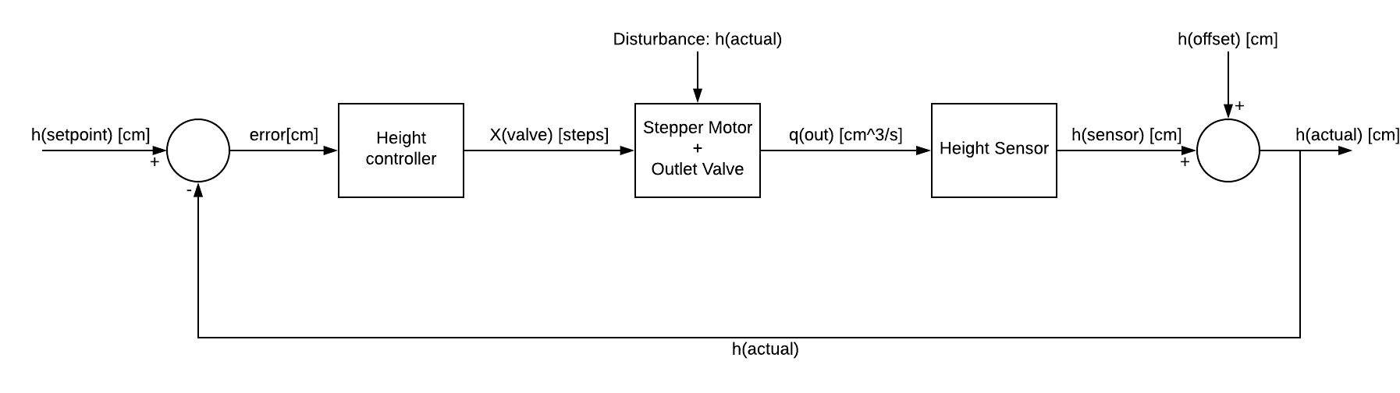

*Figure 1: Block diagram of liquid level control system.*

1. The command signal will be used to adjust the outlet valve by telling the stepper motor to move the valve to open or close by converting the error in centimeters into steps.
2. To convert the error height signal from centimeters to steps, the maximum number of steps the valve can be adjusted, 1020 steps, will be divided by the total height of the tank in centimeters, which is theoretically the maximum error that can occur (assuming the tank does not overflow). This conversion value will be multiplied by the error height signal.
3. If the error is negative, the valve should close.
4. If the error is negative, there is too much water in the tank.
5. If the error is negative, the valve position adjustment should be negative.
6. If the error is positive, the valve should open.
7. If the error is positive, there is not enough water in the tank.
8. If the error is positive, the valve position adjustment should be positive.