ABE 460

Lab Week 5: Liquid Level Simulation Model

Kathryn Atherton

September 17, 2018

Monday

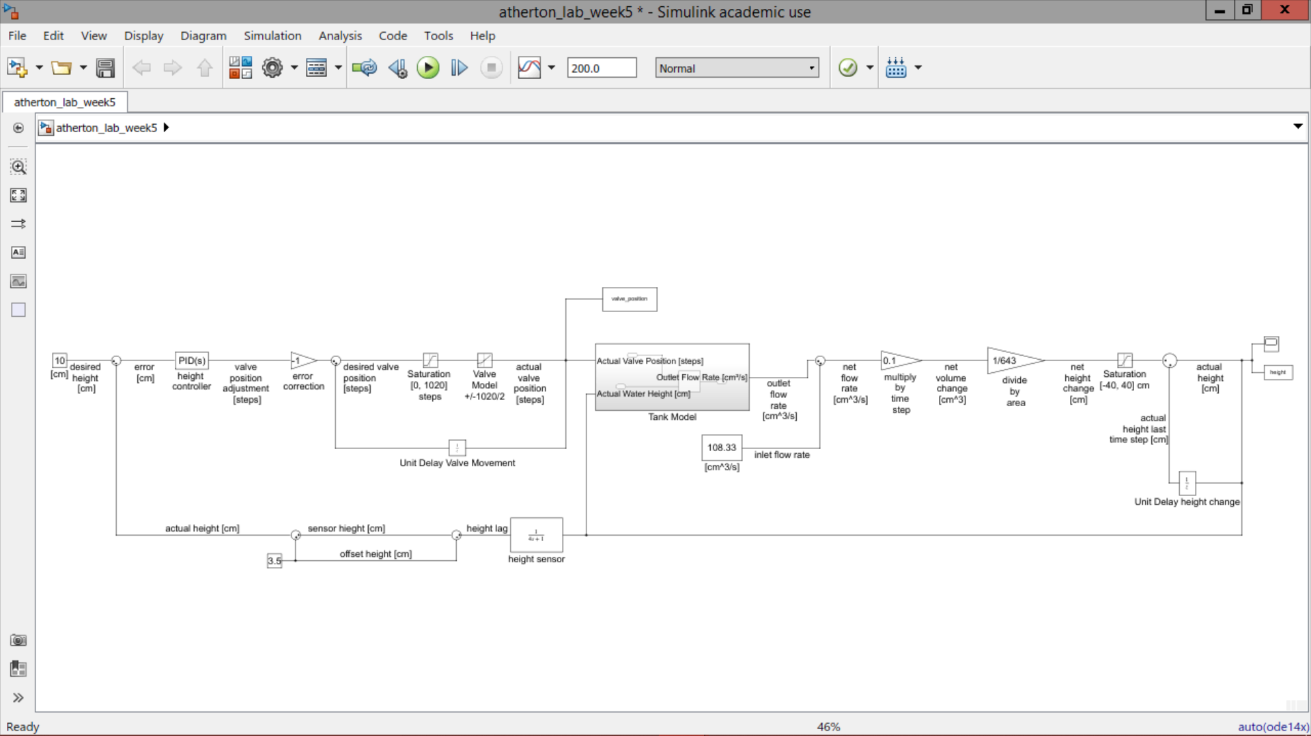

*Figure 1: Simulink Block Diagram of System*

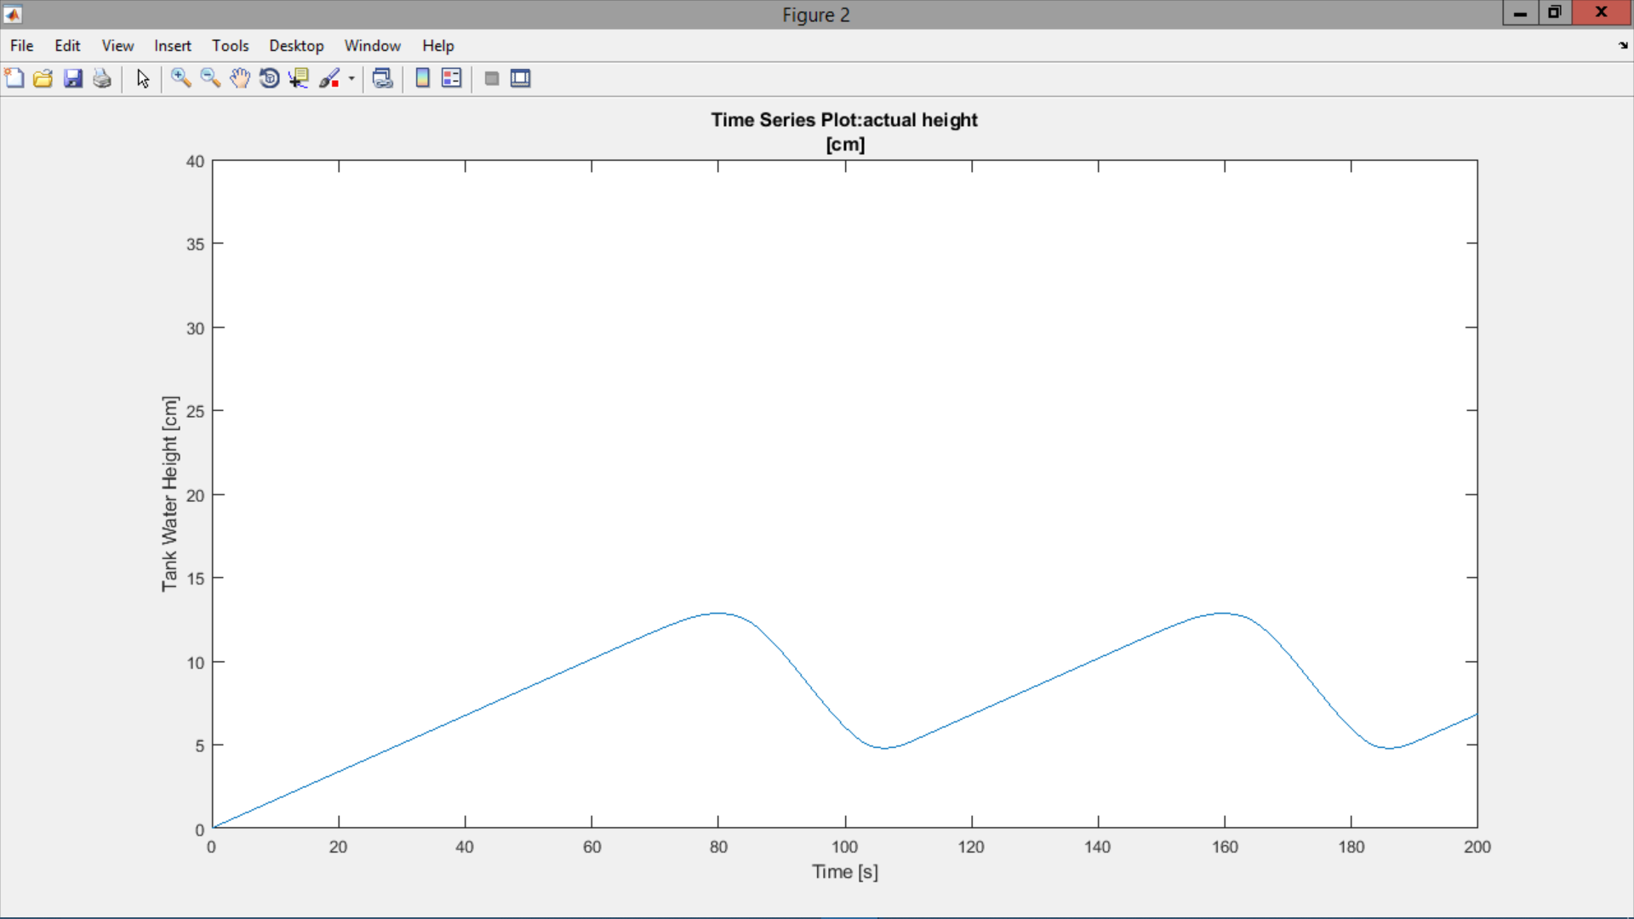

*Figure 2: Tank Water Height [cm] vs. Time [s]*

1. The graph rises to a height of 13 cm before oscillating around the desired height of 10 cm between 13 cm and 5 cm.
2. It looks this way because of the delays in the system that prevent immediate adjustment of the system.
3. The tank is at first filling to the desired height until the sensor detects that the height is greater than desired.
4. Once it is detected that the height is greater than desired, the tank adjusts itself by opening and closing the valve, but delays in the actual adjustment cause oscillations around the desired height.
5. Yes, there are oscillations.
6. The damping frequency is 0.0393 s-1.

Tp = 80s

ωd = 0.0393 s-1

1. The rise time is 80 seconds.
2. The percent overshoot is 30%.
3. The settling time is 264.55 s.

$t_{s,2\%}=\frac{4}{ω_{n}ς}$

ωd = 0.0393 s-1 = ωn \* sqrt(1-ζ2)

From the plot on p. 81 of textbook based on percent overshoot: ζ = 0.36

ωn = 0.0393 s-1 / 0.939

ωn = 0.042 s-1

ts,2% = 4/(0.042 \* 0.36) = 264.55 s

*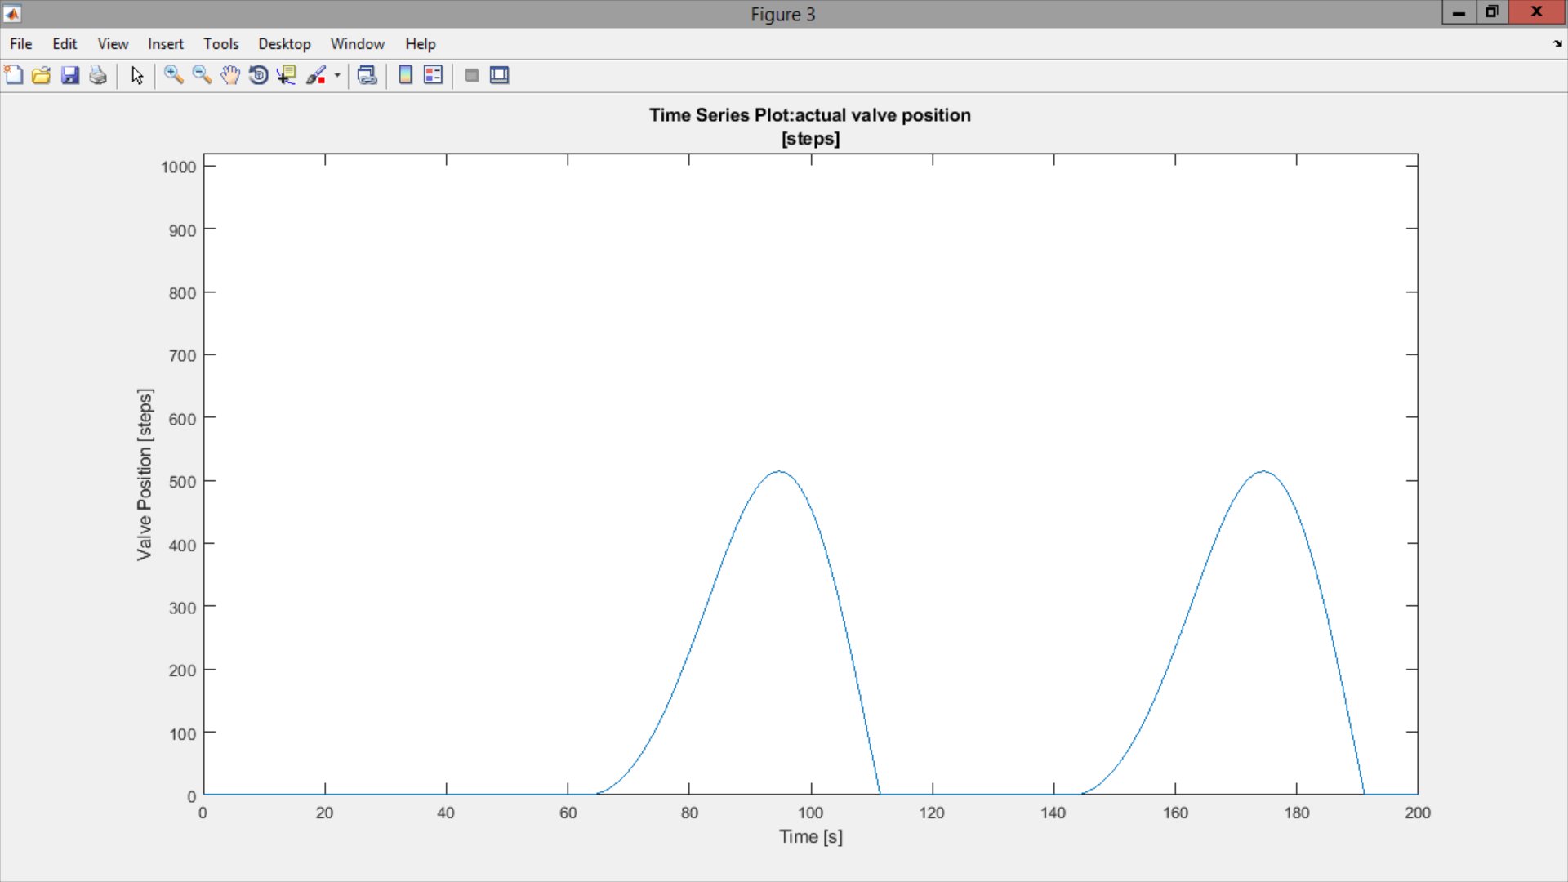*

*Figure 3: Valve Position [steps] vs. Time [s]*

1. The graph is mostly flat besides two peaks when the system needs to adjust its flow out.
2. It looks this way due to the delays in the sensor and motor adjustment.
3. The tank is filling to the desired height so the motor does not need to open during this time.
4. Later in time, the sensor has detected that the desired height has been met so the motor position must be moved, leading to the two peaks.
5. Some portions of the graph are flat because the tank is filling as fast as possible to meet the desired height.
6. The maximum opening position is 510 steps.
7. The valve never fully opens because the delay in the motor adjustment would cause the tank to empty too quickly while the valve was fully open.

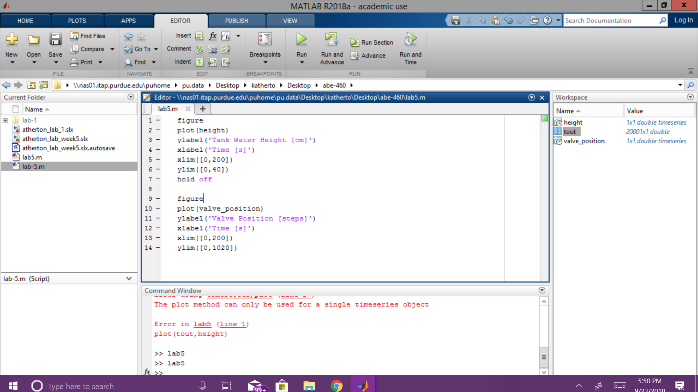

*Figure 4: MATLAB code to produce plots*