ABE 460

Lab Week 6: Liquid Level PID Controller

Kathryn Atherton

September 24, 2018

Monday

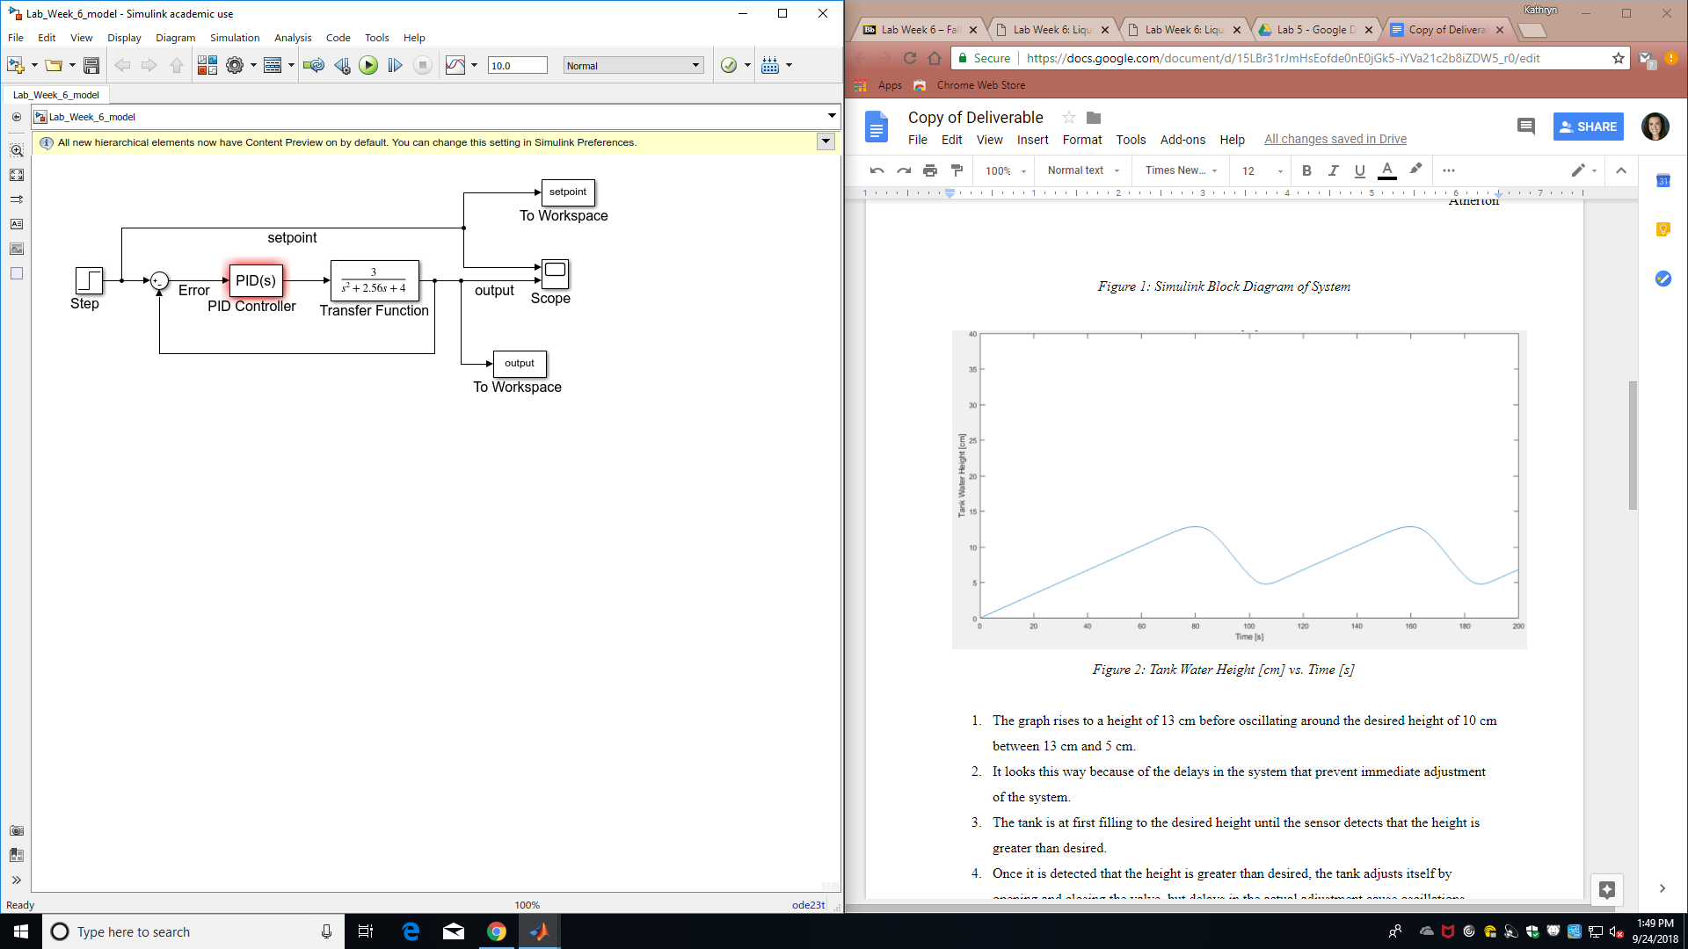

*Figure 1: Simulink Block Diagram of System*

**Problem 5.1**

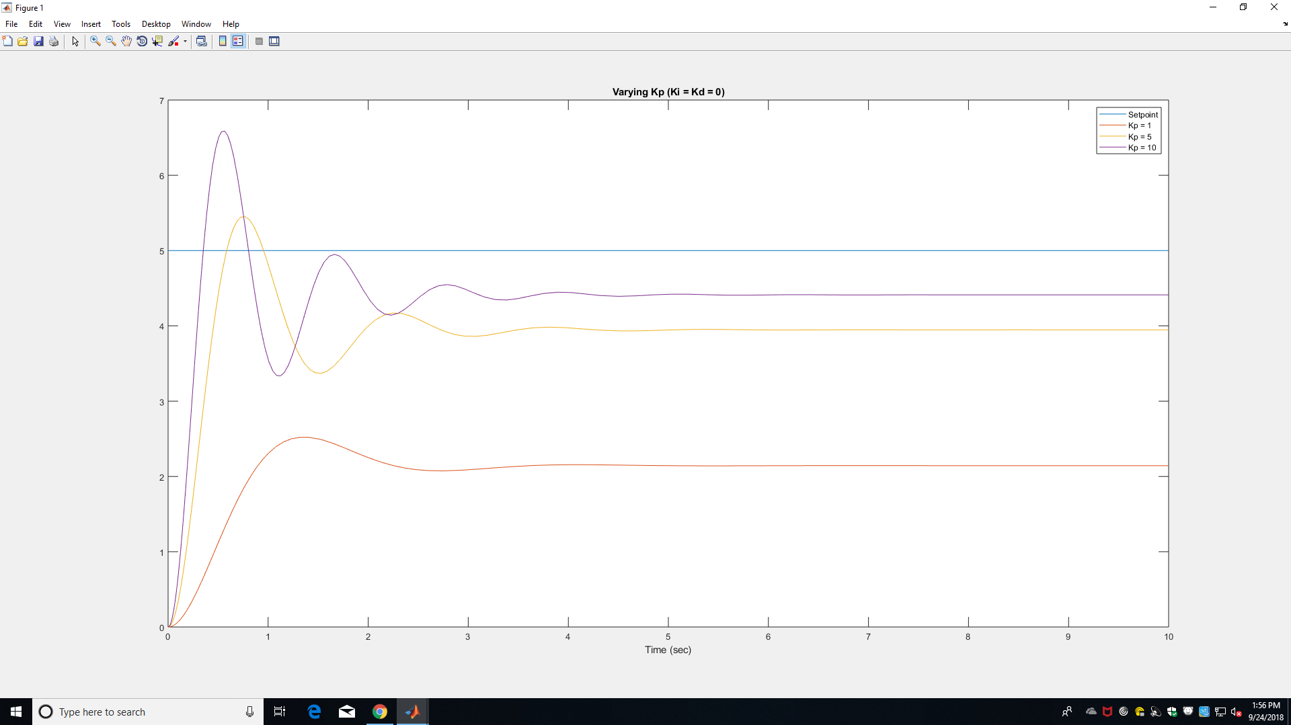

*Figure 2: Varying Kp between 1 and 10 while Ki and Kd = 0*

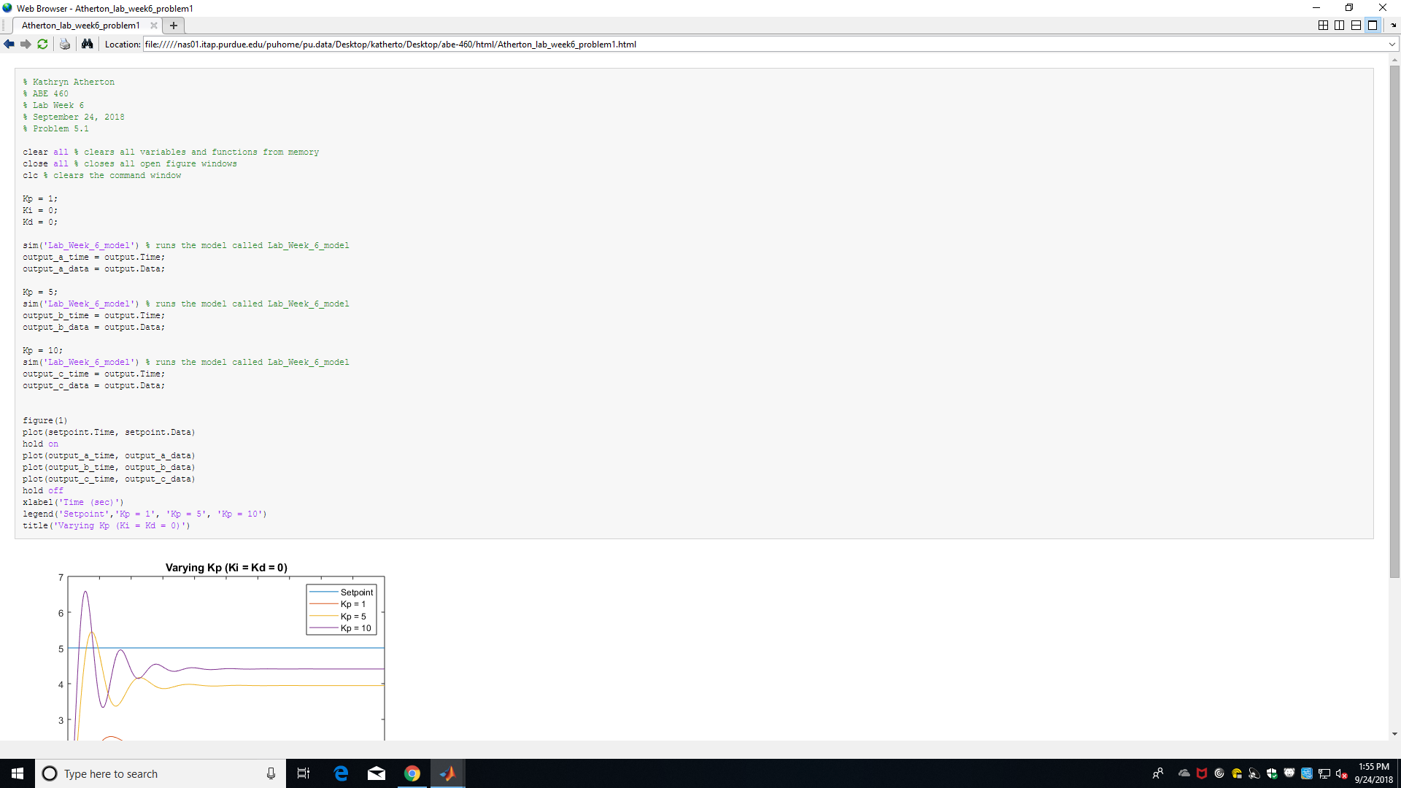

*Figure 3: MATLAB Code for Problem 5.1*

* Kp causes the magnitude of the steady state value to increase.
* As Kp increases, the steady state value increases, the initial overshoot increases, and the number of oscillations before the steady state is reached increases.
* No, you cannot get rid of steady state errors by only changing Kp.
* As Kp increases past 10, the steady state value gets closer and closer to the setpoint value, but the oscillations start with much higher error.

**Problem 5.2**

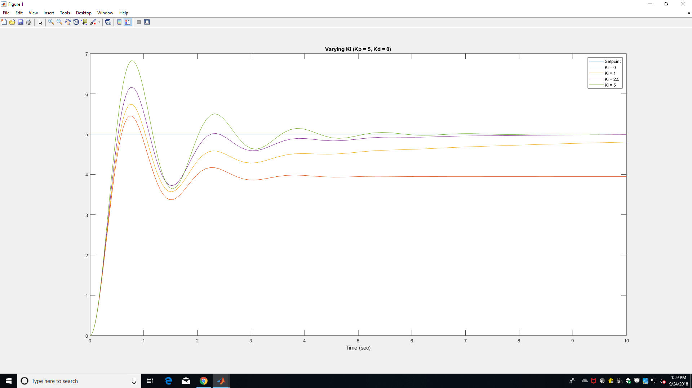

*Figure 4: Varying Ki between 0 and 5 while Kp = 5 and Kd = 0*

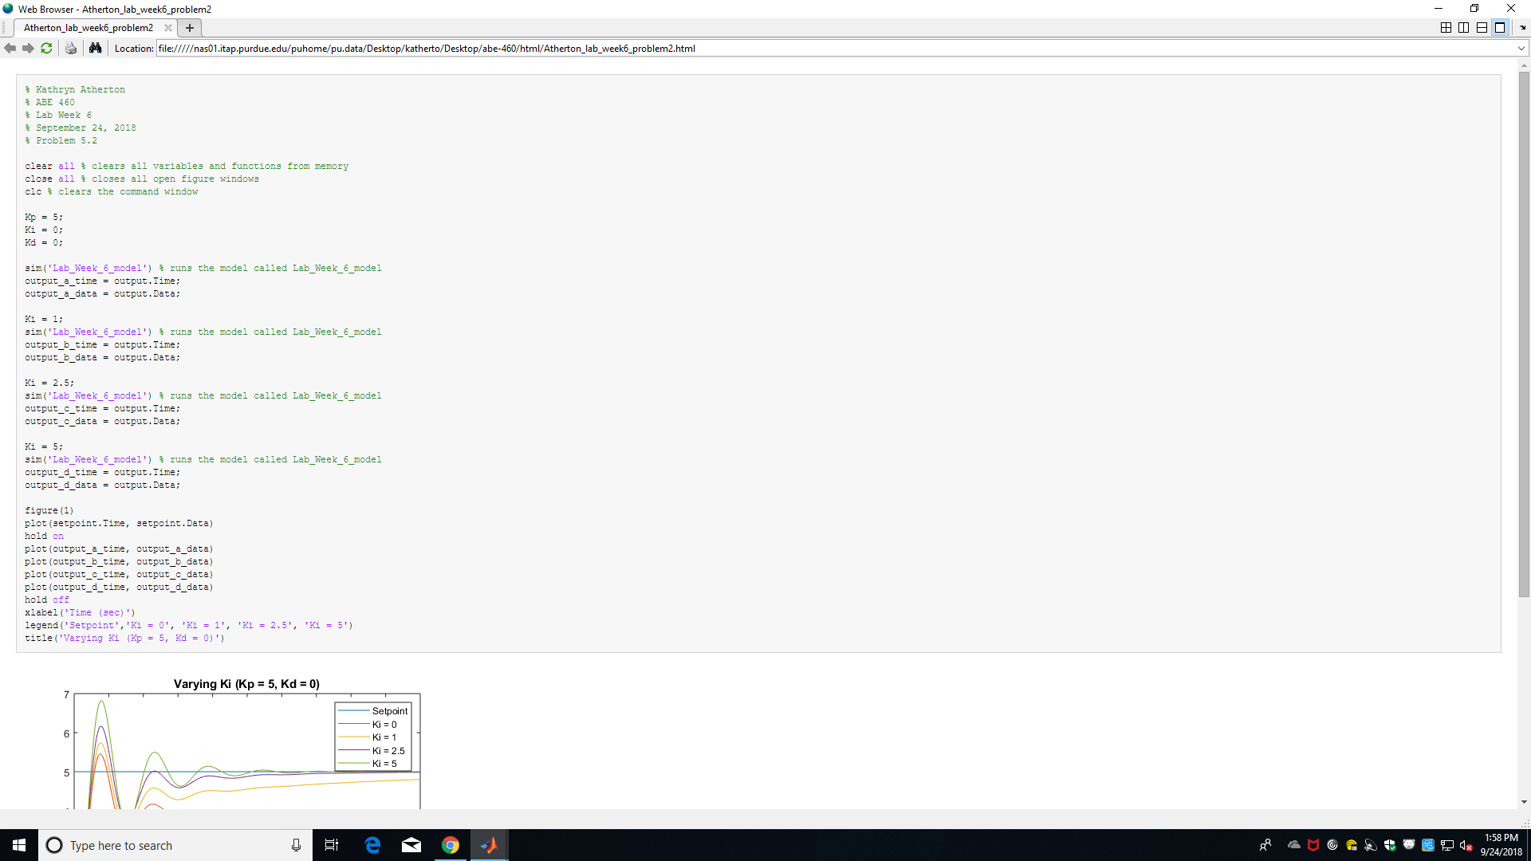

*Figure 5: MATLAB Code for Problem 5.2*

* Ki keeps the oscillations the same, only increasing the magnitude and then the final steady state value as Ki gets closer to the setpoint value.
* As Ki increases beyond 5, the oscillations become larger in amplitude and become slower to settle around the desired final value.

**Problem 5.3**

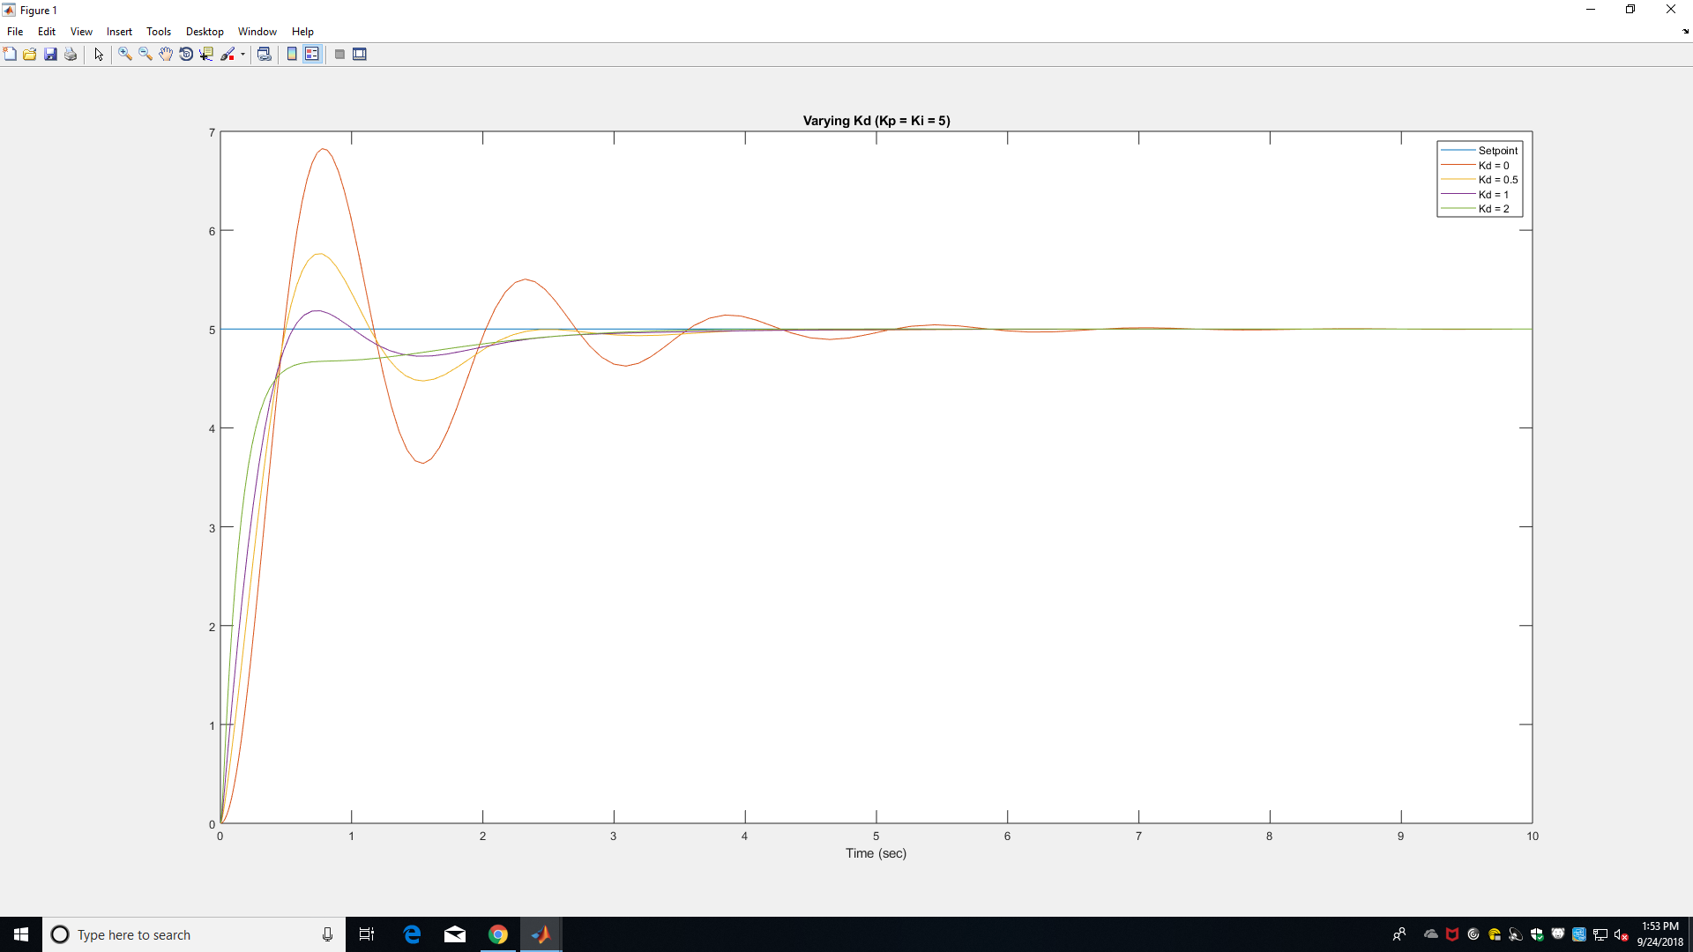

*Figure 6: Plot varying Kd between 0 and 2 while Kp and Ki = 5*

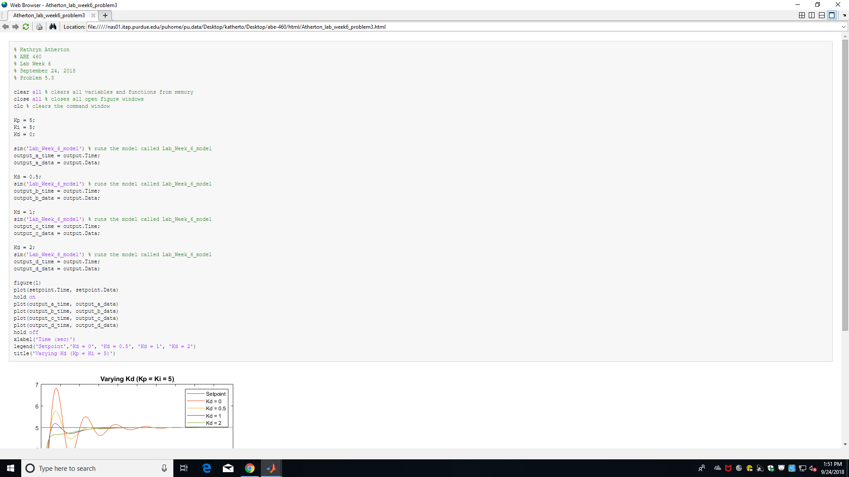

*Figure 7: MATLAB Code for Problem 5.3*

* As Kd increases, it dampens the initial overshoot but does not affect the final steady state value.
* As Kd increases past 2, it dampens the overshoot even more, and creates a sharp dip in the response curve before creating long oscillations of small amplitude around the steady state value.

**Problem 5.4**

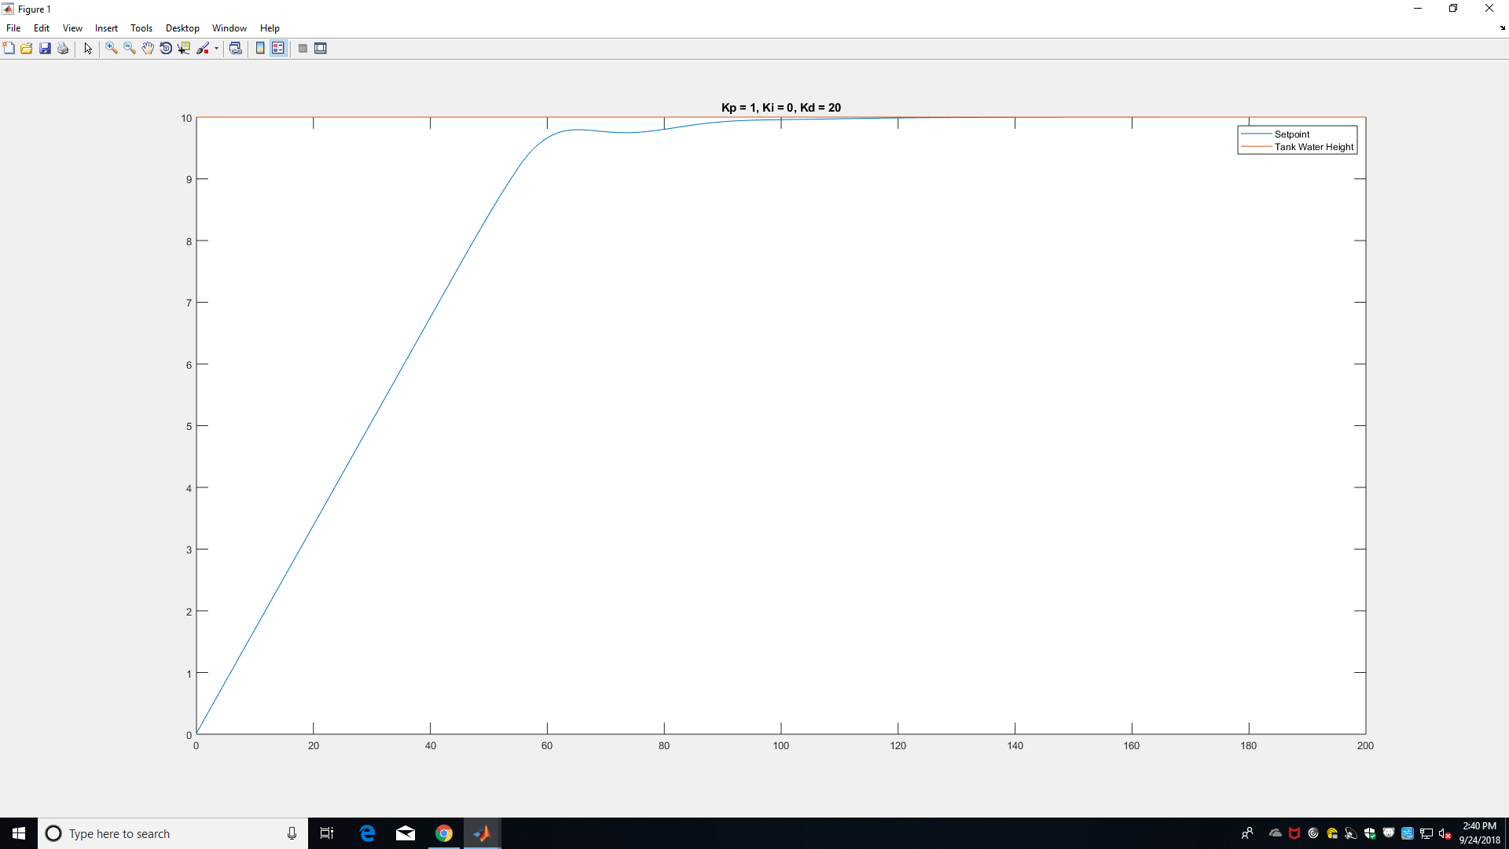

*Figure 8: Water Height vs. Time*

The chosen values for the PID were Kp = 1, Ki = 0, and Kd = 20.