ABE 460

Lab Week 7: Process Identification and Empirical Modeling

Kathryn Atherton

October 1, 2018

Monday

### Problem 3.1

1. First order time function =

Yss = 80

Y0 = 256

From MATLAB: ⊤ = 17 seconds

Overall time function =

First order transfer function =

Overall transfer function =

1. Output variable = temperature (degrees F)
2. 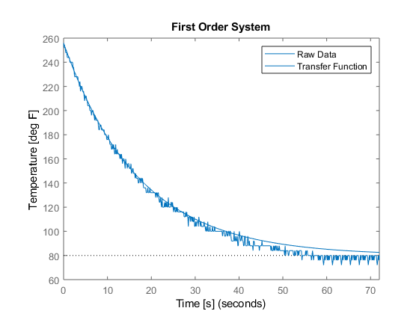

*Figure 1: First Order System Raw Data and Transfer Function Plot*

1. 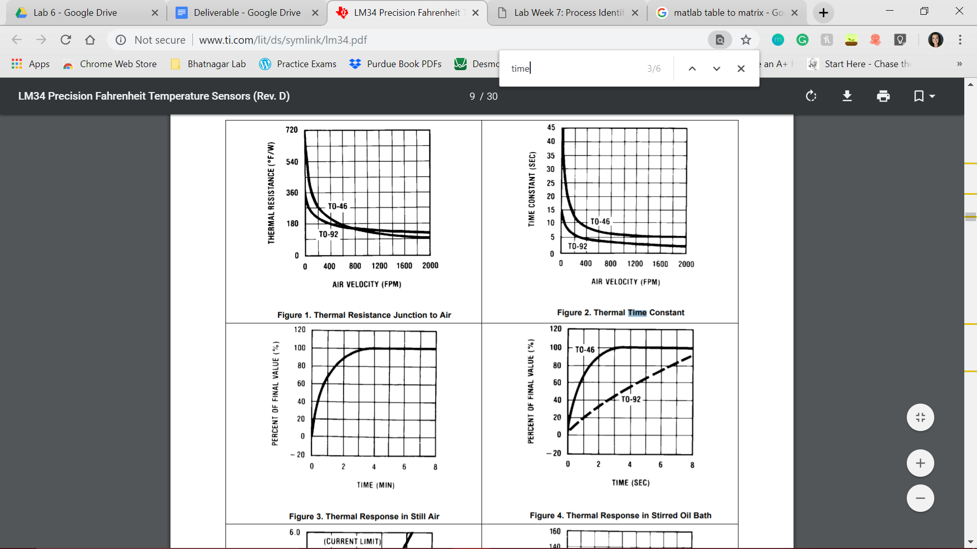

*Figure 3: Time constant comparison for T0-92 Model*

According to Figure 3, the published time constant is about 15 seconds when the air velocity is 0 fpm. This is an 11% error.

1. 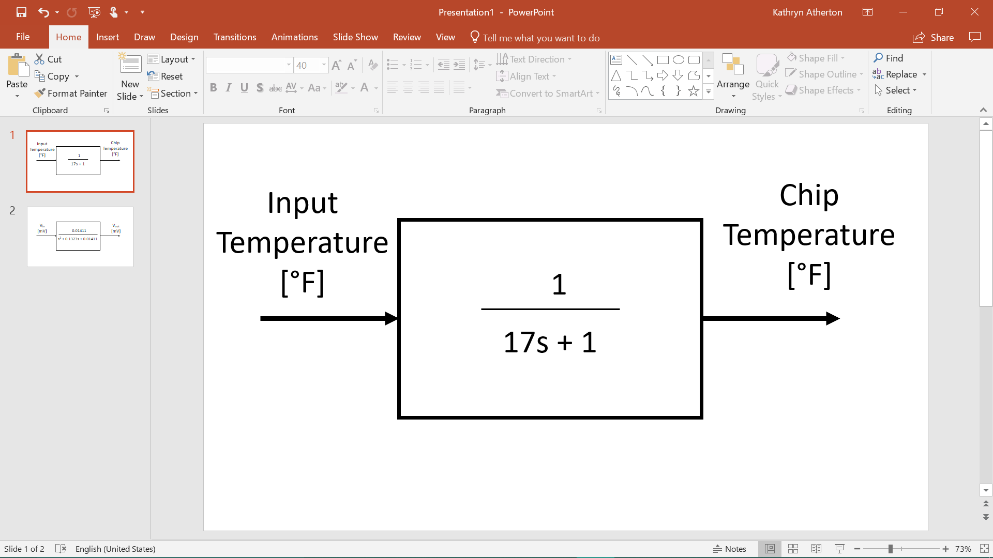

*Figure 4: First Order Transfer Function Block Diagram*

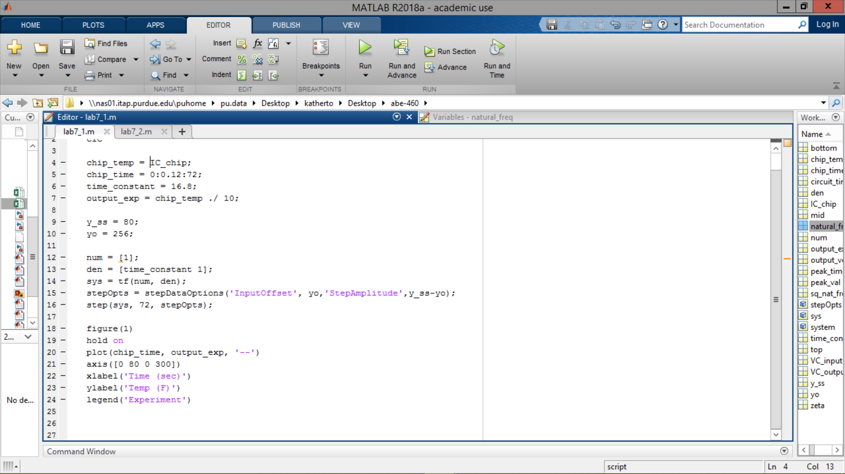

*Figure 5: MATLAB Code for Problem 3.1*

### Problem 3.2

1. Zeta = 0.55680

Peak time = 31.84

Natural frequency = 0.1188

1. 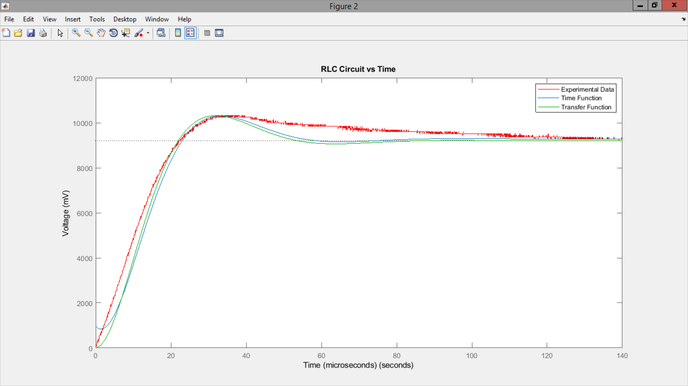

*Figure 6: Second Order System Raw Data, Time Function, and Transfer Function Plots*

1. C = 1μF

1 =

1 =

L = 1μF-1

0.1323 =

R = 0.1323 μF

1. 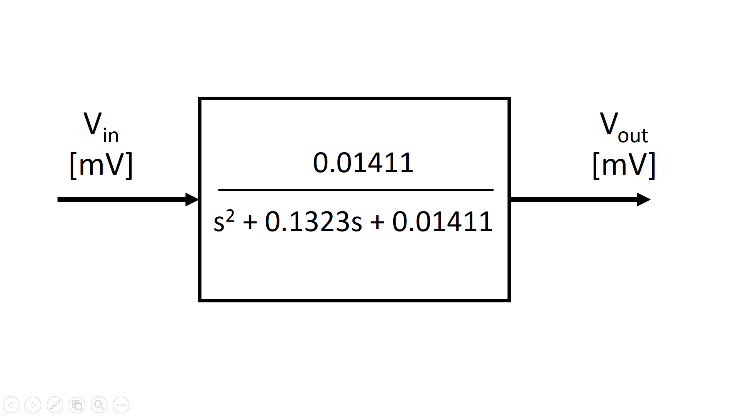

*Figure 7: Second Order Transfer Function Block Diagram*

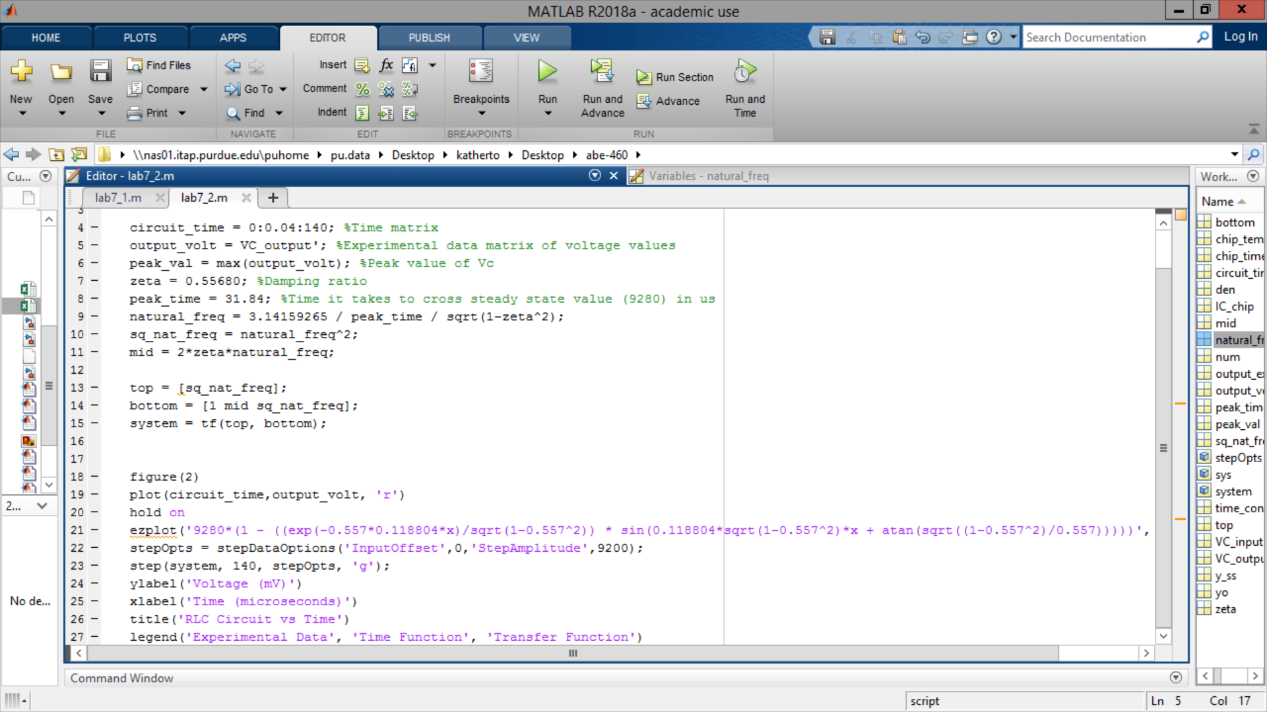

*Figure 8: MATLAB Code for Problem 3.2*