ABE 460

Lab Week 9: Liquid Level Physical System Modeling

Kathryn Atherton

October 22, 2018

Monday

**Problem 5.1:**

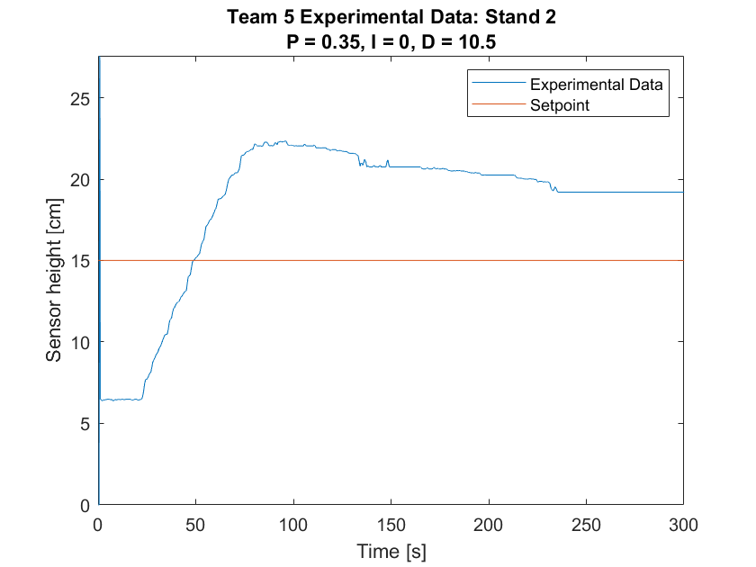

*Figure 1: Experimental Data -- Height vs. Time*

1. The initial fill rate is 111.19 cm3/s.
2. The 5% settling time is 152.08 s.
3. There is a lot of valve chatter due to the response time between the sensor, the valve, the arduinos, and the Simulink model communicating with each other. This is something that the model does not take into consideration. Additionally, as the tank is being filled, the water volume height does not necessarily stay flat due to agitation of the stand or splashing water around; as such, the sensor height is not always consistent.

**Problem 5.2:**

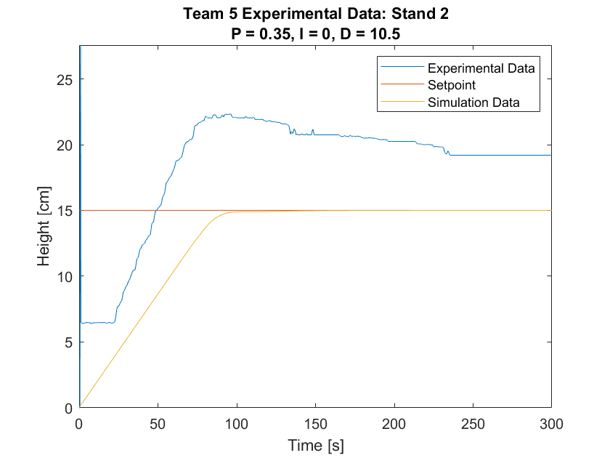

*Figure 2: Simulation and Experimental Data -- Height vs. Time*

1. The simulation does not match the experiment very well at all. The experimental data totally oershoots the setpoint while the simulation acts like a first order system and reaches a steady value at the setpoint smoothly and quickly.
2. There are differences between the model and the simulation because a model can never truly reflect all of the real-world disturbances that can occur.

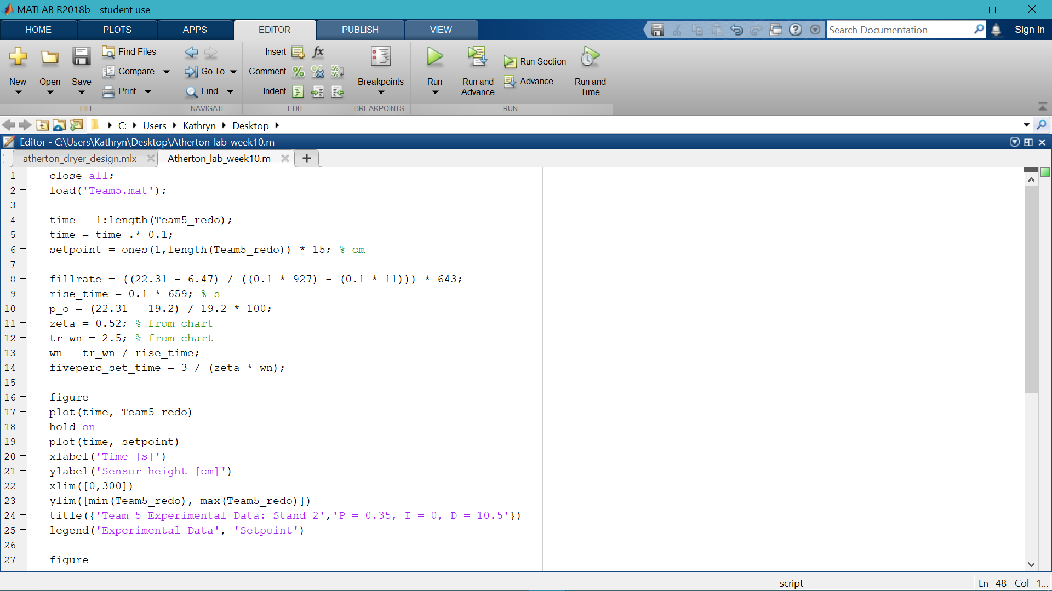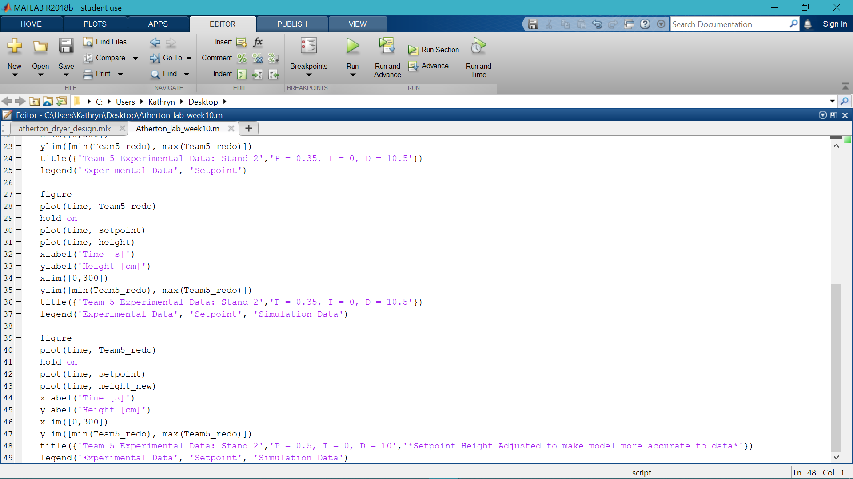

*Figure 4: MATLAB Code to produce plots and calculate needed values*