ABE 460

Lab Week 10: Liquid Level Physical System Modeling

Kathryn Atherton

October 15, 2018

Monday

**Problem 5.1:**

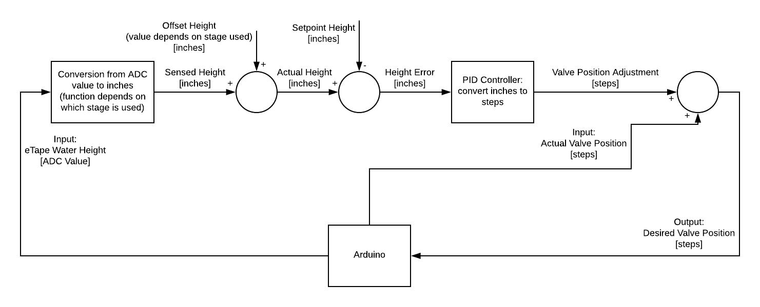

*Figure 1: Block Diagram of Physical System: Arduino-Simulink Interaction*

**Problem 5.2:**

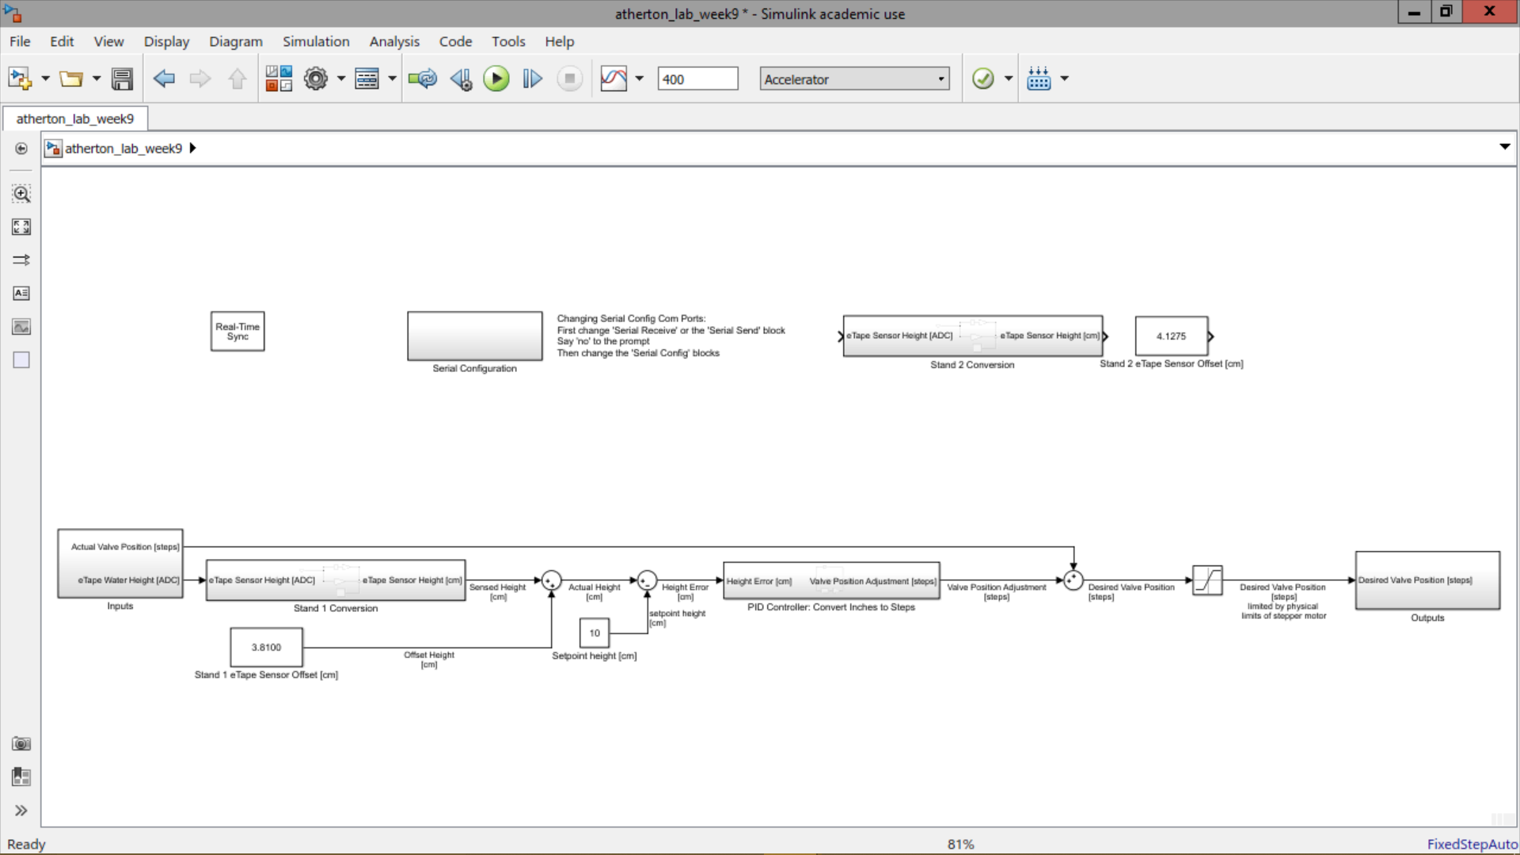

*Figure 2: Screenshot of Simulink File*

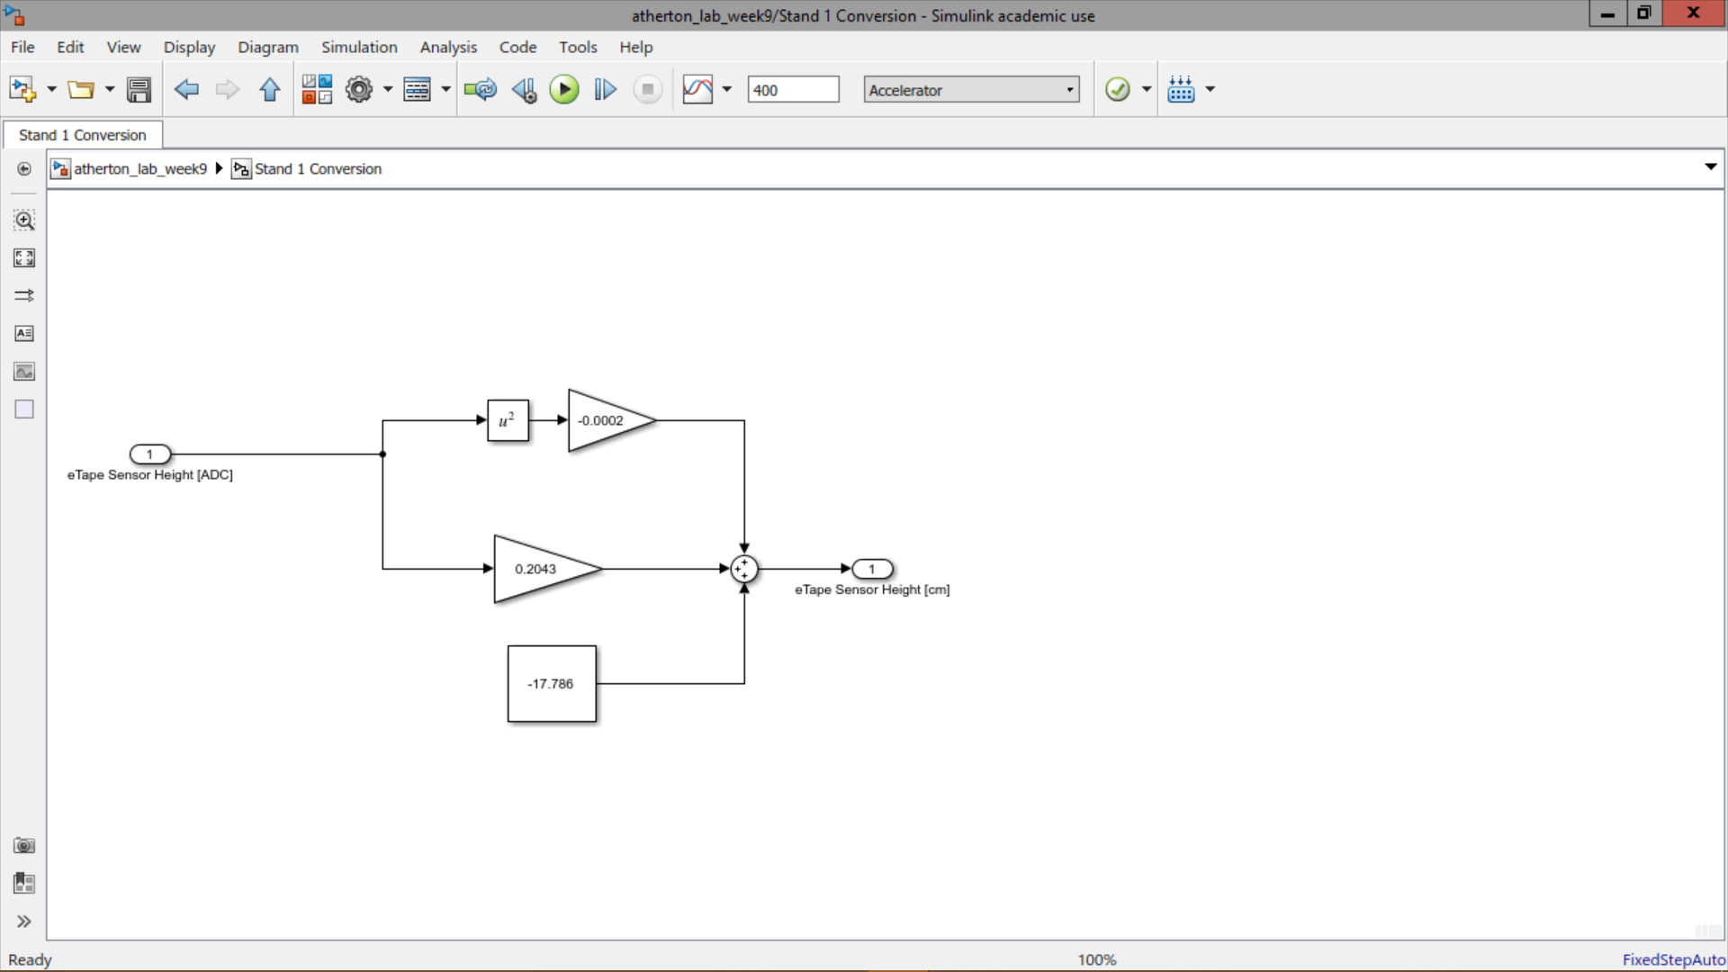

*Figure 3: Screenshot of Conversion Subsystem for Stand 1*

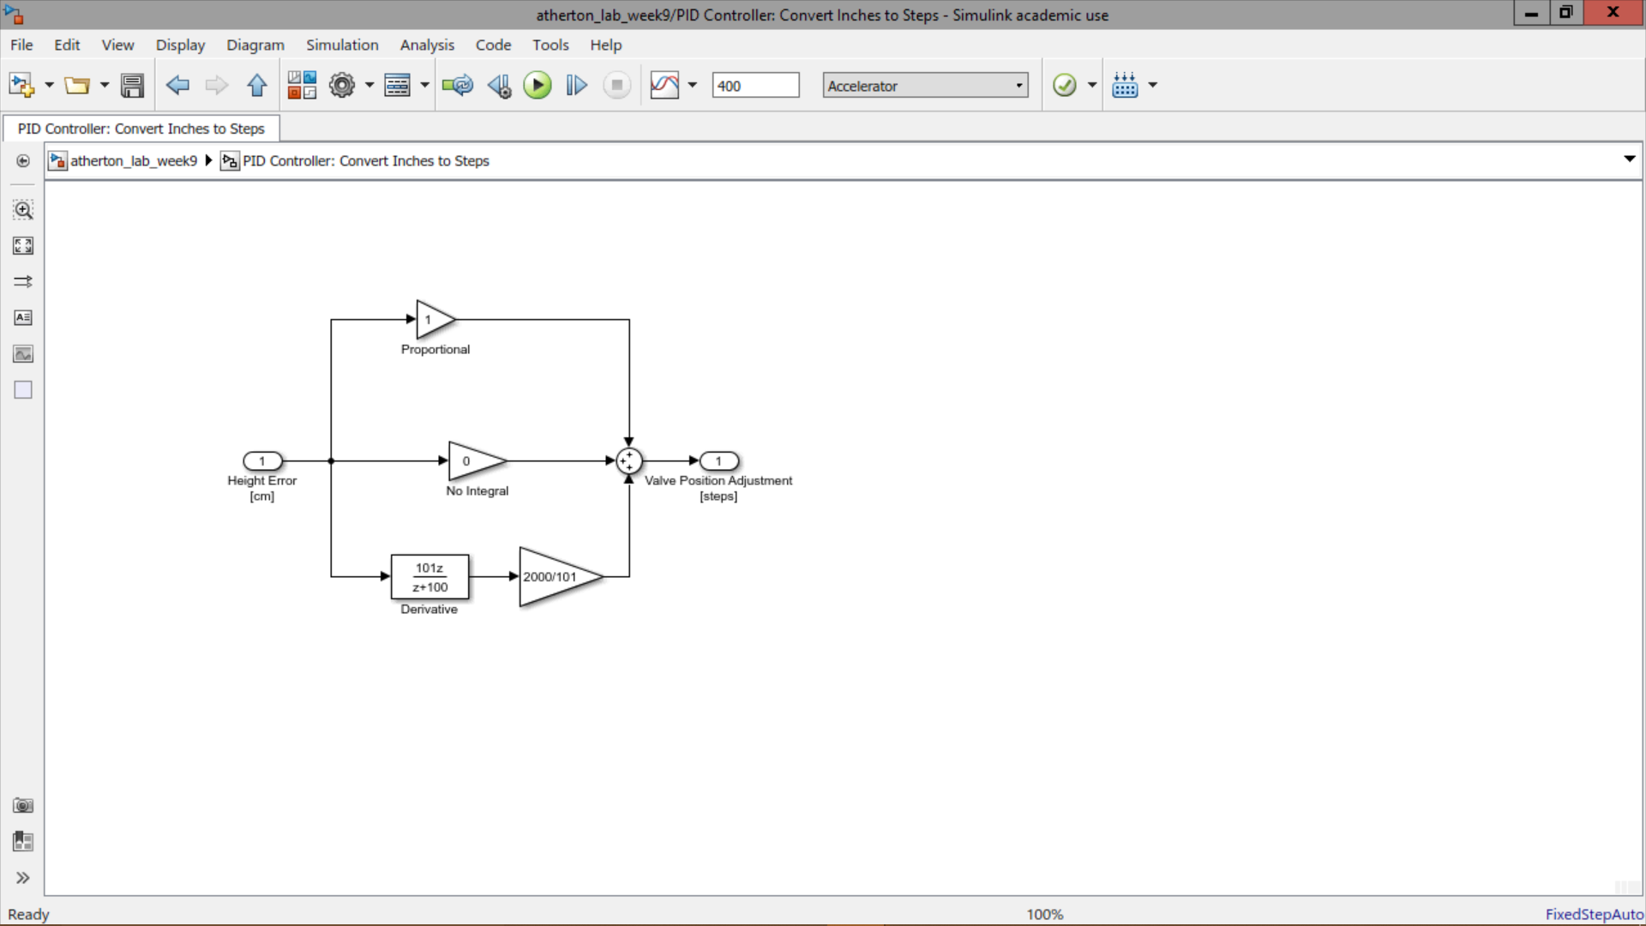

*Figure 4: Screenshot of PID*