ABE 460

Lab Week 11: Programmable Logic Controller

Kathryn Atherton

October 29, 2018

Monday

**Section 2.1**

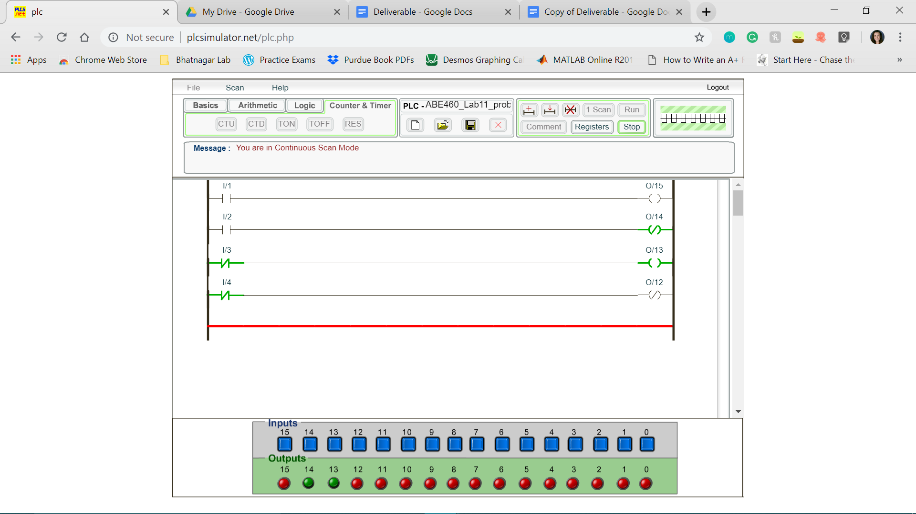

*Figure 1: Completed program for section 2.1*

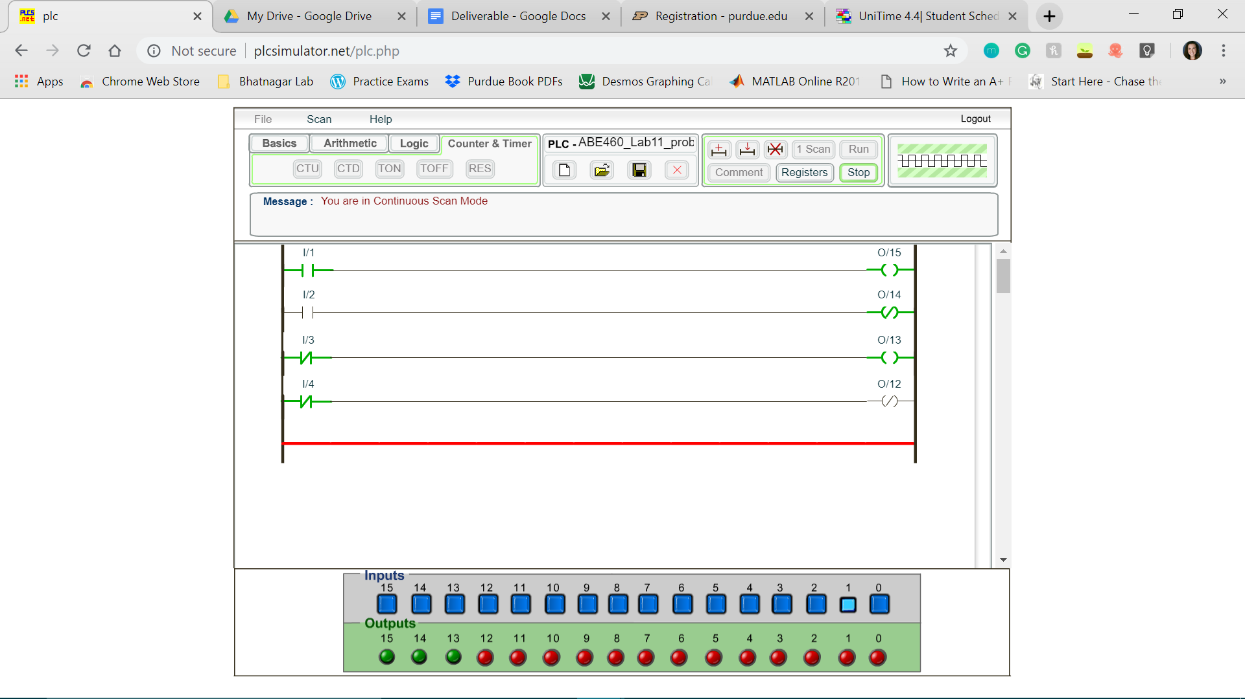

*Figure 2: Completed program for section 2.1 when Input 1 is activated*

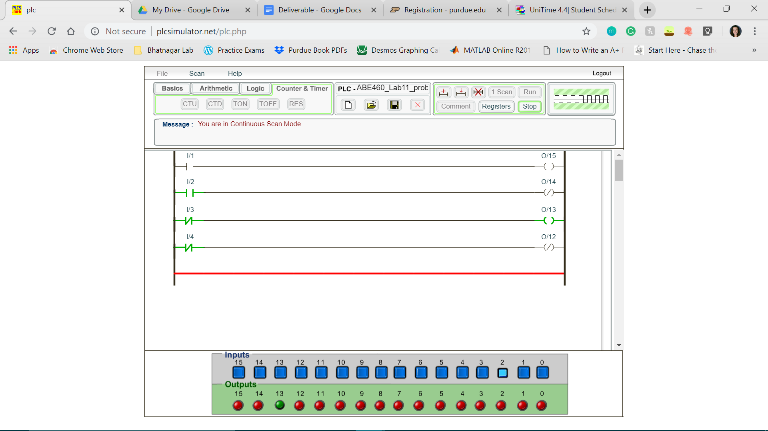

*Figure 3: Completed program for section 2.1 when input 2 is activated*

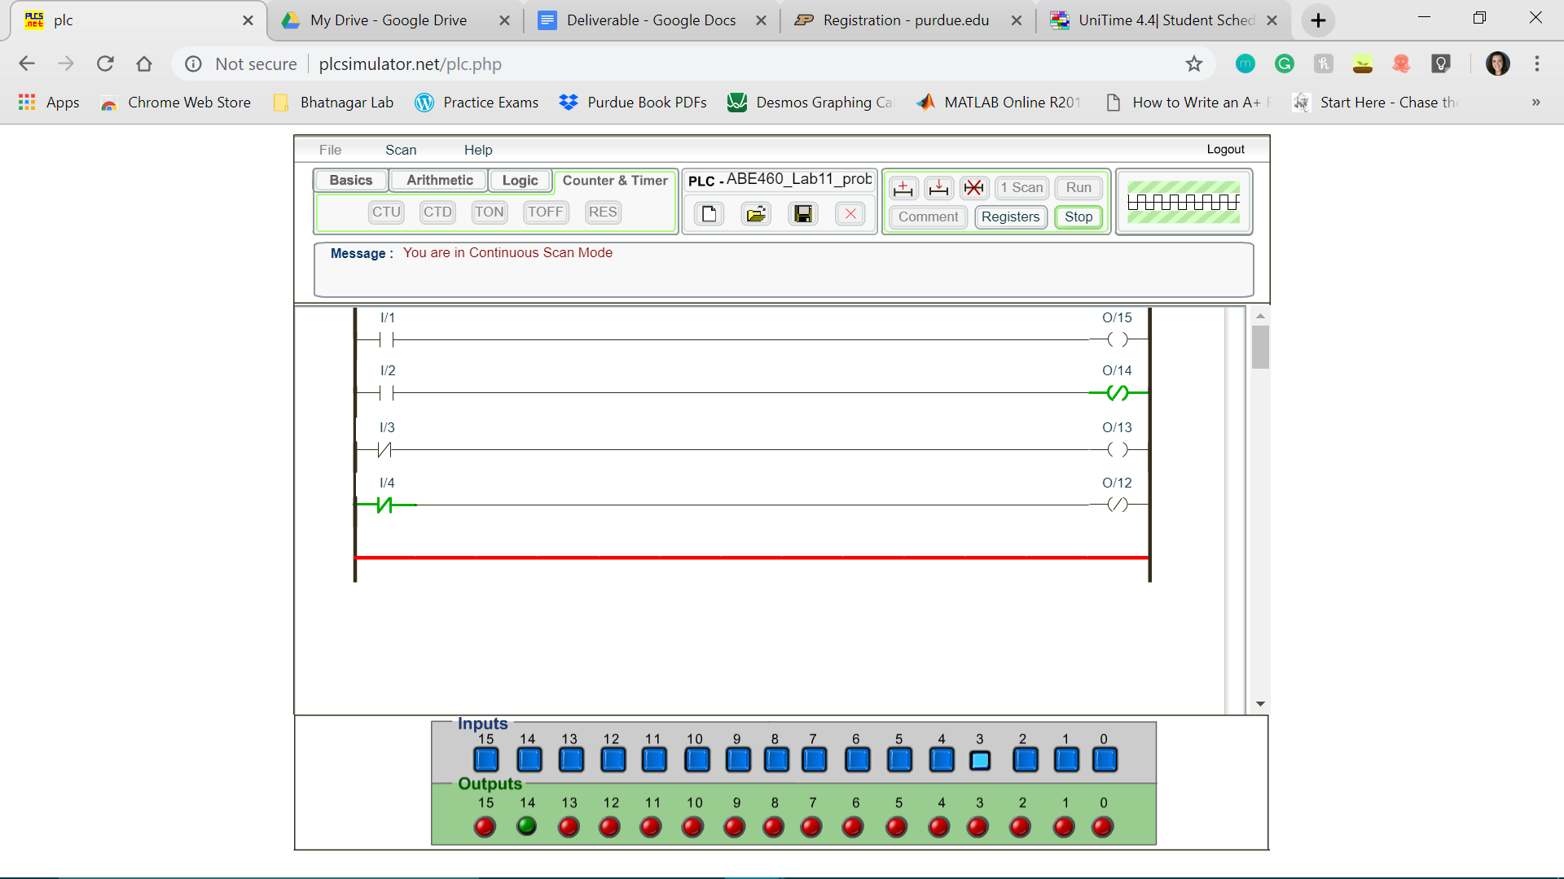

*Figure 4: Completed program for section 2.1 when input 3 is activated*

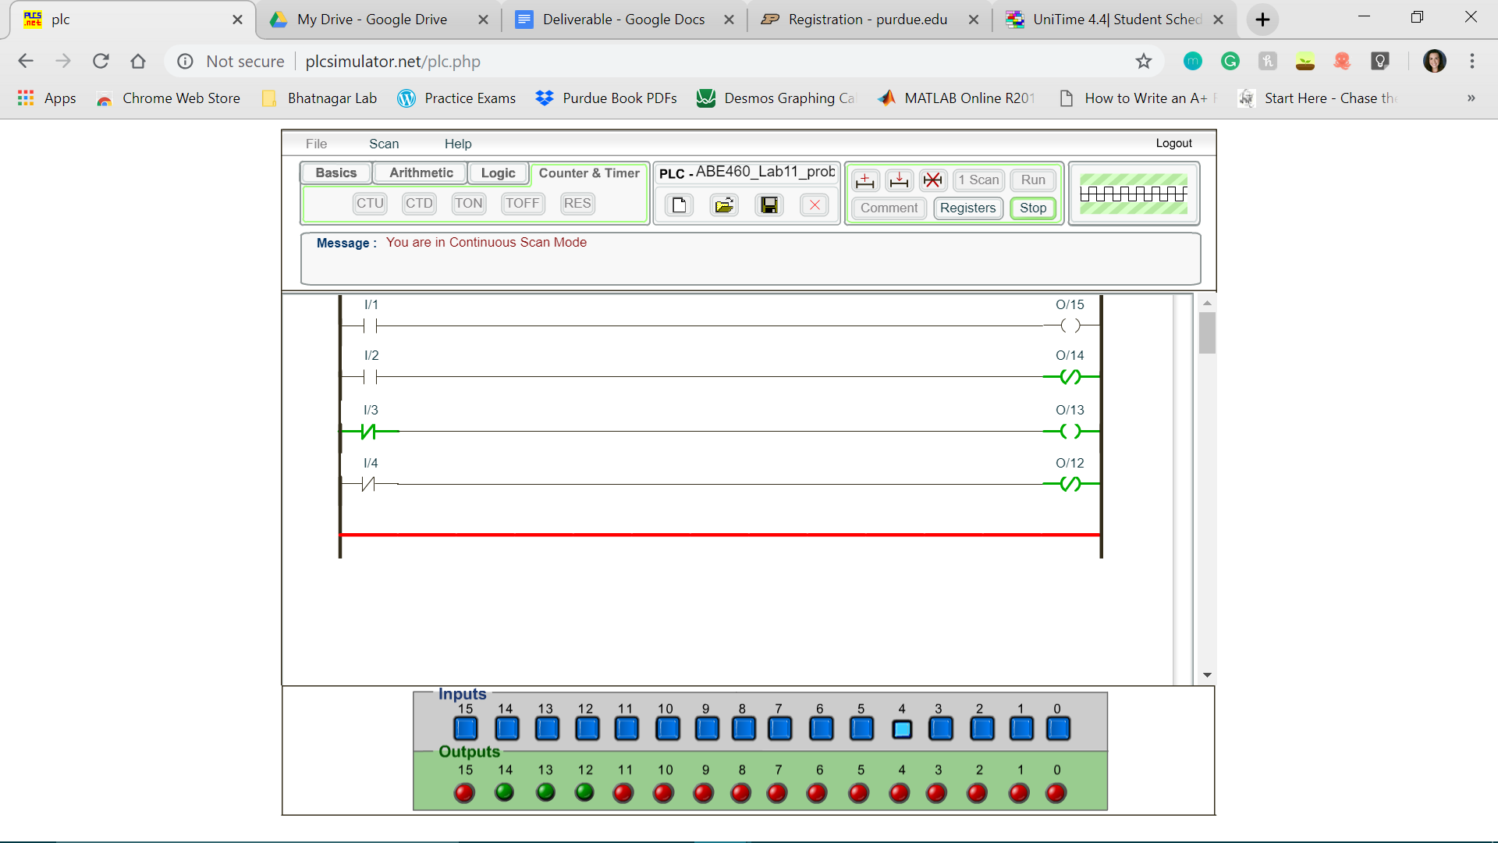

*Figure 5: Completed program for section 2.1 when input 4 is activated*

**Section 2.2**

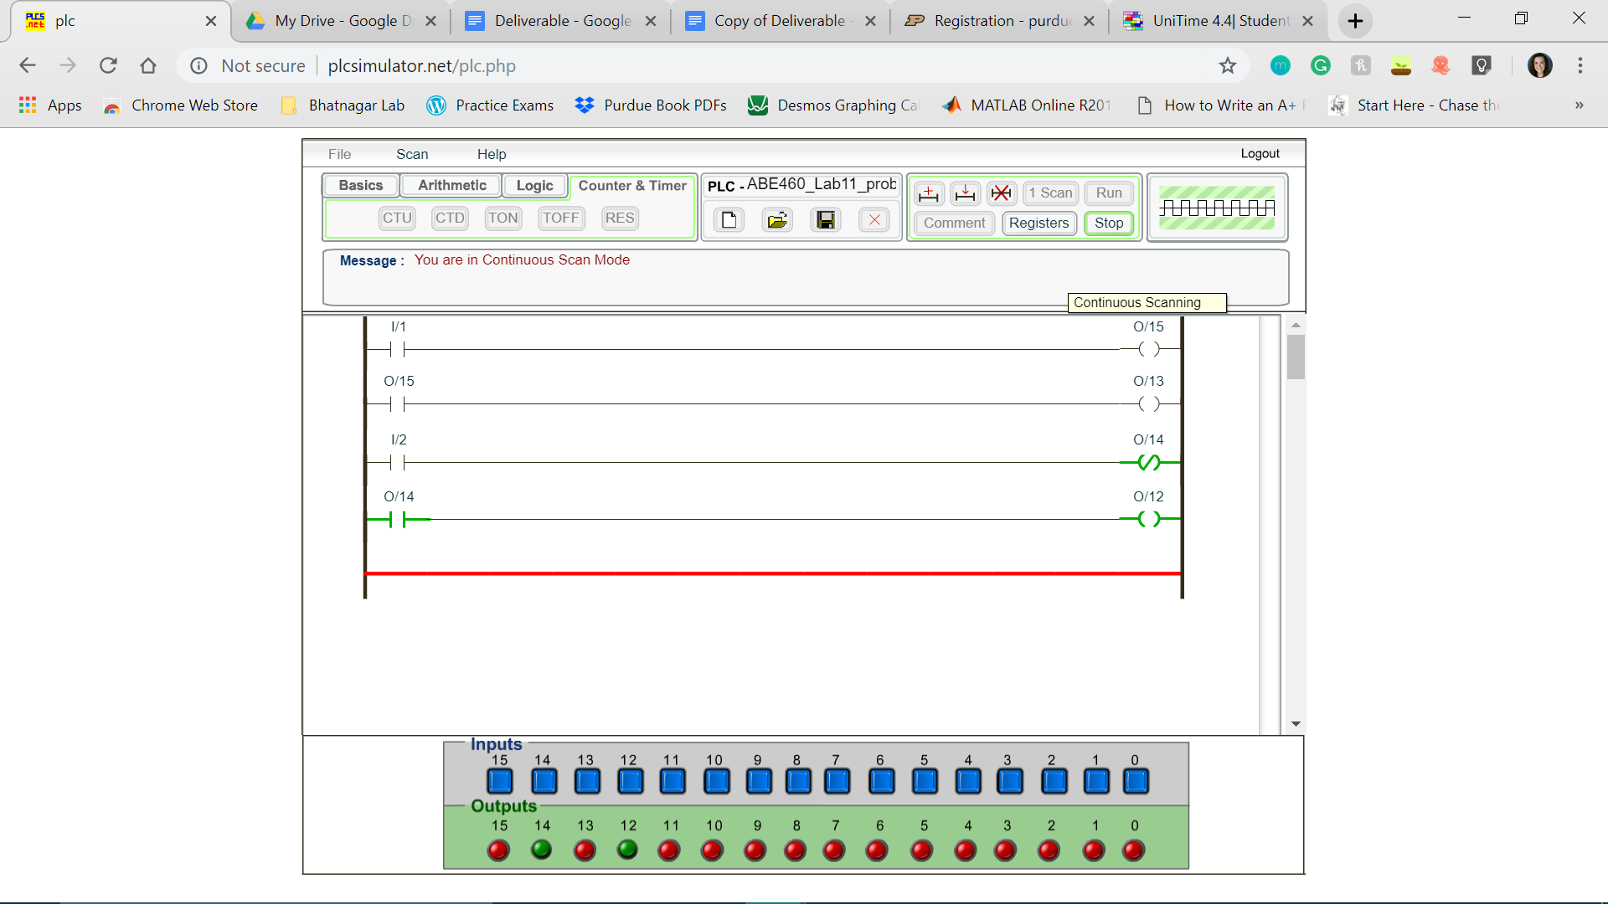

*Figure 6: Completed program for section 2.2*

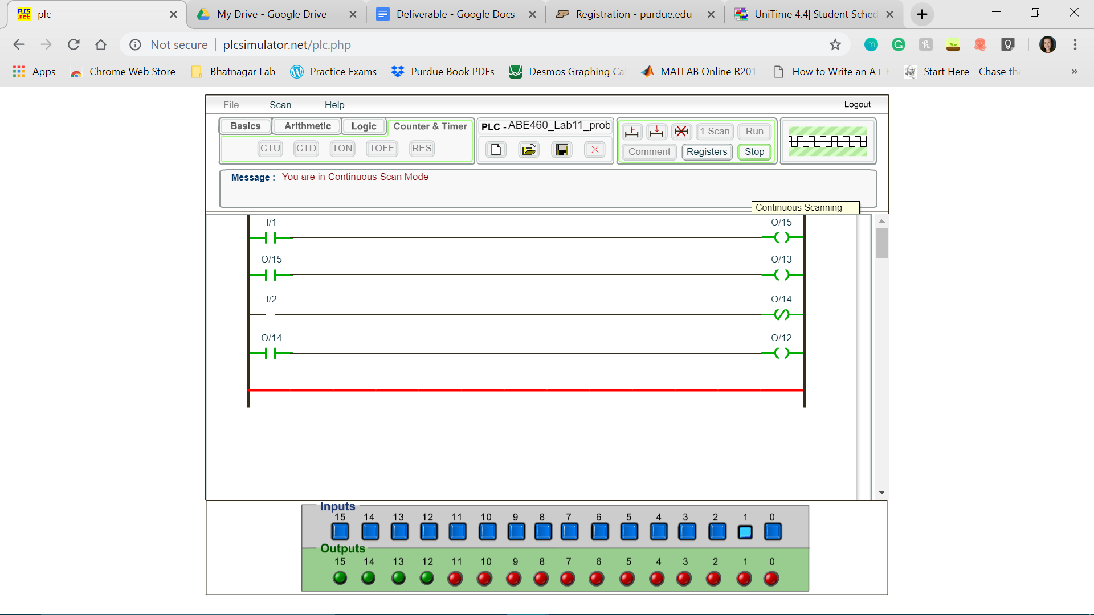

*Figure 7: Completed program for section 2.2 when input 1 is activated*

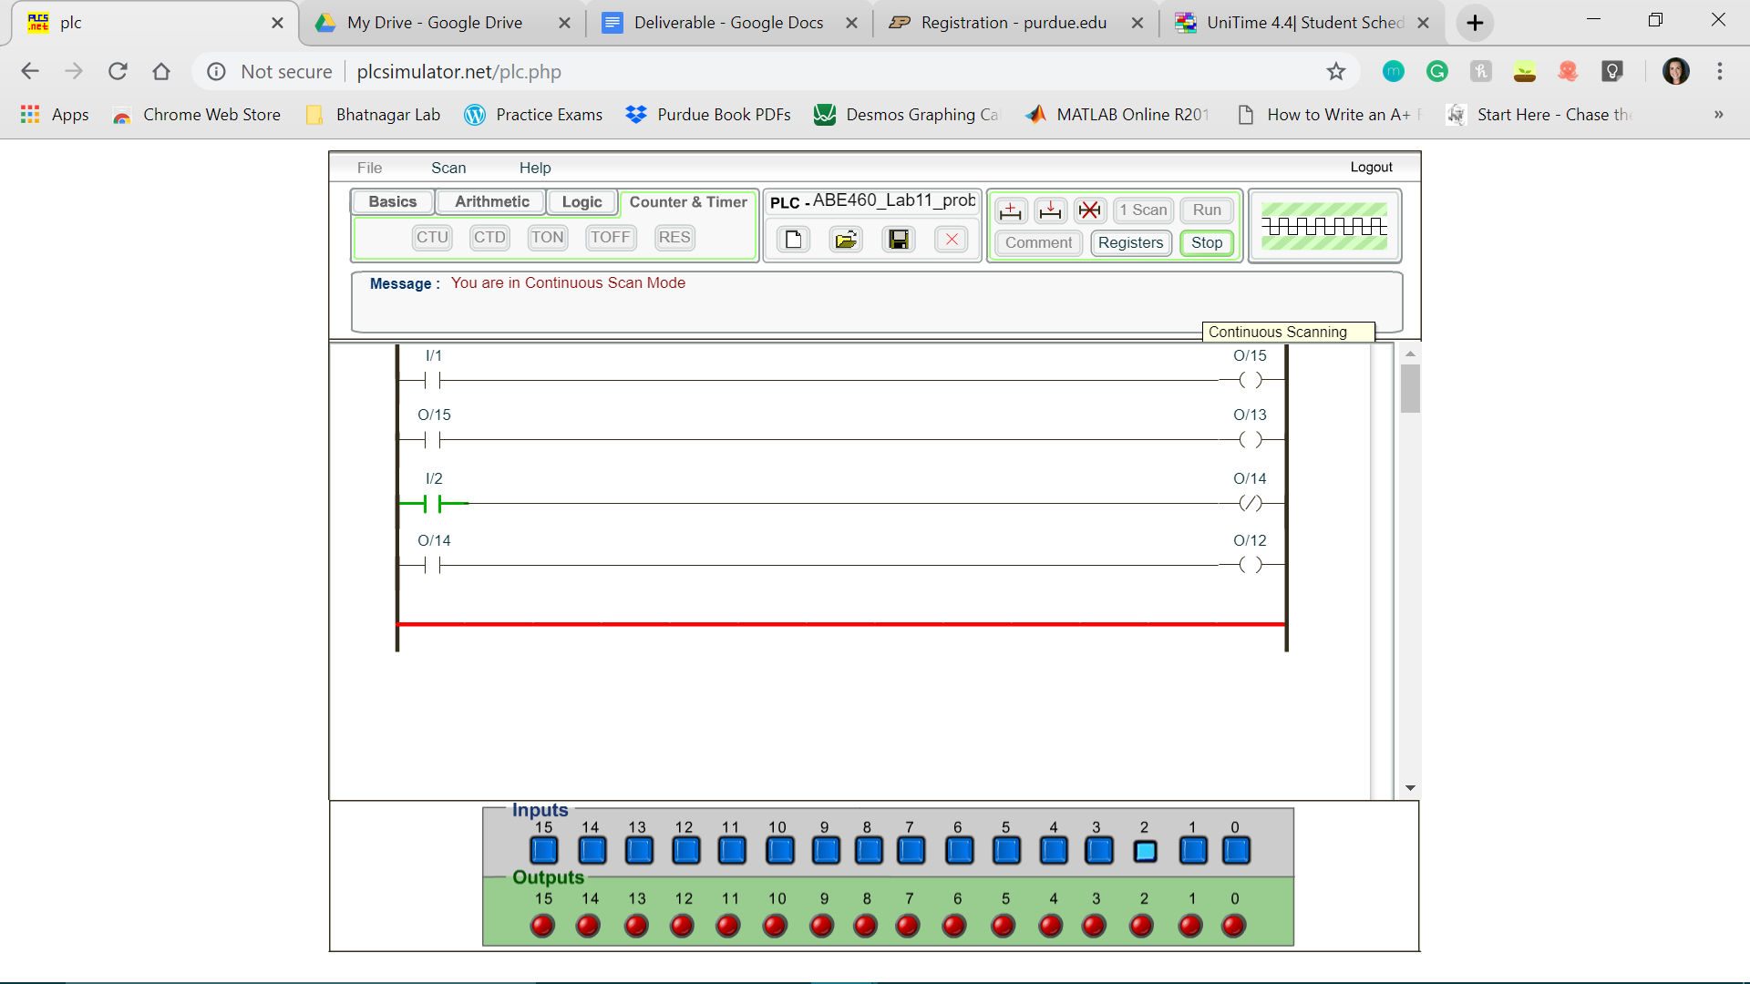

*Figure 8: Completed program for section 2.2 when input 2 is activated*

**Section 2.3**

*Table 1: Input and Output design chart*

|  |  |
| --- | --- |
| **Input/Output** | **Is it normally open or normally closed?** |
| I/1 | Usually Open |
| I/2 | Usually Closed |
| O/4 | Usually Open |

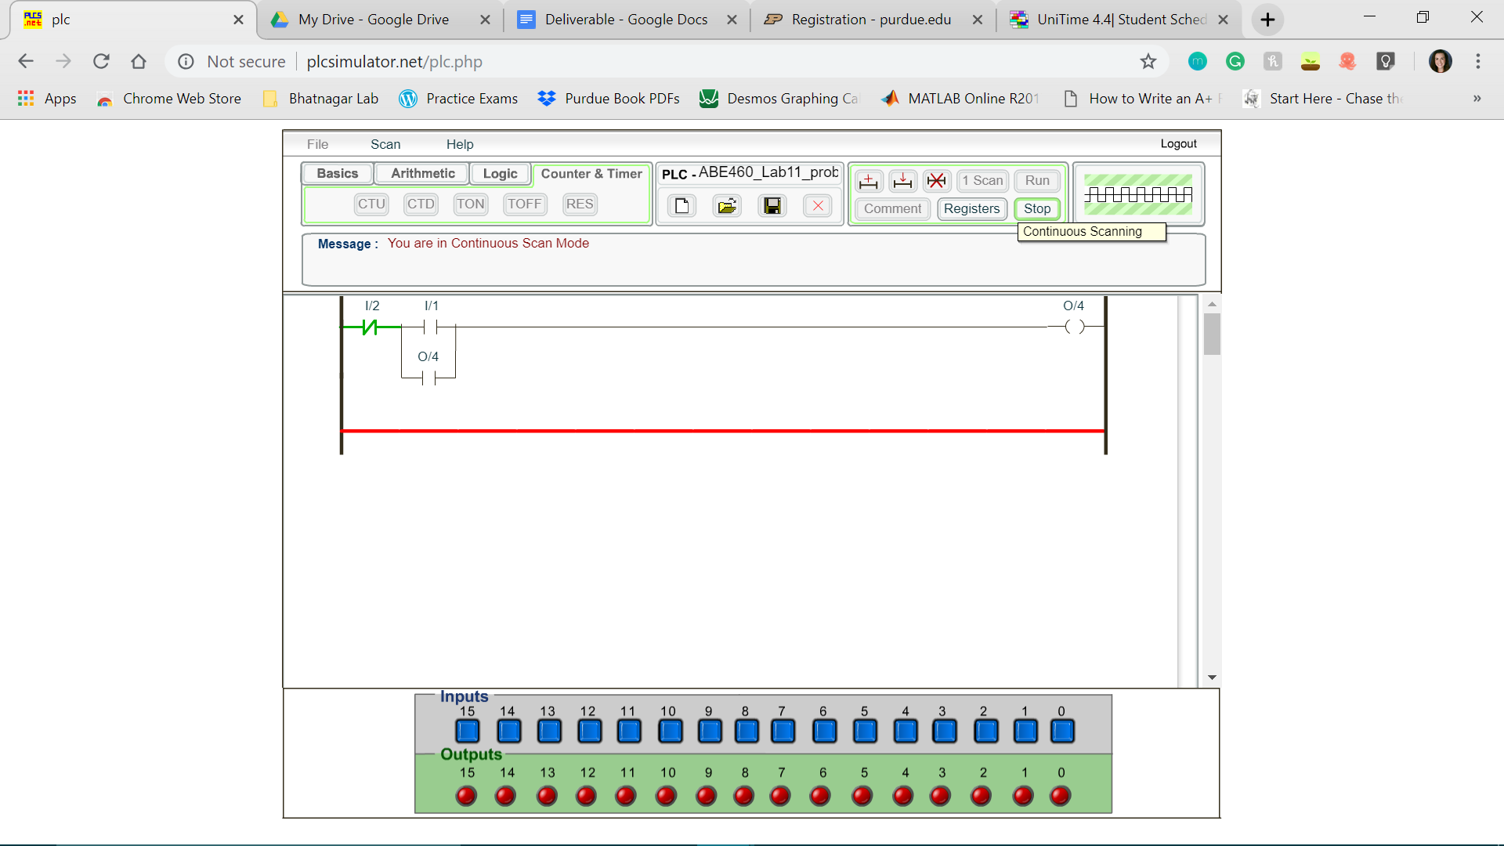

*Figure 9: Completed program for section 2.3*

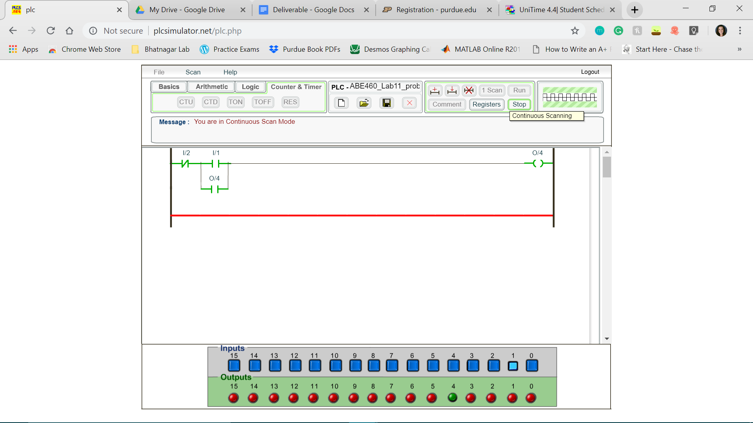

*Figure 10: Completed program for section 2.3 when input 1 (start button) is activated*

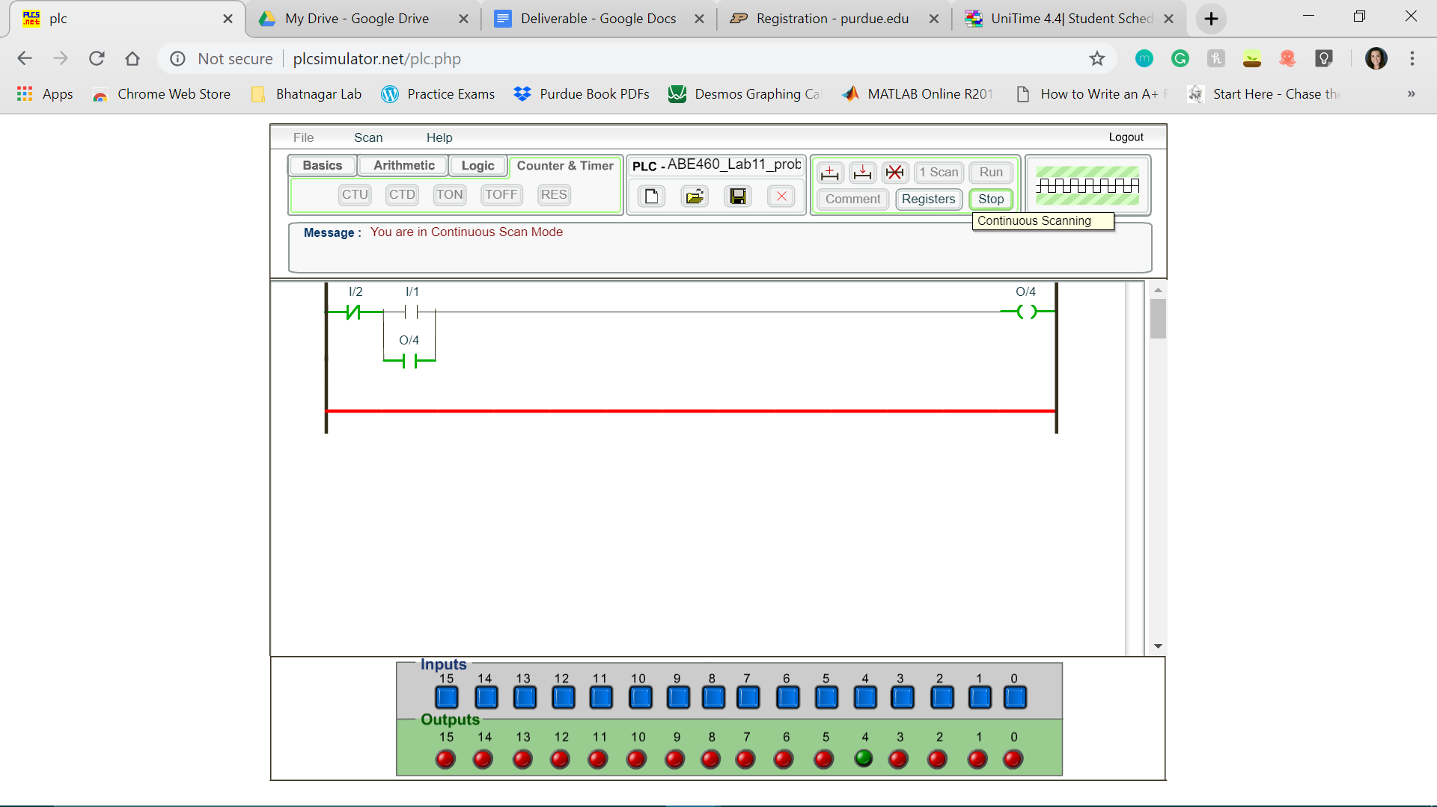

*Figure 11: Completed program for section 2.3 when input 1 (start button) is activated and then inactivated*

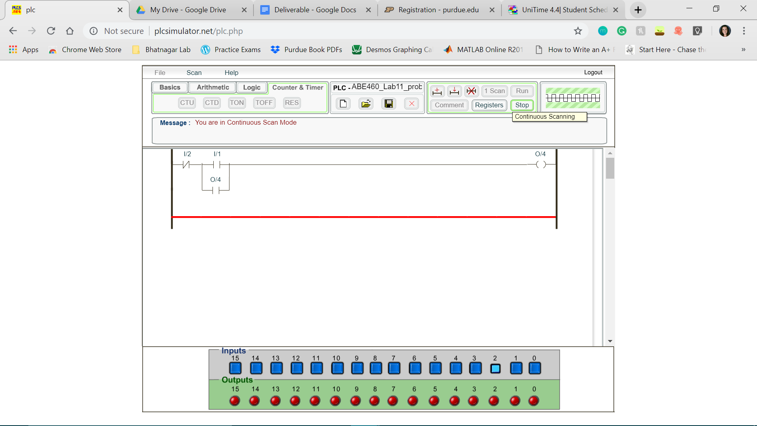

*Figure 12: Completed program for section 2.3 when input 2 (stop button) is activated*

1. The latching latches because of the “or” logic created by the loop between the I/1 and O/4 inputs.
2. The advantages of using a latching circuit over a simple on/off switch is that the system has “memory”; as such, if you want the system to stay on even after the on button has been deactivated, the system will remember that it has been in the “on” state until the off state is activated. Following the “off” state being activated, the “on” state would not be re-activated until the “on” button was pushed, even in the case of a disruption in power supply.