ABE 460

Lab Week 12: PLC Project - State Tables

Kathryn Atherton

Rohit Chatterjee

Timothy Jergens

November 05, 2018

Monday

**Regular Toasting Sequence**

*Table 1: State Table for Regular Toasting Sequence*

|  |  |  |  |  |  |  |  |  |  |  |  |  |  |  |  |  |  |  |  |
| --- | --- | --- | --- | --- | --- | --- | --- | --- | --- | --- | --- | --- | --- | --- | --- | --- | --- | --- | --- |
| State | Trigger | Timer (T1) | Move +Z direction | Move -Y Direction | Clasp | Timer (T2) | Move +X Direction | Timer (T3) | Rotate | Timer (T4) | Timer (T5) | Timer (T6) | Heat Coils On | Timer (T7) - Cook Timer | Move -X Direction | Move +Y Direction | Unrotate | Timer (T8) | Terminate |
| 1 | Start button pressed | X |  |  |  |  |  |  |  |  |  |  |  |  |  |  |  |  |  |
| 2 | Timer (T1) = 3 seconds |  | X |  |  |  |  |  |  |  |  |  |  |  |  |  |  |  |  |
| 3 | (+) Z Limit |  | X | X |  |  |  |  |  |  |  |  |  |  |  |  |  |  |  |
| 4 | (-) Y Limit |  |  |  |  |  |  |  |  |  |  |  |  |  |  |  |  |  |  |
| 5 | (-) Z Limit |  |  |  | X | X |  |  |  |  |  |  |  |  |  |  |  |  |  |
| 6 | Timer (T2) = 1 second |  | X |  | X |  |  |  |  |  |  |  |  |  |  |  |  |  |  |
| 7 | (+) Z Limit |  | X |  | X |  | X |  |  |  |  |  |  |  |  |  |  |  |  |
| 8 | (+) X Limit |  | X |  |  |  |  | X+z |  |  |  |  |  |  |  |  |  |  |  |
| 9 | Timer (T3) = 1 second |  | X |  |  |  |  |  | X | X |  |  |  |  |  | x |  |  |  |
| 10 | Timer (T4) = 1 second + ypos |  |  |  |  |  |  |  | x |  | X |  |  |  |  |  |  |  |  |
| 11 | Timer (T5) = 2 seconds or -Z limit- +Z Limit+z |  |  |  |  |  |  |  | x |  |  | X | X | X |  |  |  |  |  |
| 12 | Timer (T6) = 1 second |  | X |  |  |  |  |  | x |  |  |  |  |  |  |  |  |  |  |
| 13 | (+) Z Limit |  | X |  |  |  |  |  |  |  |  |  |  |  | X |  |  |  |  |
| 14 | (-) X Limit |  | X |  |  |  |  |  |  |  |  |  |  |  |  | X |  |  |  |
| 15 | (+) Y Limit |  |  |  |  |  |  |  |  |  |  |  |  |  |  |  |  |  |  |
| 16 | (-) Z Limit |  |  |  |  |  |  |  |  |  |  |  |  |  |  |  | X | X |  |
| 17 | Timer (T8) = 1 second |  |  |  |  |  |  |  |  |  |  |  |  |  |  |  |  |  | X |

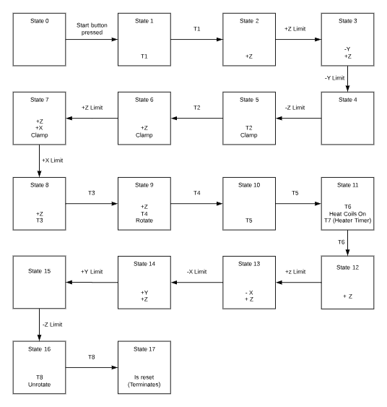

*Figure 1: State Diagram for Regular Toasting Sequence*

**Stop Button Sequence**

*Table 2: State Table for Stop Button Sequence*

|  |  |  |  |  |  |  |  |  |  |  |
| --- | --- | --- | --- | --- | --- | --- | --- | --- | --- | --- |
| State | Trigger | Timer (T1) | Move +Z direction | Move -X Direction | Move +Y Direction | Clamp | Timer (T2) | Unrotate | Timer (T3) | Terminate |
| 1 | Stop Button Pushed | X |  |  |  |  |  |  |  |  |
| 2 | Timer (T1) = 3 seconds |  | X |  |  | X |  |  |  |  |
| 3 | (+) Z limit |  | X | X |  | X |  |  |  |  |
| 4 | (-) X Limit |  | X |  | X | X |  |  |  |  |
| 5 | (+) Y Limit |  |  |  |  |  | X |  |  |  |
| 6 | Timer (T2) = 1 second |  |  |  |  |  |  | X | X |  |
| 7 | Timer (T3) = 1 second |  |  |  |  |  |  |  |  | X |

*Figure 2: State Diagram for Regular Toasting Sequence*

