Diffusivity Prediction Algorithm

## 1 Composition

Isotherms: *f*(*composition*,*temperature*) (p.620 Table 10.2)(Singh and Singh 1996)

GAB Equation:



 

 

## 2 Binding Energy

p.612

Table 10-3 p.626





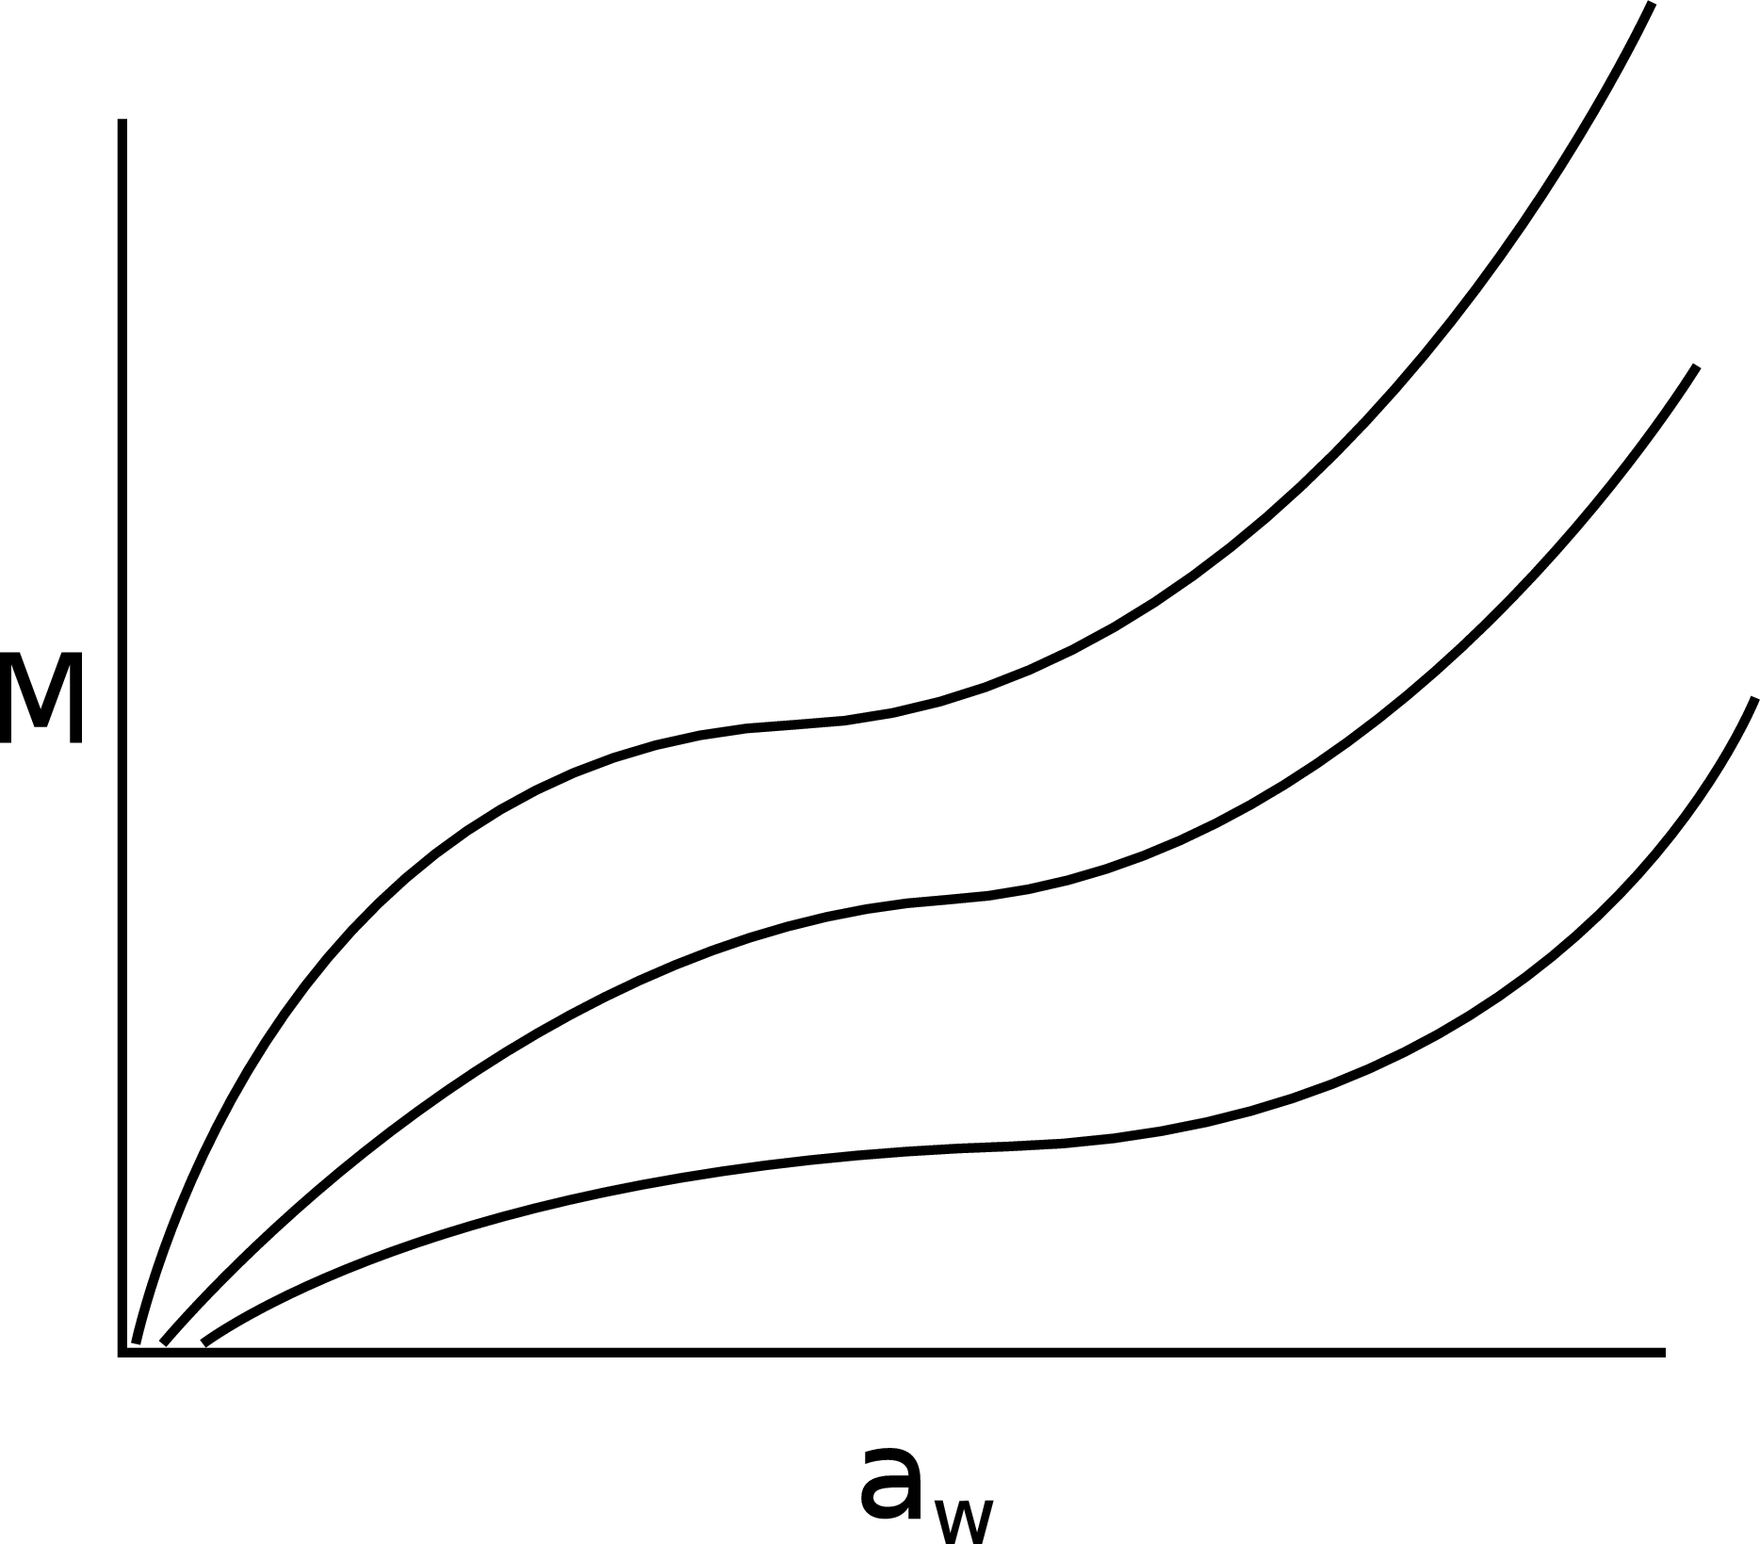 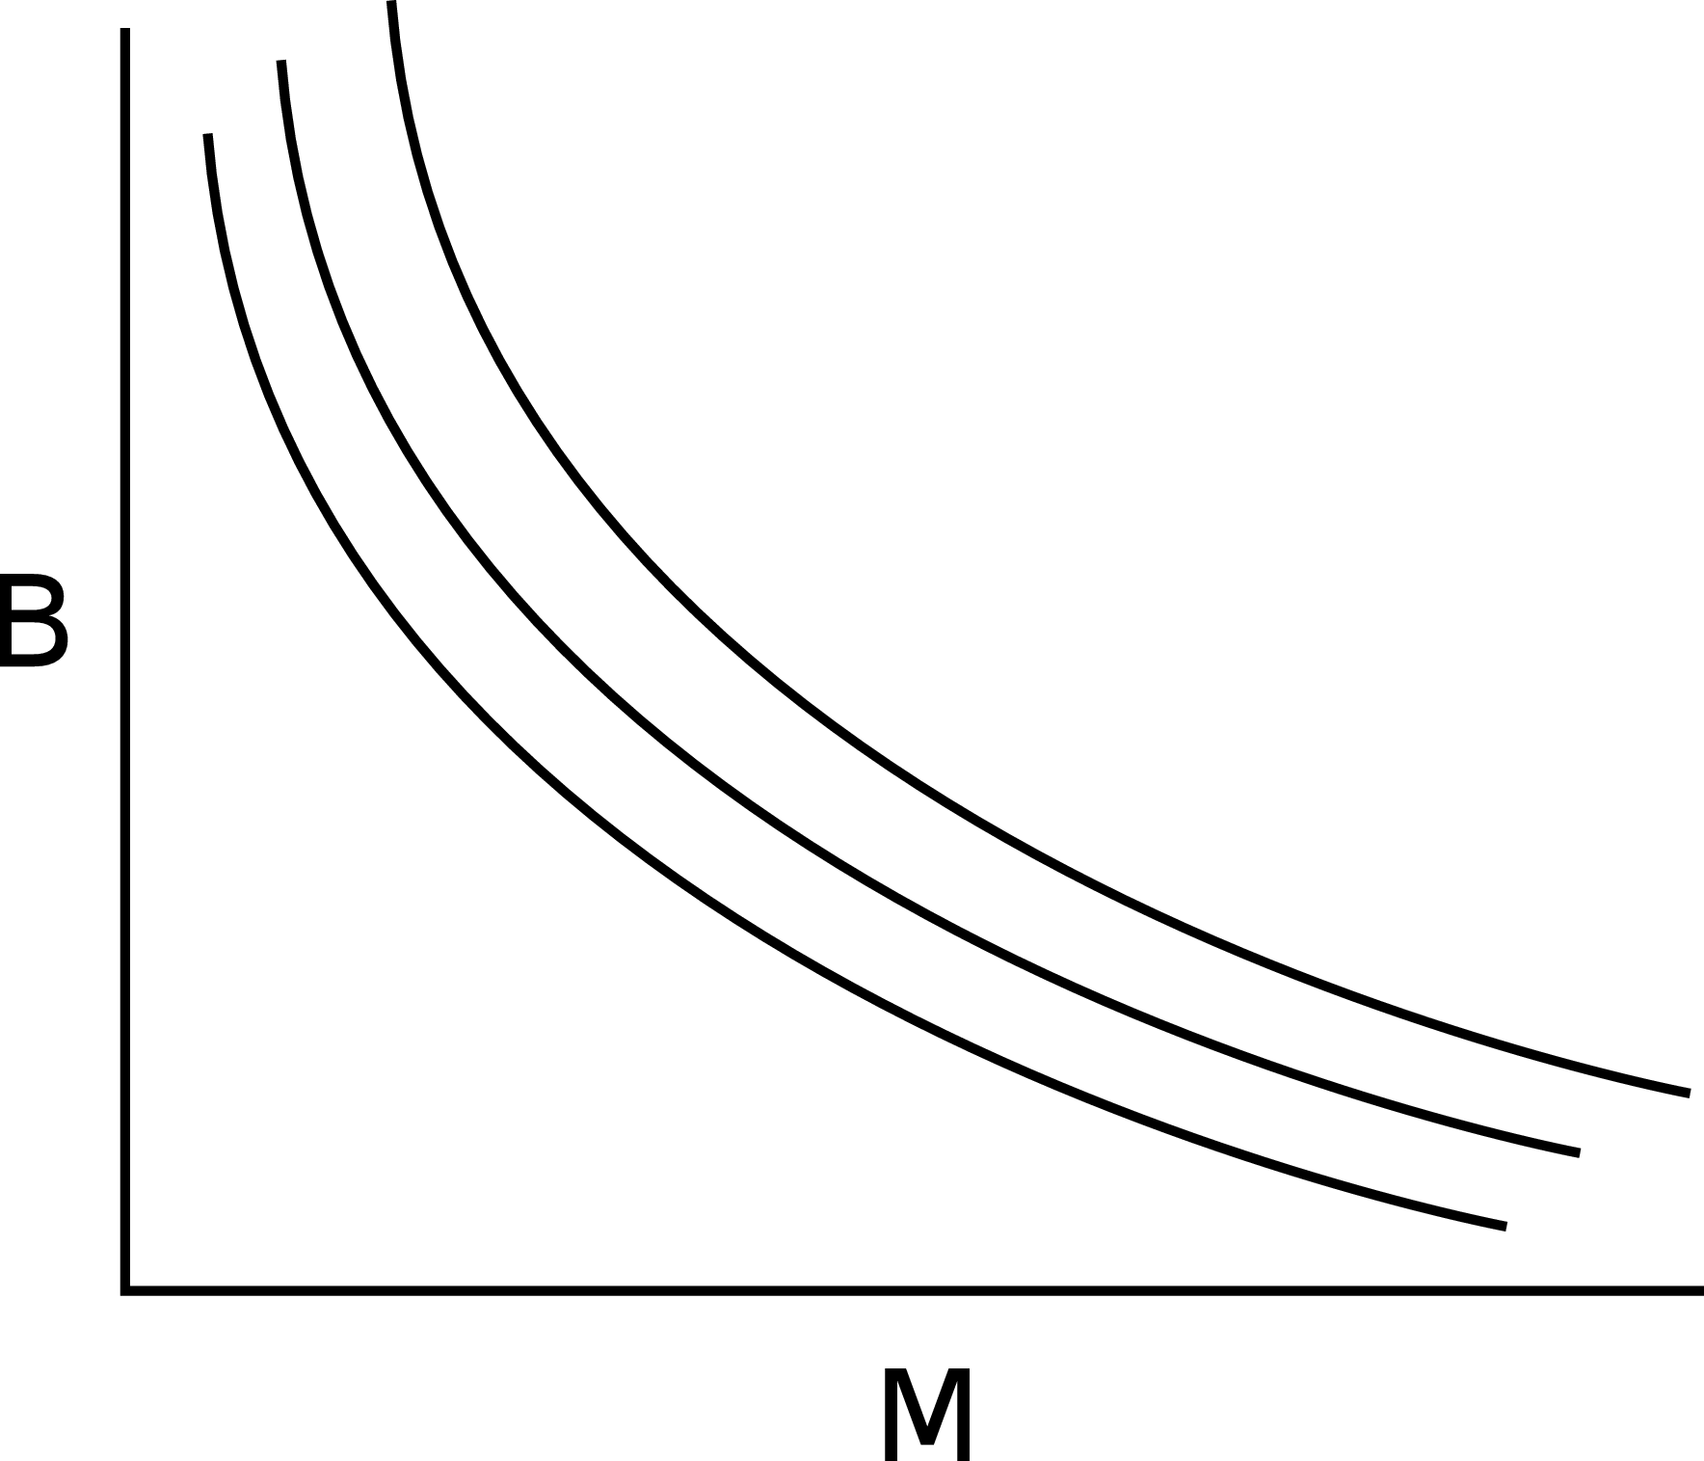

## 3 Diffusivity

Finite difference (p.506 Geankoplis)

Table 10-5 p.646

CJG   9.3-1,  3-4, 3-9

## 4 Porosity

### 4.1 Series

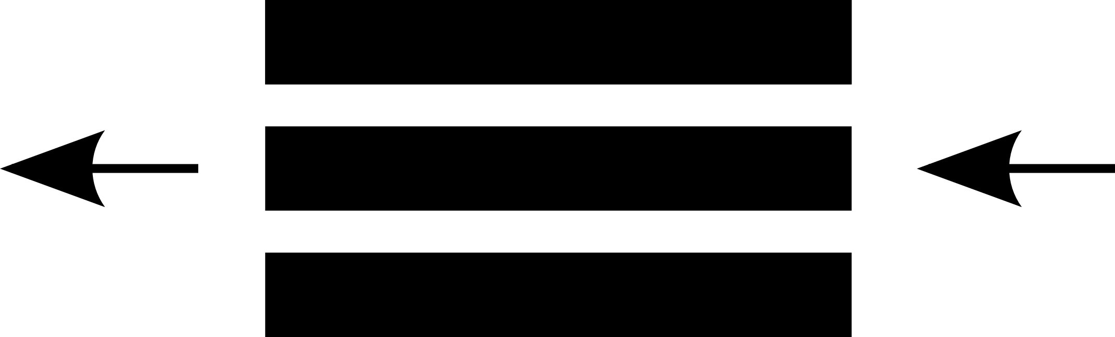

### 4.2 Perpendicular

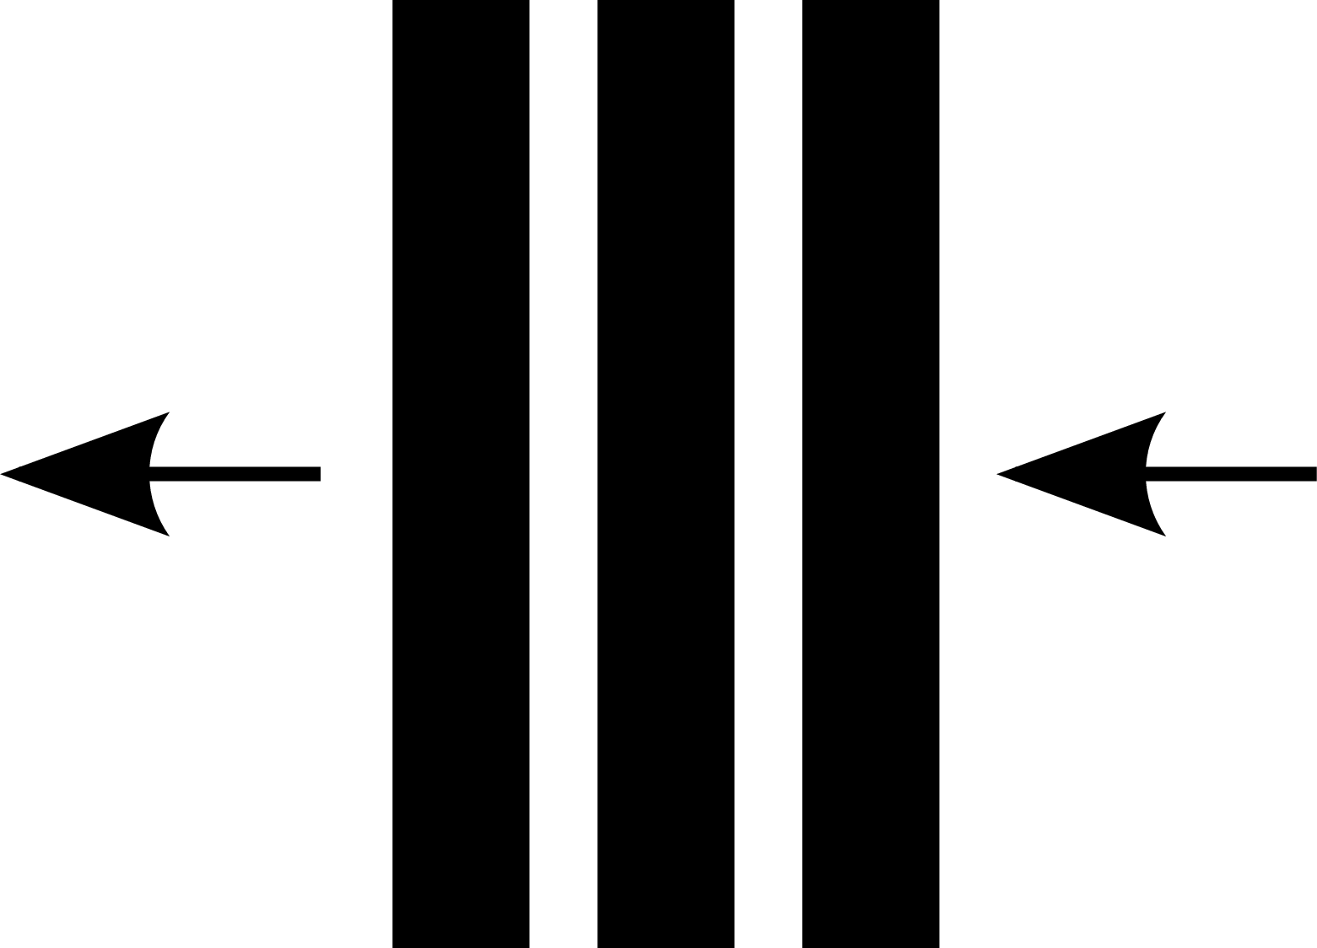

### 4.3 Effective Diffusivity

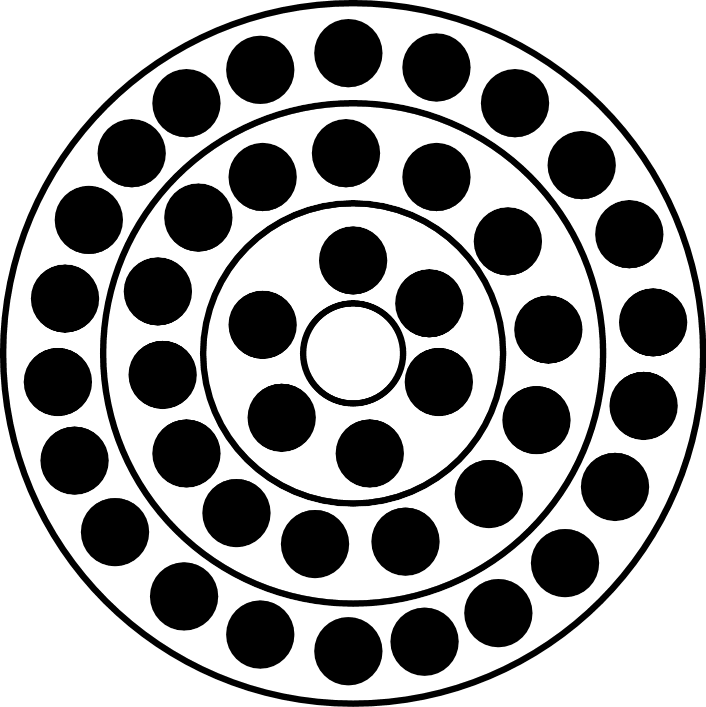

## 5 Glass Transition

Gordon Taylor: (Table 10.4 p.636)

Fox

1/Tg =  w1/Tg1 + w2/Tg2 + w3/Tg3 +

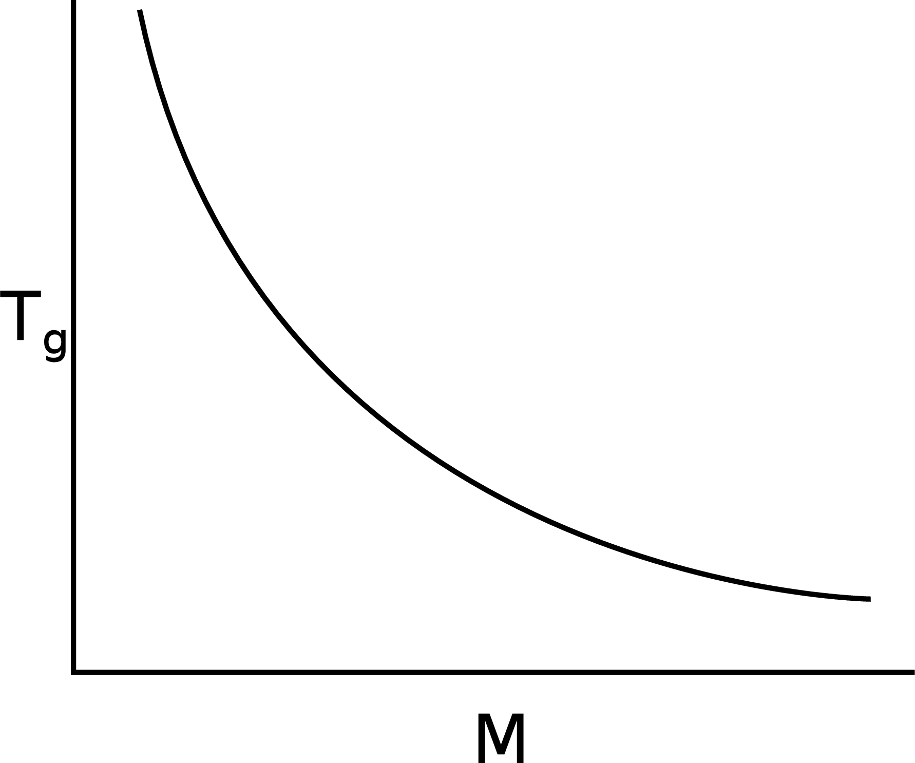

Williams-Landel-Ferry (WLF) Equation: (p.139 Lund)