Kathryn Atherton

ABE 55700

Fermentation Design

Part II

September 10, 2018

Contents

Overview 2

Assumptions 2

Equations 4

Procedure 4

Results 8

References 10

# Overview

Fermentation is a process in which a microorganism consumes sugar and produces alcohol or organic acids. It is used in industry to produce beer, wine, and other liquors, as well as cheese, kimchi, yogurt, and many other foods and products useful to humans. Fermentation conditions are important for ensuring that the process is efficient. As such, the design of the fermenter is important in keeping the reaction conditions ideal for the organism producing the desired substance. In this report, a model was created of a batch fermentation system that continuously produces 100 pounds of dry solid of a yeast product every hour. Then the specifications for a sparger and heat exchanger to maintain the desired output of the system were found.

# Assumptions

1. Each batch uses 95% of the initial substrate concentration. This assumption was given in the problem statement.
2. The initial yeast concentration is 10% of the final yeast concentration. This assumption was given in the problem statement.
3. The filling time is 25% of the fermentation time. This simplifying assumption was made to help calculate the emptying time. I believe that this is a reasonable assumption because according to the Anheuser-Busch fermentation good practices, long fill times should be avoided to prevent yeast moving in and out of anaerobic conditions and excessive yeast growth (Audet, 2015, p 7).
4. The emptying time is equal to the sum of the fermentation time and the filling time. This assumption was given in the problem statement.
5. The liquid volume fills 80% of the tank volume. This would prevent any hypothetical overflow caused by the movement of the agitator, aeration of the broth, and adding more liquid than necessary.
6. The agitator diameter is one third the diameter of the tank. This assumption comes from Jackson Figure 4.7, which graphs the Reynolds Number vs. the Power Number with the criteria that the agitator diameter is one-third the diameter of the tank.
7. The tank is three times as tall as it is wide. This assumption was made to aid in calculating the dimensions of the tank. I believe this is reasonable because fermenter diagrams in the text suggest a ratio similar to this one (Jackson, 1990, p 287).
8. The tank is cylindrical. This assumption was made because the diagrams in the text suggest this shape (Jackson, 1990, p 287).
9. The final partial pressure of oxygen leaving the tank is 10% of the total pressure. This assumption is reasonable because it is a reduction from the initial partial pressure of oxygen due to the oxygen uptake by the cells and the production of carbon dioxide, but it still maintains a concentration of oxygen above the required concentration for cell growth.
10. The Reynolds Number is 100000. This value was selected from Jackson Figure 4.7 to ensure a steady power number, which is 5.9 according to the figure.
11. The fermentation broth has the same viscosity as water. This is reasonable as it is likely that the fermentation broth is mostly made up of water.
12. The temperature of the water entering the heat exchanger is 15°C and the temperature of the water exiting the heat exchanger is 25°C. These values were taken from an example problem for a fermenter with a similar fermentation broth temperature (Shuler, Chapter 10).
13. The water velocity flowing through the heat exchanger is 1.7 m/s. This value was selected from Geankioplis Table 2.10-3.
14. The fermenter and pipes are made of stainless steel. This is reasonable because most industrial reactors are made of stainless steel due to its resistance to corrosion.
15. The pipes are cylindrical in shape. This is reasonable as this is the shape of most pipes.
16. The velocity of air through the pipe is 16 m/s. This value was selected from Geankoplis Table 2.10-3.
17. The length of the air pipe is equal to 150% the circumference of the fermenter. This was chosen because the air pipe is a spiral at the bottom of the fermenter. I assume this to be equal to three concentric circles, one with a diameter ¾ that of the fermenter, the next with a diameter ½ that of the fermenter, and the last with a diameter ¼ that of the fermenter.
18. The suction pressure of the pump is equal to atmospheric pressure, 1 atm. This is reasonable because it prevents a compression or expansion of the air being taken in which would cause even more friction than is necessary.

# Equations

1. (Geankoplis, 1993, Eqn. 6.8)

(Geankoplis, 1993, Eqn. 6.52)

1. (Assumption 8)
2. (Shuler, 2002, Eqn. 10.1)
3. (Jackson,1990, Table 4.1)
4. (Geankoplis, 1993, Eqn. 3.4-2)
5. (Shuler, 2002, Eqn. 10.3)
6. (given)
7. (Geankoplis, 1993, Eqn. 4.5-6)
8. (Geankoplis, 1993, Eqn. 4.5-8)
9. (Geankoplis, 1993, Eqn. 4.3-14)
10. (Geankoplis, 1993, Eqn. 4.3-13)
11. (Geankoplis, 1993, Eqn. 2.10-7)
12. (Geankoplis, 1993, p 98)
13. (Geankoplis, 1993, Eqn. 2.10-5)
14. (Green & Perry, 2008)
15. (Geankoplis, 1993, p 98)
16. (Geankoplis, 1993, Eqn. 2.7-28)

# Procedure

To find the fermentation time, first the final yeast cells concentration was calculated. The initial substrate concentration was converted from grams of substrate per grams of solution to grams of substrate per liter. Then the final substrate concentration was calculated knowing that the final substrate concentration should be 5% of the initial substrate concentration (Assumption 1). These two values were used in Equation 1 to find the final yeast concentration knowing that the initial yeast concentration is 10% of the final yeast concentration (Assumption 2). The initial yeast concentration was then calculated from the final yeast concentration value. Equation 2 was used to calculate the fermentation time, the result of which is 4.60 hours.

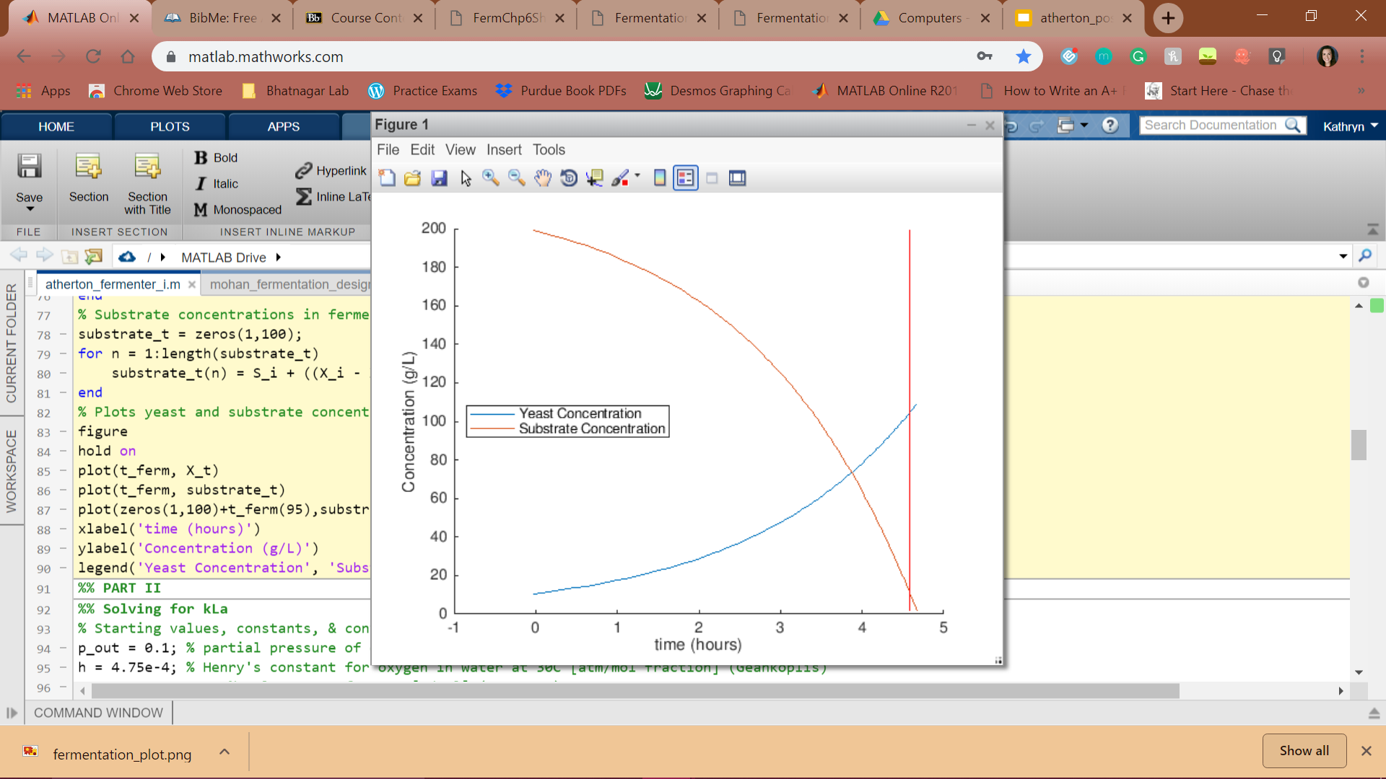

*Figure 1: Yeast and substrate concentration vs. time*. *The red horizontal line represents the time when fermentation is complete.*

To find the volume of a single fermentation tank, the fill time and emptying time were first calculated. The fill time was calculated from the fermentation time using Assumption 3. Emptying time was then calculated using the fill and fermentation times according to Assumption 4. The volume of one batch was calculated by converting the desired flow rate from pounds per hour to grams per hour, multiplying by the calculated emptying time, and dividing by the final yeast concentration, which results in a volume of 2479.61 liters. The inlet flow rate was calculated to be 0.6 L/s. In order to produce the desired constant flow, multiple fermenters are required such that while one fermenter is emptying the product, another is being filled and fermenting more product. Table 1 shows a fermentation schedule which would satisfy the required constant flow while using two fermenters over 24 hours.

*Table 1: Fermentation schedule of the first 24 hours of a fermentation process for two fermenters to ensure a constant flow of 100 pounds of yeast product per hour.*

|  |  |  |
| --- | --- | --- |
| **Time (h)** | **Fermenter 1** | **Fermenter 2** |
| 1.2 | Fill |  |
| 2.4 | Ferment |
| 3.6 |
| 4.8 |
| 6.0 | Empty | Fill |
| 7.2 | Ferment |
| 8.4 |
| 9.6 |
| 10.8 |
| 12.0 | Fill | Empty |
| 13.2 | Ferment |
| 14.4 |
| 15.6 |
| 16.8 |
| 18.0 | Empty | Fill |
| 19.2 | Ferment |
| 20.4 |
| 21.6 |
| 22.8 |
| 24.0 | Fill | Empty |

Knowing the fermentation broth volume, the tank dimensions were calculated next. The volume was converted from liters to cubic meters. This volume was divided by the percent of the total reactor volume that the fermentation broth fills according to Assumption 5, which was found to be 3099.51 liters. Using Equation 3 and Assumptions 7 and 8, the diameter of the tank was calculated to be 1.10 meters. Assumptions 6, 7, and 8 were used to calculate the tank height and the agitator diameter from the tank diameter, calculated to be 3.29 meters and 0.36 meters, respectively.

To calculate the mass transfer coefficient of oxygen from the air bubbles to the fermentation broth, Henry’s constant was found for oxygen in water at the given temperature of 30°C and Assumption 9 was used to calculate the concentration of oxygen in the fermentation broth. Equation 4 then calculated the kLa of the fermentation broth, 0.000072 h-1.

The rotational speed of the impeller was calculated by assuming a Reynolds Number that would result in a steady Power Number and found to be 36.78 rpm (Assumption 10, Equation 5). The power of the ungassed system was then calculated using the assumed Power Number and calculated impeller speed from Equation 6. The volumetric flow rate of oxygen was calculated to be 0.13 m3/s using a combination of a mass balance and the ideal gas law. With Equation 7, the power requirement for the agitator was found to be 9.64 W. Figure 2 shows that an increase in agitation speed exponentially increases the power required by the system.

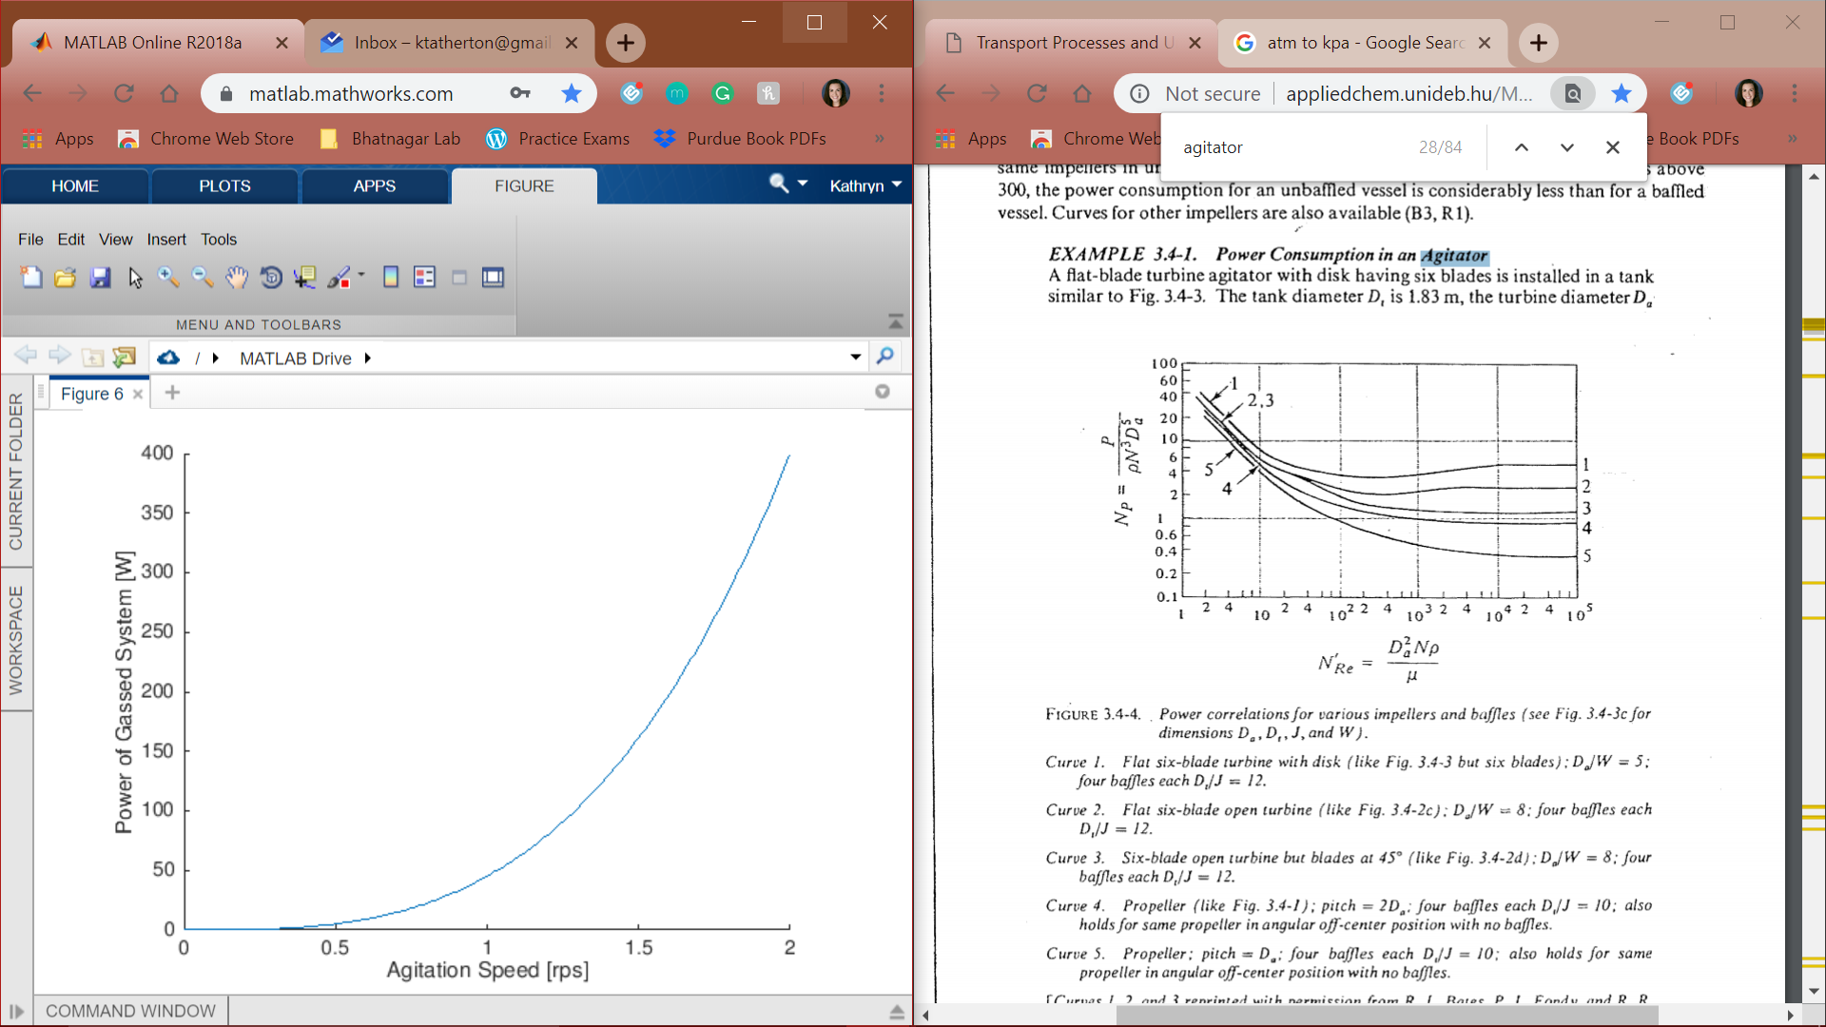

*Figure 2: Relationship of Power required by agitator and agitation speed.*

Using Equation 8 and the final yeast concentration, it was found that the heat generated from oxygen consumption is 290.77 kJ/s. The heat and assumed input and output water temperatures for the heat exchanger were then used to determine the mass flow rate of water within the pipes of the heat exchanger (Assumption 12). The pipe dimensions including cross-sectional area and diameter were calculated from this result and the heat transfer coefficients between the pipe, water, and broth were found using Equations 9 and 10. With Equation 11, the heat transfer between the water and broth were determined and then the required surface area of the heat exchanger was calculated with Equation 12 and found to be 26.17 m2.

Next, the specifications of the sparger were found. The pipe diameter was calculated with the assumed air velocity (Assumption 16). The equivalent length of the pipe due to friction within the pipe and any joints was calculated and the air Reynolds Number and Fanning friction factor were found (Equations 5 and 13). Using these results, the friction from entering, moving through, and exiting the piping as well as the friction from the sparger (Equations 14, 15, and 16) to find the total pressure drop that the pump would need to overcome, 101.58 Pa. The pump power requirement of 83.35 W was calculated using Equation 18 with the difference in pressure and the friction created within the piping system. Figure 3 shows the relationship between pumping power and air velocity, which is nearly linear.

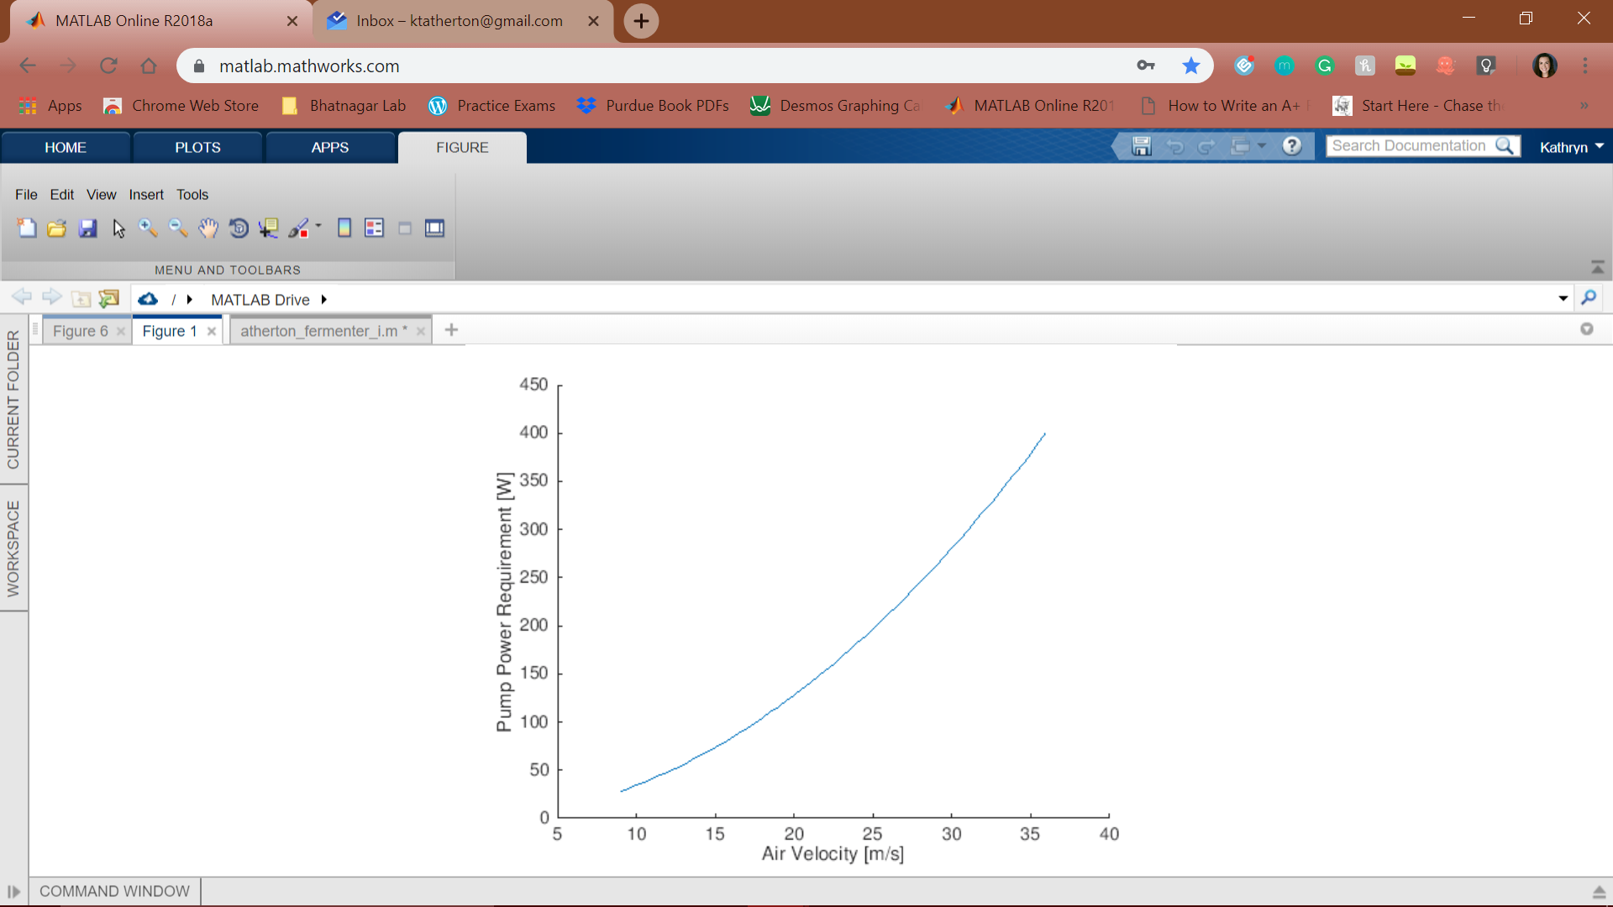

*Figure 3: Relationship between pump power requirement and air velocity.*

# Results

The result of the algorithm produced a final fermentation time of 4.60 hours. In combination with the filling and emptying time, the time for a full fermentation cycle (fill, ferment, empty) is 10.8 hours. This cycle time requires that each cycle produce 2479.61 L of product to satisfy the requirement of creating 100 pounds of product per hour. The equipment required to perform this fermentation includes two fermenters, each with a diameter of 1.10 meters, a height of 3.29 meters, an agitator diameter of 0.55 meters, and a total volume of 3099.51 liters.

To maintain a constant Reynolds Number and Power number, an impeller rotational speed of 36.78 rpm is required. From Geankoplis Figure 3.4-4, this system is most similar to a flat six-blade turbine with a disk and four baffles each. An aeration rate of 0.13 m3/s allows for a consistent flow of oxygen that is more than what is required by the cells, preventing death and inefficiency in the system. To prevent the system from overheating, a heat exchanger with a surface area of 26.17 m2 is necessary. Within the sparger, using pipes with a diameter of 0.16 m a pump that uses 83.35 W of power is required to pump the correct amount of oxygen into the fermentation tank. The pressure output required by the pump 101.58 kPa which corresponds to a turboblower pump type (Geankoplis, 1993).

# References

1. Audet, T. 2015. “Traditional and Alternative Fermentation Techniques”. Anheuser-Busch.
2. Geankoplis, C.J. 1983. “Transport Process and Unit Operations” 2nd ed. Allyn & Bacon, Inc., Boston.
3. Green, D. W., & Perry, R. H. (2008). Perry's Chemical Engineers' Handbook (8th ed.). New York, NY: McGraw Hill Companies.
4. Jackson, A.T. 1990. “Process Engineering in Biotechnology”. Open University Press.
5. Shuler, M.L., Kargi, F. 2002. “Bioprocess Engineering Basic Concepts”. (2nd ed.). Upper Saddle River, NJ: Prentice Hall, Inc.
6. Raggett, D. (1996). Specific Heat Capacities of Air. doi:10.17487/rfc1942