Review questions for Biology 230, Fall 2014

- Why are viruses not cells?
Potential answers include:
- Genetic program for limited operations only. No intrinsic means to use it
- Reproduction only through interaction with host
- Limited responses to stimuli
- Limited self-regulation
- No energy acquisition or utilization except through host

- Name two ways in which prokaryotic and eukaryotic cells are similar and three ways in which they differ.
See 8-28-14, slide 23

- Which of the following is a similarity between prokaryotes and eukaryotes?
  - Both share an identical genetic language.
  - Both share a common set of membrane-bound organelles
  - Both share common structural features.
  - a and c
  - a, b and c
Common structural features include cell membranes and flagella. However, the complexity of these structural features differ substantially between prokaryotes and eukaryotes

- Name three characteristics that are used to define a cell (prokaryotic or eukaryotic)?
Genetic program, response to stimuli, self-reproduction, homeostasis, acquisition and utilization of energy, active movement (intra or extra), evolve

- Eukaryotes are more complex than prokaryotes. Describe two disadvantages and two advantages of being more complex.
Pros:
- More flexibility to adapt to a changing situation for individual cells
- Division of labor and specialization of tasks
- Greater ability to actively influence internal and external environment
- Cells can develop and interact together to produce organisms that do some pretty amazing things (fly, take this class, etc.)
Cons:
- More things to go wrong
- More requirements for minimal sustenance and regulation
- Longer generation time so less rapid adaptation to a changing environment through natural selection

- Which of the groups below is capable of primarily hydrophobic interactions? Which is capable of primarily hydrophilic interactions? Explain your answer.
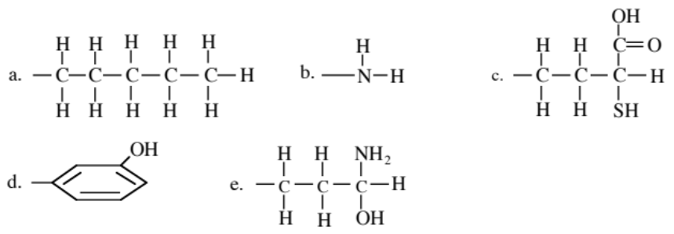
a. is capable of only hydrophobic interactions. It contains no ionizable or hydrophilic groups. b. is capable of only hydrophilic interactions since it has no component with a long carbon chain or a carbon-containing ring and no nonpolar covalent linkages. It is also capable of ionization. Groups c, d, and e are capable of both hydrophobic and hydrophilic interactions.

- DNA is isolated from two different species. Both DNA samples are found to be the same size. One of the DNA samples has a G+C/A+T ratio of 2.0 and the other 2.5. Which sample contains the smallest number of H bonds between strands? Which DNA sample would be easiest to denature?
The second sample has the higher G+C content since the ratio for that sample is the largest. The first sample contains a larger amount of A+T. Since A-T base pairs make only 2 H bonds, while G-C base pairs make three, the sample with the most A-T base pairs would have the fewest H bonds. The first sample would be easiest to denature since it is held together with the smallest number of H bonds.

- What are two main factors determining the strength of electrostatic interactions for bond formation in biomolecules?
By Coulomb’s law, F = k Q1 Q2/ 4e₀pr², so two main factors would be the charges of the involved atoms and the distances between them. Another factor that would be acceptable is the solution in which the participating. Another lesser factor might include whether one of the atoms in a bond is already covalently bonded, especially if it is a polar bond.

- Rank the bond strengths in an aqueous environment ionic, nonpolar covalent, polar covalent, hydrogen, van der Waals (there can be ties).
Covalent > Hydrogen=Ionic > van der Waals. Recall that ionic bonds are relatively weak in an aqueous environment because a hydration shell of water molecules forms around the ions.

- Why might hydrogen bonds be used between nitrogenous base pairs in DNA or RNA rather than covalent bonds?
Many H bonds that can easily be broken and reformed give great overall strength of DNA strands holding together yet flexibility to unzip them in specific locations with relatively little energy expenditure.

- Which class of macromolecules that we have discussed would be most affected by a phosphorus deficiency?
Nucleotides. Phosphorus forms the center of phosphate groups that link the ribose sugars together to form the nucleotide backbone. One could also reason that the phospholipids of cell membranes would be strongly affected, but other lipids would be unaffected.

- Protein side chains each have their own acid dissociation constant, pKa. The pKa for Arginine is 12.0. At pH = 7.0 (near physiological), will Arginine be positively or negatively charged? Why?
Most of the Arginines will have accepted a proton, and it will be positively charged.
Use pH=pKa-log10([HA+]/[HA] to solve.
7=12- log10([HA+]/[HA]
log10([HA+]/[HA]=5, so [HA+]/[HA]=100,000

- Consider an enzyme that is able to break down glycosidic bonds in glycogen but not cellulose. Why might this occur?
Sugars are linked by glycosidic bonds that can come in alpha or beta forms. As we discussed in class, glycogen and starch are alpha bonded, cellulose is beta bonded. The enzyme, like many enzymes, is specific to the glycosidic bond type.

- How are phospholipids oriented in the cell membrane? What would be the consequence of adding a hydroxyl group to the tail of the phospholipids?
The polar heads are towards the aqueous environments and the fatty acid tails are towards each other in the center. If a hydroxyls were added to the tails, that would disrupt this organization. Two potential scenarios would be the formation of lipid monolayer membranes or bilayers composed of fatty acid chains that fold upon themselves to keep their hydrophobic core and present the hydroxyls and polar heads to the hydrophilic environment.

- Manipulation of a side chain’s charge can be important for segregating proteins and also determining their structure. How might you change the charge of a side chain?
Changing the pH would be a simple way to change the charge of a side chain without changing it’s molecular components.

- Which amino acid forms covalent bonds with other amino acids of the same type?
Cysteine: the sulfur on the end can react with another cysteine to form a disulfide bond that is often used to structurally stabilize proteins.

- What type or types of bonds stabilize protein secondary structures?
Hydrogen bonds stabilize alpha helices and beta sheets, but hydrogen, ionic bonds and van der Waals forces stabilize tertiary structures.

- Mammalian phospholipase C is a complex enzyme composed of 4 parts. What is the general name for these parts, and why are they useful for protein production?
Called domains. They are modular components that can be reused in other protein complexes. Domains of the same type in different proteins have similar amino acid sequences (sequence homology).

- The pKa of aspartic acid’s (Asp) side chain is 3.8. If the ratio of [Asp]/[Asp-] = .001, what is the pH of the solution in which the protein resides?
Use the formula pH=pkA – log10[Asp]/[Asp-].
If [Asp]/[Asp-]=.001, then – log10[Asp]/[Asp-]=-(-3)=3, giving pH=3.8+3=6.8. At pH=6.8, most of the aspartic acid side chains have donated a proton and are negatively charged.

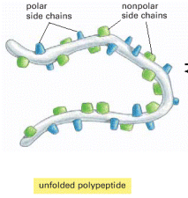
- In an aqueous solution, such as the cell cytoplasm, how would you expect the side chains shown to the right to be oriented? Why? How would this change, if at all, if the protein were placed in alcohol or oil?

In an aqueous solution, the nonpolar side chains would be oriented towards the center of the protein because they are hydrophobic. The polar side chains would be oriented towards the aqueous solution because they are hydrophilic. The orientation of the side chains would be the opposite in nonpolar media, such as oils or lipid membrane. For alcohols, which have a polar and non-polar portion, the protein folding would be determined by the length of the hydrocarbon chain of the alcohol. Generally for ethanol and longer chains, proteins tend to act more as if the solvent were non-polar.

- What method or methods might you employ if you wanted to isolate a protein with a known function or target?
A couple of possible methods would include affinity chromatography, yeast two-hybrid systems(you would use the target as the bait), or fluorescence resonance energy transfer. Other techniques also exist.

- What method or methods might you employ if you wanted to determine which proteins are present in a given sample?
A couple of possible methods would include gel electrophoresis or mass spectroscopy. Other techniques also exist.

- You want to obtain a high spatial resolution structure for a dopamine receptor in the cell membrane in both the bound and unbound states. Describe which techniques you would use to do this.
You would use NMR spectroscopy to gain high spatial resolution of a membrane bound structure. You cannot use X-ray diffraction easily because you cannot crystallize a membrane bound structure typically, nor can you easily obtain the structure rapidly in bound and unbound states.

- How does raising the temperature make reactions more likely to occur (i.e. more energetically favorable)?
Raising the temperature by addition of energy would increase the entropic component of ΔG, the change in Gibbs’ free energy. ΔG=ΔH- TΔS. The enthalpy of a reaction is typically determined by the products and reactants in the reaction and may not be affected much by temperature (assuming no changes in pressure or volume as a first approximation). Raising the - TΔS component by raising temperature would make ΔG more likely to be below zero and allow the reaction to occur spontaneously.

- X-ray crystallographic reconstructions of structures from protein samples embedded in two different solutions and then frozen show two very different conformations. What properties might differ between the two solutions? (This is a general question with multiple potential answers).
There are many potential answers to this question, depending on what you decided were the differences between the two solutions. Potential differences could include pH, polar (water) vs. nonpolar (benzene, for example), or the presence of a binding partner for the protein in one solution but not the other (e.g. insulin for the insulin receptor protein).
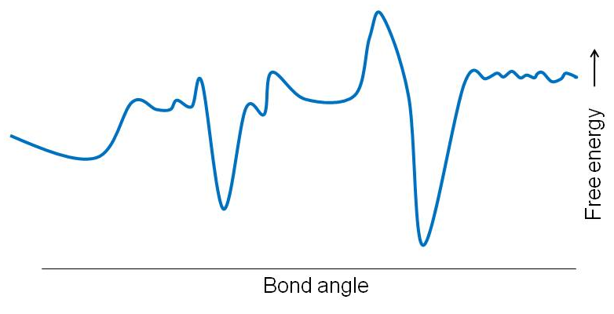
- On the right is a plot of free energy changes (positive is up) versus bond angle for a bond angle in protein. Mark which regions would be stable bond angles and justify your answer.
The free energies of the two valleys are at deep minimums relative to the other free energy fluctuations. While it would have been helpful to know the magnitude of the thermal energy fluctuations to answer this question definitively, the main point is that deep minima in the free energy with respect to change in a given variable indicates a stable state.

- Given the following amino acid sequence (P-I-G-S-T-Y) which portion of the sequence would most likely be embedded in the membrane and why? (Note that the amino acid list with side chains will be provided for the exam)
The P-I or P-I-G amino acids are likely to be in the membrane. The P and I amino acids are nonpolar and hydrophobic, meaning they would likely be embedded the membrane and away from water. G can be in either hydrophobic or hydrophilic environments.

- In the figure below - Resolution is the ability to distinguish two separate objects as being separate. The resolution distance is the minimum distance separating two objects that still allows them to be distinguished as separate objects. What are the approximate limits of resolution of the human eye, the light microscope and the electron microscope?

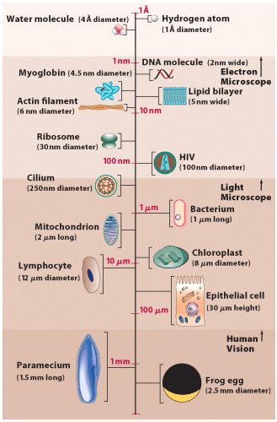
This is basically just reading from the figure above. Human vision gets down to about 250 micron resolution, the optical limit is about 0.25 microns, and the electron microscope limit is about 1 nanometer.

- You treat a partially purified preparation of protein with a reagent that breaks bonds between sulfur atoms. Which level(s) of protein structure are likely to be affected the most?
Tertiary structure would be most affected. The secondary structures, alpha helices and beta sheets, are stabilized by hydrogen bonds. The covalent disulfide bonds can link distantly separated portions of the linear primary sequence.

- Which of the following tripeptides would be most likely to be soluble in an organic (hydrophobic) solvent like benzene:
N - phenylalanine - alanine - glutamine – C
N - leucine - alanine - lysine - C
N - proline - phenylalanine - leucine – C
N - arginine - lysine - proline – C
N - glutamate - aspartate - glycine - C

These side chains are mainly hydrocarbons with nearly neutral pkA (nonpolar)

- Draw a 2D free energy contour plot comparing two bond angles between connected atoms in a protein. Label the axes as well as labeling the most stable regions of the diagram. Then do the same thing using a one dimensional free energy diagram with one fixed bond angle, and label the most probable angles in the diagram. Note that although we’ve bond angle in our examples, the same ideas apply to bond rotation and distance between atoms.
This is similar to what we did on 9-11-14, slides 7,8.

- Draw a hydropathy plot for a hypothetical protein, label the axes, and indicate regions that are likely to be associated with the cytoplasm or extracellular space. Redraw the plot if 6 phenylalanines were added to the N-terminus (usually how the protein is ordered for counting the amino acids) and 6 arginines were added to the C-terminus.
Axes should be amino acid number on the x-axis and free energy (of solvation) on the y-axis. Peaks with a large negative free energy are considered are considered hydrophilic and will associated with the hydrophilic cytoplasm and extracellular space. If 6 hydrophobic phenylalanines are added to the N-terminus, that will significantly increase the height of the leftmost portion of the plot, and if 6 hydrophilic arginines are added to the C-terminus, that will significantly decrease the height of the rightmost portion of the plot.

- What characterizes the amino acid sequences that chaperones typically bind?
They are short hydrophobic sequences.

- What is a consequence of protein misfolding?
Consequences include impaired function, protein degradation, and formation of protein aggregates that can either be degraded or cannot be degraded as in the tau tangles and amyloid plaques.

- Name an advantage of having molecular chaperones.
They protect proteins from the cellular environment in order to promote proper folding. When chaperonins such as GroEL/GroES are involved, it is an ATP dependent process.

