Study questions for Bio 230, exam 2

- What must be regenerated in glycolysis in order for reactions to proceed? NAD+
- What does an enzyme do that speeds up a reaction, in terms of energetics?
An enzyme lowers the activation energy of the transition state for a reaction.
- The ΔG of a reaction is -5 kcal/mol. An enzyme is added at high concentration to catalyze the reaction. What is the ΔG now?
The ΔG of the reaction is still -5 kcal/mol. Enzymes do not change the free energy of the initial and final states of a reaction.
- Describe a mechanism by which the ES complex promotes the transition to EP.
Substrate orientation, altering the local charge environment at the active site, and putting mechanical strain on the substrate were mentioned as way to promote the transition to EP.

- 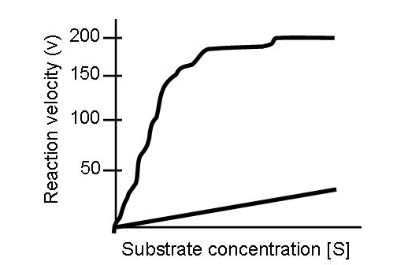In the above diagram, what is Vmax? Draw a line showing where Km falls. What is the reaction velocity at Km? For the catalyzed reaction (non-linear line), Vmax = 200. So the reaction velocity at Km would be 100.

- 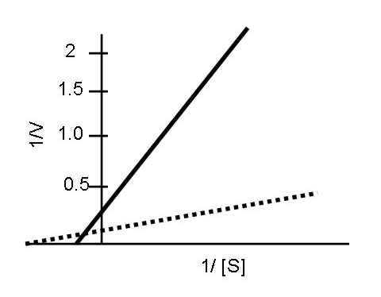In the above diagram, which line is the catalyzed reaction (solid or dashed)? The dashed line is the catalyzed reaction. The y-intercept of a Lineweaver-Burke plot is 1/Vmax. Since the solid line has a larger value of 1/Vmax than the dashed line, this means that its Vmax is smaller and represents the uncatalyzed reaction.
- On the same plot, draw a line showing a) competitive inhibition b) classic non-competitive inhibition c) mixed non-competitive inhibition. A competitive inhibitor would increase Km but not Vmax, so the y-intercept would be the same and the slope of the line, given by Km/Vmax, would increase. The x-intercept at -1/Km would decrease. A classic non-competitive inhibitor would decrease Vmax without changing Km. Therefore, the y-intercept at 1/Vmax would increase and the slope of the line would increase. The x-intercept would not change. For a mixed non-competitive inhibitor, Vmax decreases and Km increases. This would increase the slope, increase the x-intercept and decrease the y-intercept. NOTE that we did not talk about mixed inhibition, so you will not have to know that.
- What is pyruvate converted to in order to begin the TCA cycle? Acetyl-CoA
- Suppose a toxin prevents the dissociation of CoA from succinyl-CoA. How many NADH molecules have been produced from each pyruvate in this scenario? 3. How many FADH molecules have been produced? 0. Assuming a continuing supply of pyruvate, what would have to be added to the medium or into the cell to continue producing NADH?
Any of the following could be added to continue the reaction: succinate, fumarate, malate or oxaloacetate. If one wanted to get all of the electron carriers, it would be best to add succinate. After a long time, HS-CoA would also need to be added.

- Why are fatty acids able to ultimately produce so much more ATP than glucose molecules?
Two reasons. First, HS-CoA binds to the end of the fatty acid chain. Then fatty acid enters the fatty acid cycle, during which FADH2 and NADH are produced. These can enter the electron transport chain. Second, the two terninals carbons are cleaved with CoA to form acetyl-CoA and a fatty acid chain that is two carbons shorter. The acetyl-CoA enters the TCA cycle, producing another 3 NADH, 1 FADH2, and 1 GTP. So for a 16 carbon fatty acid, we run through the fatty acid cycle 7 times (the last cycle will just be acetyl-CoA that does not need to be cleaved) and the TCA cycle 8 times (16 carbons/2 carbons for each acetyl-CoA).

- What is the source of energy used to drive the formation of ATP?
The proton gradient across the inner mitochondrial membrane.

- 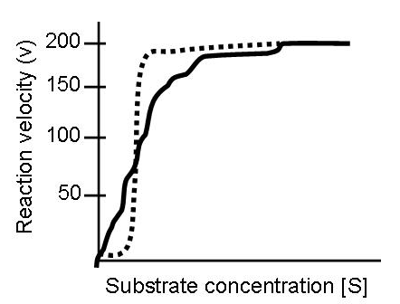If the solid line represents standard Michaelis Menten kinetics, is the Hill coefficient of the dashed line in the above plot >1, <1, 1, or 0? What type of cooperativity does this plot depict? Positive.

- What advantage, if any, does positive cooperativity provide at high [S]? At moderate [S]? For high [S], positive cooperativity does not influence v because it is near Vmax. At moderate [S], positive cooperativity can allow a major change in v over a small [S] range.
- What kind of organism reaches equilibrium?
- one that is actively metabolizing
- one with a low metabolic rate
- a dead organism
- a eukaryote
- prokaryote
- Doubling the concentration of enzyme will ______ the V_{max} and _____ the K_{M}.
 |  | - double, not alter
 |  | - not alter, double
 |  | - double, double
 |  | - not change, not alter
 |  | - halve, halve
- What kind of inhibitor binds very tightly to an enzyme often forming a covalent bond with an amino acid in the active site?
 | A) |  | irreversible
 | B) |  | reversible
 | C) |  | uncompetitive
 | D) |  | reversible and uncompetitive
 | E) |  | None of these are correct.
- In what ways can pyruvate and NADH be metabolized in anaerobic respiration? Pyruvate can be converted by lactate or ethanol in anaerobic respiration and NADH is regenerated to NAD+. In aerobic respiration?
It is converted to Acetyl CoA, and the electrons from NADH are transported to the mitochondria.

- What molecule is responsible for conveying 2 carbons from pyruvate to the Krebs cycle. Acetyl CoA
19. In which of the compartments or membranes would the following things be found?
a) | Glycolytic enzymes. Cytoplasm
b) | Electron transport system. Inner mitochondrial membrane/cristae
c) | Krebs Cycle enzymes. Mitochondrial matrix (mostly) and inner mitochondrial membrane (succinate dehydrogenase)
d) | ATP synthase. Cristae
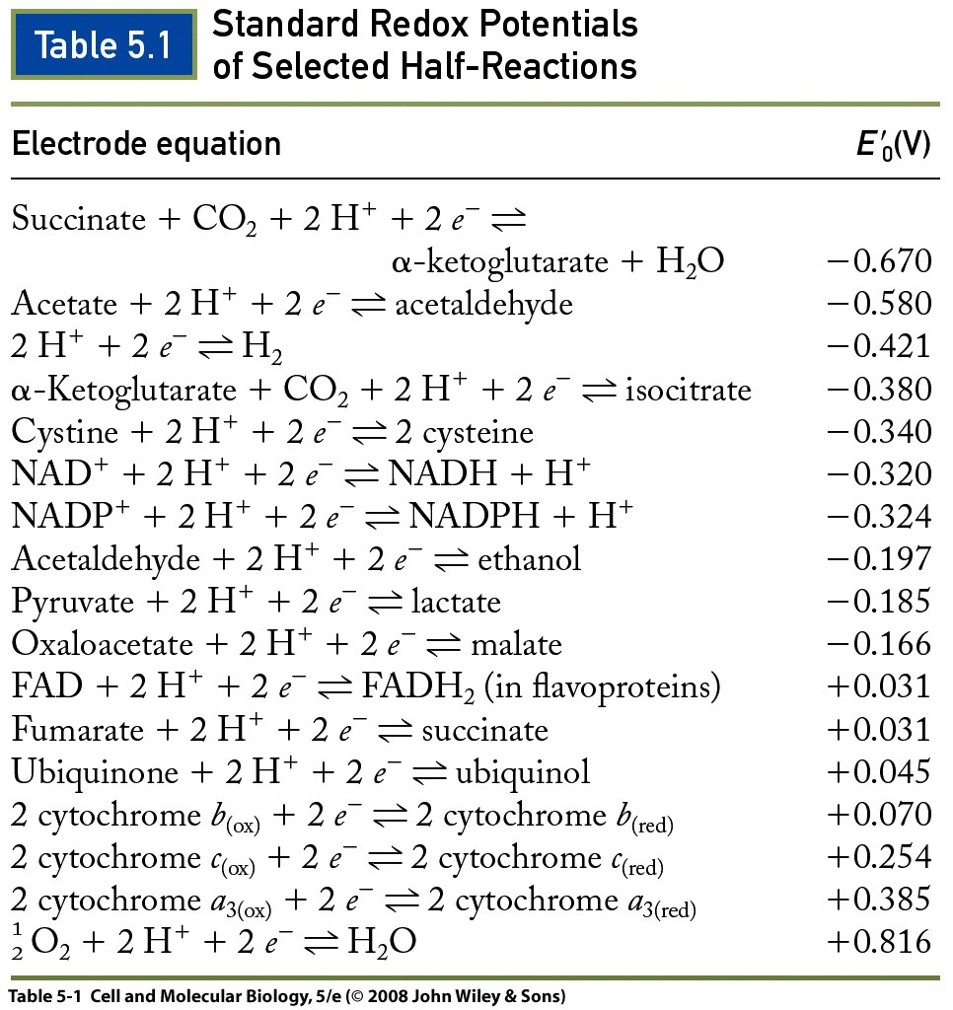
20. Given the table above, will α-ketoglutarate + CO2 + 2H+ + 2e- spontaneously form isocitrate? Why or why not? No. ΔG’° = -nFΔE’₀. Since ΔE’₀ is negative, ΔG’° will be positive and the reaction will not proceed spontaneously.

21. Using the same table above, name one molecule that NADH would donate electrons to and one molecule that NAD+ would accept electrons from.
NADH will donate electrons to any molecule whose E’₀ for accepting electrons (reactions going from left to right in table) is more positive than -0.32 V. NADH will accept electrons from any molecule whose E’₀ is more negativ than -0.32 V, because the reverse reaction (right to left on table) will be more positive than 0.32 V and can overcome the free energy barrier for NAD+ to accept electron. Thus, NADH will donate electrons to any of the molecules in the left half of the equation from acetaldehyde downward. Also, we know that oxygen and most of the molecules in the bottom half of the chart are electron acceptors in the electron transport chain. NADH will accept electrons from any molecule in the right half of the equation from cysteine upward, including isocitrate, H2, acetaldehyde, or alpha-ketoglutarate.
22. Which steps in the electron transport chain would be blocked by limiting motion within the inner mitochondrial membrane?
Movement of UQH2(ubiquinol) from complex I or complex II to complex III. Movement of cytochrome c from complex III to complex 4. Everything taking place in complex III and complex IV would be blocked, because those steps depend on reduced ubiquinone to move through the membrane from complexes I and II to complex III.

- Describe the three conformations of the beta subunit in ATP synthase.
Open state (O). Low affinity for ATP. If bound, ATP is released.
Loose state (L). ADP+Pi are loosely bound.
Tight state (T). ADP+Pi are tightly bound (high affinity for them) or after spontaneous conversion to ATP, ATP is tightly bound.

- Would a mutated ATP synthase without a gamma subunit be able to produce ATP? Why or why not?
No, it would not. Rotation of the c subunits by proton influx causes the gamma subunit to rotate. The orientation of the gamma subunit with respect to the beta subunit determines the beta subunit’s conformation. If the mutated gamma subunit were non-functional, it would not be able to change the beta subunit conformations to produce ATP. (Don’t need to remember delta subunit)If the delta subunit were mutated, the ATP head could be disconnected from the base. ATP synthase could still produce ATP as long as the alpha and beta subunits of the ATP synthase head could be held in the proper place, but otherwise it would not produce ATP.

- What is the role of H+ translocation in generating ATP by ATP synthase?
Proton translocation causes the c subunits in the base of the ATP synthase to rotate. This in turn rotates the gamma subunit, whose orientation of the gamma subunit with respect to the beta subunit determines the beta subunit’s conformation.

- Describe one way that the kinetics of the TCA cycle are regulated.
High concentrations of ATP and NADH both inhibit different steps of the TCA cycle (both inhibit pyruvate to Acetyl CoA, isocitrate to alpha-ketoglutarate, and alpha ketoglutarate to succinyl coA). High concentrations of ADP upregulate the isocitrate to alpha ketoglutarate step.

- If a toxin inserts sodium-permeable channels into the inner mitochondrial membrane, what will happen to the proton motive force and why?

The proton motive force will decrease significantly because the mitochondrial membrane potential will largely collapse.Recall that the voltage gradient produced by Na and K charge imbalance is more responsible for the proton motive force than the pH gradient.

