- Give a biological example of passive diffusion, facilitated diffusion, and active transport.

- A mutation in an ion channel has increased flux twofold. Using Fick’s law, what property of the pore has probably changed?

- A membrane is permeable only to water. It is placed in a solution with 150 mM KCl inside and 15 mM KCl outside. What happens?

- From the question above, what is the equilibrium potential if the membrane is permeable only to Cl-? To K+? to both?

- In ion channels, what is the name of the region that determines ion permeability?

- In ion channels, what are two common gating mechanisms that control whether a channel is open or closed?

-80 mV
0 mV
- Describe the cycle of events that occur if the membrane potential changes according to the voltage step shown above for the voltage-dependent sodium channel used to generate action potentials.

- What initially changes the channel conformation for the Na/K pump?

- Why do K+ ions dissociate from the Na/K pump?

- Give one biological example of a symport and one example of an antiport.

- Which part of the neuron ends in a presynaptic terminal? Which part contains postsynaptic receptors?

- Draw a voltage versus time plot for an action potential elicited in response to current injection through a microelectrode. Below that, plot the changes in the Na+ and K+ channel conductances.

- What specialization allows action potentials to travel long distances (1 meter in our nerves to our limbs) rapidly and with minimal energy expenditure?

- From the generation of an action potential in the presynaptic neuron, describe how an excitatory postsynaptic potential is generated in the postsynaptic neuron.

- Give a biological example of passive diffusion, facilitated diffusion, and active transport.

- A. cAMP dissociates PKA catalytic subunit
Pathway 1 | Pathway 2
B. insulin binds to insulin receptor
C. docking protein binds to receptor
D. glucagon binds to receptor
E. adenylyl cyclase produces cAMP
F. GTP displaces GDP on G-protein
G. PIP3 is formed
H. transautophosphorylation
I. GTP-alpha activates its effector
J. receptor dimerization

Steps for two pathways are shown above. Place the steps A through J in the proper pathway and in the proper order, with the top step as the first step in the sequence.

- What allows water to pass in and out of cells more rapidly than diffusion across the membrane? How does this occur?
- A single ligand binding to a G-protein coupled receptor can lead to significant signal amplification in the cell. Describe one way that the intracellular signal is amplified in G-protein coupled receptor pathways.

- You awake from studying for Bio 230 to find that the exam starts in three minutes, so you sprint out the door. Epinephrine stimulates glycogen breakdown to glucose. How is glycogen synthesis inhibited by epinephrine After the exam, you eat three donuts and are ready to nap. How is glycogen synthesis stimulated by insulin ?

- Describe one example of divergence in signaling pathways and one example of convergence in signaling pathways

- Describe how glycogen synthase activity is regulated by the pathways for glycogen breakdown versus glycogen synthesis.

- Name two functions of the cytoskeleton and give one example of when this function is used.

- Describe or draw and label the structure of a microtubule. Show how to distinguish the plus and minus ends.

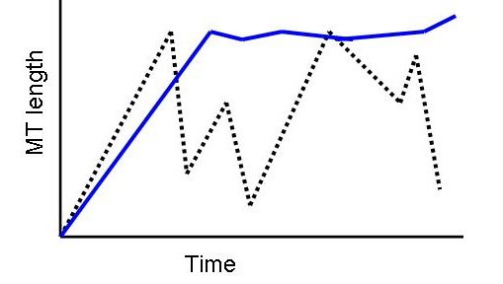
- In the diagram to the left, what has probably been added to the cell for the blue line? For the dashed line, would you expect the [GTP] to be high or low?

- What is the force generating segment in kinesin, dynein, and myosin?

- What is one way to control the rate of kinesin movement along a microtubule? What will happen if a non-hydrolyzable form of ATP is introduced into a kinesin microtubule cell free system?

- What are two similarities and two differences between tubulin protofilaments and actin microfilaments?

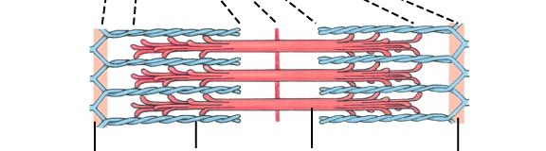
- What is the structure to the left and what is its function? Label the parts indicated by the lines on the bottom.

- How are microtubules able to be generated initially, meaning, what facilitates their initial formation (nucleation)?

- What does ATP binding (as opposed to hydrolysis) do in the motor cycles of both kinesin and dynein?

- Name two factors that determine transition temperature.
- How might you test that a protein is associated with a lipid raft?
- If you wanted to measure membrane fluidity, what is one way that you could do it?
- How would you determine whether a portion of a protein is extracellular or cytoplasmic?

