**Formulae Sheet**

**CHE320**

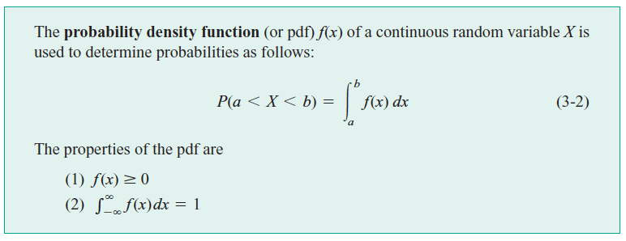

For a continuous random variable, the probability that the variable falls between the values $a$ and $b$ is given by:

where $F(b)$ and $F(a)$ are cumulative of $f(x)$ defined by:

$F\left(x\right)=\int_{0}^{x}{f\left(x'\right)dx'}$.

The normal probability distribution function is given by:



The normal distribution function with mean $μ$ and standard deviation $σ$ is shown below:

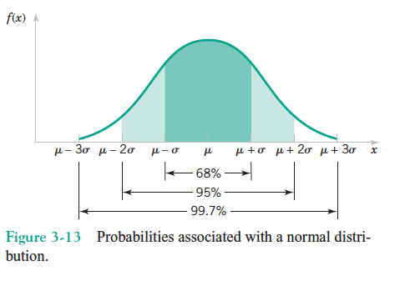

The normal distribution function with $μ=0$ and standard deviation $σ=1$ is called standard normal distribution. This is given by:

$N\left(0,1\right)=\frac{1}{\sqrt{2π} }exp\left(-x^{2}\right)$

The cumulative of this function is available as “standard normal distribution table”

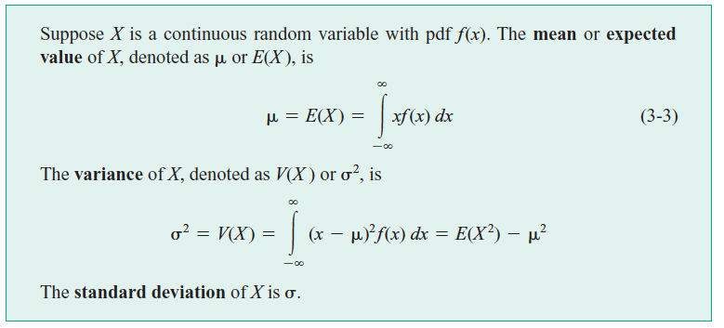

**Lognormal probability distribution** function is given by: 

**Binomial distribution:**

If the probability distribution of  is given by:



where  is the number of trials and  is the probability of success. This is called binomial distribution. 

**Poisson Process:**

If the probability distribution of is given by:



Here  is the average number of events in the given interval. 

**Exponential distribution:**

If the probability distribution of is given by:



**Functions of Random variables:**

**Linear function of independent random variable:**

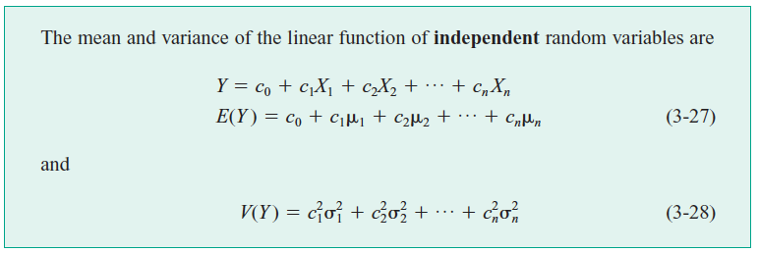

**Non-linear function of independent random variable:**

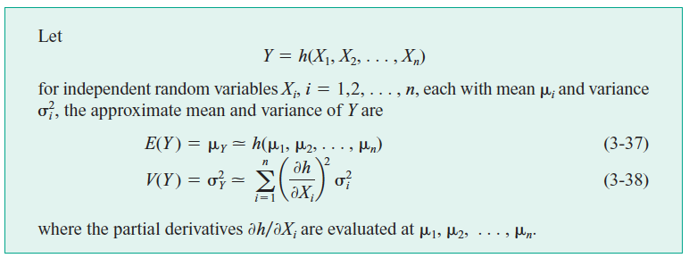

Test of independence: If the joint probability density function is given by:

$f\left(x,y\right)dxdy=f\left(x\right)dx×f\left(y\right)dy$, X and Y are independent.

**Dependent random variables:**



Correlation coefficient: $ρ_{X_{1}X_{2}}=\frac{Cov(X_{1}X_{2})}{σ_{1}σ_{2}}$

**Statistic, sampling distribution and central limit theorem:**



If we are sampling from a population that has an **unknown probability distribution** whose mean is $μ$ and variance is $σ$, the probability distribution of the sample mean ( $\overline{X})$ is approximately normal with mean $μ$ and variance $\frac{σ^{2}}{n}.$