# Lab 10: Simple Linear Regression (Chapter 6)

## Objectives

* Learn the basic form of a single variable simple linear regression model
* Use JMP to create an empirical linear model
* Analyze your model using JMP outputs
* Check your assumptions using residuals

## Simple Linear Regression Models

Empirical models, which are models created using data, are helpful in allowing us to predict output variables based on input variables without having to run further experiments. We’ll start working with models by looking at simple linear regression models, with one response (y, the dependent variable) and one regressor (x, the independent variable):

## EQUATION

## The beta parameters are regression coefficients.

## Creating models can still be considered a form of hypothesis testing; now, we are testing if our regression coefficients fit with the model of our choice. In this case, we are testing if our slope and intercept betas fit a linear regression model. We can use JMP to

## Linear Regression in JMP

After loading your data in JMP, select Analyze > Fit Y by X.

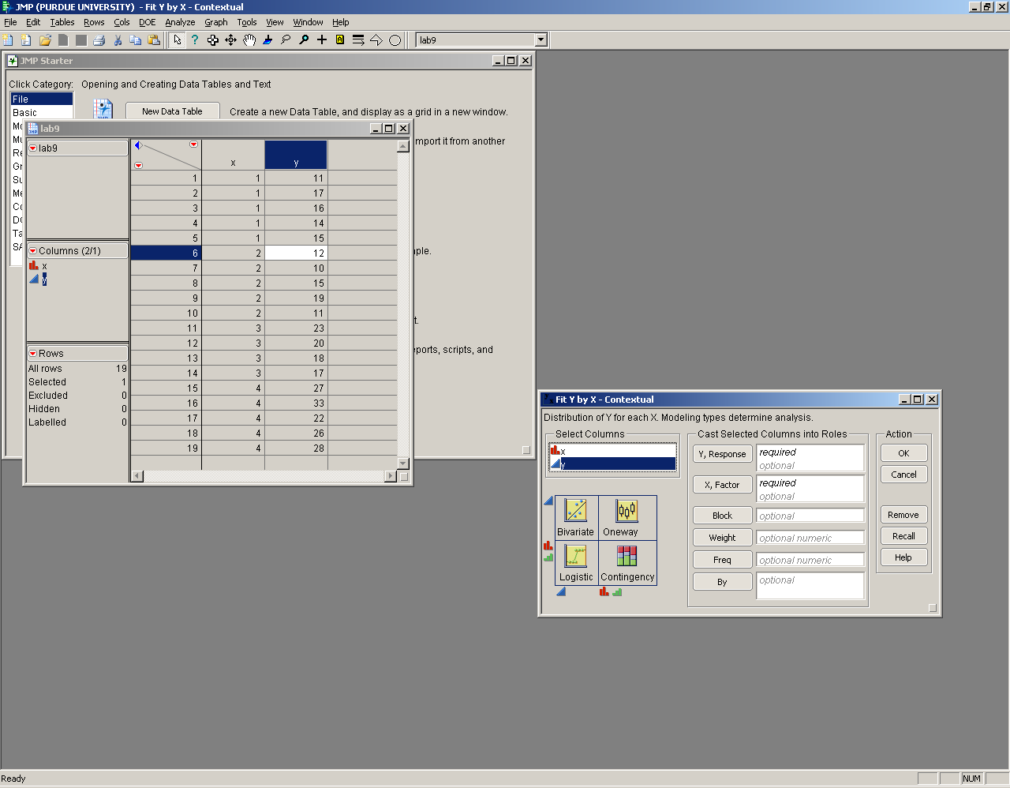

Remember last week we were doing one-way ANOVA analysis, in the upper right quadrant, when we related a discrete or nominal x variable (denoted by the red or green icons) to a continuous y variable (denoted by the blue triangle). Now, we are relating two continuous variables, which is the bivariate analysis, in the upper left quadrant.

After putting in your data, JMP outputs the following information.

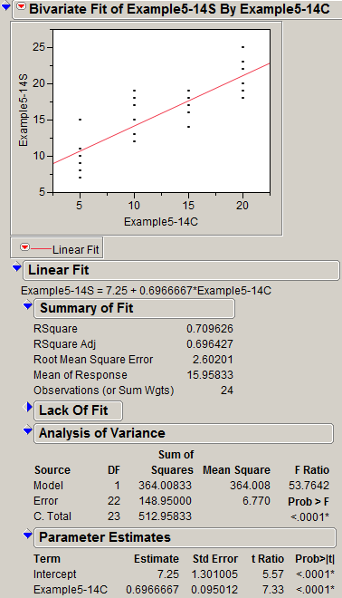

Let’s take a look at everything we can analyze in the output:

* *Summary of Fit*: This section helps you to determine if your model is sufficient. An R-squared value of 1 is ideal; the lower the R-squared, the more your model deviates from the actual data. A low R-squared value could signify that a model besides a linear model should be used – we will discuss this more in the future. Equations for calculating the other errors listed in this section can be found in your textbook.
* *ANOVA*: This section lists more errors having to do with the model and, more importantly, the P-value that tells you that your model can be used with at least one significant independent variable.
* *Parameter Estimates*: **This section gives you the information to create your linear model**; the first beta listed is the intercept and the second is coefficient of whatever term is listed in the table, in this case Example-5-14C. This table also lists the P-value (Prob>|t|) to determine if the estimate is significant or not.
* *Confidence Intervals*: You can calculate confidence intervals on the betas using equations 6-31 and 6-32 in the text and plugging in the T values and standard errors given by JMP. You can also add a confidence interval to the mean response by clicking the red triangle and adding “Confid Curves Fit.”

**Checking Assumptions**

Similar to the one-way ANOVA, **linear regression assumes that the observations are normally and independently distributed with the same variance for all treatments or factor levels. These assumptions should be checked by examining the residuals.** A residual is the difference between an observation and its estimated (or fitted) value from the statistical model being studied. Lab 9 explains how to save residuals and analyze them to check if your assumptions are valid, or read more in section 6-2.5 in the textbook.

## Lab 10 Exercises

Pierce (1949) measured the frequency (the number of wing vibrations per second) of chirps made by a ground cricket, at various ground temperatures. Since crickets are ectotherms (cold-blooded), the rate of their physiological processes and their overall metabolism are influenced by temperature. Consequently, there is reason to believe that temperature would have a profound effect on aspects of their behavior, such as chirp frequency.

For the Lab 10 data uploaded to Blackboard, consider the effect of temperature (factor) on the frequency of chirping (response).

1. State H0 and H1 formally and describe what they mean in your own words.
2. State any assumptions.
3. Use JMP to run the linear regression and determine if you can reject H0 or not.
4. Which fitting parameters (β's) are significant with α = 0.05?
5. Explain if your assumptions are valid using your residuals.
6. Assume the data points are given in the order they were recorded. Add another column that contains the row number so you can plot the residuals versus the row number. Do you see any patterns here?
7. What frequency would you expect crickets to chirp at 72 degrees F? At 32 degrees F?