**Examination I CHM 257 Spring 2016**

**50 pts total**

**NOTE: points will be subtracted for incorrect answers even if a correct one is also shown.**

1. Give the formal atomic charges for all atoms in this molecule: **2 pt**

C: 0 N: +1: **1 pt**

H: 0 F: 0 4 zeroes: **1 pt**

O: 0

1. Draw the complete Lewis structure (with all atoms and bonds and lone pairs) for one isomer of this molecule:

CNOH3 **2 pts** **any below structure: 2 pts; no lone pairs: - 0.5;**

**C with 5 bonds/N with 2 bonds/O with 4 bonds: 0 pts**



1. Based on the VSEPR (valence shell electron pair repulsion) theory, give the shapes of these molecules: **2 pts**

COS SiH3+ H-Se-H CH3O**-**

**linear trigonal planar bent tetrahedral**

**0.5 pts 0.5 pts 0.5 pts 0.5 pts**

1. Circle the molecules shown in question 3 that are polar. **2 pts**

COS: **1 pt** CH3O**-**: **1 pt** all additional structures: **- 0.5 pts each**

1. Which one of the isomers shown below is more stable? Why? What type of isomers are these?  **3 pts**

Right: **1 pt;** less Coulombic repulsions**: 1 pt;** constitutional**: 1 pt**

1. Indicate two structures below that are constitutional isomers:____,____

D or G and either A, B, C, F or H; or A or C and either B, D, F, G, H; or F or H and either A, B, C, D, G **1 pt**

conformational isomers: __D_,__G___ **1 pt** *cis*-, *trans*-isomers: _A_,__C__ **1 pt**

identical molecules __F__,_H_ or __G,__D_ **1 pt** total: **4 pts**



1. Give the proper and complete IUPAC name for the molecule shown below: **4 pts**

3-ethyl-2,4,4-trimethylhexane: **4 pts**

Any error: **-0.5 pts each**

1. Draw a proper Lewis structure for this compound: *trans*-4-bromo-3-fluoro-1,1-dimethylcyclopentane. **5 pts**

No obvious *cis-, trans*-: **- 1 pt**

Any error: **- 0.5 pt each**

1. Show the structures of all constitutional and *cis*-, *trans*-isomers for this molecule: C3H6O. **3 pts any 6 of below structures: 0.5 pts each**

**any incorrect ones: - 0.5 pts each**

1. Point out one equatorial and one axial H atom in the structure shown below.

**2 pts**



1.  Consider the molecules shown below. How many H atoms are bound to the carbon atoms indicated with an arrow? **5 pts**

Each correct answer: **1 pt**

1. Show one primary, secondary, and tertiary carbon atom in one of the above structures. **3 pts**

**three correct answers are shown in above figure: 1 pt each**

1. What is the name of the specific conformer shown below? Is it a favorable conformer? Justify. **3 pts**

eclipsed conformer: **1 pt**

not favorable: **1 pt**

Coulombic repulsion: **1 pt**

1. Show a conformational isomer in chair conformation for the molecule shown

below left. **2 pts**

any error: **-0.5 pts each**

methyl group in wrong place: **-1 pt**

impossible to tell whether *cis*- or *trans*: **-1 pt each**

not conformational isomer: **total 0 pt**

15. Draw a carbon-skeleton formula (line angle formula) for *cis*-1-isopropyl-4-methyl-

cyclohexane in the chair conformation: **3 pts**



either structure: **3 pts**

no chair: **-1 pt**

impossible to tell whether cis or trans: **-1 pt**

completely wrong orientation: **-1 pt**

other errors: **-0.5 pts each**

16. Give a complete IUPAC name for below molecule. **5 pts**



*trans*-4-*sec*-butyl-2-isopropyl-1,1-dimethylcyclohexane: **5 pts**

(or any name that allows drawing the correct structure)

No cyclo: **-1 pt**; other errors: **-0.5 pt each**

EXTRA CREDIT. Explain why below picture on the electronic structure of atoms is incorrect. **5 pts**

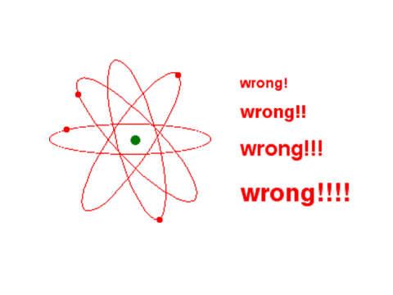Electrons do not exist on circular orbits but

orbitals at varying distances from nucleus and

with different probabilities of existence in three dimensions around the nucleus

