EXECUTIVE SUMMARY

1. Problem you solved
2. Unique design
3. Factual description of performance

***Note: Do not use first person pronouns. Use “the team” as the pronoun OR passive voice.***

The task was to build a tower to maximize a score determined by a given equation that took into account the number of straws used, the weight supported, and the height of the tower. The tower was to be made with a maximum of fifty plain straws and a roll of scotch tape. Straw overlapping could not exceed one inch, and a continuous piece of tape connected to a joint between two straws could not extend more than one inch past the joint. The height of a vertical or nearly-vertical straw could not be under 3.75”. Also, tape could not be used to structurally support the tower, and prototypes built with outside materials were forbidden.

Before construction even began, the question of how tall the tower would be was discussed. The team did not want to construct a tower that would be too tall to be stable and that would support very little weight because that would result in a lower score due to the score being inversely related to the number of straws used. Additionally, the team did not want to be penalized exponentially by having a tower that was shorter than 1.6 feet because the score was set to the power of height-0.6. Thus, it was decided that a good compromise between height and weight capacity that would get the best score would be approximately 1.6 feet tall.

One of the first problems the team encountered was how to connect straws together linearly. The best idea for connecting straws linearly was to make four cuts into one of the ends of a straw in order to create 4 petals that could be folded back, allowing the straw with petals to be inserted into the end of another (fig. 1). This type of connection created stronger joints because there was a tighter fit than if a plain straw were inserted into the end of another.The petal connection also allowed the team to save tape on linear connections and make use of it on other parts of the tower. Ultimately, although this type of connection had many benefits, it caused long chains of straws to develop a bend. Fortunately, this was noticed early in the building process, thus any bends were mitigated with diagonal supports.

Another problem that immediately presented itself was what shape the base of the tower would be. Since a strong, simple shape that required a minimal amount of straws was needed, an equilateral triangle design was utilized. In an effort to increase the strength of the base even further, petal joints were applied when building the triangular base, and the joints were placed along the sides of the triangle, rather than the points (fig. 2). This allowed the corners of the base to be much stronger than if they were the meeting point of multiple straws, which was beneficial because the vertical supports were connected at the corners of the triangle base.

It was decided that the tower would have a taper so the weight placed on top of the tower would be spread out over a larger area at the base. However, this prompted the group to decide how big the top and base of the tower would be. Since the cardboard square placed on top of the tower was 4”x4”, it was decided that the top of the tower would be an equilateral triangle of side length 4”. As for the base size, the team was limited to the largest equilateral triangle that four straws could make, so the side length of the base triangle was 7”.

The tower was extremely unstable at this point. It could not stand under its own weight. In order to stabilize the tower along its length, two additional equilateral triangles were constructed such that they would fit around the vertical supports and be equally spaced vertically along the tower. These triangles had different sizes as a result.

Even with triangular supports at even intervals along the tower, it was still fragile. Thus, diagonal supports were added in an X pattern on each side of the top and bottom segments of the tower and in a / pattern on each side of the middle segment of the tower. These supports ran from the point of one horizontal triangular level to an opposite point on the next horizontal triangular level (fig. 3). These greatly strengthened the top and bottom segments of the tower.

At this point, the tower was very rigid, but testing with weights revealed that the vertical support on one side of the top segment of the tower began to bend as more weight was added. This bending would ultimately lead to failure on that vertical support, so a diagonal support was added to relieve the pressure on that segment. This addition allowed the tower to support a 5lb. laptop.

The final height of the tower was 1.75 feet, and 42 straws were used in its construction. The tower held 93.65 ounces of lead shot before one of the vertical supports in the top section of the tower buckled. Thus, using the given equation, the final score of the team was 4.405 points.

**Figure 1**

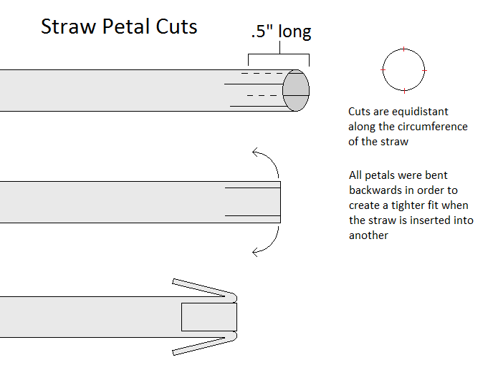

**Figure 2**

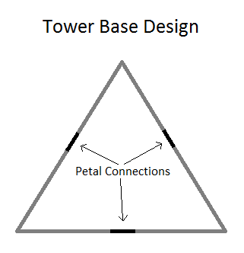

**Figure 3**

