ASSIGNMENT: C3 Bonus

FILE: C3_ACT_katherto.pdf

DATE: 3 February 2016

BY: Kathryn Atherton

katherto

Joshua Hahn

Hahn28

Hannah Mackin Schenck

hmackins

SECTION: 03, 1:30-3:30

TEAM: 45

ELECTRONIC SIGNATURE:

Kathryn Atherton

Joshua Hahn

Hannah Mackin Schenck

The electronic signatures above indicate that the document submitted for evaluation is the combined effort of all team members and that each member of the team was an equal participant in its creation. In addition, each member of the team has a general understanding of all aspects of the document.

**TASK 1**

PART A:

Flowchart: next page

PART B:

Code: file C3_ACT_Task1B_katherto.c

PART C:

Code: file C3_ACT_Task1C_katherto.m

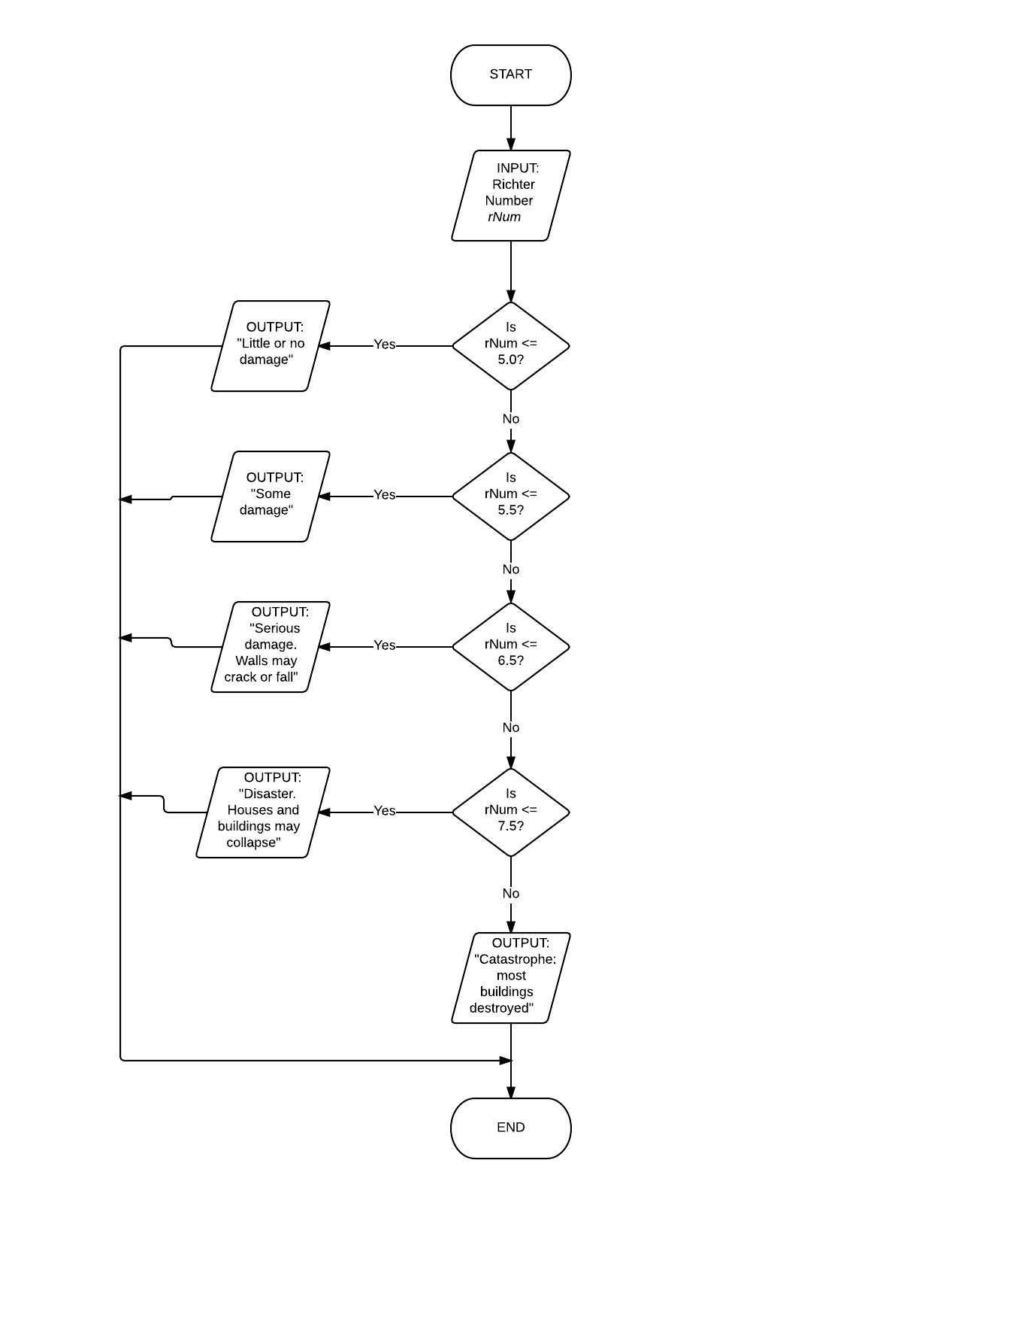

**TASK 2**

|  |  |  |
| --- | --- | --- |
| Expression | Equivalent Expression | Value |
| a > b && c < d && D - 1 | (a > b) && (c < d) && D – 1 | 0 |
| a < !b || !!a | (a < !(b)) || !(!(a)) | 1 |
| a + b < !c + !!D + !c | (a + b) < !(c) + !(!(D)) + !(c) | 0 |
| a – x || b * c && b / a | ((a – x) || (b * c)) && (b / a) | 1 |
| ((a < b) < c) || D – 1 – ‘A’ | ((a < b) < c) || (D – 1) – ‘A’ | 1 |

Code: file C3_ACT_Task2_katherto.c

**TASK 3**

Flowchart

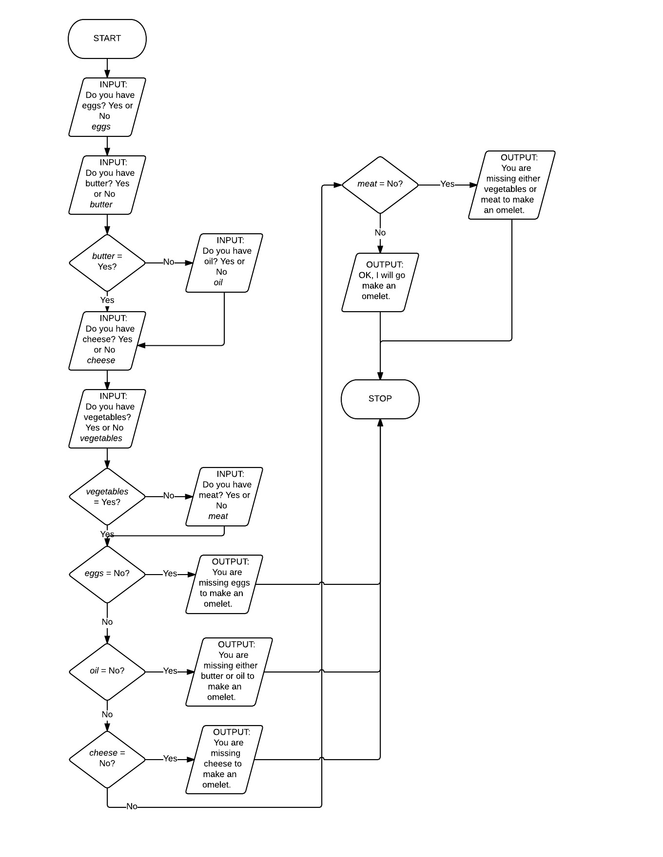

Code: file C3_ACT_Task3_katherto.c

**TASK 4:**

PART A:

Code: file C3_ACT_Task4_katherto.c

PART B:

(assume a = 5, b = 10)

|  |  |  |
| --- | --- | --- |
| OPERATOR SYNTAX | DESCRIPTIVE NAME | EXAMPLE |
| a = b | Assignment | a = b 🡪 a = 10 |
| a + b | Addition | 5 + 10 = 15 |
| a – b | Subtraction | 5 – 10 = -5 |
| +a | Unary plus | +a = 5 |
| -a | Unary minus | -a = -5 |
| a * b | Multiplication | 5 * 10 = 50 |
| a / b | Division | 5 / 10 = 0 |
| a % b | Modulo | 5 % 10 = 5 |
| ++a | Prefix increment | ++a = 6 (changes value before use) |
| a++ | Postfix increment | a++ = 6 (changes value after use) |
| --a | Prefix decrement | --a = 4 (changes value before use) |
| a-- | Postfix decrement | a-- = 4 (changes value after use) |
| a == b | Equal to | 5 == 10 🡪 0 (false) |
| a != b | Not equal to | 5 != 10 🡪 1 (true) |
| a > b | Greater than | 5 > 10 🡪 0 (false) |
| a < b | Less than | 5 < 10 🡪 1 (true) |
| a >= b | Greater than or equal to | 5 >= 10 🡪 0 (false) |
| a <= b | Less than or equal to | 5 <= 10 🡪 1 (true) |
| !a | Logical negation | !5 🡪 0 (false) |
| a && b | Logical and | 5 && 10 🡪 1 (true) |
| a || b | Logical or | 5 || 10 🡪 1 (true) |
| a += b | Addition assignment | a += b 🡪 a = 15 |
| a -= b | Subtraction assignment | a -= b 🡪 a = -5 |
| a *= b | Multiplication assignment | a *= b 🡪 a = 50 |
| a /= b | Division assignment | a /= b 🡪 a = 0 |
| a %= b | Modulo assignment | a %= b 🡪 a = 5 |
| a &= b | Bitwise and assignment | a &= b 🡪 a = 1 (true) |
| a |= b | Bitwise or assignment | a |= b 🡪 a = 1 (true) |
| a ^= b | Bitwise xor assignment | a ^= b 🡪 a = 9765625 |
| a <<= b | Bitwise left shift assignment | a <<= b 🡪 a = 5120 |
| a >>= b | Bitwise right shift assignment | a >>= b 🡪 a = 0 |