Budget

Gantt Chart

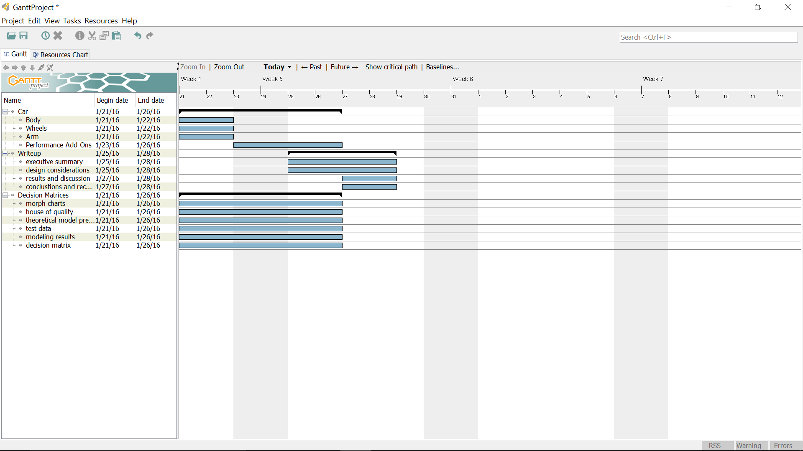

Morphological Charts

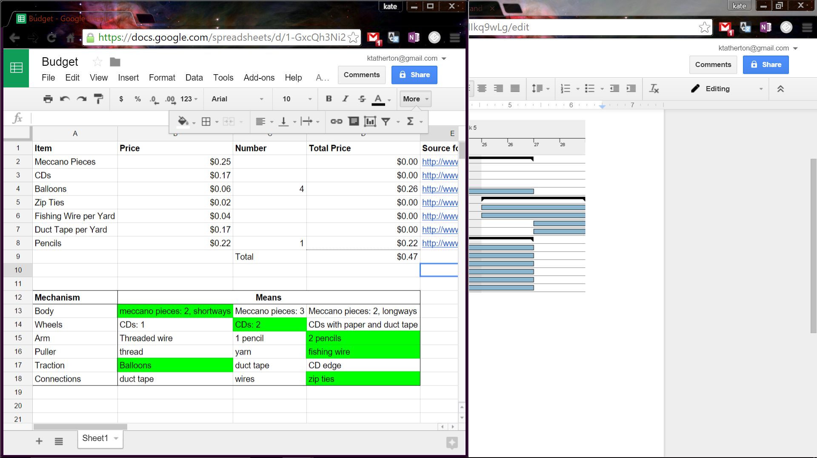

House of Quality

Test Data