**Project 3 Report**

**Team 45**

Kathryn Atherton

Joshua Hahn

Hannah Mackin Schenck

TO: Mr. Pierce, Harris Lead Engineer

FROM: Jane Smith, StarPower Inc. CEO

DATE: April 15, 2016

SUBJECT: Autonomous Lunar Vehicle Design and Performance

In January, StarPower Inc. was tasked with building an Autonomous Lunar Vehicle (ALV) for your company that is able to precisely unload three radio antenna units to specific locations, given the GPS coordinates of the locations, as well as those of dangerous hazards, in under 10 minutes.

To create a viable solution, the team began by brainstorming key design aspects of the ALV, including how and where the antenna would be unloaded, the design of the wheels and body, and how the ALV would overcome hazards. Then, design specifications were created and target values determined for each specification. With measurements of success established, the team began building and testing prototypes against the measurements in order to attain the best possible ALV for your company.

The prototype which best meets the design specifications consists of a basic NXT robot framework for the body, six small wheels connected to two separate motors, a conveyor belt consisting of two flat tires placed below a cage built to hold the antenna units, and a ramp connected to the end of the conveyor belt to control the dropping of the antenna.

The ALV designed by the engineering team is capable of movement over both rough and smooth terrains at speed of 20 centimeters per second. The robot can accurately turn any specified number of degrees within 10 degrees by utilizing a gyro sensor. In transporting the antenna units, the ALV is able to unload the units in the correct orientation 66% of the time on Earth’s gravity. The ALV can also detect drop off zones by utilizing a magnetic sensor. The ALV code implements a path finding algorithm referred to as a wavefront search in order to calculate the most efficient path to each drop off location while avoiding obstacles. The ALV is also capable of determining its position on the lunar surface using bluetooth communication with a satellite positioning system.

In the final demonstration, the robot was only able to successfully navigate to point A due to a communication error with the GPS system. The error caused the system to calculate the location of the robot incorrectly. In the mini-track portion of the final demonstration, three antenna were dropped in the correct place, while 2 out of the three antennas were dropped in the correct orientation.

In the future, the team plans to determine the cause of the communication error with the GPS system, as well as improve the navigation code to enable the ALV to be able to move in any direction for any distance to speed up the execution of the mission. Additionally, the team hopes to improve the accuracy of the antenna dropping system by changing the length and angle of the 3D printed slide.

StarPower Inc. is very grateful to have received this task, and hopes to be able to continue working with Harris during this project. If you have any questions regarding the ALV prototype, logic, or performance, the team would be happy to meet with you to go over your questions in detail.

**Executive Summary**

The team was tasked with creating an Autonomous Lunar Vehicle (ALV) to transport antenna units to specific locations using GPS navigation, safely unload the units, and avoid obstacles. The ALV also must be able to detect unknown hazards and be easily re-programmable for future missions. The team’s design to solve the problem presented consists of a basic, block-like framework for the body with a slanted brick to keep the design compact, three small wheels on either side of the chassis, a conveyor belt placed below a cage built to hold the three antenna units, and a 3D printed slide connected to the end of the conveyor belt to control the unloading of the antenna.

During the final demonstration, the team’s ALV prototype was able to easily turn towards all of its specified headings and overcome the rough terrain in its path at a speed of 20 centimeters per second. However, the ALV was only able to navigate to the first checkpoint due to an issue with the GPS system. An incorrect number was sent to the GPS system which caused the robot’s coordinates to be calculated incorrectly. During the mini-track portion of the final demonstration, it was able to drop the antenna units in the correct orientation two out of three times, dropping all three antenna units in the desired location, which is typical of the ALV. Testing found that the ALV unloads the antenna in the correct orientation 64% of the time, far below the target value of 100% set by the team.

One aspect of the design that reduced the robot’s efficiency is that it is overly reliant on receiving GPS coordinates, which, if incorrect, prevents the ALV from reaching the correct locations. Additionally, the efficiency of the design was reduced by bluetooth communication and the pathfinding algorithm. By using bluetooth communication, the robot had to stop moving and wait in order to receive correct coordinates. In addition, the pathfinding logic requires a lot of memory and limits the robot to moving one 10 centimeter square at a time and turning in increments of 90 degrees. Finally, as aforementioned, the antenna units are only dropped with an accuracy of 66%, which the team looks to improve going forward.

**Design Considerations**

The ALV went through many stages of design before the team settled on the final design. The overarching goal was to create a compact frame so that it will pack easily within the capsule. Other considerations that went into the final design were the anticipated performance of the design and the feasibility of each solution with the resources available. The various ideas brainstormed by the team can be seen in Table 1. Highlighted are the components which went into the final design.

**Table 1: Morphological Chart of Team Brainstorming**

|  |  |  |  |
| --- | --- | --- | --- |
| **System** | **Means** | | |
| Body | Tank | Multi-wheel design |  |
| Wheels | treads | big wheels | small wheels |
| Drop-off system | bed with treads | separate container for each antenna |  |
| Drop-off location w/ respect to robot | behind | to the side(s) |  |
| Overcome obstacles | snow plow | drive over |  |

When designing the systems for transportation and drop off of the antenna, the team considered how the antenna would be stored and where they would be dropped off from. The team brainstormed that it was possible to store the antenna on a long conveyer belt, in a cage feeding to a small conveyer belt, or in separate containers. After considering each option, it was decided that storing in separate containers would require too many motors and too much space to be feasible. The team then experimented stacking the antenna on top of a long conveyer belt, as seen in Figure 1. This idea was discarded because it was found that the antennas did not fit well in the space available and that it would not be practical to support the conveyer belt so that it could hold the required 600 grams.

**Figure 1: Prototype 1 -- Conveyor Belt Design**

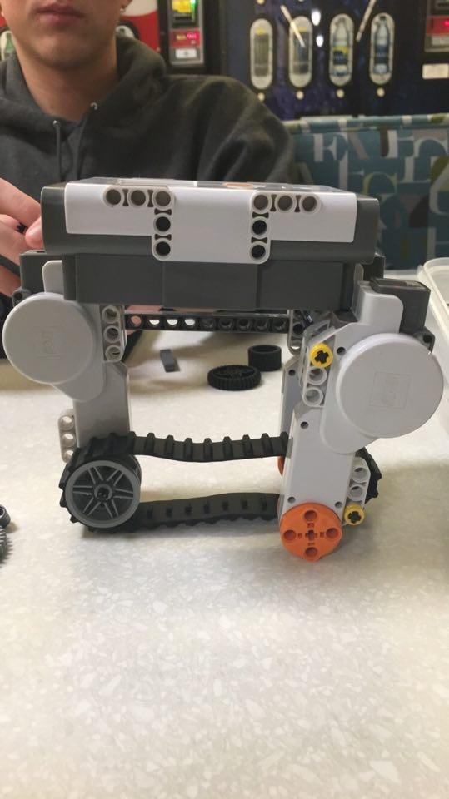

In the end, the team used the cage design, seen in Figure 2, because it was compact and allowed for reasonable precision when placing the antenna.

**Figure 2: Cage Design**



The cage design used is unique to the ALV because it is lightweight and easy to modify if the ALV needs to carry more antenna or antenna of a different size. Another unique feature in the ALV’s design is the slide on the back of the ALV as seen in Figure 2. The slide is designed to be integrated between the gear chain and under the conveyer belt. It is hollow to reduce the weight it adds to the ALV and it has elevated walls to help guide the antenna down the length of the slide.

The other decision that had to be made concerning the antenna handling systems was where the antennas would be dropped off. The team found that the options were off the front, the back, and the sides of the ALV. The team decided that dropping the antenna off from the front of the ALV was inefficient because the ALV would have to maneuver around the antenna once it was placed. Next, the team considered dropping the antennas off from the sides. This idea was discarded because this design did not work well with our goal of having a compact design and the team also felt that it could cause balancing issues when the ALV is fully loaded. Therefore, the team chose to drop off the antenna behind the ALV since this option allowed for the most accuracy and was better able to be integrated with the body of the ALV.

Next, the team needed to determine the optimal rotation speed of the conveyor belt. In order to make the dropping of the antenna units more consistent and gentle, the rotation speed had to be lowered to 12 from the speed that it was originally set at, 20. The data from this test can be seen in Table 2.

**Table 2: Conveyor Belt Speed Testing**

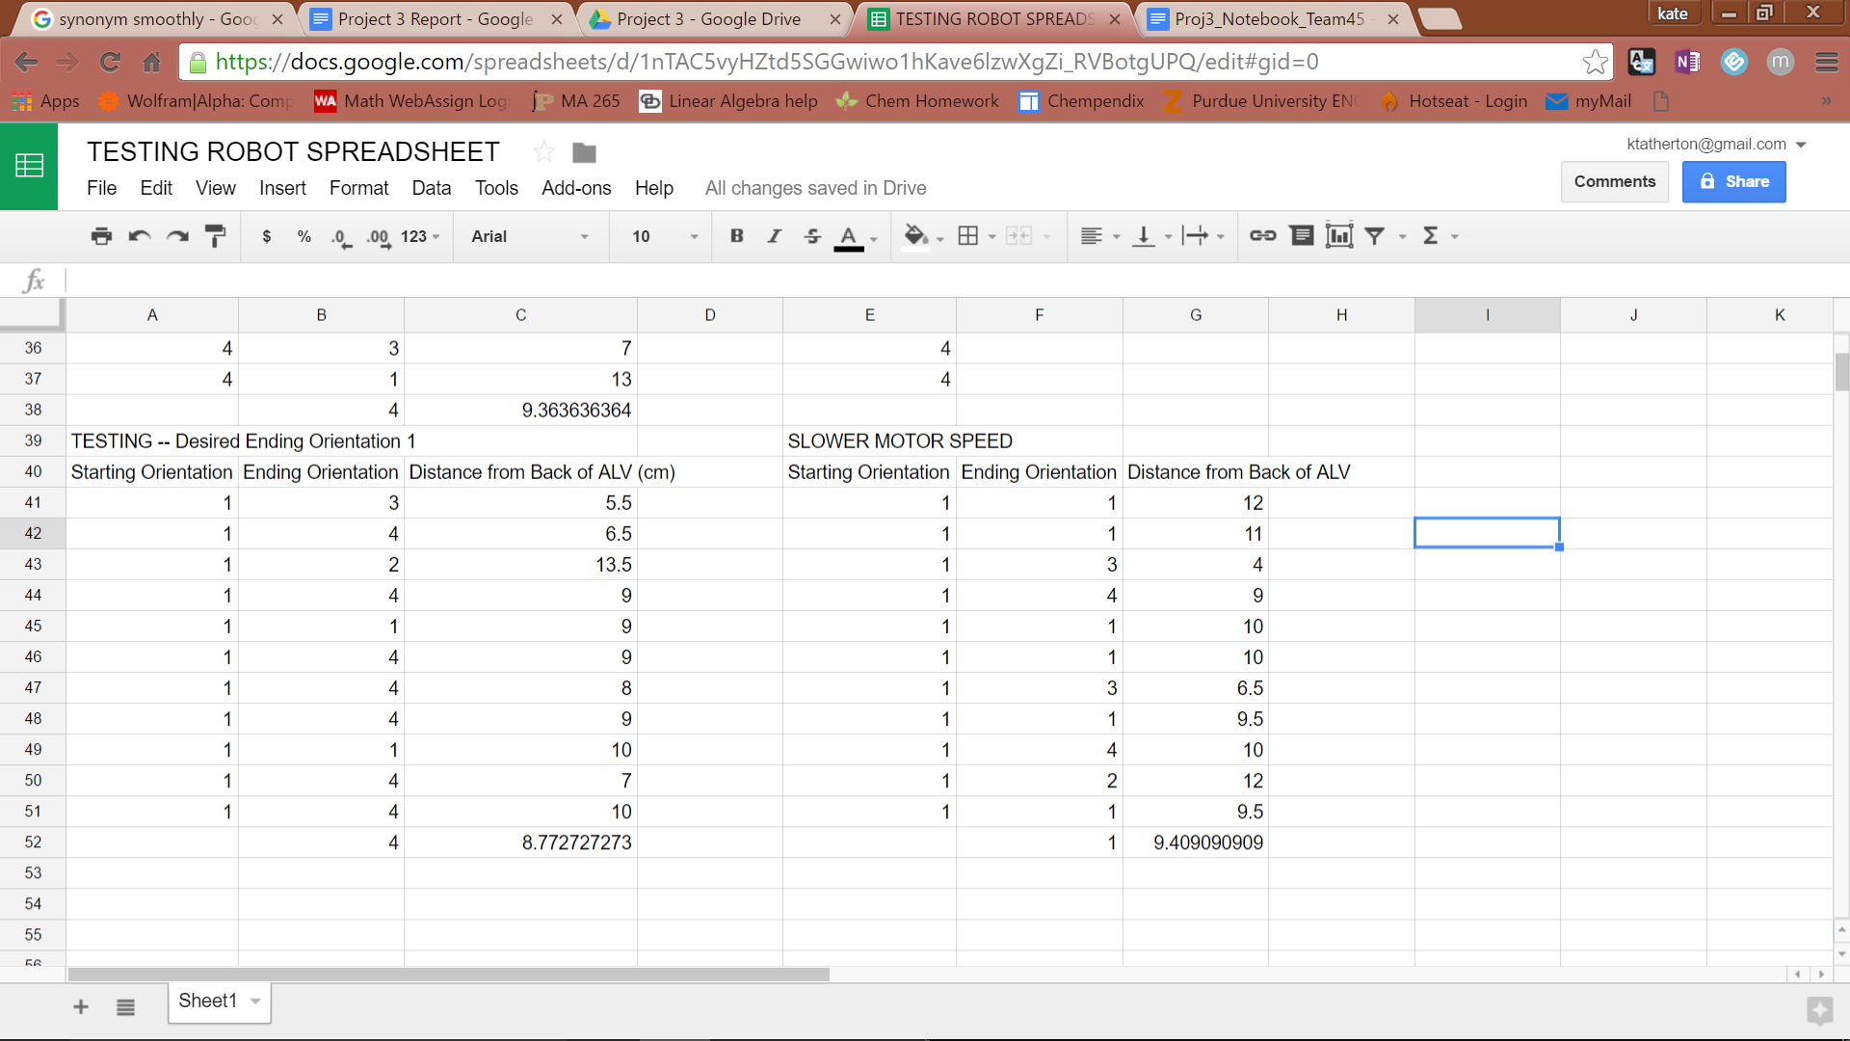

When designing the movement system, the team decided that the ALV would need two motors, one for the right side and one for the left side to control turning. Each motor would also have to be connected to a gear chain containing multiple wheels. Initially the team built the AVL with four wheels and a short gear chain. After the cage and motor for dropping off the antenna were attached, it was obvious that in order for the ALV to maintain balance, the last wheel had to be farther back, so the gear chain had to be extended. Once the rear wheel was moved back, the team observed that the ALV was unsturdy and sagged in the middle. Therefore, the team added a third wheel in the center.

When brainstorming ideas for the body of the AVL, the team decided on two possible orientations for the NXT brick: slanted and flat. Although the design with the flat brick would be more modular, it would also be less compact. The team also found that the designs using a flat brick were not as stable as the ALV had to be to perform well. The slanted brick, as seen in Figure 2, fixed these problems. It is a unique aspect that allows the ALV to be much more compact and provides a much sturdier base.

**Figure 3: Slanted Brick**



The last decision the team had to make was how to traverse small obstacles. It was determined that the ALV could either drive over the obstacles or use a plow to push the objects out of the way. The team worried that a plow would get stuck on the obstacles or would scrape the ground in uneven terrain. A plow would also require a large piece on the front of the ALV which would be cumbersome and make the ALV larger than necessary. The team decided to design the ALV to drive over the obstacles. This simplified the design of the ALV, but made it susceptible to navigational problems since the ALV might bounce off course while going over an obstacle.

In addition to hardware challenges, the team faced a variety of software challenges. One major software challenge was path navigation. The team considered three options for path navigation. The first option was to navigate using the ultrasonic sensor and surrounding environmental cues such as large mountains. The second option was to hardcode a path that the robot would have to follow. The third option was to implement a wavefront search algorithm, which calculates a path using a matrix representation of the map.

The first option was quickly discarded. Although this option would allow the robot to most efficiently avoid hazards, it would be difficult to implement due to a lack of sensors. The engineering team was only provided with one ultrasonic sensor, which the team decided was not sufficient to fully implement this option. With only one sensor, the robot could detect obstacles in front of it, but not on its sides. The team thought that at least two additional sensors would be required in order to fully observe its environment. In addition, since the final demonstration map was supplied to the team with limited time before the final demonstration, the team was worried about time constraints with implementing this option. Ultimately, the team decided to go with a different option.

The second option involved hardcoding a path for the robot to follow. While this option would likely be the easiest to implement, the code would not be reusable and would not be equipped to handle any unforeseen hazards. For example, if the robot would happen to get off track due to lunar objects in its way, it would not be able to quickly recover, if it was able to recover at all. In addition, the code would only be useful for the final prototype demonstration, which defeats the purpose of the project. The purpose of the project is to develop code that can be utilized in a full lunar mission. It would be pointless to develop a code that is only applicable in one situation, so option two was also discarded.

The third option was a wavefront search algorithm. The algorithm structure is demonstrated in a flowchart in Figure 4.

**Figure 4: Algorithm Flowchart**

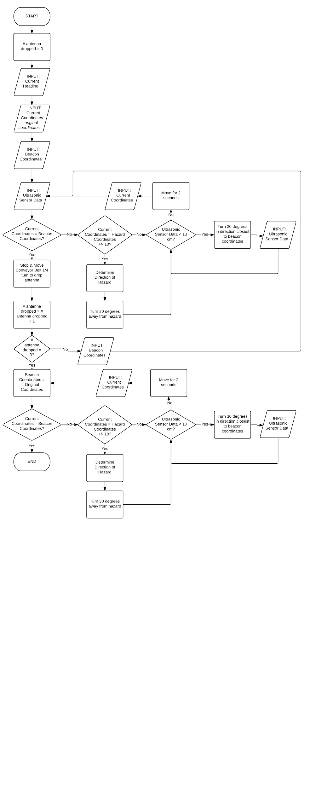

This algorithm generates a map of the environment that the robot can then follow. A sample wavefront map can be seen in Figure 5.

**Figure 5: Wavefront Map**

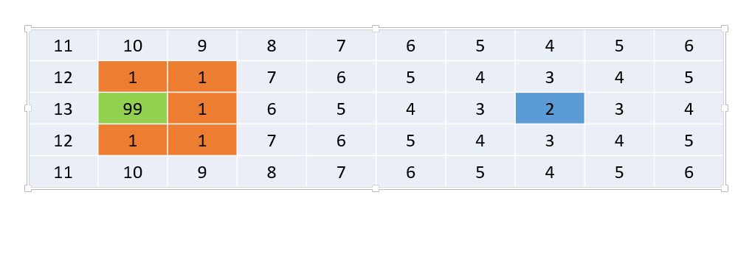

Once the map has been generated, the robot can then follow the path to the goal. The team ultimately decided to use this algorithm in the final code. This code is easily adapted to multiple scenarios, a major weakness of the other two options. It also allows the robot to plan and follow the most efficient route. However, this option also has some disadvantages. Although the path it followed was efficient, it often brings the robot in close proximity to environmental dangers. Sometimes the most efficient route is not the safest. In addition, the wavefront map takes up a lot of memory space on the robot, which might become an issue for larger maps.

Another coding issue was precise robot movements, particularly moving set distances in a straight line and turning specified numbers of degrees. There were two coding options considered for straight line movement. The team could either turn on the motors for a specified amount of time, or have the motors turn a specified number of counts. The team quickly decided that it would be better to have the motors turn for a specified number of counts, as this was not dependent on the battery level of the robot and the turns could be quickly calculated by knowing the wheel circumference and the desired distance traveled. The data in Table 3 was collected by setting the vehicle to go five feet in a straight line, then measuring the offset distance in inches. The same test was run two hours later.

**Table 3: Movement Data for Time vs. Motor Counts**

|  |  |  |
| --- | --- | --- |
| Motor Control | Initial Average Offset Distance (Inches) | Average Offset Distance 2 Hours Later (Inches) |
| Time | 1.8 | -6.3 |
| Encoder Counts | 2.2 | 1.9 |

The same options were considered for turning. However, the team discovered an odd problem. Due to the design of the robot itself, neither option worked optimally. Although the robot could turn the specified number of degrees in one direction, it did not turn the same number of degrees when it turned the other way.

Because of this, the team brainstormed a third alternative. The team installed a gyro sensor on the robot that measured the angular velocity of the robot. By sampling the angular velocity over a small, known time frame, the number of degrees turned could be calculated by multiplying the average angular velocity by the time frame over which it was sampled. This is a rather unique aspect of the ALV’s design and allows the robot to accurately turn any number of specified degrees, as seen in Table 4.

**Table 4: Turning Data with Time, Encoder Counts, and Gyro Sensor**

|  |  |  |
| --- | --- | --- |
| **Turning Method** | **Average Degrees Off from a 90 degree right turn** | **Average Degrees Off From a 90 degree left turn** |
| Time | 11 | 31 |
| Encoder Counts | 7 | 22 |
| Gyro Sensor | 2 | 2 |

The final coding challenge was determining the robot’s location on the simulated surface. The team considered two different systems for accomplishing this goal. The robot could either communicate with a satellite positioning system or use environmental cues to determine its position. The team decided not to use environmental cues for a variety of reasons. Without access to the environment itself for testing, the team thought that it would be difficult for the robot to accurately identify environmental hazards. The robot would be able to tell how far away it is from an environmental cue, but not determine what that environmental cue is. This left the team to utilize the GPS software. The software itself provided a variety of issues. For one, the GPS system is comparatively slow, as it forces the robot to stop moving and wait a few seconds in order to send and receive messages. However, the coordinates received were extremely accurate. Because of this, the team decided to utilize the GPS software in the final code.

The final design of the robot can be seen in Figure 6. The robot has a slanted central brick attached to a frame of 6 small wheels. Antenna are stored in a cage on the back of the robot and are deployed with the assistance of a 3D printed sled. The robot moves using encoder values and turns precisely by using a gyro sensor. The code implements a wavefront search algorithm for pathfinding and utilizes Bluetooth communication with the GPS system to accurately determine its position on the lunar surface.

**Figure 6: Final Robot Design**

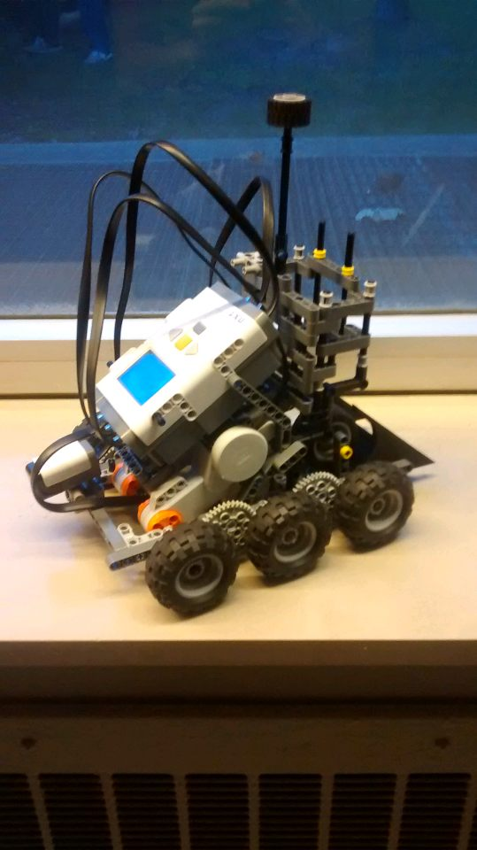

**Results and Discussion**

During the final presentation, the team’s ALV did not perform to its full potential, but nonetheless, performed well. It was very successful in traversing the terrain of the course. However, the robot did not perform to specification when unloading the antenna units and utilizing the GPS software.

During the final demonstration, the robot was successfully able to navigate to the first location, but was unable to continue due to an issue with Bluetooth communication. In order to calculate the robot’s coordinates, the GPS identifies a colored beacon and uses its height off the ground to calculate the robot’s position. However, the incorrect height was repeatedly sent due to unknown issues, causing the GPS to return incorrect coordinates. Because of this, the robot was not able to navigate to any checkpoints after the first location.

However, in testing outside of the final demonstration, the ALV performed up to specifications. The ALV was able to successfully navigate objects because its design allowed for precise, controlled movement. By utilizing the gyro sensor, the robot was able to effectively turn and follow the planned path. The code also effectively implement the wavefront algorithm to calculate efficient paths when the correct GPS coordinates were received. ALV performance data outside of the final demonstration is summarized in Table 5.

**Table 5: Robot Performance vs. Specifications**

|  |  |  |
| --- | --- | --- |
| **Technical Need** | **Target Value** | **Actual Performance** |
| Velocity | .5 feet / second | 20 cm / second == 0.66 feet / second |
| Stopping Distance from Given Specific Location | < 3 cm | < 5 cm |
| Difference in Location from where Robot is to where it thinks it is | < 5 cm | 0 cm |
| Difference in Direction from where Robot is facing to where it thinks it is facing | < 10 degrees | < 10 degrees |
| Height of Hazards Able to Overcome | > 20 mm | 20 mm |
| Weight able to Carry | > 600 grams | 600 grams |
| Distance from edge of antenna to edge of beacon | 0 cm | 2 cm |
| Number of antenna placed with the correct side facing up | 3/3 | 2/3 |
| Value of errors ALV can handle | >= 32 (i.e. 2, 4, 8, 16, 32) | 32 |

The ALV did not perform perfectly in dropping the antenna units during the mini-track portion of the final performance, as one of the three units was dropped in an incorrect orientation, but it performed exactly to the consistency it did in testing. During testing, the robot could deploy all three antenna with about 66% accuracy. Because of how the antenna are dropped, they tend to roll a certain number of times. The testing was done with antenna that weighed about 160 grams. In the final demonstration, the antenna weighed about 65 grams, which affected the final orientation of the antenna.

**Conclusions & Recommendations**

In the final demonstration, the ALV was only able to make it to the first checkpoint due to communication issues with the GPS system. On the mini track, three antenna were deployed correctly, two with the correct orientation. The ALV has its various advantages and disadvantages. The ALV can easily traverse the given terrain and properly unload the antenna units at the correct locations using the magnetic sensor and GPS system. Primary flaws in the design include reliance on GPS coordinates and imperfect antenna deployment.

The best aspects of the team’s design are its size and adaptability to real-life missions. The compact size allows for easy maneuvering and turning around the course, as well as effortless traversal of the rough terrain. Its modular code and Bluetooth communication allow the ALV to be easily adapted to a real-life situation, whether it be on the moon or on the earth.

The downfalls of the current design are its reliance on the GPS system and the inconsistency of the antenna dropping. The reliance on the GPS causes the ALV to execute the mission much slower than the team had hoped, as it takes time to communicate with the GPS system. Additionally, if the GPS coordinates are calculated incorrectly, as occurred during the final demonstration, the robot is unable to complete the mission, as it has no idea where it actually is on the course. Finally, the steep slide caused the antenna units to fall in inconsistent orientations.

To improve the ALV’s performance, the team believes that continuing to develop the navigation code would improve the ALV’s execution of the course. Future developments would improve the navigation algorithm in order to calculate paths more efficiently. In addition, path following could be improved upon so that the robot can travel in multiple directions, not just the cardinal directions, and for any distance, not just one grid space at a time. The team also believes that extending the length of the 3D printed slide would make the dropping of the antenna units even more gentle and consistent, improving upon the 66% accuracy in the dropping mechanism.