Kathryn Atherton

**IT226 Biotechnology Lab I (IT226)**

**Fall 2016**

**Reflection 3**

**Due Tuesday, October 25**

1. What is the difference between a spot titer and a full plate titer? Which protocol do you perform first during phage purification? Why?
   * A spot titer is performed with many dilutions of a phage lysate (usually, my partner and I do 8) on one plate
   * A full plate titer is performed with one agar plate for dilution of a phage lysate. It is used to determine the titer of the lysate, as the plaques are easier to count on one large plate, rather than in small spots.
   * A spot titer is performed first during phage purification because it verifies the presence of phage by producing clearings on the bacterial lawn prepared. It also ensures a logical order of decreasing concentration of phage is found in the bacterial lawn clearings before the lysate is used to perform a full plate titer, which is used to calculate the titer of the lysate.
2. Describe the morphology of the plaques from the phage you isolated and purified. Be sure to include morphological traits beyond size. Why isn’t size the best morphological trait to use as you purify your phage and provide documentation to support that you are isolating a pure phage population?
   * The plaques isolated are about ½ cm across and nearly perfectly round. They are also very clear inside, with hardly any cloudiness.
   * Size is not the best morphological trait to use to support that the phage population is pure as the size is just one trait of many of a phage’s plaque. Various phage may produce similar plaque sizes, or, if the concentration of phage is high on a plate, the size of a plaque may not be accurately determined. Other traits need to be considered, such as the turbidity, so that on any plate one can see whether the phage sample is pure or not.
3. Review the guidelines for “Taking Plaque Pictures” found in Protocol 12.3 from the HHMI SEA phage discovery guide. As noted in the discovery guide, properly documenting plaque morphology throughout the purification process is critical. Look at the examples in Figure 12.3-1.
   * Are the photos in your current lab manual acceptable?
     + The photos in my lab manual are not acceptable, as they are not taken from the top. They are taken from underneath the plate with a light behind the plate.
   * Include a copy of an acceptable photo below from early in your purification ***and*** later in your purification process with detailed figure legends.
   * 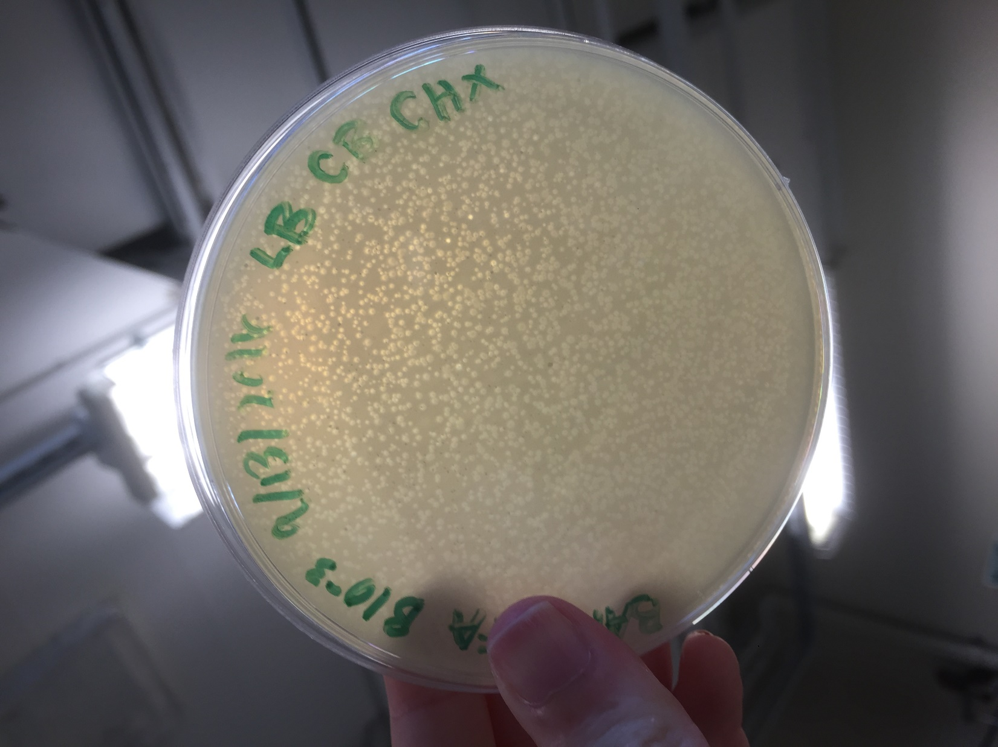
     + *Figure 21: Serial Dilution, Picked Plaque B, Concentration: 10^-3, September 15, 2016*
   * 0 を 0 り つ ? % づ を - 
     っ %. ゆ み 0 り の の 。 
     つ % 0 。 り の 0 を 
     。 、 や っ 0 り の り ? : ノ 
     み ゆ ら み の 
     秀 兮 を 
     + *Figure 64: Streak Plate developed from Large Plaque picked, October 20, 2016*
4. We used direct plating to capture our phage but there is another alternative method that has a higher rate of success, known as enrichment, that is discussed in your laboratory manual.
   * Why do you think enrichment is more likely to yield positive results for capturing a phage versus the direct plating protocol?
     + Enrichment is more likely to yield positive results than direct plating because the conditions of the incubation period allow for more bacterial replication, thus more phage replication and lysis. Larger concentrations of phages that infect the bacterial host are created than were in the initial sample collected from the environment.
   * Given our long term research objective, why do you think we use only direct plating and not enrichment to capture phage?
     + We only use direct plating to ensure that new phage are being discovered and isolated. There is not any growth of the bacteria, so all of the different types of phage in a sample are seen on the plate after a day or two. With enrichment, more positive results are found, but it is more difficult to differentiate different types of phage from each other, as there is a higher volume of plaques.
5. Why do you need to determine the titer of your phage lysates? What are some of the properties of individual phages that would lead to higher or lower titers in a given phage preparation?
   * The titer of phage lysates needs to be determined to find the total number of phage particles in a lysate per milliliter. This concentration determines whether or not the lysate is viable to collect DNA and archiving the phage discovered. If the lysate titer is too low, a sizeable DNA sample will not be able to be collected and a new lysate will need to be formed.
   * The number of phage created per replication in a host cell will create higher and lower titers. The more phage created by a host cell before lysis, the higher the concentration of phage collected in the lysate and the higher the titer.
6. Why do you need to perform an empirical test---why not calculate the area of a plaque and infect the for your webbed plates immediately? What are the different parameters that can vary from one infection to the next that may influence a typical titer procedure?
   * An empirical test needs to be performed because calculating the area of a plaque does not tell you the concentration of the lysate used to create the plate on which the plaque was formed. The empirical test finds the volume of lysate will produce a webbed plate with the concentration of the lysate AND the area needed to cover.
   * Parameters that can vary from one infection to the next include the distance between un-infected bacteria and a bacteria that has just lysed, the time the infections are allowed to occur (sometimes, they are incubated for two days, and other times they are incubated over the weekend – 5 days total), and the number of new phage created by one bacteria’s lysis vs. another.
7. Why do you think that a “web pattern” is better than complete lysis for isolating high numbers of phage particles?
   * A web pattern is better than complete lysis because it ensures that there are still some bacterial cells in the plate, and individual plaques are just about visible. If all bacterial cells are killed, that means that the yield of phage will be lower, as all the bacteria were infected before multiple rounds of lysis and infection finished. In a webbed plate, several rounds of lysis, which amplifies the phage, have occurred and the plate should have many phage to collect.
8. Think of an experiment to perform if you continue to obtain more than one morphology in your phage preparations (e.g. some plaques are large and clear, and some are much smaller and cloudy).
   * How would you determine that an individual phage yielded two different morphologies?
     + One could determine that an individual phage yielded two different morphologies by creating streak plates. You pick a plaque from each morphology and create a special plate to isolate just the phage in that plaque. If both streak plates create both morphologies, they come from the same phage.
   * What could be a possible mechanism by which one phage could yield two different morphologies?
     + One possible mechanism is that the density of bacterial cells present in one area of the plaque is different than in another. If the density is high, a larger plaque may form, as more phage are created in this area and thus can spread to more and more bacteria. If the density is low, a smaller plaque may form, as there are less instances of lysis and a smaller chance that more bacterial cells are infected.