**IT226 Biotechnology Lab I**

**Fall 2016**

**Reflection 4**

**Due Tuesday, November 8**

1. Drew, who is incredibly conscientious and cares deeply about the environment, decided it would be best to use the same pair of gloves throughout the “Phage DNA Extraction” procedure (Protocol 9.1). Why is this, although good for the environment, a pretty bad idea?

* This is a bad idea because the various chemicals and enzymes used in the various steps could contaminate the sample in following steps. One in particular is the RNase in the nuclease mix which is very stable and will contaminate equipment. One is to keep that in one area to prevent such contamination. By using the same gloves throughout the procedure, the stable enzymes are not contained in one single step or area.

1. What was the final concentration of DNA for your phage? Using the concentration of your DNA sample, calculate how many microliters of DNA are needed to obtain 0.5 micrograms of DNA.

* The final concentration of DNA for my phage was 105.3 ng/uL.
* 105.3 ng/uL * 0.001 ug/ng = 0.1053ug/uL
* 0.5 ug * uL / 0.1053 ug = 4.75 uL

1. If you want to prepare 25mL of 0.8% agarose for a DNA agarose gel, how much powdered agarose will you add to 25 mL of buffer? How much of the 10 mg/mL EtBr stock will you need to add so the final EtBr concentration is 0.5 micrograms/mL?
   * 0.8% = x g / 25 mL * 100
   * 0.008 * 25 = x =
   * 10 mg/mL * 1000 ug / 1mg = 10000 ug/mL
   * 10000x / (25+x) = 0.5ug/mL
   * 10000x = 12.5 + 0.5x
   * 9.5x = 12.5
   * X = 1.316 mL
2. Following the protocol guidelines from **Protocol 10.4: Analyzing Restriction Enzyme Gels**, perform a qualitative and quantitative analysis of your restriction enzyme digest and address the questions below:
3. **Qualitative:**
   * + Provide a picture of your gel.

* Label each lane according to its contents.
* Using the “map” of the DNA ladder, label each ladder band with its size in base pairs.
* Looking at each lane, and the gel as a whole, answer these questions:
  + Is there DNA in each lane? How do you know?
    - It appears that there is not DNA in lane 6, as there are not any bands of DNA sections seen in the lane.
  + Did each restriction enzyme cut the phage DNA? How do you know?
    - It appears that each enzyme did cut the phage DNA as there are small bands of DNA sections seen in each lane below where the uncut DNA band ends.
  + Which restriction enzyme cut the most? Which cut the least?
    - It appears that EcoRI cut the most and ClaI cut the least.
  + If there is a problem with your gel, can you identify the cause?
    - I cannot see a problem with this gel.

***NOTE*** This is not my group’s gel. We have not made it this far in the protocol, so this is a different group’s that I am using for this reflection. I will post my own in my notebook when I am able to do so.

lanes 1. 2. 3. 4. 5. 6. 7.

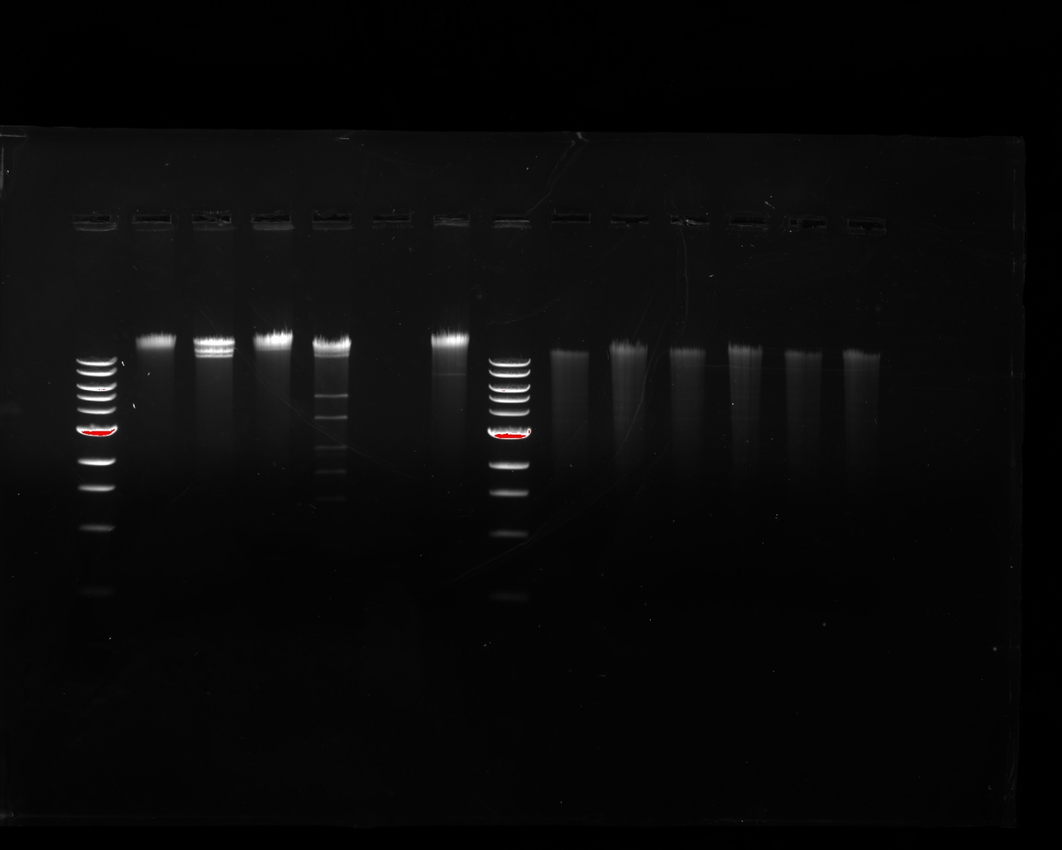

10,000 bp

6,000 bp

5,000 bp

3,000 bp

2,000 bp

1,500 bp

1,000 bp

500 bp

1. Ladder
2. Uncut DNA
3. Bam HI
4. Cla I
5. Eco RI
6. Hae III
7. Hind III
8. **Quantitative:** Perform a quantitative gel assessment----calculate band size.

* Using a ruler and a pen, draw a line at the top of the gel photo, above the wells or below the wells. The line will act as a reference for measuring the distance migrated by the DNA.
* Make a standard curve of the DNA ladder.
  + Using Table 10.4-1 as a guide, make a table in your notebook or an Excel spreadsheet.
  + Fill in the values for known DNA fragment sizes of the ladder.
    - DNA ladders (also known as standards or markers) contain DNA fragments of known sizes. The fragment sizes are manufacturer-specific; therefore, it is important to use the proper map when assigning band sizes to your ladder.
  + Measure the distance migrated, in centimeters, of each band in the ladder. Start at the line you drew at the top of the gel and stop at the top of each band.
  + Record these data in the table or spreadsheet.
  + Create a semi-log plot of these data points to create a standard curve. The graph can be made by hand or by using Excel.
  + What is the purpose of creating a semi-log plot?
    - The purpose of creating a semi-log plot is to create a more linear-like progression in the case where one axis has a larger range of data than the other.
* Estimate restriction fragment lengths by using the standard curve.
* Compare the results from your gel with those for other bacteriophage.

|  |  |
| --- | --- |
| Distance Traveled (mm) | DNA Ladder Fragment Size (bp) |
| 12.5 | 10,000 |
| 22.5 | 6,000 |
| 27.5 | 3,000 |
| 35 | 2,000 |
| 40 | 1,500 |
| 50 | 1,000 |
| 62.5 | 500 |

Bam HI 🡪 about 7,000 base pairs = about 20 mm

Cla I 🡪 about 9,000 base pairs = about 13 mm

EcoRI 🡪about 7,000 base pairs = about 20 mm; about 5,000 base pairs about 25 mm; about 4,000 base pairs = about 26 mm; about 2,500 base pairs = about 27 mm; about 1,750 base pairs = about 37 mm; about 1,250 base pairs = about 45 mm

Hae III 🡪 no visible bands

Hind III 🡪 about 10,000 base pairs = about 12.5 mm; about 5,500 base pairs = about 23 mm

This phage’s bands are much more defined than those for other phage that I have seen, such as the phage whose gel is to the right in the image above. Thus, it is difficult to tell how similar the genomes may be based on the gel data.

***Document your results and analysis in your laboratory notebook and include a copy with this reflection***.