IT227 Biotechnology Lab 2

Spring 2017

Kathryn Atherton

Reflect on your experience thus far and ***consider the following questions***:

* What do you think is going well?
  + My group works very efficiently together. We feel good about the work we have produced and we are looking forward to moving forward with a new phage genome.
* What suggestions do you have for improvement?
  + I think a better outline of our next steps for the poster symposium as well as the next phage genome would be a good improvement.
* What are you learning that you can apply to your career goals and interests?
  + I am learning about the patterns in a genome that are followed by nature as well as the kind of evidence needed to back up scientific claims. As I want to do research in genetics, this experience is very key to what I might expect in my future career.
* What is your greatest take away or “aha” moment thus far?
  + Once I discovered how best to use each of the programs we were given and the order in which we were to look at the various programs and pieces of evidence in our decision-making process, I understood how to execute the annotation.
* What remaining questions do you have?
  + When can we start working on a new genome? If we don’t finish another genome before May or want to work on more genomes, how can we do so? Are there any other programs or resources you would recommend to someone who enjoys this research?

As you prepare your poster for the upcoming presentation, you should consider the story that you will share with the audience, based upon the data and evidence that you have thus far. In addition, the data and evidence may reveal additional unknowns that you haven’t considered previously but could provide critical new directions for the next research question. You should carefully consider what results you expected to find based upon the large foundation of existing research and now that you have your actual results, how do your expected findings compare to what you actually found. Often new research directions and fruitful paths for discovery can arise from reflection and evaluation of unexpected findings as it can make our assumptions explicit and encourage us to ask more questions.

* ***Provide one visual*** to highlight what results you expected based upon what is known about mycobacterium and mycobacteriophage, including the phage genome you are working on this semester
  + 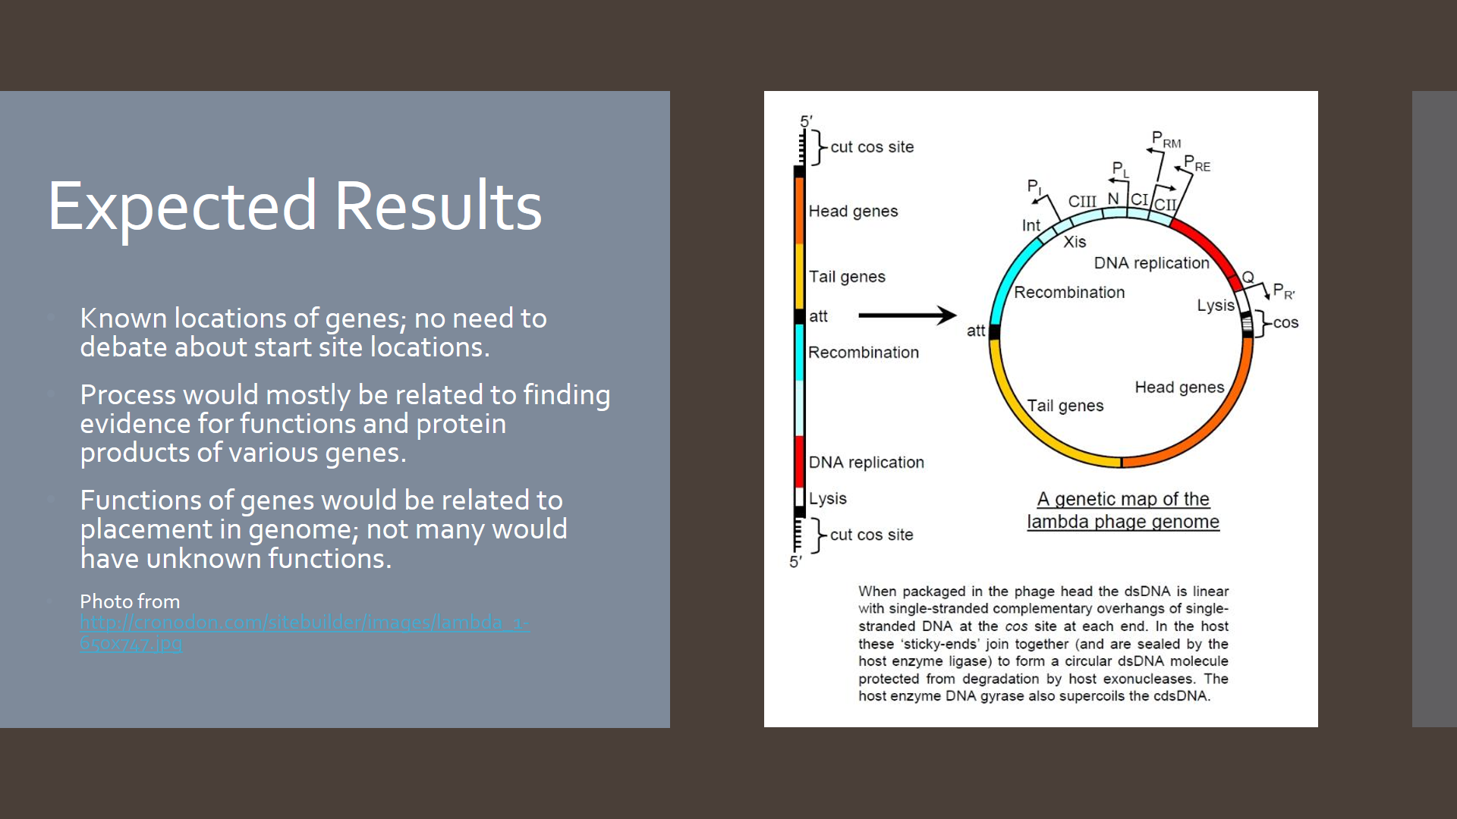
* ***Provide one visual*** to briefly summarize your actual results from your project thus far, highlighting the result that you feel is most noteworthy----perhaps it is the result that you did not expect or perhaps it closely matches the expected results. The story that you want to tell is your choice but it must be supported by the data and evidence you have gathered from either your literature review, your in-silico discovery using bioinformatics tools, or both.
  + 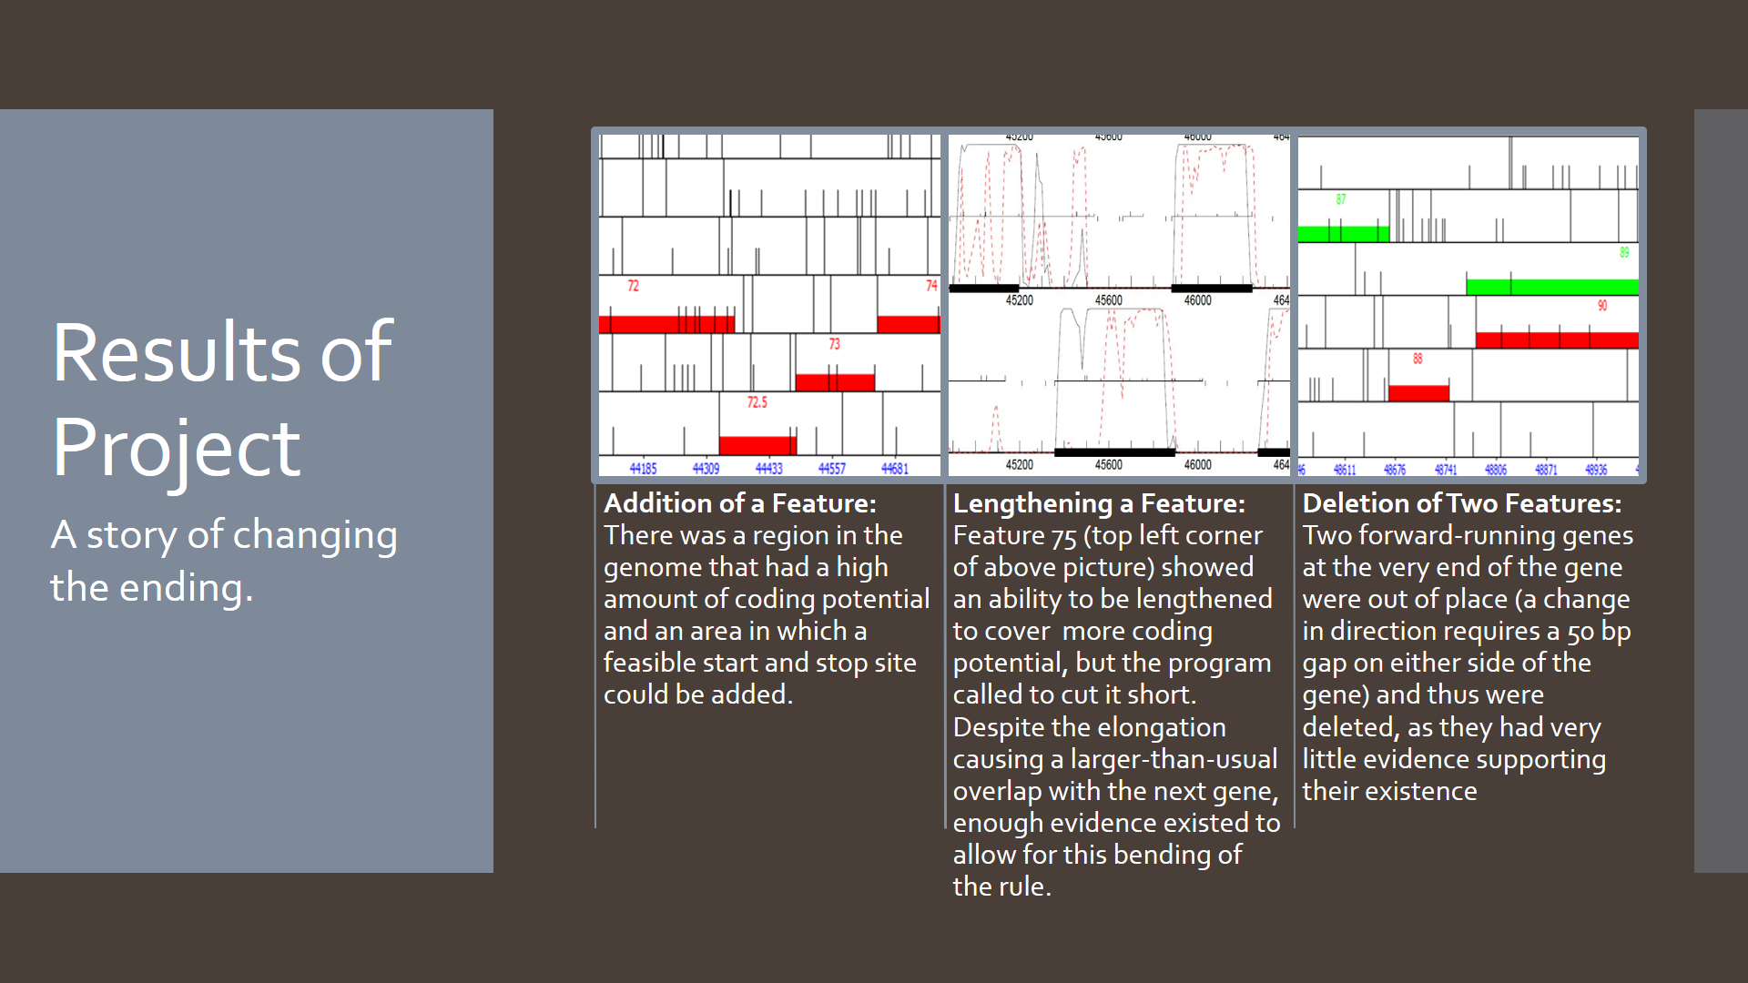

In addition to the two figures provided above, you should ***prepare a draft of a genome announcement for your phage*** in order to help guide you in writing the story based upon your data from this semester for both your poster presentation and final research paper.

The genome announcement should be adapted from the format of the genome announcements published by the American Society of Microbiology (<http://genomea.asm.org/> ) and author guidelines found here: <http://genomea.asm.org/site/misc/authors.xhtml> .

In addition, several genome announcements have been published by the SEA Phages community and are listed on the phagesdb website here: <http://phagesdb.org/publications/>

**Abstract:** Mycobacteriophage JewelBug is a phage isolated from a soil sample in West Lafayette, IN, using Mycobacterium smegmatis mc2155 as a host. JewelBug’s genome is 50,341 bp long. The section from 40900 bp to 50341 bp contains 25 protein-coding genes, eight of which have predicted functions. JewelBug shares a strong similarity in nucleotide sequence with phages of cluster A, subcluster A6.

The SEA-PHAGES project is an international effort furthering the field of genetics by discovering and determining the function of novel genes from mycobacteriophage. Research through this project aims to produce an annotated genome of a newly isolated species of mycobacteriophage to add to the database of phages and genes. Because a mycobacteriophage’s bacterium host, *M. smegmatis*, is closely related to *Mycobacterium tuberculosis*, the project contributes to the understanding of genetics of infectious diseases with potential applications in fighting antibacterial resistance and genetic engineering.

Mycobacteriophage JewelBug was found in 2012 approximately 24 centimeters below the surface in mildly wet and clumpy soil sample in West Lafayette, IN (40.42208 N, 86.917246 W). Through wet lab procedures such as plaque purification, amplification, and DNA isolation, the phage was characterized. The plaques are cloudy and approximately 0.5 to 1 centimeter in diameter. The Purdue Genomics Facility then sequenced the genome using Illumina Sequencing. The JewelBug GC Content is 61.6%. JewelBug has a siphoviridae morphology.

Glimmer and GeneMark were used to generate an auto-annotation of the JewelBug genome of length 50,341 bp with 10 bp overhang, which was then refined by careful manual inspection. Originally, a total of 24 open reading frames were identified in the section 40900 bp to 50341 bp, but after manual inspection, two deletions and one addition of features were made, bringing the final total to 23 genes. These features were read in the backward direction in the complementary strand. The start codon frequencies were as follows: 8.7% for TTG, 37.1% for ATG, and 52.5% for GTG, which was very similar to the general guidelines for start codon frequencies. BLASTing the genome showed that JewelBug is closely related to phages VohminGhazi, Isiphiwo, McFly, Kazan, CloudWang9, and Artemis2UCLA, placing JewelBug in cluster A, subcluster A6.

The JewelBug genome sequence has yet to be submitted to GenBank.