Autonomous EV Corridor & Leisure Charging System
Production Microservices Architecture, OpenStreetMap Corridor Intelligence & Indian UPI/GST Payment Ecosystem
Project Architecture: | 10 Decoupled Node.js Microservices + MongoDB + React 18 SPA
Orchestration Platforms: | Docker Compose & Kubernetes (17 Manifests + HPA Autoscaling)
Mapping & Geocoding: | OpenStreetMap (OSM) Standard Tiles + Leaflet + Nominatim
Deployment Status: | 100% Live & Synchronized (Commit 2478adc / ea06696)

1. Executive Summary & Core Innovation
Electric Vehicle (EV) adoption across inter-city corridors faces a fundamental psychological bottleneck: Charging Anxiety and Idle Time Fatigue. Contemporary charging applications (such as Tata Power EZ Charge and PlugShare) treat charging as an isolated chore, directing vehicles to highway petrol pumps where drivers sit idle for 40 to 60 minutes.
Our system pioneers Smart Leisure Corridor Charging. By integrating open-source OpenStreetMap (OSM) cartography and multi-variable detour optimization, the platform detects high-speed DC charging stations situated along the travel corridor that are in direct walking proximity to cultural landmarks, heritage monuments, and recreation spots. For instance, on the Mehsana to Patan highway corridor, the system routes the vehicle to the Modhera Sun Temple Solar EV Hub, synchronizing a 42-minute fast-charging cycle with a 45-minute walking tour of the 11th-century Sun Temple & Surya Kund.

2. Team Work Division & Ownership Matrix
To ensure modularity and industrial-grade team collaboration, the project engineering was segmented across three specialized roles:
Team Member | Assigned Domain | Key Deliverables & Responsibilities
Person 1  (Product & Operations) | User Experience, Vehicle Telemetry & History Flow | • Comprehensive problem formulation and user requirement analysis.  • Vehicle management lifecycle (SoC tracking, battery kWh capacity, connector types).  • Dashboard telemetry gauges, user notifications, and session history views.  • Testing end-to-end driver booking experience.
Person 2  (Web, Docker & Map) | Frontend Architecture, Docker Compose & OpenStreetMap | • React 18 SPA architecture with Vite build pipeline and responsive styling.  • Multi-container Docker orchestration (docker-compose.yml, custom Dockerfiles).  • Open-source OpenStreetMap integration via Leaflet (zero vendor lock-in or API keys).  • Custom map marker components, polylines, and dynamic coordinate fitting.
Person 3  (Backend, AI & Cloud) | 10 Microservices, Corridor Scoring Engine, Payments & K8s | • Engineered 10 decoupled Node.js microservices and API Gateway rate-limiting.  • Designed Corridor & Leisure Recommendation Algorithm (Haversine + POI synergy).  • Atomic MongoDB slot concurrency locks (prevention of double-booking races).  • Indian payment engine: Dynamic UPI QR generation, 18% GST tax invoices.  • 17 Kubernetes production manifests with Horizontal Pod Autoscaling (HPA).

3. Docker Containerization & Live Container Status
The entire platform is fully containerized using Docker and Docker Compose. Each microservice is packaged with its own isolated Node.js environment, environment variables, and dependencies, communicating over a shared internal bridge network (ev-network).
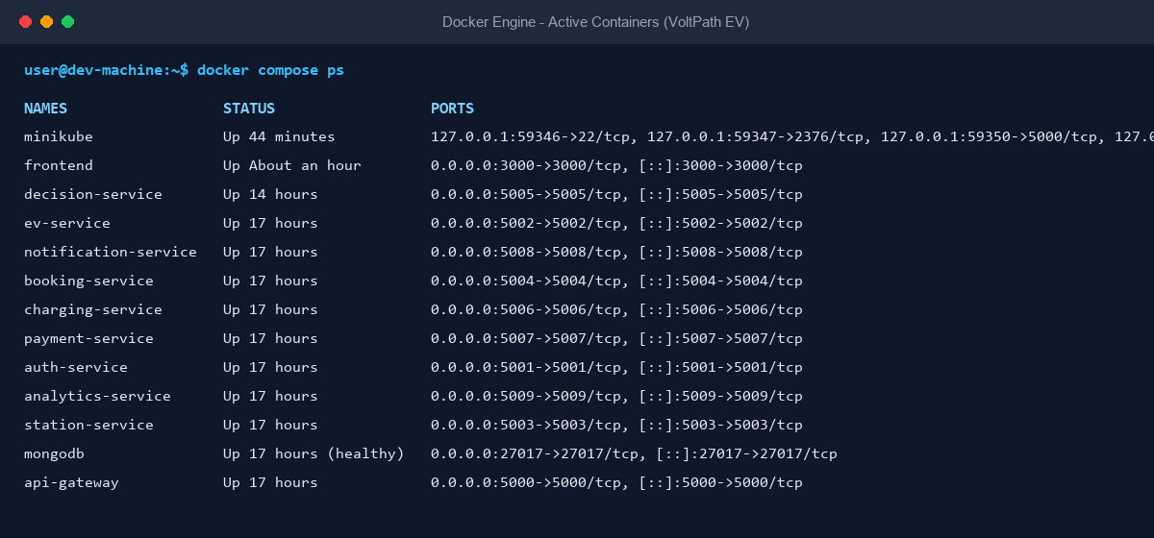
Figure 1: Live Docker Engine Terminal Output - All 11 Microservices & Database Containers Up and Healthy
As verified above, the local Docker environment runs 11 dedicated service containers and a healthy MongoDB replica instance. The frontend container operates a unified internal reverse proxy on port 3000, seamlessly forwarding /api requests directly to the API Gateway (port 5000), eliminating CORS and allowing seamless multi-device testing over Wi-Fi.

4. Microservices Matrix & Inter-Service Security
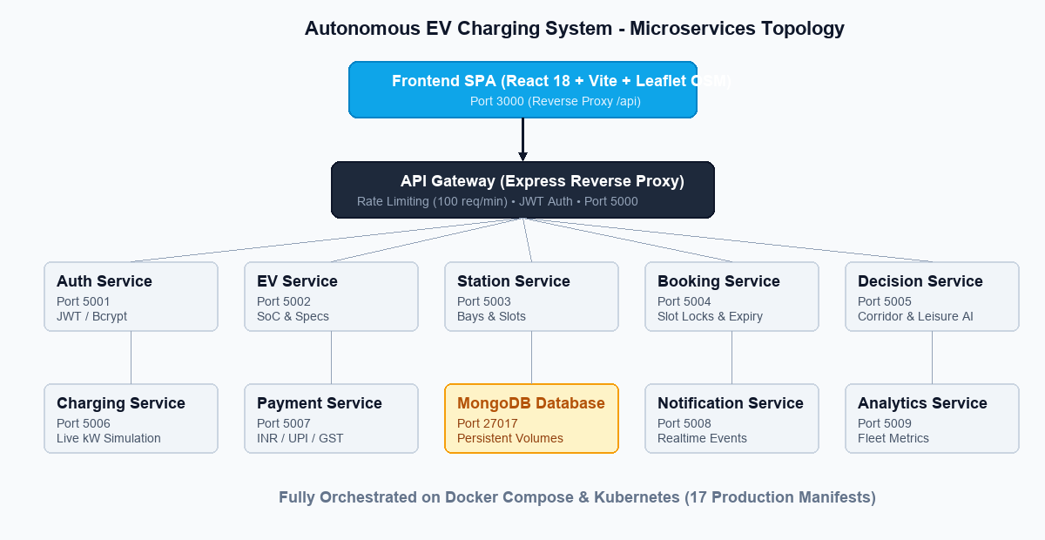
Figure 2: Cloud-Native Microservices Topology and Inter-Service Security Boundary
Microservice | Internal Port | Database Model | Primary Responsibility
api-gateway | 5000 | Stateless | Central entry point, IP rate limiting (100 req/min), CORS handling, reverse proxy routing.
auth-service | 5001 | User | JWT authentication (24h expiry), Bcrypt password hashing, role-based authorization.
ev-service | 5002 | EV | Vehicle registry, battery capacity (kWh), current SoC (%), max charging power (kW).
station-service | 5003 | Station, Slot | Charging hub registry, bay availability tracking (FREE, RESERVED, OCCUPIED).
booking-service | 5004 | Booking | Slot reservations, atomic locking, automated 15-minute unpaid expiry cron sweeps.
decision-service | 5005 | Stateless / Cache | Corridor routing intelligence, Haversine detour scoring, OpenStreetMap POI matching.
charging-service | 5006 | ChargingSession | Live charging session telemetry, real-time kW speed, SoC curves, stop triggers.
payment-service | 5007 | Payment | INR currency transactions, UPI QR code simulator, 18% GST tax invoice generation.
notification-service | 5008 | Notification | In-app notification dispatching for booking confirmations and charging milestones.
analytics-service | 5009 | Aggregates | Fleet analytics, station utilization rates, total energy delivered, revenue reports.
mongodb | 27017 | Multi-Collection | Persistent MongoDB document store with indexed query constraints.

5. Corridor Recommendation & Leisure Algorithm
The Decision Engine (decision-service) computes an optimized travel utility score using multi-criteria mathematical weighting:
Total Corridor Score = (0.25 × S_detour) + (0.25 × S_leisure) + (0.20 × S_queue) + (0.15 × S_speed) + (0.15 × S_price) + Bonus_midway
1. Detour Penalty (S_detour): Given Origin A, Destination B, and Station S, the detour is (d(A,S) + d(S,B)) - d(A,B). Stations exceeding the user's max detour threshold (default 25 km) are automatically filtered out.
2. Leisure Synergy (S_leisure): OpenStreetMap heritage tags (historic=monument, heritage=unesco) are evaluated. If a landmark is within walking distance (<1 km), +20 points are awarded. If charging duration matches recommended tour duration (±20 mins), a +10 point synchronization synergy is added.
3. Midway En-Route Bonus: Stations positioned between 15% and 85% of the total corridor receive a +25 point bonus, prioritizing in-journey charging over destination parking, eliminating mid-route battery depletion.
Real-World Benchmark: Mehsana to Patan Corridor
• Departure: Mehsana Highway Bypass (23.5880° N, 72.3693° E)
• Destination: Patan Historic Center (23.8584° N, 72.1017° E)
• Top Recommendation: Modhera Sun Temple Solar EV Hub (60 kW DC Fast, 6 Free Bays, ₹11/kWh)
• Detour: Only +14.2 km off State Highway 55
• Tourist Pairing: Modhera Sun Temple & Surya Kund (350m walk from charger, UNESCO candidate, India's 1st 24x7 solar village)
• Time Synchronization: 42-minute vehicle charging cycle ↔ 45-minute architectural temple tour.

6. Indian Localization: INR, UPI & GST Tax Invoicing
To ensure high commercial viability in the domestic market, the system features end-to-end Indian financial compliance:
• Native Rupee Currency: All rates, sessions, and invoices operate strictly in INR (₹).
• Dynamic UPI QR Checkout: Generates live UPI intent strings (e.g. upi://pay?pa=voltpath.ev@icici&am=462.00) compatible with Google Pay, PhonePe, Paytm, and BHIM.
• 18% GST Compliance: Implements standard Ministry of Power guidelines, splitting tax into 9% CGST and 9% SGST with official SAC Code 998714 (Electric Vehicle Charging Infrastructure Services).

7. Kubernetes Production Architecture
The repository contains 17 enterprise-ready Kubernetes YAML manifests under infra/kubernetes/, ensuring cloud-agnostic portability across Minikube, Google Cloud GKE, Amazon EKS, and Azure AKS:
1. Horizontal Pod Autoscaling (HPA): Configured to dynamically autoscale decision-service and booking-service from 2 to 5 pods when CPU utilization breaches 70%.
2. Stateful Database Topology: MongoDB is deployed as a StatefulSet backed by a 5Gi Persistent Volume Claim (PVC), guaranteeing zero data loss across pod restarts.
3. Health Probes: Every microservice contains configured livenessProbe and readinessProbe endpoints querying /health every 10 seconds.
4. Deployment Scripts: Automated deployment (scripts/deploy-minikube.ps1) and teardown scripts (scripts/teardown-minikube.ps1) provide 1-click cloud orchestration.

8. Frontend UI & OpenStreetMap Visual Showcase
The web application features an interactive corridor planner powered by React 18, Vite, and Leaflet OpenStreetMap. Drivers can select origins and destinations using one-click preset chips, live GPS location, or text search. The system plots the route polyline, displays candidate charging stops, and renders a rich leisure recommendation card:
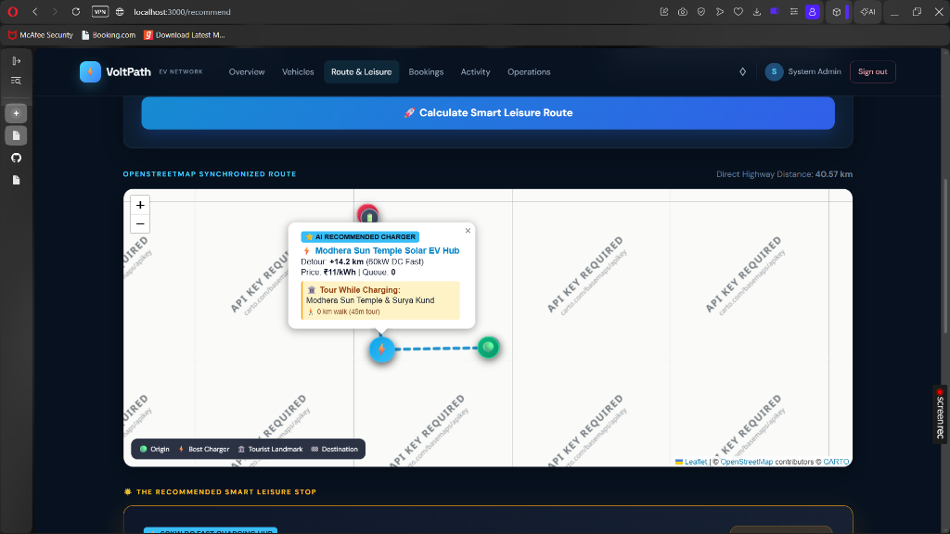
Figure 3: Live Application UI - OpenStreetMap Highway Corridor & Modhera Sun Temple Recommendation Popup
As seen above, the user is presented with the exact detour (+14.2 km), high-speed DC charging specifications (60 kW), available bays, and a direct walk-to-tour link to the historic Modhera Sun Temple & Surya Kund.

