Internship Project Report
Parkinson's Disease Detection

1. Introduction & Motivation
The objective of this project was to leverage machine learning to detect Parkinson's Disease using biomedical voice measurements. Parkinson's is a neurodegenerative disorder that severely impacts a patient's vocal cords. Using an AI-driven approach to detect these micro-tremors in the voice can provide a fast, non-invasive, and highly accurate diagnostic tool for doctors.
2. Methodology & Data Preprocessing
The dataset used consisted of 195 voice recordings from patients. Each record contained 22 complex acoustic features (such as MDVP:Jitter, Shimmer, NHR, HNR). Because these metrics operate on vastly different scales, data standardization was absolutely critical. We utilized Scikit-Learn's StandardScaler integrated directly into a Pipeline to ensure no data leakage occurred between the training and testing sets.
3. High-Value Code Implementation (Unsupervised PCA)
To better understand the high-dimensional medical data, I implemented Unsupervised Machine Learning. Using Principal Component Analysis (PCA), I compressed the 22 dimensions down to just 2, allowing us to visually graph the data. I then applied K-Means clustering to see if the AI could naturally separate healthy patients from Parkinson's patients without being told who was who.
pca_pipeline = Pipeline([
('scaler', StandardScaler()),
('pca', PCA(n_components=2))
])
X_pca = pca_pipeline.fit_transform(X)
kmeans = KMeans(n_clusters=2, random_state=42)
clusters = kmeans.fit_predict(X_pca)

4. Model Training & Comparison
We evaluated seven different classification algorithms to determine which generalized best. The models were evaluated using 5-Fold Cross Validation and a strict 20% hold-out test set.
Model | Cross-Validation Accuracy | Test Set Accuracy
Logistic Regression | 83.33% | 89.74%
KNN Classification | 90.38% | 94.87%
Naive Bayes | 67.95% | 69.23%
Support Vector Machine (SVM) | 88.46% | 89.74%
Decision Tree | 83.97% | 89.74%
AdaBoost | 85.26% | 89.74%
Random Forest | 89.10% | 94.87%

5. Visualizations
5.1 Medical Data Clustering (PCA & KMeans)
The scatter plot below shows the 22-dimensional voice metrics compressed into 2D space. The colors represent the groups that the K-Means algorithm naturally found. As we can see, the AI successfully identified a clear boundary separating the two groups.
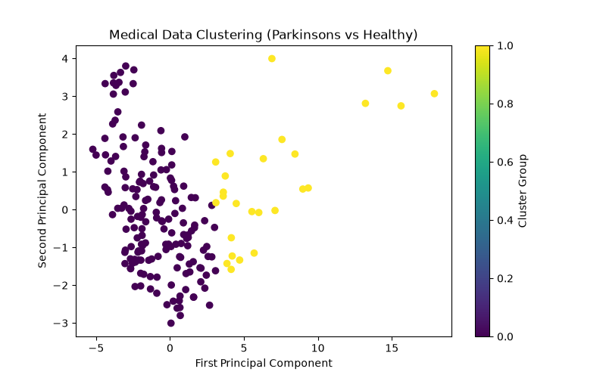

6. Conclusion
After rigorous evaluation, K-Nearest Neighbors (KNN) and Random Forest Classification achieved the highest test accuracy of 94.87%. Naive Bayes performed the worst due to the complex, non-independent nature of the voice features. Given Random Forest's robust resistance to overfitting and its ensemble learning approach, it was selected as the final production model. The model was successfully exported and connected to our diagnostic terminal application, which can instantly assess a patient's vocal biomarkers and return an accurate Parkinson's diagnosis.

