Graphing Lab - 50 points

Objective: Learn how to:
- Read different types of graphs
- Organize data into a data table and graph using Google Sheets

Background: Data tables and graphing are used by scientists to display the data that is collected during a controlled experiment. A graph must be constructed to accurately depict the data collected. An incorrect graph often leads to the acceptance of an incorrect hypothesis or detract from the acceptance of a correct hypothesis.

The graph should contain 4 major parts: the title, the independent variable, the dependent variable, and
the units for each variable.
- The Title: this shows what the graph is about. Reading the title should give the reader an idea about the variables displayed on the graph. It should be a concise statement placed above the graph. It should be a relationship or a comparison.
- The Independent Variable: this is the variable that can be changed or manipulated by the experimenter. This variable should be placed on the horizontal or x-axis.
- The Dependent Variable: this is the variable directly affected by the independent variable. It is the result of what happens. This variable should be placed on the vertical or y-axis.
- Units: should be in parenthesis next to your independent and dependent variables

How do I know what type of graph to use?
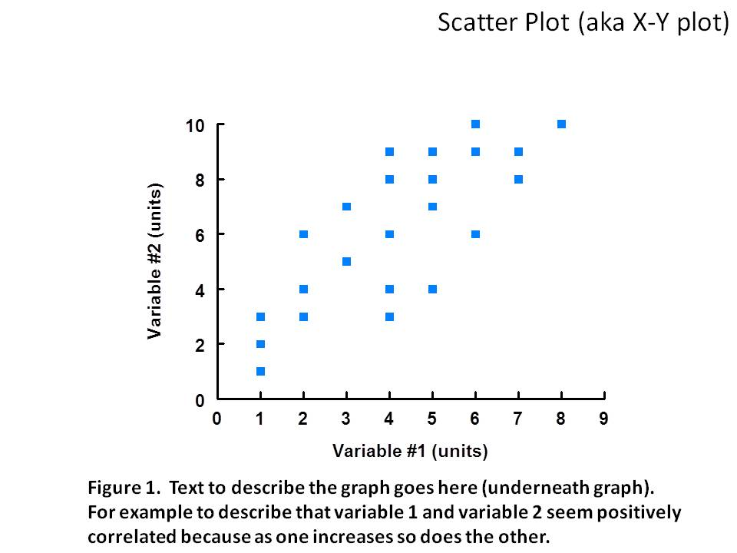
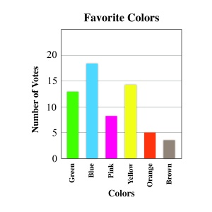
→ X-Y Scatter Plot: The most common type of graph you will use to graph your data is an x-y scatter plot. X-Y plots are used to determine relationships between the two different variables. If both variables increase at the same time, they have a positive relationship. If one variable decreases while the other increases, they have a negative relationship. If there is a relationship, it may be linear or exponential. Sometimes the variables don't follow any pattern and have no relationship. If the graph is proportional, directly proportional, or inversely proportional be sure to identify it as such.

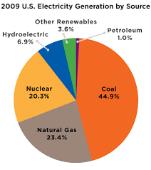
→ Bar Graph: a bar graph is used to compare two or more different groups. They do not show a relationship and do not change over time.

→ Pie Chart: Pie charts are best to use when you are trying to compare parts of a whole. They do not show a relationship and do not change over time.

Instructions: For each of the graphing scenarios below, first create a data table and then a graph using Google sheets, copy it into this assignment, and answer the associated questions. Type your answers to the questions in RED.

*** IMPORTANT ***
When making your data tables in Google sheets only include the units in the title, NOT after the numbers. If you try to make a graph with units in the data table, you will get a “No Data” error.

____________________________________________________________________________________

Graphing Scenario #1: The data table below shows ocean water temperature at various depths. Graph your data on an X-Y scatter plot and insert the graph next to the data table. When graphing your data, make sure to include a title.

Data Table: |  | Graph:(10 pts)
Water depth (m) | Temperature (ºC)
50 | 18
75 | 15
100 | 12
150 | 5
200 | 4

- Why is the X-Y scatter plot the best choice to graph this data? (2 pts)

- What is the relationship between water depth and temperature? (describe the line) (2 pts)

- The approximate water temperature at a depth of 125 m would be about: (2 pts)

Graphing Scenario #2: A group of students did a beach clean up at Sandys. Of all of the pieces of trash collected, 55% was cigarette butts, 20% was plastic, and 25 % was Styrofoam. Create a data table and a pie chart showing the data.

Data Table: (5 pts) |  | Graph:(10 pts)
Type of trash | Percentage

- Why is the pie chart the best choice to graph this data? (2 pts)

Graphing scenario #3: The population of Oahu is [about] 900,000. Kauai’s population is 58,000. Maui’s is 120,000. Big Island is 150,000. Create a data table and bar/column graph of this data.

Data Table: (5 pts) |  | Graph:(10 pts)

- Why is the bar/column chart the best choice to graph this data? (2 pts)

