I had a student ask, “What, exactly, do I need to turn in for the homework assignments. I said that I’d like to see the R commands, the R output, and a brief commentary. Then I realized that it might be helpful to see a real example. So I made up a simple homework assignment to illustrate what I’m looking for.

Here are the sample homework questions.

1. Read in the data on various body measurements. A description is at

--> http://www.amstat.org/publications/jse/datasets/fat.txt

and the file can be found at

--> http://www.amstat.org/publications/jse/datasets/fat.dat.txt

Display the first few rows and the last few rows of the data.

2. List all of the bmi values.

3. List the last row of the data set only.

4. Calculate a summary for bmi.

5. Draw a histogram for bmi and interpret it.

6. Show the association between age and bmi using a correlation.

Answer to 1.

Here are the R commands to read in the file. [[Switch to a fixed width font like Courier New for R commands and R output.]]

> fn <- "http://www.amstat.org/publications/jse/datasets/fat.dat.txt"

> fd <- read.table(file=fn)

Here are the first few rows of the data set.

> head(fd)

V1 V2 V3 V4 V5 V6 V7 V8 V9 V10 V11 V12 V13

1 1 12.6 12.3 1.0708 23 154.25 67.75 23.7 134.9 36.2 93.1 85.2 94.5

2 2 6.9 6.1 1.0853 22 173.25 72.25 23.4 161.3 38.5 93.6 83.0 98.7

3 3 24.6 25.3 1.0414 22 154.00 66.25 24.7 116.0 34.0 95.8 87.9 99.2

4 4 10.9 10.4 1.0751 26 184.75 72.25 24.9 164.7 37.4 101.8 86.4 101.2

5 5 27.8 28.7 1.0340 24 184.25 71.25 25.6 133.1 34.4 97.3 100.0 101.9

6 6 20.6 20.9 1.0502 24 210.25 74.75 26.5 167.0 39.0 104.5 94.4 107.8

V14 V15 V16 V17 V18 V19

1 59.0 37.3 21.9 32.0 27.4 17.1

2 58.7 37.3 23.4 30.5 28.9 18.2

3 59.6 38.9 24.0 28.8 25.2 16.6

4 60.1 37.3 22.8 32.4 29.4 18.2

5 63.2 42.2 24.0 32.2 27.7 17.7

6 66.0 42.0 25.6 35.7 30.6 18.8

Here are the last few rows of the data set.

> tail(fd)

V1 V2 V3 V4 V5 V6 V7 V8 V9 V10 V11 V12 V13

247 247 29.1 30.2 1.0308 69 215.50 70.50 30.5 152.7 40.8 113.7 107.6 110.0

248 248 11.5 11.0 1.0736 70 134.25 67.00 21.1 118.9 34.9 89.2 83.6 88.8

249 249 32.3 33.6 1.0236 72 201.00 69.75 29.1 136.1 40.9 108.5 105.0 104.5

250 250 28.3 29.3 1.0328 72 186.75 66.00 30.2 133.9 38.9 111.1 111.5 101.7

251 251 25.3 26.0 1.0399 72 190.75 70.50 27.0 142.6 38.9 108.3 101.3 97.8

252 252 30.7 31.9 1.0271 74 207.50 70.00 29.8 143.7 40.8 112.4 108.5 107.1

V14 V15 V16 V17 V18 V19

247 63.3 44.0 22.6 37.5 32.6 18.8

248 49.6 34.8 21.5 25.6 25.7 18.5

249 59.6 40.8 23.2 35.2 28.6 20.1

250 60.3 37.3 21.5 31.3 27.2 18.0

251 56.0 41.6 22.7 30.5 29.4 19.8

252 59.3 42.2 24.6 33.7 30.0 20.9

Answer to 2.

Here are all the bmi values.

> names(fd) <- c("case","fat.b","fat.s","dens","age","wt","ht","bmi","ffw","neck","chest","abdomen","hip","thigh","knee","ankle","biceps","forearm","wrist")

> fd$bmi

[1] 23.7 23.4 24.7 24.9 25.6 26.5 26.2 23.6 24.6 25.8 23.6 26.3 26.3 28.5

[15] 27.4 26.3 27.3 29.2 28.2 27.6 27.3 29.1 21.2 21.4 23.2 21.9 20.3 22.9

[29] 22.4 23.8 23.6 22.2 23.3 30.5 32.2 32.0 29.1 29.7 48.9 31.8 39.1 29.9

[43] 31.2 29.2 19.1 21.3 20.6 20.6 20.4 20.2 21.3 20.6 21.1 19.9 21.1 26.9

[57] 27.6 29.3 28.4 29.2 28.2 26.8 27.6 27.9 29.5 28.3 21.3 21.3 22.8 21.6

[71] 23.1 21.9 20.8 21.5 23.3 22.9 23.7 26.7 23.0 25.1 25.1 23.4 25.3 24.5

[85] 24.7 26.0 24.6 26.0 23.7 23.3 25.4 26.2 23.4 26.3 23.4 26.1 24.8 25.9

[99] 23.7 26.7 25.9 23.6 24.0 25.5 26.0 24.8 26.0 26.0 24.0 24.7 25.6 26.3

[113] 25.6 23.3 24.0 23.4 23.6 24.3 24.6 25.3 26.2 25.5 23.9 23.9 25.6 26.2

[127] 26.4 23.4 25.2 23.9 23.7 24.3 25.8 24.8 24.5 26.8 23.5 24.1 23.3 26.6

[141] 24.6 25.3 25.6 21.6 22.1 21.9 27.7 29.8 19.3 31.8 22.5 30.7 19.7 24.4

[155] 26.1 21.6 30.4 24.6 20.3 24.4 20.4 25.9 24.4 19.8 29.7 28.1 25.3 30.3

[169] 33.3 25.2 23.4 20.6 24.8 24.3 31.0 21.3 23.7 33.2 27.5 29.8 28.0 18.1

[183] 22.7 23.0 21.8 23.1 29.7 28.6 27.0 28.0 22.5 29.8 27.4 28.3 21.6 27.2

[197] 23.1 23.1 22.3 26.4 25.4 22.0 27.6 23.7 32.3 27.6 27.2 26.1 22.9 22.5

[211] 21.4 27.4 23.0 27.4 22.8 37.6 21.6 22.2 27.2 22.7 24.5 31.0 25.0 22.2

[225] 26.8 20.0 25.6 25.3 25.4 25.2 24.1 24.9 24.2 25.2 24.1 26.1 25.8 31.9

[239] 22.6 30.9 20.8 33.9 31.8 30.3 29.9 22.8 30.5 21.1 29.1 30.2 27.0 29.8

Answer to 3.

Here is the last row of the data.

> fd[252, ]

case fat.b fat.s dens age wt ht bmi ffw neck chest abdomen

252 252 30.7 31.9 1.0271 74 207.5 70 29.8 143.7 40.8 112.4 108.5

hip thigh knee ankle biceps forearm wrist

252 107.1 59.3 42.2 24.6 33.7 30 20.9

Answer to 4.

Here is a summary for bmi.

> summary(fd$bmi)

Min. 1st Qu. Median Mean 3rd Qu. Max.

18.10 23.10 25.05 25.44 27.33 48.90

[[NOTE: INTERPRETATION IS IMPORTANT, BOTH HERE AND FOR THE NEXT TWO QUESTIONS. You don’t have to describe every single number, just pick two or three to talk about.]] Rounding to two significant figures, the mean is 25, the range is 18 to 49.

Answer to 5.

Here is a histogram for bmi.

> hist(fd$bmi)

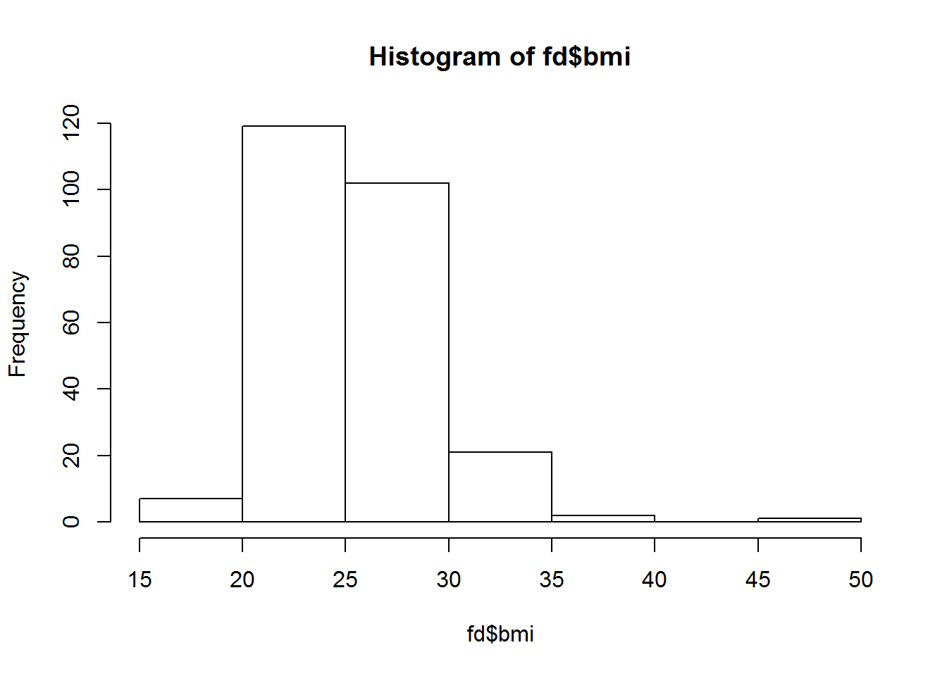The distribution is slightly skewed with a possible outlier between 45 and 50.

Answer to 6.

Here is a correlation between bmi and age.

> cor(fd$bmi, fd$age)

[1] 0.1188513

The correlation is 0.12. There is little or no association between bmi and age.

What you see here is only a suggestion. Feel free to create a format that you like. The three things I am looking for are

a listing of the R commands that you used,

the text or graphical output, and

a brief interpretation.