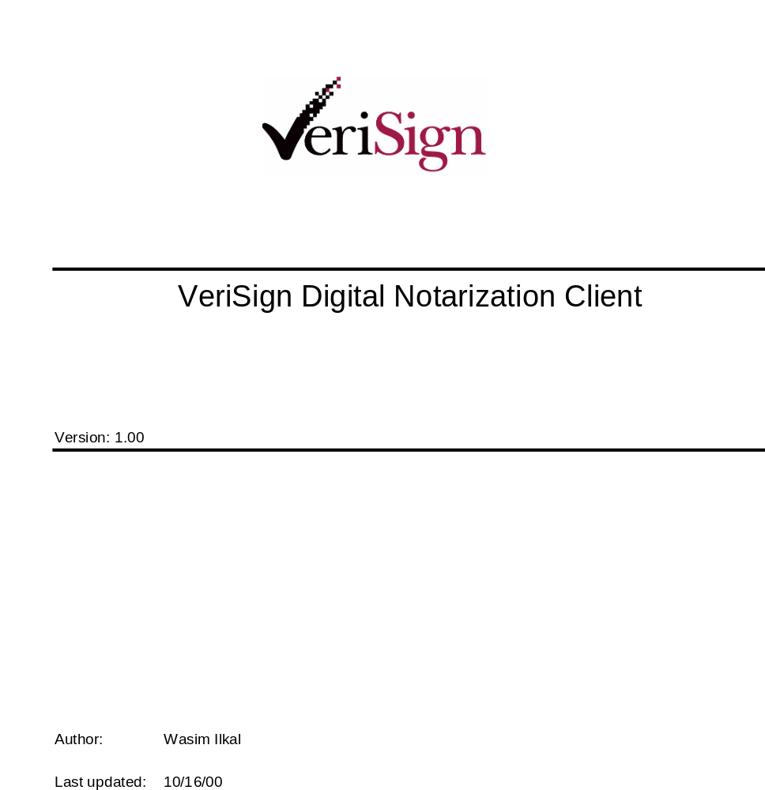

VeriSign Digital Notarization Client
Verisign High-Level Design Document

Version: 1.00

Author: Wasim Ilkal
Last updated: 11/1/2000 07:08:00 PM

© 2000 VeriSign, Inc. All rights reserved.
Printed in the United States of America

Trademark Notices
VeriSign and OnSite are registered trademarks of VeriSign, Inc. The VeriSign logo, VeriSign Trust Network, and Go Secure! are trademarks and service marks of VeriSign Inc. Other trademarks and service marks in this document are the property of their respective owners.
No part of this publication may be reproduced, stored in or introduced into a retrieval system, or transmitted, in any form or by any means (electronic, mechanical, photographic, audio, or otherwise) without prior written permission of VeriSign, Inc.
Change History
Date | Name | Reviewers | Description

Contents
1 Definitions……………………………………………………………………………………………..4
2 Scope…………………………………………………………………………………………………..4
3 High-Level Design…………………………………………………………………………………….4
3.1 Applications……………………………………………………………………………………..6
3.2 Plugin Interface for Netscape browser………………………………………………………..6
3.3 Notarization Client Component………………………………………………………………..6
4 Interaction with PTA………………………………………………………………………………….14
5 Integration with Notarization Web Service…………………………………………………………15
6 User Interface………………………………………………………………………………………….16
7 Receipt Format………………………………………………………………………………………..16
8 External Dependencies……………………………………………………………………………..16
9 Testing………………………………………………………………………………………………..16

Definitions
This section contains definitions of terms and abbreviations in this document.
Term | Definition
URL | Always refers to a fully qualified URL including the protocol type
COM | Component Object Model
PTA | VeriSign’s Personal Trust Agent
Notarization Record | Contains the timestamp server response and any data, which we decide to go into the record. Note - This term is used instead of a ‘receipt’.
Transaction Record | It contains information describing a transaction, e.g. a payment transaction. It can describe other transactions also.

2 Scope
The VeriSign Digital Notarization (timestamping) client is a Windows application that uses VeriSign’s Digital notarization service for timestamping and later verifying transaction records. It exposes an API, which can be used through a Web browser; it also integrates with the Windows shell by providing a right click context menu.
It uses the PTA for performing signatures, verification and in general certificate management. It integrates well with the current Web based notarization service provided by VeriSign. Notarization records generated by the Web based service can be verified by the client and vice versa.

High-Level Design
The following diagram gives a high level view of the major functional modules and their interaction. The main component in the design is the ‘Notarization Client Scriptable Component’. This encapsulates the functionality of the entire client that includes an ActiveX interface, and a Windows shell interface. The diagram is followed by a detailed explanation of each component.

Applications
C/C++/Script Language
Web Browser
Windows Shell

Notarization Client Scriptable Component

Plugin interface for Netscape browser

ActiveX Object
Exposes interfaces required for Notarization, Preference Management and the PTA
Shell Extension (Menu)
Exposes interfaces required for a Context Menu

UI
Registry

Notarization Record
VeriSign’s Digital Notarization Service

  - Applications – As shown in the diagram the Notarization Client component exposes an ActiveX API. This API can be used from script language or from any other COM aware language to perform notarization/verification operations. This particular Notarization Client component also exposes an API, which can be used by the Windows shell.

  - Plugin Interface for Netscape browser – Since Netscape does not support an ActiveX interface
a plugin will be written to wrap all the ActiveX control method. This plugin will internally call the ActiveX control.

  - Notarization Client Component – This is a COM module which exposes 5 interfaces, IVSNotarize, IVSPTA, IVSNotarizeUIPref, IVSNotarizeAppPref and IContextMenu. The IVSPTA interface is the existing PTA interface, the IContextMenu is the standard Windows interface for a context menu, the other interfaces are for performing notarization/verification functionality and for setting application and user interface preferences.

IVSNotarize IVSNzUIPref IVSNzAppPref IContextMenu IVSPTA

Notarization Client ActiveX control
PTA

This diagram shows the various interfaces exposed by the ActiveX control. These are described in detail below.

IVSNotarize interface : This is the primary interface exposed by the COM module. This interface contains functions, which allow digital notarization of documents and verification of corresponding notarization records. It also has functions, which allow access to the secondary interfaces. The following methods and properties are provided as part of this interface –
Methods -
- HRESULT Initialize()
Return Value – a code indicating the result of the operation.
Working – this method initializes the control. This method must be called before
calling any other ActiveX method/property else an error will be returned.

- HRESULT Close()
Return Value – a code indicating the result of the operation.
Working – this method un-initializes the control by resetting the state information. The
state information includes which server the client is connecting to, what is
the hashing algorithm etc. If Close() is called then Initialize() must be called
again, else any method that is called will give an error.

- HRESULT NotarizeDocument(STRING Document, WORD UIMask, WORD
DWORD Response Type, STRING Response)
I/P Parameter :
Document – is the complete path of the document to be digitally notarized. A
document could be a file or it could be a transaction record or any data
that needs to be notarized. This is in the form of a URL. Only the ‘file://’
will be supported in this version. If this parameter is NULL then this
method will prompt the user to enter the document path.
UIMask – this is a bit mask that determines if/what user interface is shown to indicate
the progress of the method. This could take values such as; show no UI,
show a progress bar, show completion UI etc
Response Type – this indicates what should be the format of the response returned by
the last parameter. The response could be the response that is
returned by the timestamp server, or it could be a Notarization
Record constructed from the timestamp server response. In either
case the ‘Response’ would be base64 encoded.
O/P Parameter:
Response – is the base64 encoded response.
Return Value – a code indicating the result of the operation.
Working – this function creates the hash of the ‘Document’, generates a timestamp
request and creates an attached signature of the request. If submits (http post)
the request to the notarization web server. The certificate selection and
signature operations are performed by the PTA. Certificate selection is
constrained by whatever criteria is set before calling this method. If necessary
the user will be prompted to select a certificate. This function assumes that the
user has set the timestamp server URL, hashing algorithm, roaming preferences
if applicable etc. The ‘UIMask’ is provided so that the user can be given
feedback about the progress of the operation. This progress is shown by means
of a progress indicator. The end of operation can be indicated by this function
or by the calling function depending on the ‘UIMask’.
Note : The certificate, which is used to perform the signature, should be recognized by the
timestamp server

- HRESULT VerifyNotarizationRecord(STRING Notarization Record, DWORD
Record Type, BOOL ui)
I/P Parameter :
Notarization Record – is either the complete URL of the file in which the notarization
record is present (currently only file:// is supported) or is a
string which contains the record. If the record is a string then it
should be base64 encoded.
Record Type – indicates whether the first parameter is a URL or the record itself.
ui – is a flag that indicates if a user interface will be shown after a verification has
been done. This ui will contain details regarding the verification and validity of
the notarization record. Before the ui is displayed the user should set the ui
preferences as described later using the IVSNotarizeUIPref interface.
Return Value – a code indicating the result of the operation.
Working – this function interprets the notarization record and verifies that the
notarization server response that is contained in the record is valid, it also
verifies that the original transaction record that was notarized has not been
modified.

Properties -
- NotarizationServer(STRING Notarization server)
Type – Set property
I/P Parameter :
Notarization server – is the notarization server URL to which the notarization
request will be submitted. E.g. for the VeriSign’s
notarization service this would be
http://notarization.verisign.com/timestamp/getstamp
Working – this function sets the notarization server. This function should be called
before notarizing a document.

- HashAlg(STRING Hash Algorithm)
Type – Set property
I/P Parameter :
Hash Algorithm - the hash algorithm that will be used to hash the transaction record.
Working – this function sets the hash algorithm, which should be used, for hashing the transaction record. While generating a notarization request the entire transaction record is not sent to the notarization server. A hash of the record is sent. This is one of the functions that should be called before notarizing a document.

- DisplayDigitalID(WORD Display Flag)
Type – Set property
I/P Parameter :
Display Flag – a value indicating whether the digital id used for signing the
notarization request is displayed during the signature operation.
Working – this option is provided so that the flexibility is there to either display or hide
the certificate which is used for signing. The end user may or may not want to
see the certificate.

- VerificationPreference(WORD Preference Type)
Type – Set property
I/P Parameter :
Preference Type – can be one of OCSP/CRL/NONE.
Working – this function sets the method of verifying the notarization sever signature
while verifying the notarization record. A chain verification of the server signature can be done using different protocols, or a chain verification need not be done if desired. This function should be called before verifying a notarization record.

- IVNzVSPta(INTERFACE PTA)
Type – Get property
O/P Parameter :
PTA – is a pointer to the PTA interface.
Return Value – a code indicating the result of the operation.
Working – this function returns a pointer to the VeriSign Personal Trust Agent. The
notarization client component exposes the PTA interface so that the user of the API can work with one object instead of two (PTA and Notarization client). This also reduces the number of forwarding interfaces that the Notarization Client Component may have to expose. E.g. if the user wants to set a certificate selection criteria then the Notarization Component will have to provide a method for this, this method in turn would call the PTA to set a search criteria. This is explained in more detail in the section describing the interaction with the PTA.

- INzAppPref(INTERFACE Application Preference)
Type – Get property
O/P Parameter :
Application Preference – is a pointer to the application preferences interface.
Return Value – a code indicating the result of the operation.
Working – the application preference interface allows setting of application settings in
the registry. These are explained in detail in the section which describes the
Application Preference Interface.

- INzUIPref(INTERFACE UserInterface Preferences)
Type – Get property
O/P Parameter :
UserInterface Preferences – is a pointer to the user interface preferences interface.
Return Value – a code indicating the result of the operation.
Working – this interface allows setting of user visible settings.

PTA Interface : The PTA interface is described in detail in the PTA client document. This interface can be obtained from the IVSNotarize interface using the IVSPta() property.

Application Preference Interface : The application preference interface manages application settings. This interface can be obtained from the IVSNotarize interface using the INzAppPref() property. Application preferences is a generic way to set application settings in the Windows registry. In case of the notarization client this interface is used to set notarization specific settings in the registry. These settings are then used by an application, in our case the Windows shell extension to initialize itself.
Note – the registry settings are for use by an application, the settings should NOT be used when using the ActiveX methods from a browser.
The following methods/properties are provided as part of this interface –
Methods -
- HRESULT SetApplicationPreference(STRING Application Name, STRING
Preference Name, VAIANT Preference Value)
I/P Parameter :
Application Name – this is the application for which the preference has to be set. It
identifies the registry key under which the setting will be kept.
E.g. for the notarization shell application if will be
‘Notarization’. This parameter has been provided so that any
application setting can be set in a generic way.
Preference Name – this is the name of the preference to be set. E.g. for the
notarization shell application the preference name could be the
‘Notarization server’, ‘Hash alg’, ‘Verification preference’,
‘Application Name’, ‘Crypto mode’ , ‘Roaming Mode’, ‘Display
Certificate’ etc.
Preference Value – this is the value for the preference.
Return Value – a code indicating the result of the operation.
Working – this is a generic function for setting application preferences. If the
‘Application type’ is ‘Notarization’ then the registry key under which the
preferences would be saved is ‘MyComputer \ HKEY_CURRENT_USER \
Software \ VeriSign, Inc \ Notarization’. This function can be used by a web
page to set application preferences in the registry. In the notarization shell
extension case we can have a web-pages which uses this function to set
appropriate settings so that the Windows shell extension can initialize itself
appropriately. This can happen when the client is being downloaded or at any
later time.

- HRESULT GetApplicationPreference(STRING Application Name, STRING
Preference Name, VARIANT Preference Value)
I/P Parameter :
Application Name – this is the application for which the preference has to be
obtained. It identifies the registry key under which the setting
will be kept. E.g. for the notarization shell application if will be
‘Notarization’. This parameter has been provided so that any
application setting can be obtained in a generic way.
Preference Name – this is the name of the preference to be obtained. E.g. for the
notarization shell application the preference type could be the
‘Notarization server’, ‘Hash alg’, ‘Verification preference’,
‘Application Name’, ‘Crypto mode’ , ‘Roaming Mode’, ‘Display
Certificate’ etc.
O/P Parameter :
Preference Value – this is the value for the preference.
Return Value – a code indicating the result of the operation.
Working – this is a generic function for getting application preferences. If the
‘Application type’ is ‘Notarization’ then the registry key from where the
preferences would be obtained is ‘MyComputer \ HKEY_CURRENT_USER
\ Software \ VeriSign, Inc \ Notarization’. This function can be used by a web
page to get application preferences from the registry.

User Interface preferences interface : The user interface (UI) preferences interface is
used to set the UI settings for the dialog that will be displayed after a notarization record
is verified. A web-page may display a dialog after verification, in this case the dialog box
will be customized depending on the settings. The properties which can be set include the
title of the dialog, the logo that appears on the dialog, the text which describes the
file/transaction that was notarized etc.
The UI will consist of a dialog similar to the PTA. It will consists of two part, one will
describe the notarization record (receipt) and the other will describe the validity of the
record. If the document that was notarized was a text document then it will be displayed
else the URL for the document will be displayed.

The following methods/properties are provided as part of this interface –
Properties –
- UILogoURL(STRING LogoURL)
Type – Set property
I/P Parameter :
LogoURL – the fully qualified URL for the logo to be displayed on the dialog
Working – this sets the logo URL for the dialog box. This logo will be displayed on the
dialog. This function will cache the logo on the user machine so that everytime
the dialog is displayed it will not be obtained form the server.

- UITitle(STRING Title)
Type – Set property
I/P Parameter :
Title – is the title on the dialog box.
Working – sets the title that will be displayed on the dialog box.

- UIDescription(STRING Description)
Type – Set property
I/P Parameter :
Description – the string that describes what was notarized, a file or a transaction.
Working – this string will be of the form “The file %s was digitally notarized by ….”. The ‘%s’ is a replacement text that will be filled in from the information in the receipt file. The string can be anything, but it should have a placeholder that will be filled in by the program.

- UIHelpURL(STRING HelpURL)
Type – Set property
I/P Parameter :
HelpURL : is the URL where the HTML help pages for the product will be present.
Working – when the user clicks on the help button he will taken to a web-page which
will describe the working of the notarization process. This location can be set
using this property.

Shell Extension Interface : The Notarization Client Component not only provides an ActiveX interface but also a Windows Context Menu interface which provided a right click menu option for notarizing documents. This is a standard windows interface (IContextMenu), for more details refer to the Windows help.
The shell extension uses the settings in the registry to initialize itself. These settings
should be set using the INzAppPref interface.

Interaction with PTA

The PTA is an important component in the working of the Notarization Client component. It provides functionality for certificate management, preference management, user interface settings and cryptographic operations.
The PTA control can be used independently of the Notarization client component. This however has some issues like -
- A web page will have to deal with 2 control instead of one, i.e. do a CreateOject() for PTA and CreateObject() for Notarization.
- The Notarization client component may have to expose some methods that just end up calling methods in the PTA. This leads to repetition of interfaces.
To overcome these drawbacks the Notarization component can reuse the PTA control by means of a COM mechanism called Containment or Aggregation. In this method the Notarization component would internally do a CreateObject() of the PTA and expose this interface as if it were its own.

Notarization interfaces… IVSPA

Notarization Component ddd

PTA Component

Reuse of the PTA component through Containment or Aggregation.

Integration with Notarization Web Service

This section assumes that a compatible Notarization record (Receipt) is generated by the Notarization Web service and the Notarization Client component. Since the client component has an ActiveX interface, it can be scripted to create notarization requests and verify notarization records. To achieve this the existing Notarization service web pages have to be enabled for downloading of the client component and having the necessary script in the pages.
Currently the Web interaction is that the user selects a file and the file is uploaded to the Web server to do the notarization operations. With the client integrated approach the file need not be uploaded to the server. This is true of the verification process as well.
The following is an example of what the script might look like for a notarization operation:
NzObject = CreateObject(Notarization Component)
NzObject.Initialize()
// Use NzObject to set preferences like notarization server, hash algorithm,
// certificate, etc,
NzObject.CreateNotarizationRequest(….)
NzObject.SendNotarizatioRequest(…)
NzObject.CreateDigitalReceipt(…)
…
…
NzObject.Close()

The integration can also involve using the PTA to logon to the notarization server. To achieve this web pages will have to be developed to do PTA based client authentication and the web server will have to use the PTA server plugin. The current authentication mechanism is based on SSL client authentication via the web browser.

User Interface
The user interface (UI) will be a simple dialog based interface similar to the PTA dialogs. It will have some features to customize the interface through the IVSNotarizeUIPref interface described earlier. The UI will be invoked when a notarization record (receipt file) is double clicked from the Windows shell. The UI will show the details that are present in the record like, time when record was generated, a URL to the file/transaction that was notarized and whether the file/transaction has been modified after obtaining the notarization record.
This UI can also be invoked from the web-page which is setup to verify a notarization record depending on the settings which are set on that page.

Receipt Format
The Receipt format is to be decided.

8 External Dependencies
The Client depends on the functionality of various software modules. These are
- PTA – Is used to perform cryptographic operations like signing, verification. It is
also used to do certificate lifecycle management, like determining which certificate to select, has the certificate expired etc.
- BSafeLite – Is used to generate a random number which is used as a nonce while submitting
the timestamping request. Use of a nonce avoids server replay attacks.
- Simder – Is used for the ASN.1 encoding/decoding of the timestamp request/response.

9 Testing

