Make sure to orientate the cables correctly. If the cables are reversed it will damage your drives and Disk ][ interface card. Disk ][ Drive Select is designed to work with the standard Disk ][ interface card and has been tested with Disk ][ floppy drives and FloppyEmu drives. It can be used to swap two drives on two ports(1-1 and 2-2 / 1-2 and 2-1) or to swap two drives on one port(1-1 / 1-2)

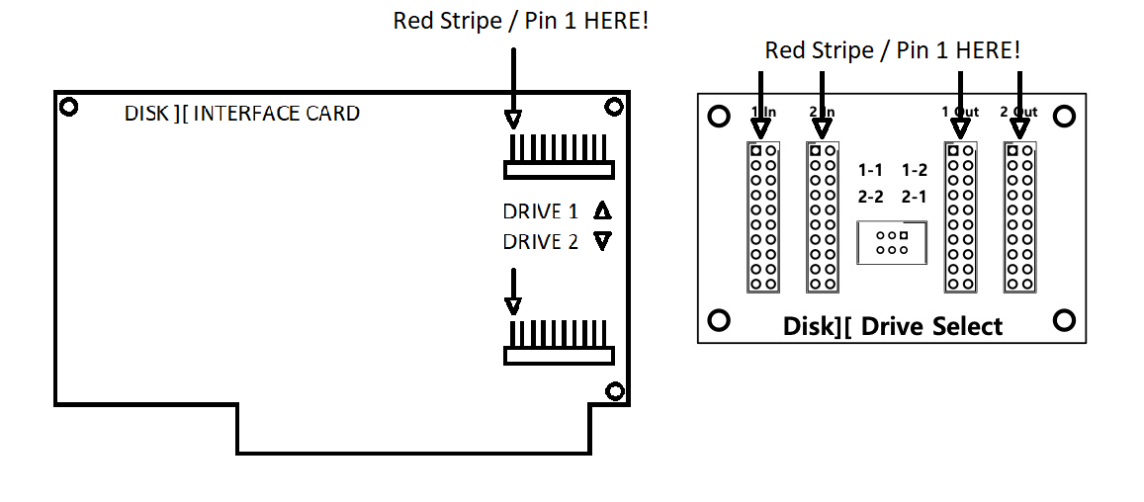

Swap two drives on two ports(1-1 and 2-2 / 1-2 and 2-1)

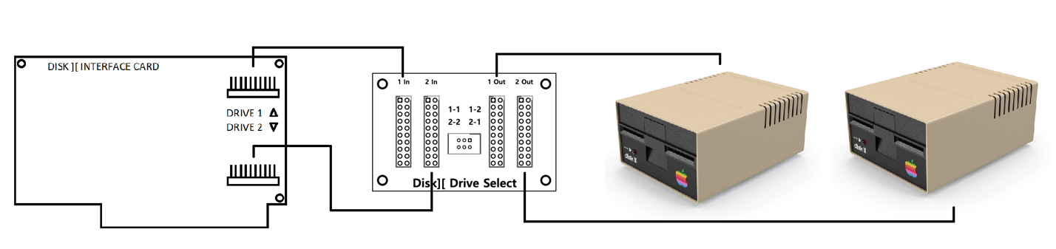

Swap two drives on one port(1-1 / 1-2)

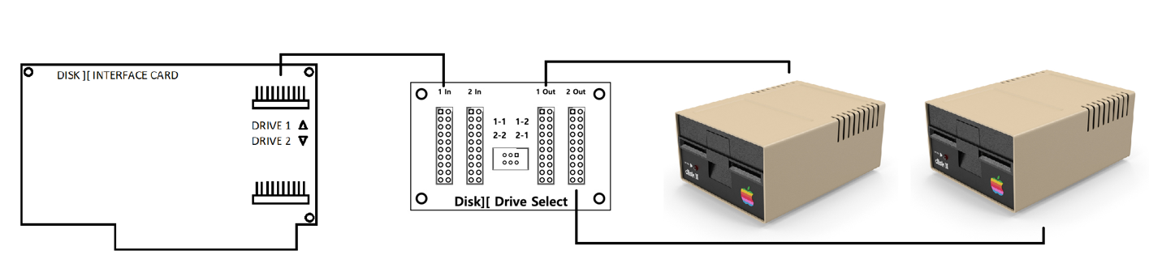

Thank you for your purchase!