 | THE FUTURE IS NOW · DEFEND YOUR LENS™

━━━━━━━━━━━━━━━━━━━━━━━━━━━━━━━━━━━━━━━━━━━━━━━━━━━━━━━━━━━━━━━━━━━━━━━━━━━━━━━━━━━━━━━━━━
ADVANCED  LENS and SCREEN CARE  AI-formulated lens cleaner for smart glasses, AR-coated lenses, sensor-integrated optics, and premium eyewear.  Contains Scratch Resistant Properties  ENGINEERED FOR: ◇ Smart glasses ◇ AR-coated lenses ◇ Sensor-integrated optics ◇ Premium eyewear ◇ Face Shields ◇ Delicate optical surfaces ◇ Smartphones, Tablets SAFELY REMOVES: ◇ Oils & fingerprints ◇ Dirt & contaminants ◇ Environmental residue ◇ Smudges & film ◇ Reduced streaking and residue ◇ Premium eyewear ◇ Premium eyewear  Scratch-resistant · AR safe · AI-driven formula · Streak-free finish | 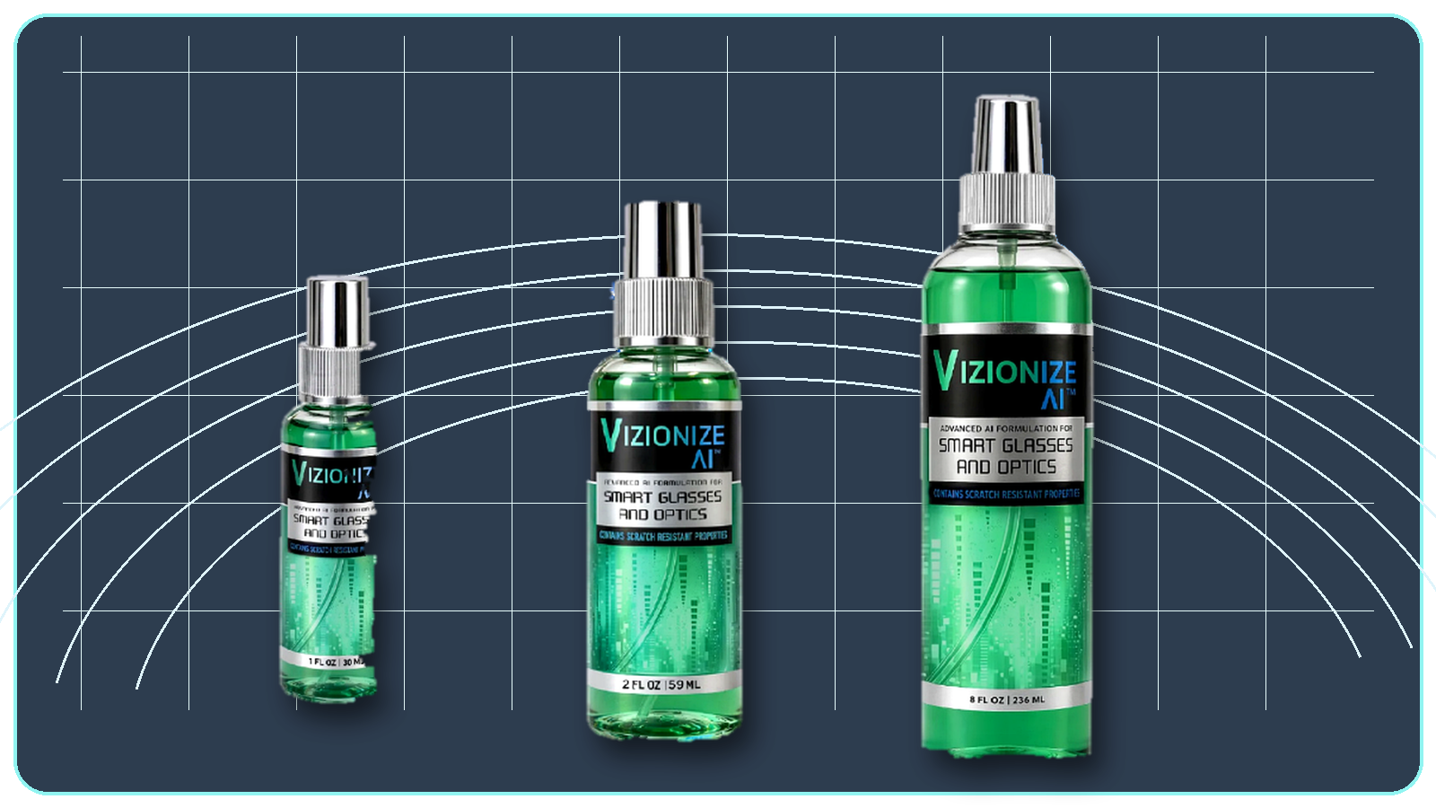  DEFEND YOUR LENS™  …and many other surfaces needing clarity

USD RETAIL PRICING
All prices in BBD · VAT inclusive
Product | 1-4 units | 5-9 units | 10+ units | Item #
1 oz Bottle | $5.95 | $4.95 | $3.95 | VIZ-1OZ
2 oz Bottle | $9.95 | $7.95 | $6.95 | VIZ-2OZ
8 oz Bottle | $13.95 | $11.95 | $9.95 | VIZ-8OZ
1 Gallon Refill | $259.95 | $219.95 | $189.95 | VIZ-GAL
2.5 Gal Cubitainer | $479.95 | $419.95 | $369.95 | VIZ-CUB
Microfiber Cloths x100 | $399.95 | $349.95 | $299.95 | VIZ-MFC

Distributed by:  Classic Visions  Your optical supply partner.  Web: www.classicvisions.net  Email: russell@classicvisions.net | Ready to use at the counter or by email  The price table is editable. Use this as a customer handout, email attachment, WhatsApp sheet, or counter reference.  VIZIONIZE AI™ patent-pending formula. Prices subject to change without notice. |   Scan to order online

