
THE FUTURE IS NOW · DEFEND YOUR LENS™

━━━━━━━━━━━━━━━━━━━━━━━━━━━━━━━━━━━━━━━━━━━━━━━━━━━━━━━━━━━━━━━━━━━━━━━━━━━━━━━━━━━━━━━━━━
ADVANCED  LENS and SCREEN CARE  AI-formulated lens cleaner for smart glasses, AR-coated lenses, sensor-integrated optics, and premium eyewear.  Contains Scratch Resistant Properties  ENGINEERED FOR: ◇ Smart glasses ◇ AR-coated lenses ◇ Sensor-integrated optics ◇ Premium eyewear ◇ Face Shields ◇ Delicate optical surfaces ◇ Smartphones, Tablets SAFELY REMOVES: ◇ Oils & fingerprints ◇ Dirt & contaminants ◇ Environmental residue ◇ Smudges & film ◇ Reduced streaking and residue ◇ Premium eyewear ◇ Premium eyewear  Scratch-resistant · AR safe · AI-driven formula · Streak-free finish | 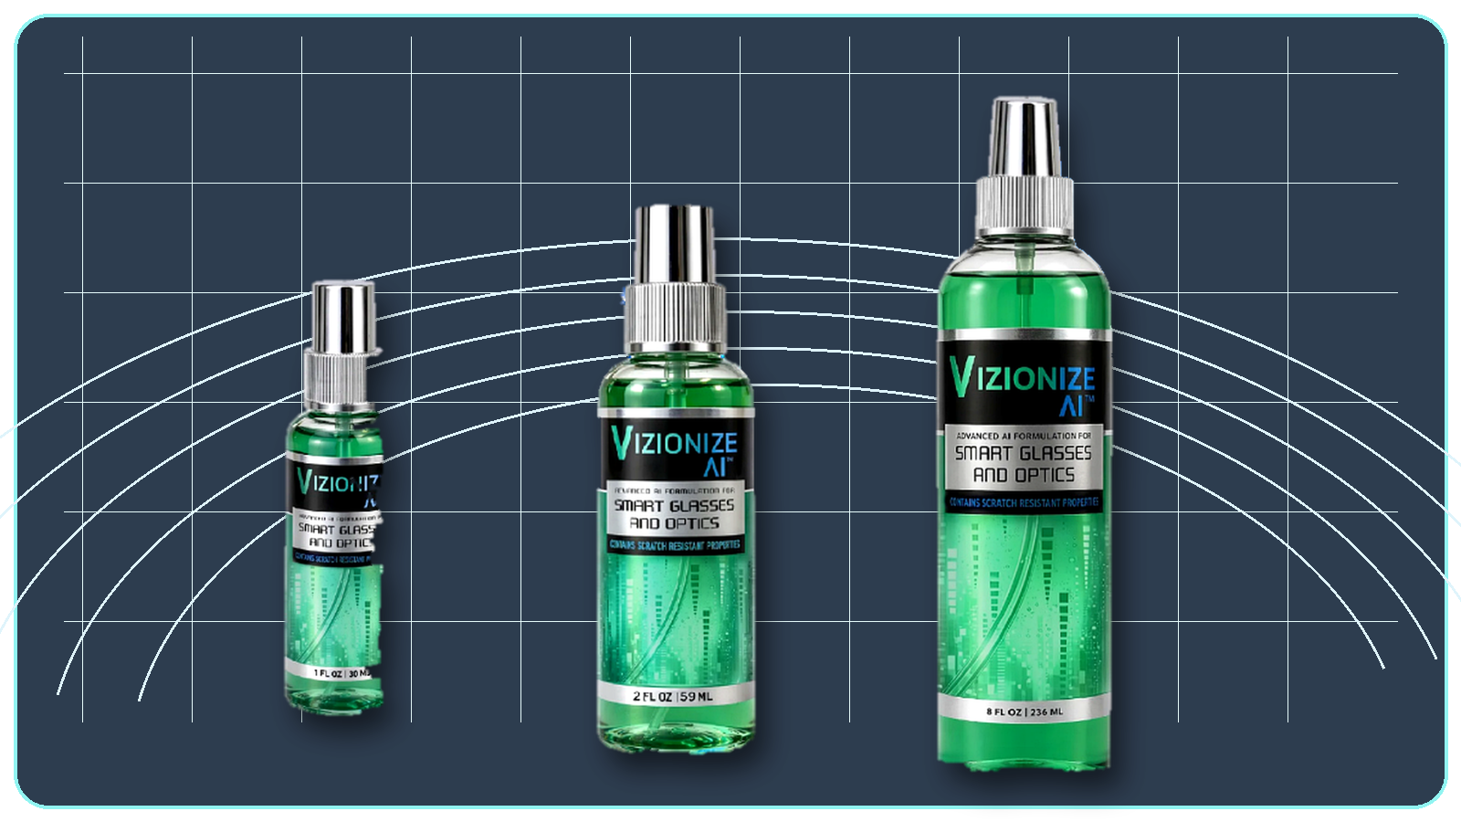  DEFEND YOUR LENS™  …and many other surfaces needing clarity

USD Wholesale Prices
All prices in USD
Product | 1-4 units | 5-9 units | 10+ units | Item #
1 oz Bottle | $2.98 | $2.48 | $1.98 | VIZ-1OZ
2 oz Bottle | $4.98 | $3.98 | $3.48 | VIZ-2OZ
8 oz Bottle | $6.98 | $5.98 | $4.98 | VIZ-8OZ
1 Gallon Refill | $129.98 | $109.98 | $94.98 | VIZ-GAL
2.5 Gal Cubitainer | $239.98 | $209.98 | $184.98 | VIZ-CUB
Microfiber Cloths x100 | $199.98 | $174.98 | $149.98 | VIZ-MFC

Distributed by:  Classic Visions  Your optical supply partner.  Web: www.classicvisions.net  Email: russell@classicvisions.net | VIZIONIZE AI™ patent-pending formula.  Prices subject to change without notice. |   Scan to order online

