Unit 10 Packaging Installers

**Corey Crooks**

**Purdue University Global**

**IT481 – Advanced Software Development**

**Ahmad Kassem**

**June 28th, 2023**

**The VM Environment**

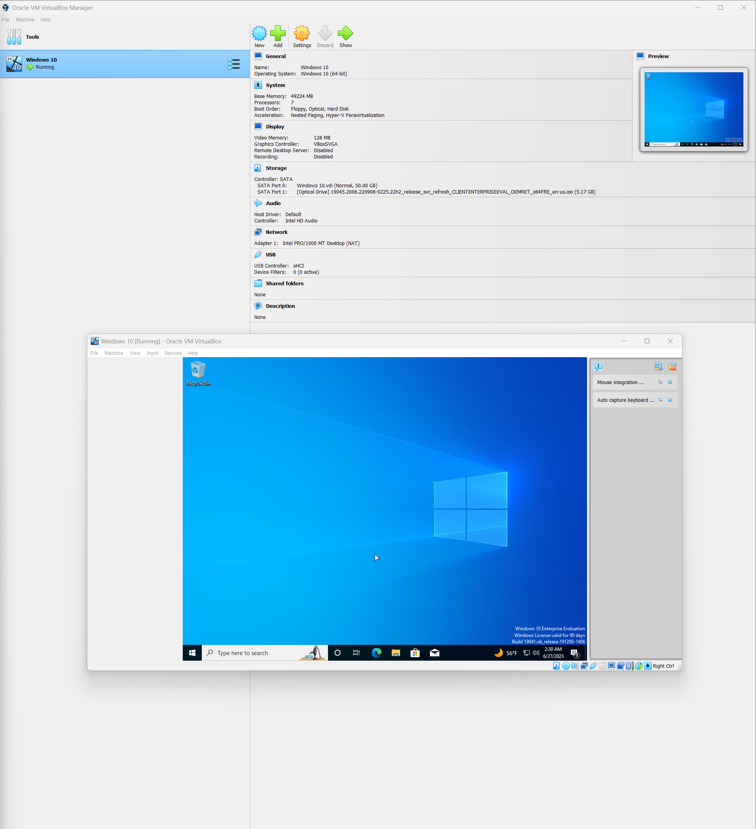

Above is the Virtual Machine settings as well as the freshly installed Virtual Machine running Windows 10 on Oracle VM VirtualBox. Overall, the installation was pretty straightforward; Microsoft provides evaluation keys of Windows 10 for free to download, so setting up the VM and the OS was not an issue.

**Packaging the Unit 9 Project as an Installer**

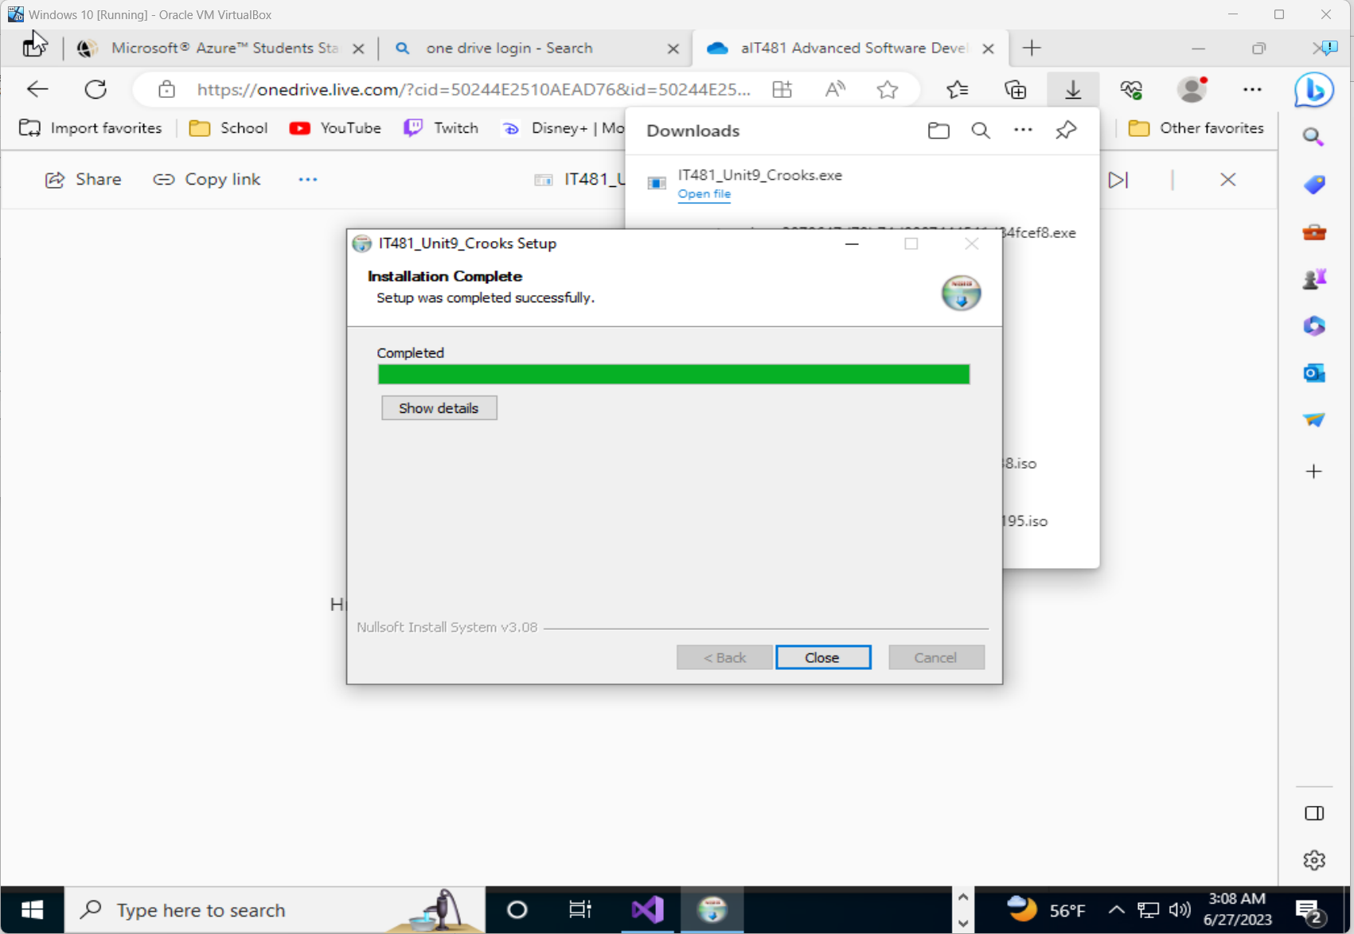

Above is a screenshot of the same VM showing a successful installation of the Unit 9 program. I used NSIS for the installer package, and did not find difficulty setting this stage up. All in all, It was just a quick zip procedure followed by pointing the directory.

**Installing Prerequisites and Running the Program(s)**

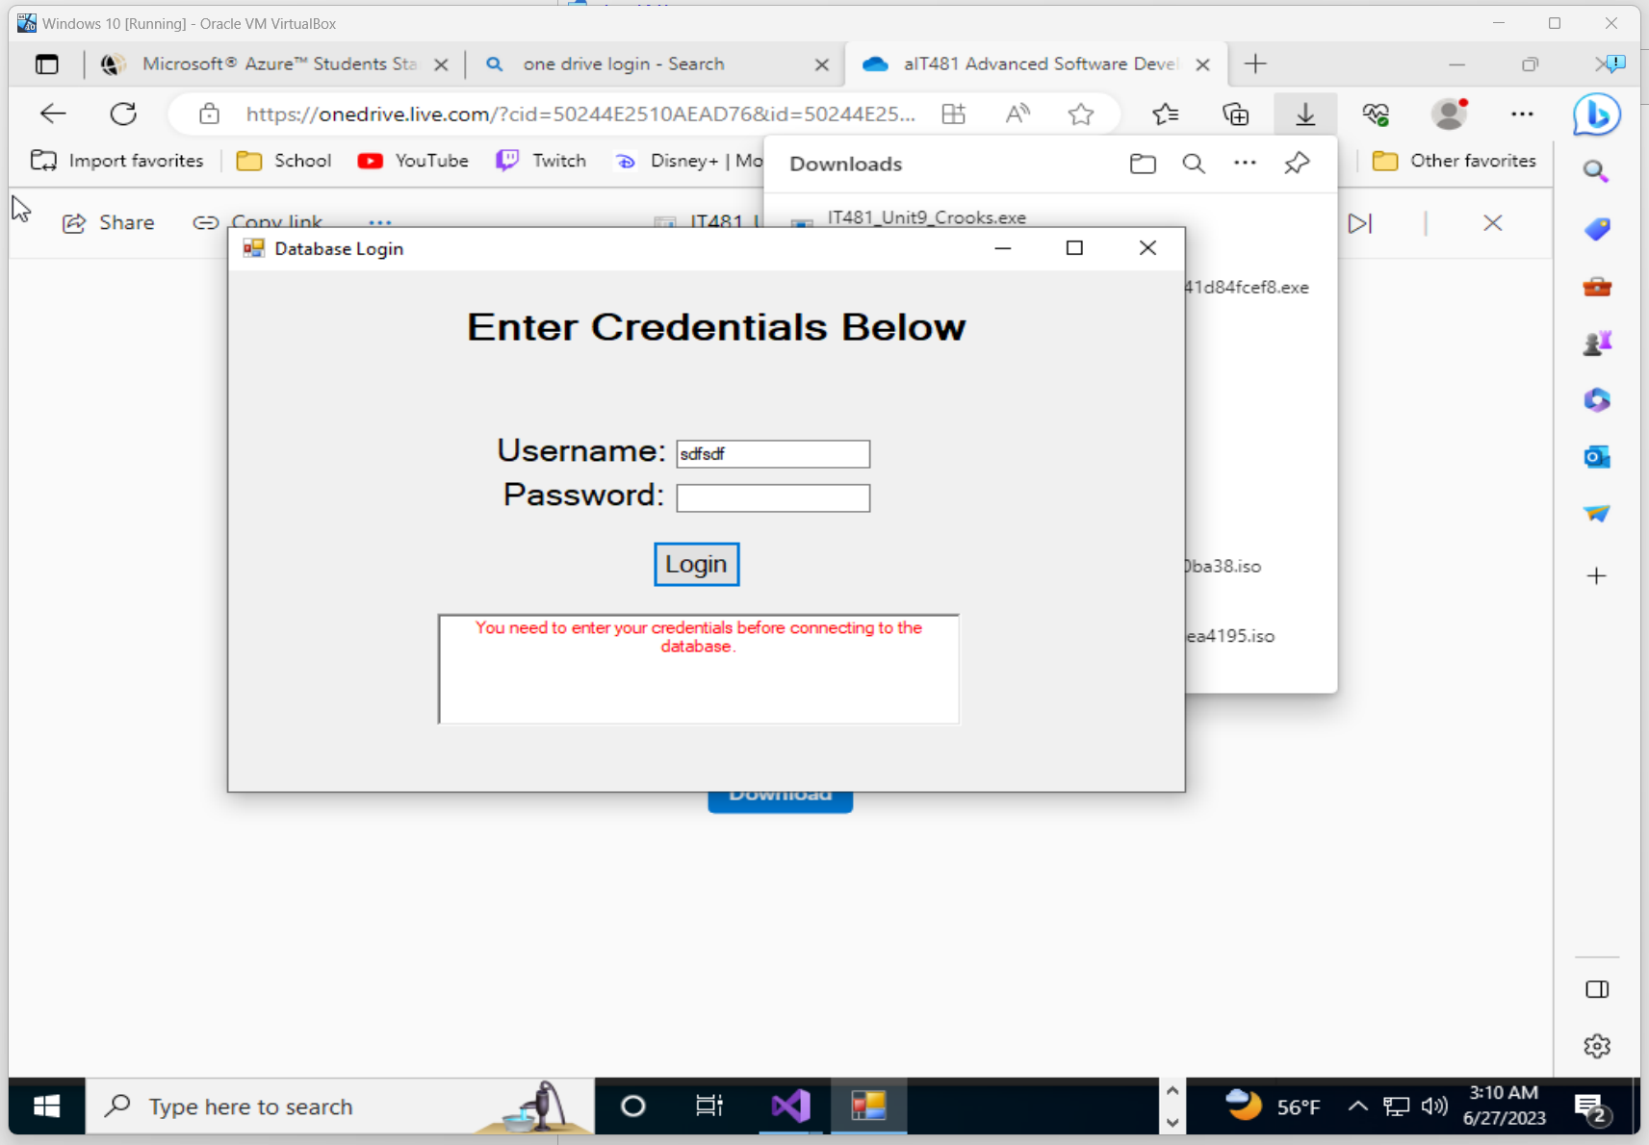

This is the step that I found the most difficulty on—not because the program itself was malfunctioning, but because Azure makes downloading and installing Microsoft SQL server as well as Visual Studio an absolute nightmare. Knowing what version to download, the year of publication, and the specific packages/settings to run at is quite frustrating when half of them present an error upon installation due to digital rights management. But once SQL Server and Visual Studio were successfully installed, I was able to launch my program with no problems at all.