Unit 3 Northwind Login Screenshots and Repository Link

**Corey Crooks**

**Purdue University Global**

**IT481 – Advanced Software Development**

**Ahmad Kassem**

**May 10th, 2023**

**Program at startup:**

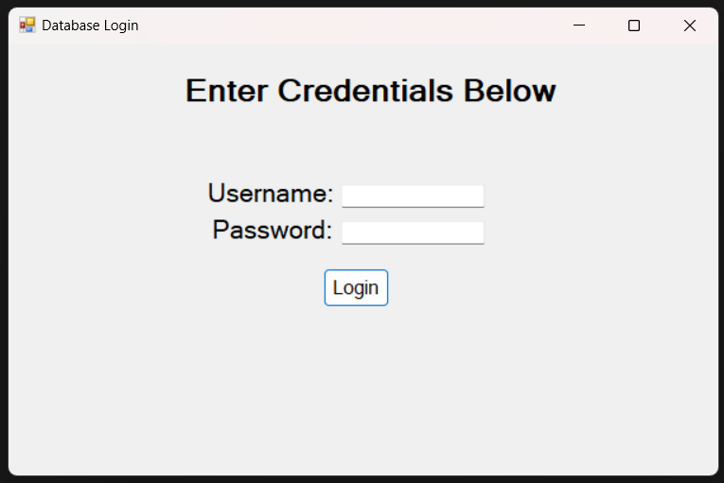

**Program entering wrong credentials:**

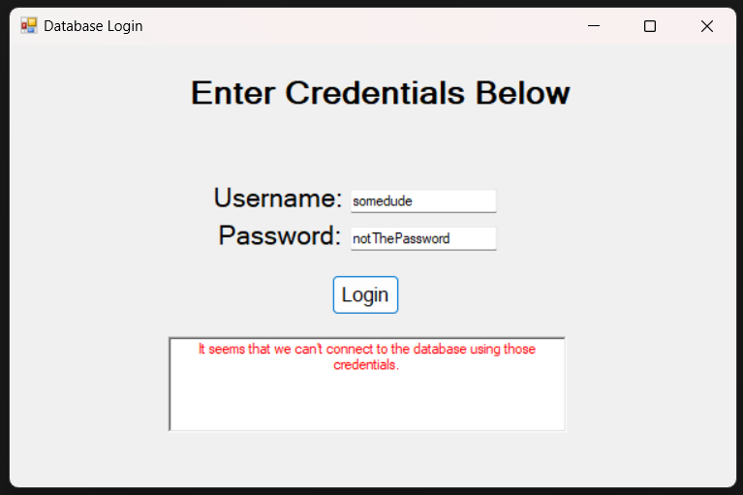

**Program logging in as CEO:**

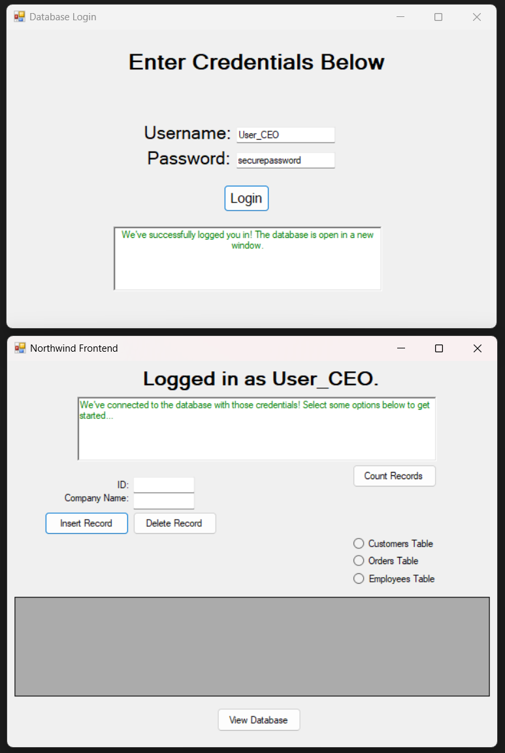

**Program with invalid input (no table selection):**

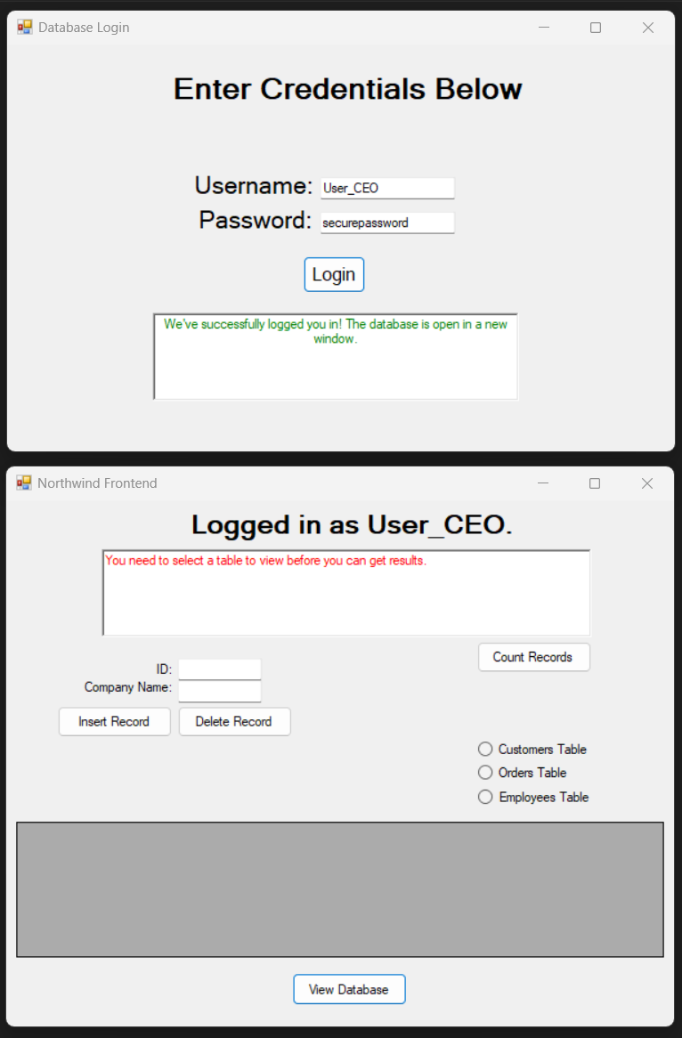

**Program logging in as HR:**

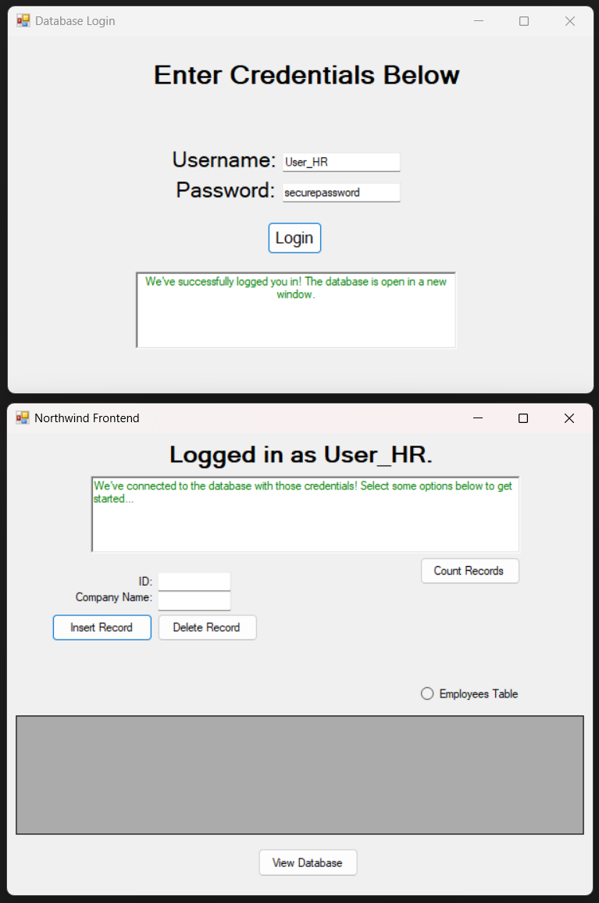

**Program viewing records as HR:** 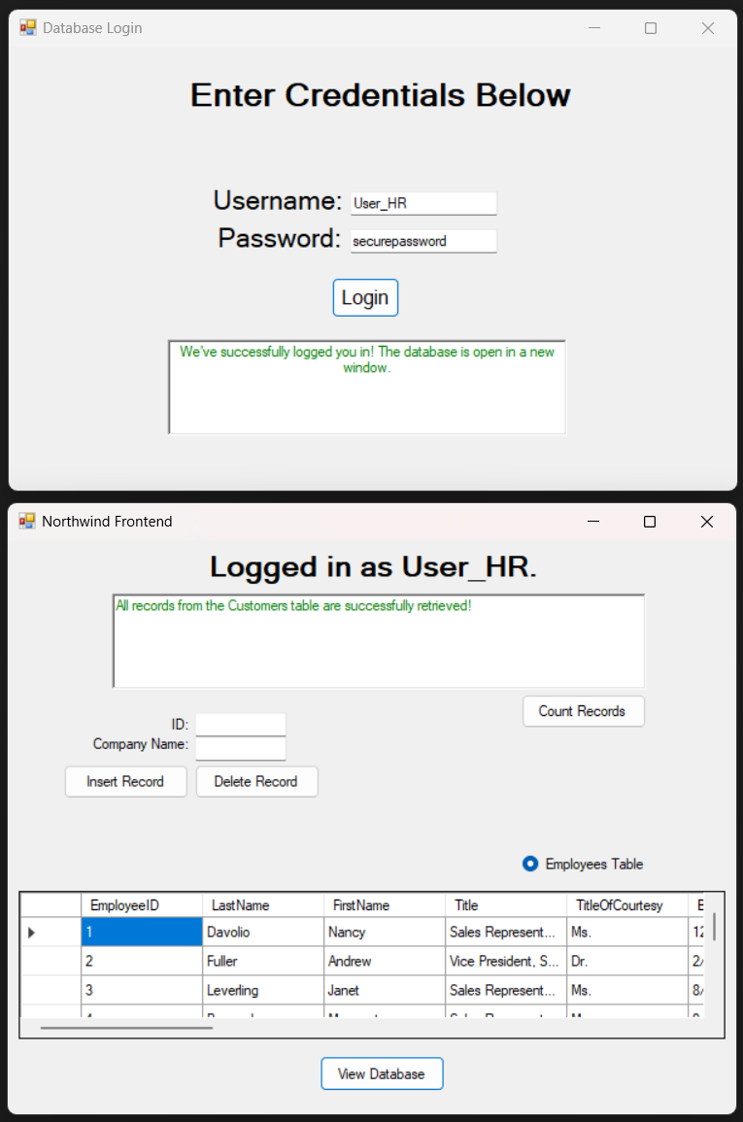

**Program logging in as Sales:**

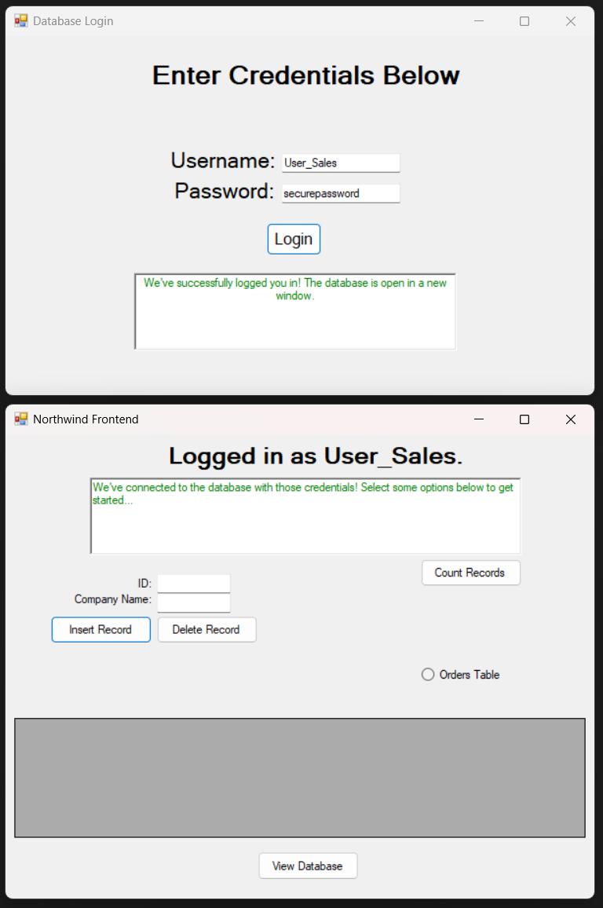

**Program viewing records as Sales:**

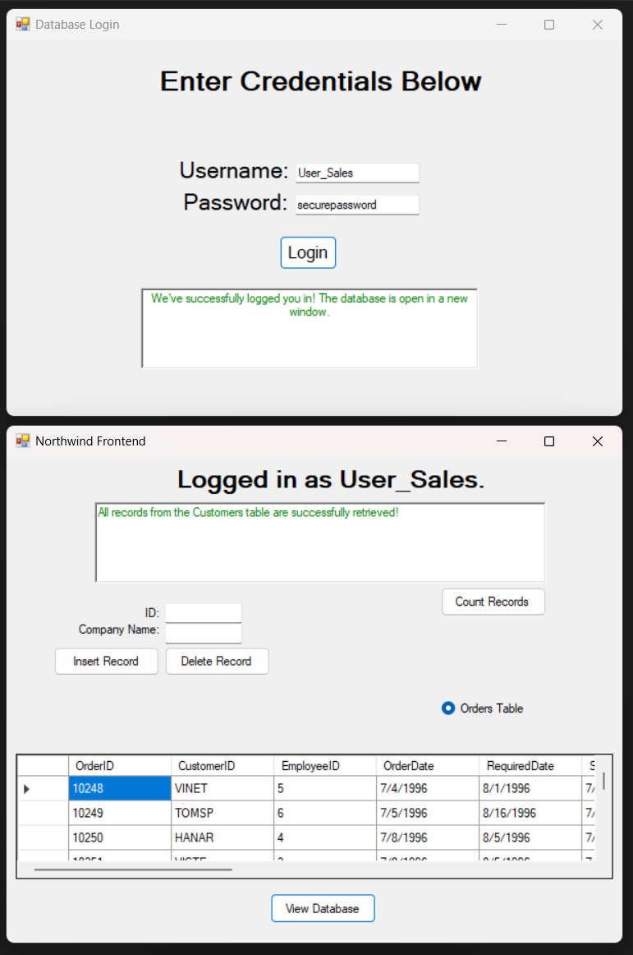

**SCM Proof and Link (Including SQL Script):**

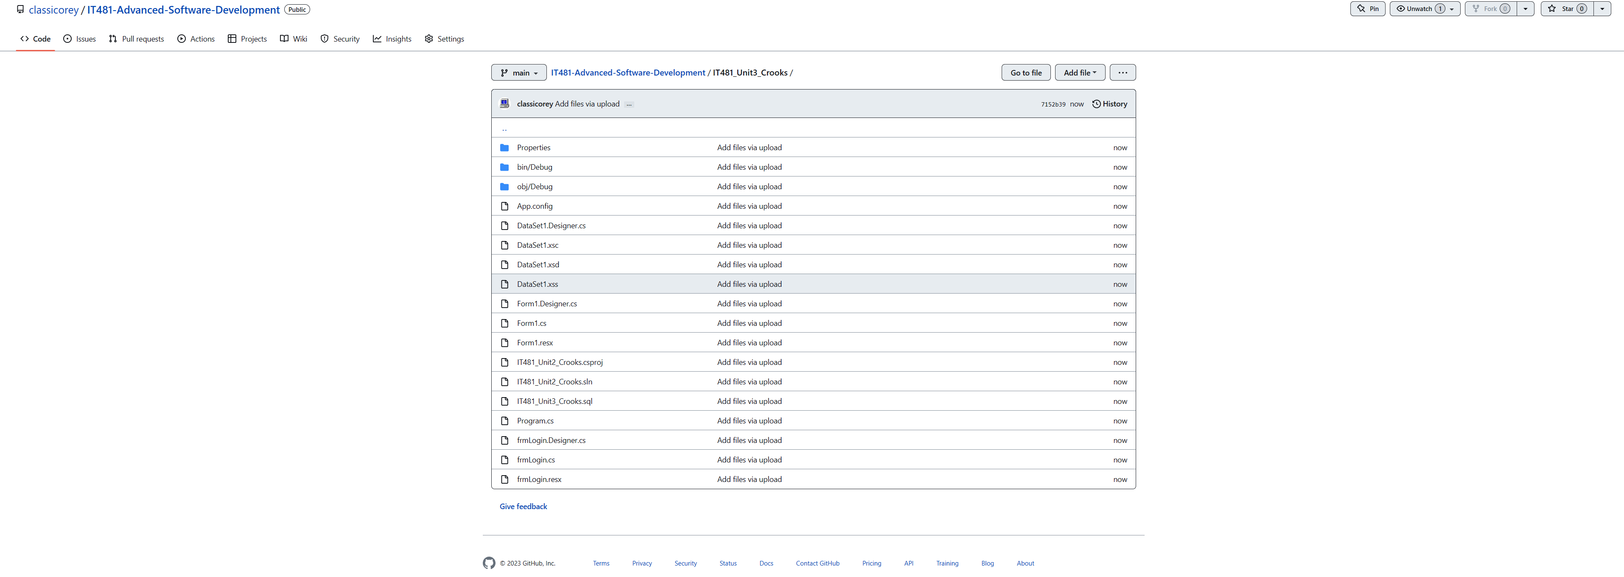

URL:

https://github.com/classicorey/IT481-Advanced-Software-Development/tree/main/IT481_Unit3_Crooks