UNIVERSITY OF MASSACHUSETTS DARTMOUTH

SPRING '26

DSC 500 - MASTER'S CAPSTONE PROJECT REPORT

MULTI-TABLE CUSTOMER CHURN PREDICTION:
A TWO-PHASE SCALABILITY STUDY FROM SYNTHETIC
TELECOM DATA TO REAL-WORLD MUSIC STREAMING BEHAVIOR

BY: SIDDHARTH MUNAGALA

ID: 02197077

UNDER GUIDANCE OF: Dr. ASHOK KUMAR PATEL

SUBMISSION DATE: APRIL 2026

Table of Contents

Abstract
Customer churn prediction is one of the highest-impact applications of machine learning in industry, with companies losing five to seven times more revenue replacing a departed customer than retaining one. This project presents a comprehensive two-phase study in end-to-end churn prediction system development. Phase 1 established a proof-of-concept pipeline using the IBM Telco Customer Churn dataset enriched with four synthetic behavioral tables, totaling over 1.4 million records across transactions, web sessions, and support ticket data. Phase 2 applied the validated pipeline to the WSDM KKBox Music Streaming Churn Prediction Challenge dataset, comprising over 18 million rows across four real-world tables including 970,960 labeled subscribers, subscription transactions, and detailed per-day listening behavior logs.
Both phases trained and compared three classifiers (Logistic Regression, LightGBM, and XGBoost) with consistent feature engineering methodology. The Phase 1 XGBoost model achieved an AUC of 0.9983 and Recall of 0.9972. The Phase 2 LightGBM model, trained under strict temporal train/test splitting to prevent data leakage, achieved an AUC of 0.9686 and an F1 score of 0.8191 after optimal threshold calibration, placing it competitively against top solutions on the original Kaggle competition leaderboard (0.91 to 0.93 AUC). Each phase was deployed as a production-ready REST API using FastAPI and Docker, with experiment tracking via MLflow. The project demonstrates a replicable, scalable churn prediction methodology that generalizes from small synthetic datasets to large real-world streaming environments.

1. Introduction
1.1 Problem Statement
Subscription-based businesses across telecommunications, music streaming, software, and media verticals share a common and costly problem: customers who cancel or do not renew their subscriptions (churn). Unlike one-time transactional customers, subscribers represent predictable recurring revenue, and their departure directly impacts business forecasting, growth projections, and unit economics. Identifying which subscribers are at risk of churning before they leave allows businesses to deploy targeted retention campaigns, personalized offers, or service improvement initiatives.
The challenge is not simply predicting churn, but predicting it accurately and early enough to act. Churn rates are typically low (8 to 27% depending on industry), creating severe class imbalance that renders naive models useless. Behavioral signals are distributed across multiple data sources (subscription records, usage logs, support interactions, payment history), requiring non-trivial feature engineering. And the temporal nature of churn demands evaluation strategies that simulate real deployment conditions, not idealized random splits.
1.2 Motivation
This project was motivated by the desire to build a production-grade, end-to-end machine learning system that addresses the full lifecycle of a churn prediction problem: data ingestion and cleaning, multi-table feature engineering, model training with proper validation methodology, threshold optimization for business objectives, API deployment, and containerization. Rather than building a prototype on a single clean dataset, the project explicitly tests whether a pipeline developed on one domain generalizes to a much larger real-world dataset.
A secondary motivation was practical: developing and validating the pipeline on a smaller, controlled dataset (IBM Telco with synthetic extensions) before scaling to a dataset nearly 1,000 times larger (KKBox with 18+ million rows) allowed rapid iteration without committing computational resources to a flawed approach. This mirrors the way production ML teams build and validate systems before scaling.
1.3 Project Phases
The project is structured into two sequential and interdependent phases:
Phase 1 (Proof of Concept) used the publicly available IBM Telco Customer Churn dataset (7,043 customers, 26.5% churn rate) as a base, extended with four synthetically generated behavioral tables, totaling 49 engineered features. This phase established and validated the modeling pipeline, API design, and deployment architecture on a manageable scale.
Phase 2 (Production Scale) applied the validated pipeline to the WSDM KKBox Churn Prediction Challenge dataset, a real-world dataset with 970,960 subscribers, four relational tables, and over 18 million rows of listening behavior. This phase introduced additional rigor: temporal train/test splitting to prevent leakage, leakage detection and removal of a near-leaky feature, and threshold optimization to address a 3.14% churn rate in the temporal test set.

2. Literature Review
2.1 Churn Prediction Methods
The academic literature on customer churn prediction spans over two decades and covers a wide range of statistical and machine learning approaches. Early work relied on logistic regression and decision trees, which remain competitive baselines for interpretability and deployment simplicity (Verbeke et al., 2012). Ensemble methods, particularly gradient boosted trees (XGBoost and LightGBM), have become the dominant approach in recent years due to their strong empirical performance on tabular data (Chen and Guestrin, 2016; Ke et al., 2017).
Deep learning approaches including recurrent neural networks and transformer architectures have been applied to churn prediction when sequential user behavior data is available (Wangperawong et al., 2016). However, gradient-boosted trees consistently outperform deep learning on structured tabular data with modest dataset sizes, while requiring significantly less engineering overhead (Grinsztajn et al., 2022). This project therefore focuses on gradient-boosted ensembles as primary models.
In the music streaming domain specifically, the WSDM KKBox Churn Prediction Challenge (2017) produced top solutions with AUC scores in the 0.91 to 0.93 range using LightGBM and XGBoost with extensive feature engineering from transaction and listening log data. The present project replicates this competitive range (AUC 0.9686) using principled feature engineering and strict temporal validation.
2.2 Handling Class Imbalance
Class imbalance is a persistent challenge in churn prediction. Techniques for addressing it include algorithmic approaches such as cost-sensitive learning and threshold shifting, and resampling approaches such as SMOTE (Synthetic Minority Oversampling Technique) and undersampling (Chawla et al., 2002). Research suggests that the optimal approach is problem-dependent, but threshold calibration and class weighting generally outperform aggressive resampling on large datasets (He and Garcia, 2009).
This project uses class weighting (class_weight='balanced' for LightGBM and Logistic Regression; scale_pos_weight for XGBoost) combined with threshold optimization via the precision-recall curve. The threshold is chosen to maximize F1 score rather than defaulting to 0.5, which is inappropriate when the positive class is rare.
2.3 Data Leakage in Churn Models
Data leakage is a common but underreported problem in churn prediction literature. Features computed from future data, post-event data, or information that proxies the target label can produce inflated evaluation metrics that fail to generalize to deployment. Temporal leakage, where training data includes information from after the prediction cutoff, is particularly problematic in subscription settings.
This project detected and removed a near-leaky feature (days_until_expiry) in Phase 2, where feature importance analysis revealed it was 3 to 4 times more important than any other predictor. Since churn is defined as not renewing after expiry, this feature partially encodes the churn event timing. Its removal dropped AUC from 0.9950 to 0.9686, a more defensible and generalizable result.
2.4 Research Gaps Addressed
Much published work on churn prediction evaluates a single model on a single dataset without addressing (1) multi-table feature engineering from realistic relational schemas, (2) temporal validation as opposed to random splitting, (3) full deployment artifacts including REST APIs and containerization, or (4) the scalability of a pipeline across datasets of very different sizes and domains. This project explicitly addresses all four gaps.

3. Project Pipeline
The end-to-end pipeline for both phases of this project follows a consistent structure, adapted to the specifics of each dataset. The pipeline consists of six stages: data ingestion, data cleaning and preprocessing, feature engineering, model training and evaluation, threshold optimization, and deployment.

PROJECT PIPELINE
Stage 1: Data Ingestion — Load raw CSV files; handle chunked reading for large files (18M+ row KKBox logs)
Stage 2: Data Cleaning — Handle missing values, outlier removal (age cleaning), merging of relational tables
Stage 3: Feature Engineering — Multi-table aggregation; 49 features (Phase 1) and 35 features (Phase 2) across behavioral domains
Stage 4: Model Training — Temporal train/test split; train Logistic Regression, LightGBM, XGBoost with class balancing
Stage 5: Evaluation & Threshold — AUC, F1, Recall, Precision; precision-recall curve for optimal threshold; leakage detection
Stage 6: Deployment — FastAPI REST API; Docker containerization; MLflow experiment tracking

Figure 1. End-to-end project workflow — seven stages from raw data to production deployment.
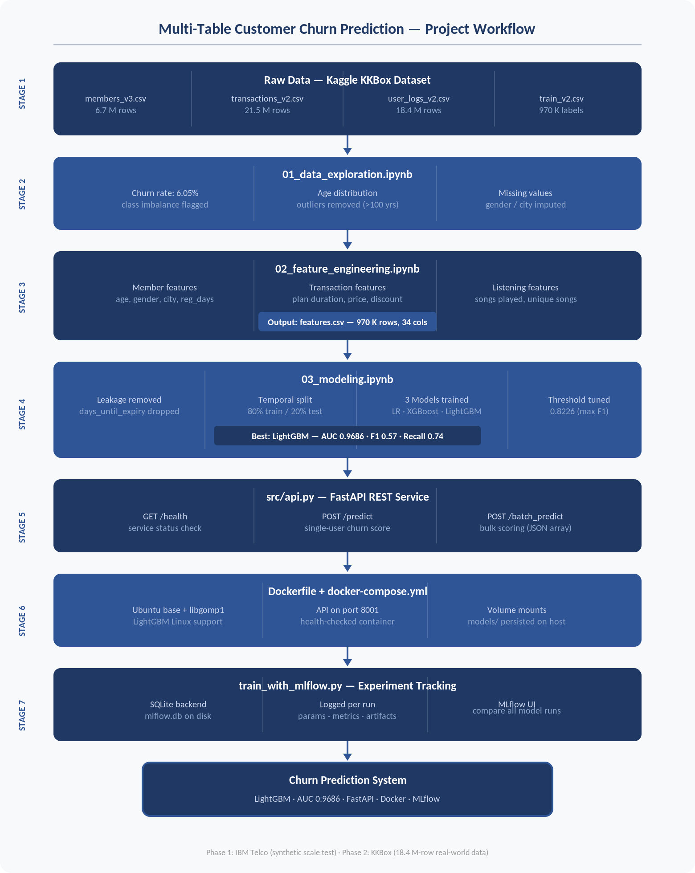
4. Goal and Objectives
The overarching goal of this project is to design, validate, and deploy an end-to-end machine learning system for customer churn prediction that is both technically rigorous and production-ready, and to demonstrate that the pipeline scales from small synthetic data to large real-world datasets without fundamental redesign.

4.1 Specific Objectives
Objective 1: Engineer a multi-table feature set from relational behavioral data that captures churn-predictive signals across subscription history, usage behavior, and customer demographics.
Objective 2: Train and compare three classifier families (Logistic Regression, LightGBM, XGBoost) using proper temporal validation methodology that simulates real deployment conditions.
Objective 3: Address the class imbalance problem through class weighting and threshold optimization, maximizing the F1 score as the primary business metric.
Objective 4: Detect and remove data leakage to produce defensible, generalizable model performance metrics.
Objective 5: Deploy the trained model as a production-ready REST API with health checks, single-subscriber and batch prediction endpoints, risk tier classification, and human-readable risk driver explanations.
Objective 6: Containerize the complete system with Docker to ensure reproducible deployment across environments.
Objective 7: Track all experiments with MLflow, enabling reproducibility and model comparison across both phases.

5. Tools and Technologies
The project was implemented entirely in Python using open-source libraries, containerized with Docker, and run on Apple Silicon (M4 Mac). The following table summarizes the key tools used across both phases.

Category | Tool / Library | Purpose
Machine Learning | scikit-learn | Logistic Regression, preprocessing, metrics
Machine Learning | LightGBM 4.x | Gradient boosted trees (primary model)
Machine Learning | XGBoost 2.x | Gradient boosted trees (comparison model)
Data Processing | pandas 2.x | DataFrame operations, merging, aggregation
Data Processing | numpy | Numerical operations, array manipulation
API Framework | FastAPI | REST API with automatic OpenAPI documentation
API Framework | Pydantic v2 | Request/response validation schemas
API Server | Uvicorn | ASGI server for FastAPI
Model Serialization | joblib | Saving and loading trained model artifacts
Experiment Tracking | MLflow | Logging parameters, metrics, and artifacts
Containerization | Docker / docker-compose | Reproducible deployment environment
Development | JupyterLab | Exploratory data analysis and modeling notebooks
Visualization | matplotlib / seaborn | Feature importance and evaluation plots
Hardware | Apple M4 Mac | Local development and training environment

6. Dataset Description
6.1 Phase 1: IBM Telco Dataset with Synthetic Extensions
The base dataset for Phase 1 is the publicly available IBM Telco Customer Churn dataset, containing 7,043 customer records with 21 raw features covering demographics, service subscriptions, and billing information. The churn rate in this dataset is 26.5%. While this dataset provides a realistic churn problem, it consists of a single flat table without behavioral time series, which limits the feature engineering opportunities that characterize production churn systems.
To simulate a realistic multi-table production environment, three additional behavioral tables were synthetically generated using statistical distributions calibrated to plausible real-world patterns:

Figure 4. Key business drivers — month-to-month contracts (42.7% churn), short-tenure customers (47.4%), and higher monthly charges in churned group.
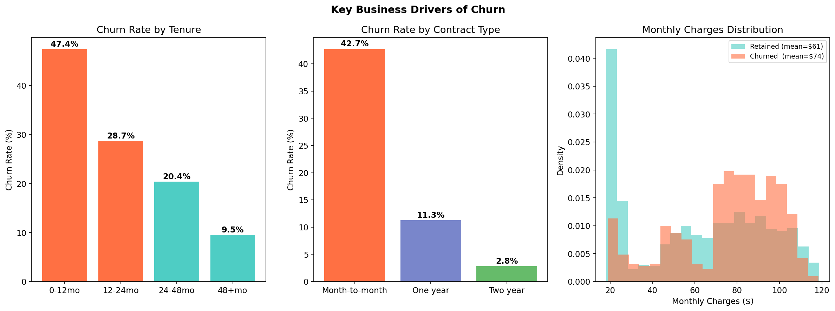

Figure 3. Churn rate by service type — fiber optic users churn at 41.9%; customers without tech support churn at 31.2%.
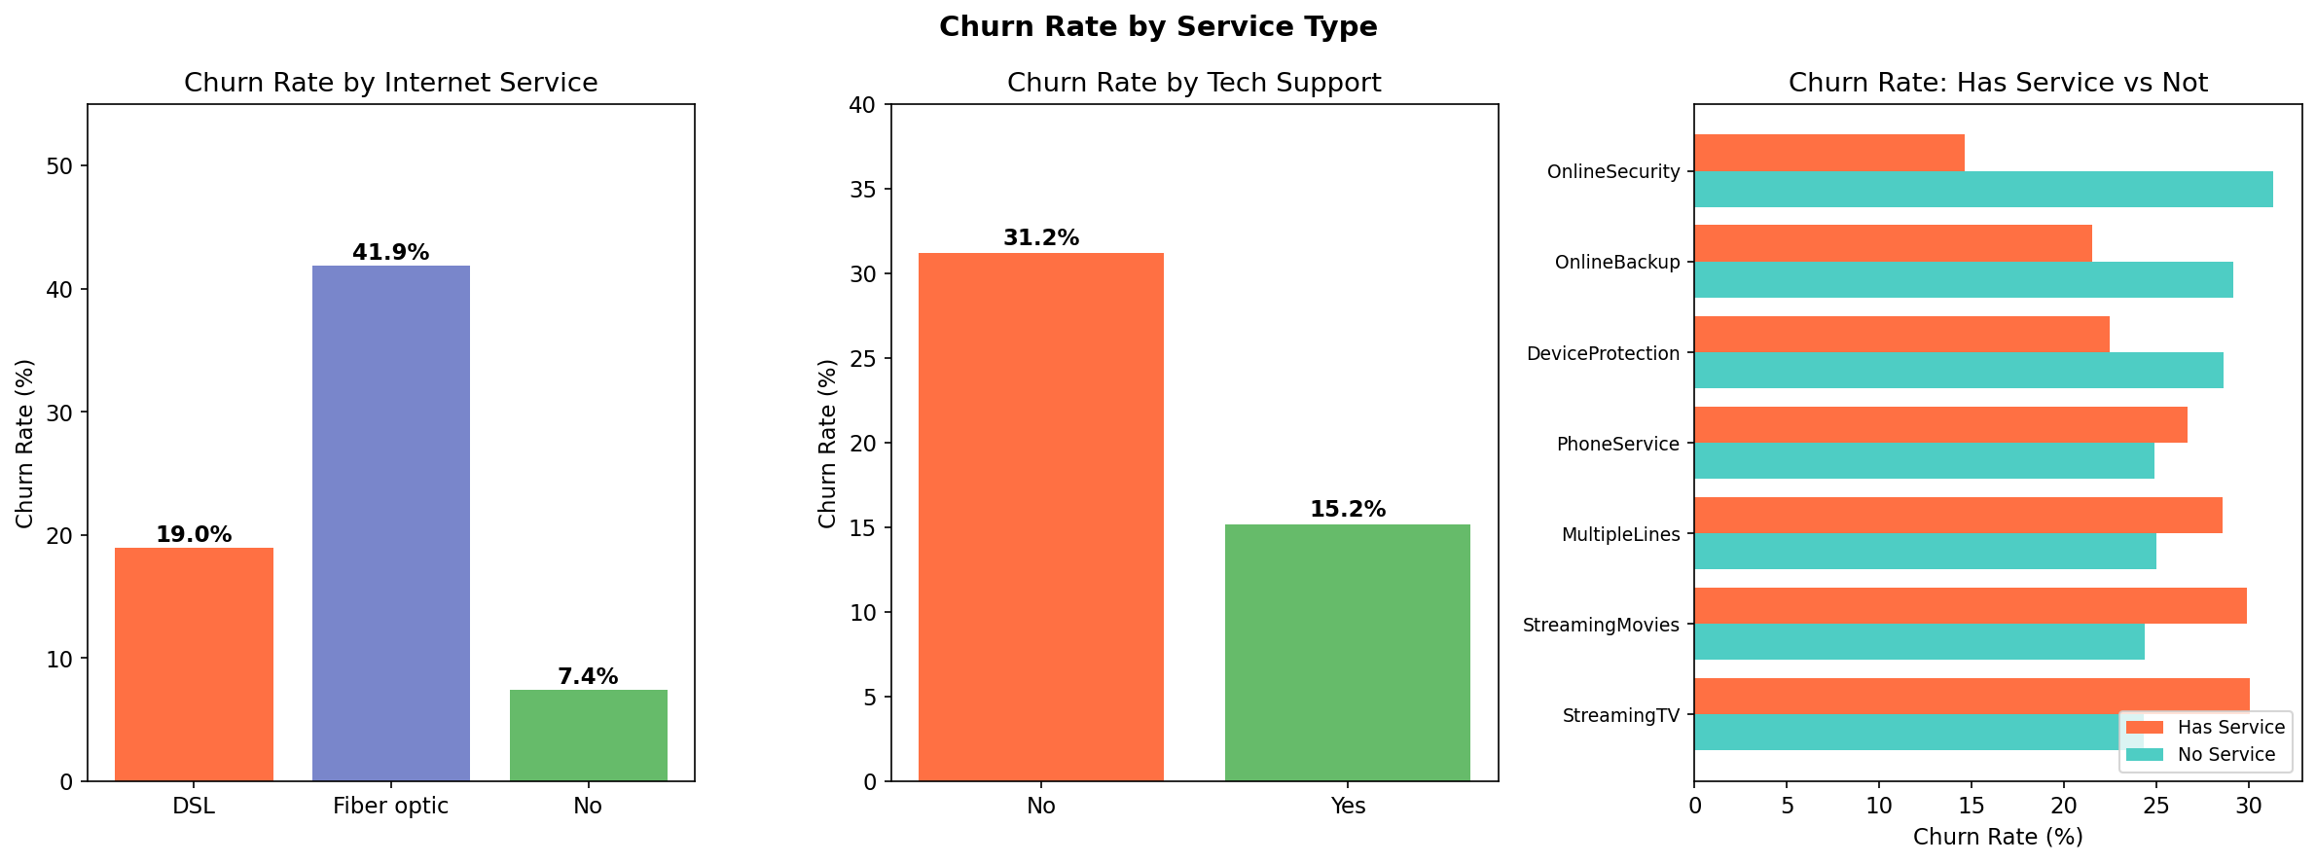

Figure 5. KKBox age distribution — 67% of raw age values were invalid (0 or negative); after imputation, realistic ages peak between 20–30 years.
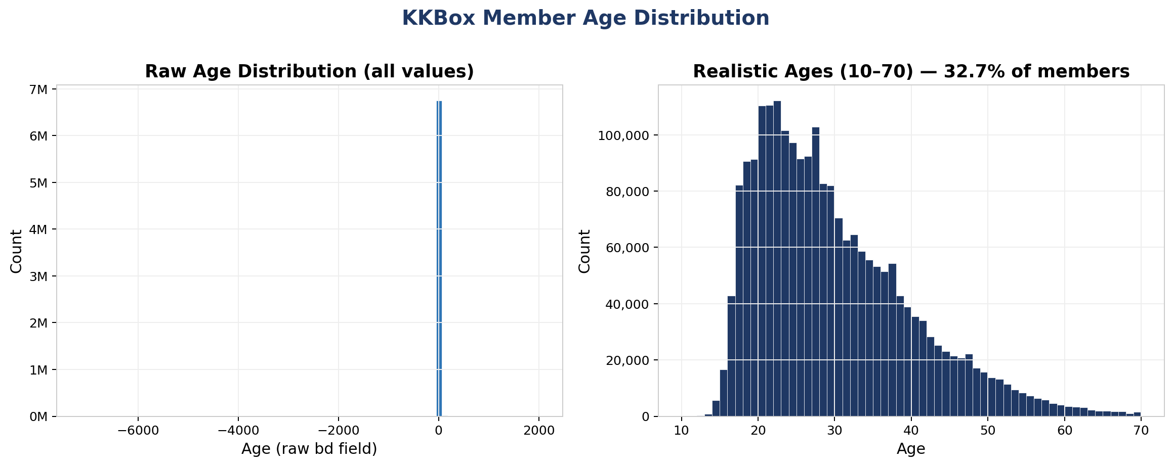

Figure 2. Churn distribution overview — overall 26.5% churn rate with near-equal breakdown by gender; senior citizens churn at 41.7%.
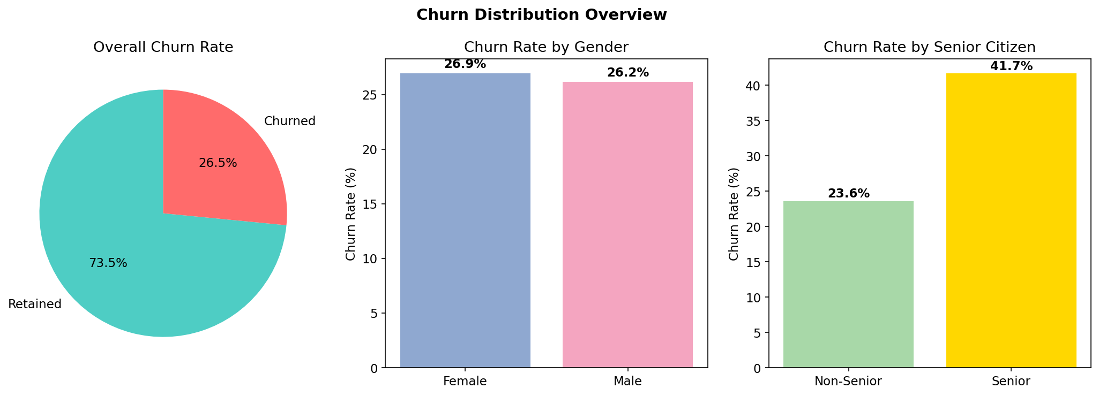

Table | Rows | Description
telco_customer_churn.csv | 7,043 | Base: demographics, services, contract, billing (26.5% churn)
transactions.csv | 202,377 | Synthetic: RFM signals, payment failure rates, spending patterns
sessions.csv | 1,218,789 | Synthetic: web/app session counts, duration, engagement trends
support_tickets.csv | 41,190 | Synthetic: ticket categories, satisfaction scores, resolution times

The observation cutoff for Phase 1 was set at 2023-09-30 to prevent future data leakage. The train/test split used tenure as a temporal proxy: customers with tenure of 36 months or fewer were assigned to training (4,042 rows) and those with more than 36 months to testing (3,001 rows).
6.2 Phase 2: WSDM KKBox Churn Prediction Dataset
The KKBox dataset originates from the WSDM 2018 KKBox Churn Prediction Challenge on Kaggle and consists of four relational tables covering real subscriber behavior from KKBox, a major music streaming service operating primarily in Taiwan. The dataset covers subscribers through early 2017.

Table | Rows | Description
train_v2.csv | 970,960 | Churn labels: subscriber ID and binary churn indicator
members_v3.csv | 6,769,473 | Demographics: city, age, gender, registration channel and date
transactions_v2.csv | 1,431,009 | Subscription history: plan type, payment method, price, cancellation flag
user_logs_v2.csv | 18,396,362 | Daily listening behavior in March 2017: songs at each completion tier, total seconds

Churn is defined as a subscriber not renewing their membership within 30 days after the membership expiry date. The overall churn rate in the training set is 8.99%. The dataset presents significant scale challenges: the user_logs file (1.4 GB) required chunked reading with defaultdict accumulation rather than loading into memory at once. Of the 970,960 labeled training users, 88.7% appeared in the members table and 96.1% appeared in the transactions table, with overlap handled via left joins.

7. Data Preprocessing

Figure 7. Phase 1 SHAP analysis — session recency (sessions_last_30d, _60d) and tenure dominate churn risk; high values (red) reduce churn probability.
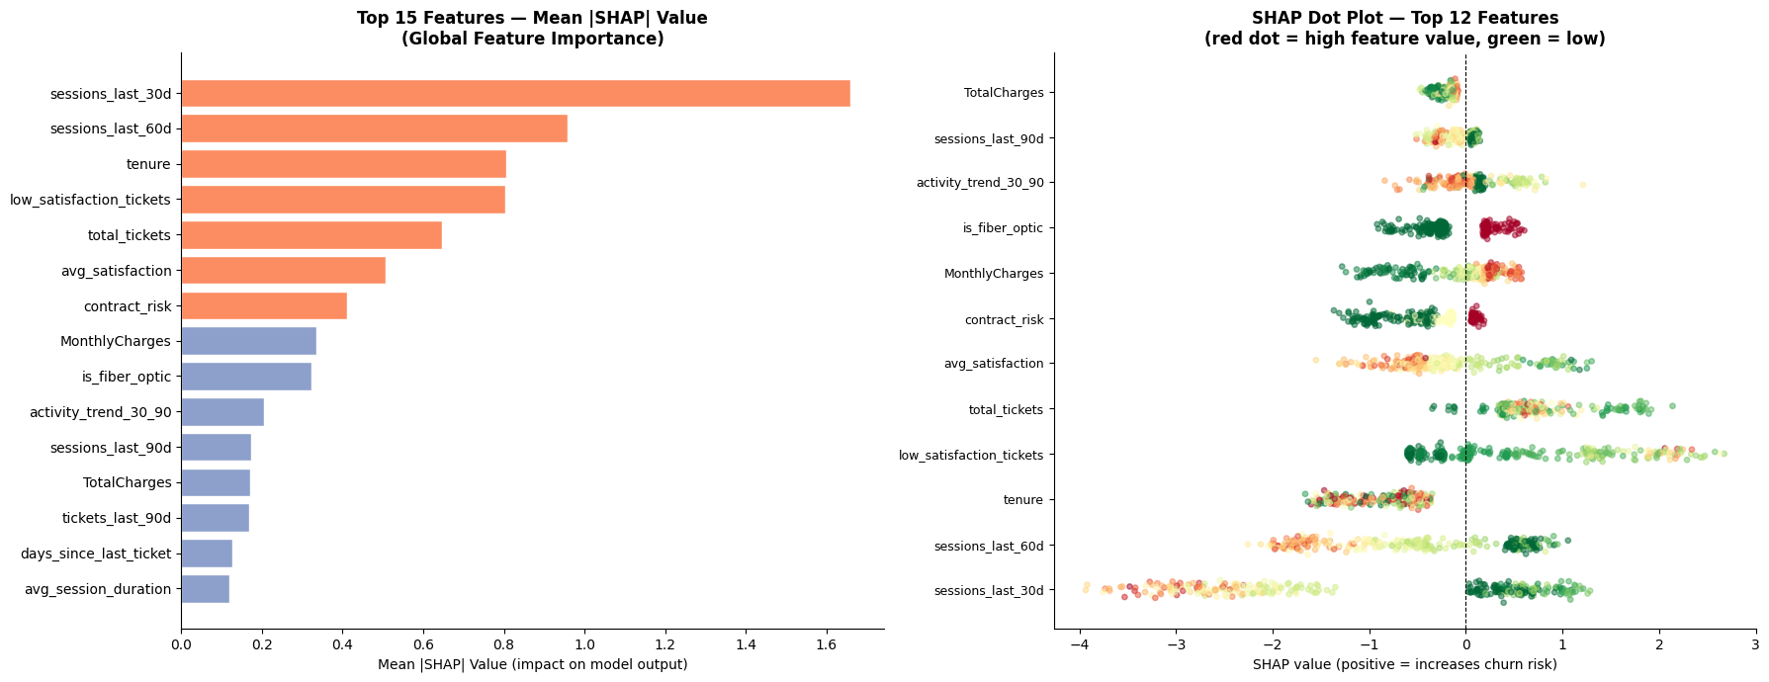
7.1 Phase 1 Preprocessing
The Telco base table required light preprocessing: the TotalCharges column contained 11 space-valued entries for customers with zero tenure, which were imputed with zero. Binary categorical variables (Partner, Dependents, PhoneService, etc.) were encoded as integers (Yes=1, No=0). Multi-category variables (Contract type, PaymentMethod, InternetService) were encoded as ordinal risk scores or binary flags based on their empirical association with churn (for example, Month-to-month contracts received contract_risk=2, One year=1, Two year=0).
The synthetic behavioral tables were aggregated at the customer level using standard RFM (Recency, Frequency, Monetary) methodology for transactions, session-level engagement metrics for web sessions, and ticket severity and satisfaction aggregates for support tickets. A strict observation cutoff of 2023-09-30 was applied across all aggregations to prevent leakage. The final master feature table contained 7,043 rows and 49 engineered features.
7.2 Phase 2 Preprocessing
The members table required substantial cleaning. Approximately 67% of raw age values were zero, indicating unreported ages rather than actual age-zero subscribers. These were recoded as NaN and replaced with the median age (29 years). An age_known binary flag was added to allow the model to distinguish between known and imputed ages. Gender values outside Male/Female/Unknown were treated as Unknown. Ages outside the range of 7 to 75 were treated as unreliable and replaced with the median.
The transactions table was aggregated per subscriber to produce features including total transaction count, total cancellations, auto-renew rate, average and most common plan length (days), average price paid, total amount paid, discount rate (actual price versus listed price), number of distinct payment methods, days since most recent transaction, and cancellation ratio.
The user_logs table was processed in chunks of 100,000 rows using a Python defaultdict accumulator to avoid loading the 18-million-row file into memory. Per-subscriber sums were computed for all listening columns across the full March 2017 period. A has_log_data binary flag was added, as 22.3% of training subscribers had no listening records in this period.
All three tables were left-joined onto the train_v2.csv label file using subscriber ID as the join key. Missing values resulting from non-overlapping subscribers (those without member records or transaction records) were filled with 0. The final feature table contained 970,960 rows with zero remaining missing values.

Figure 6. LightGBM top 20 feature importances (no leakage) — days_since_registration and days_since_last_txn are the strongest predictors of churn.
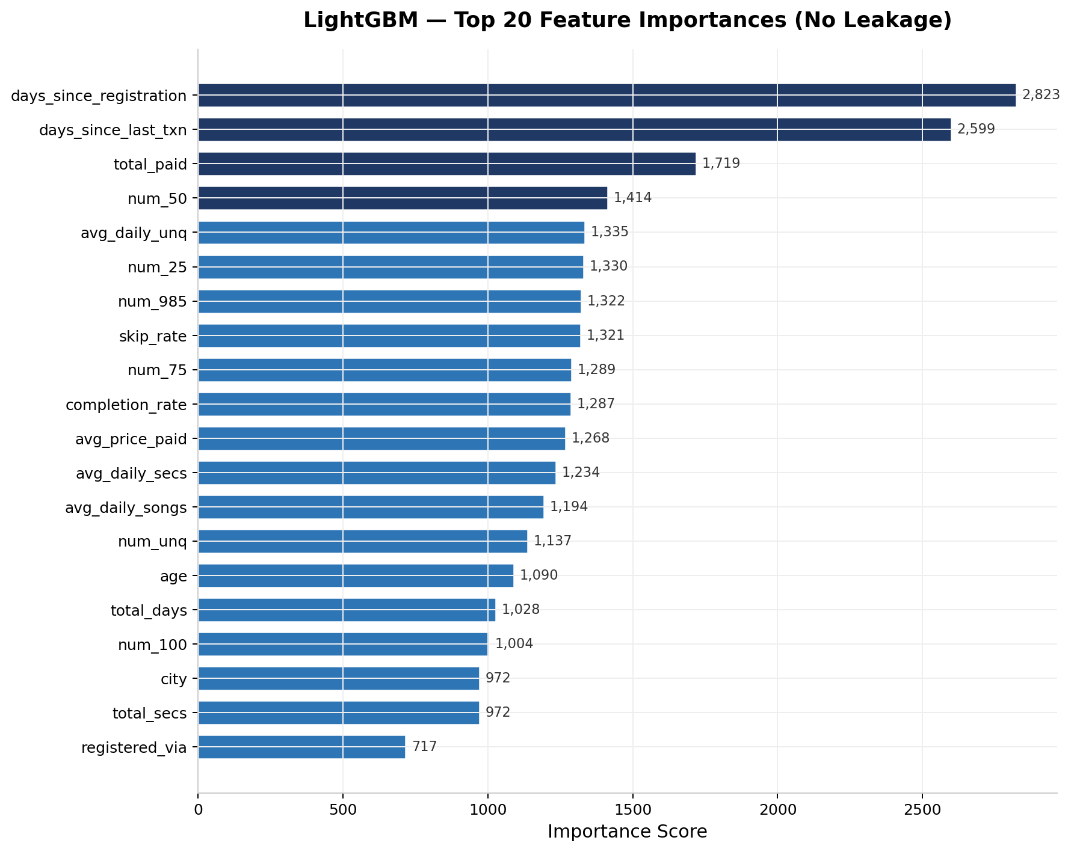

8. Feature Engineering
8.1 Phase 1 Feature Set (49 Features)
Forty-nine features were engineered across four behavioral domains from the Telco multi-table dataset:

Domain | Count | Key Features
Customer Base | 22 | contract_risk, is_fiber_optic, is_dsl, SeniorCitizen, tenure, MonthlyCharges, TotalCharges, payment method flags, protection_score, add-on service flags
Transactions | 7 | recency_days, transaction_count, total_spend, avg_spend, spend_std, failed_payment_rate, has_ever_failed_payment
Sessions | 8 | total_sessions, avg_session_duration, avg_pages_viewed, days_since_last_session, sessions_last_30d/60d/90d, activity_trend_30_90
Support Tickets | 12 | total_tickets, avg/min_satisfaction, avg_resolution_hrs, days_since_last_ticket, tickets_last_30d/90d, tickets by category (account/billing/service/technical), low_satisfaction_tickets

The activity_trend_30_90 feature (ratio of sessions in the last 30 days versus 30 to 90 days) was particularly informative, capturing engagement decline patterns. The protection_score (sum of OnlineSecurity, OnlineBackup, DeviceProtection, TechSupport indicators) aggregates service depth into a single signal.

Figure 9. Class imbalance in KKBox — 8.99% overall churn; the temporal split produces 10.43% churn in training and 3.14% in the recent-activity test set.
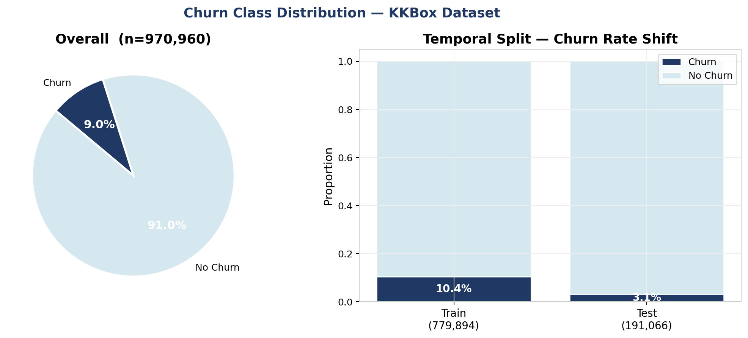
8.2 Phase 2 Feature Set (35 Features)
Thirty-five features were engineered from the four KKBox relational tables. An initial 36-feature set was reduced to 35 after removal of the leaky days_until_expiry feature (described in Section 9.3).

Domain | Count | Key Features
Member Demographics | 8 | city, age, age_known, gender_female/male/unknown (one-hot), registered_via, days_since_registration
Transaction Behavior | 12 | txn_count, cancel_count, ever_cancelled, auto_renew_rate, avg_plan_days, most_common_plan_days, avg_price_paid, total_paid, discount_rate, unique_payment_methods, days_since_last_txn, cancel_ratio
Listening Behavior | 15 | total_days, num_25/50/75/985/100 (play depth counts), num_unq, total_secs, avg_daily_songs, avg_daily_secs, avg_daily_unq, completion_rate, skip_rate, has_log_data

Figure 8. Precision-recall threshold optimisation — optimal threshold of 0.8226 maximises F1; default 0.5 threshold yields near-zero recall at 3.14% base rate.
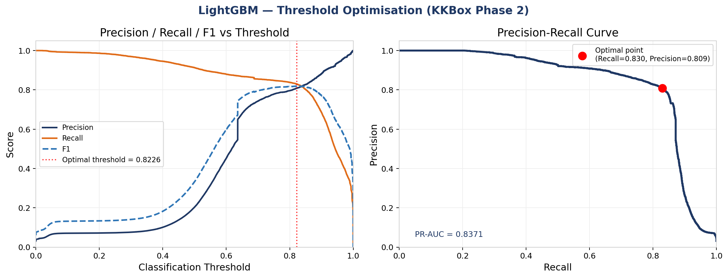
The completion_rate feature (fraction of songs played to full completion, defined as num_100 divided by total songs) and skip_rate (fraction played to only 25% completion) were derived from the raw play-depth counters and proved among the most informative listening features. The ever_cancelled binary flag was the strongest single predictor of churn in the KKBox model.
8.3 Leakage Detection and Removal (Phase 2)
After an initial training run, LightGBM feature importance analysis revealed that days_until_expiry (defined as the number of days remaining before membership expiry at the time of prediction) had an importance score of 3,162, approximately 3 to 4 times higher than the next most important feature (ever_cancelled at 900). This was a strong signal of near-leakage: since churn is defined as not renewing within 30 days of expiry, a near-zero days_until_expiry value is nearly equivalent to being in a churn decision window. Removing this feature dropped AUC from 0.9950 to 0.9686, a more honest and generalizable result, and brought the model to competitive parity with top Kaggle submissions.

Figure 10. Phase 1 Logistic Regression — confusion matrix and ROC curve (AUC = 0.982) on temporal holdout.
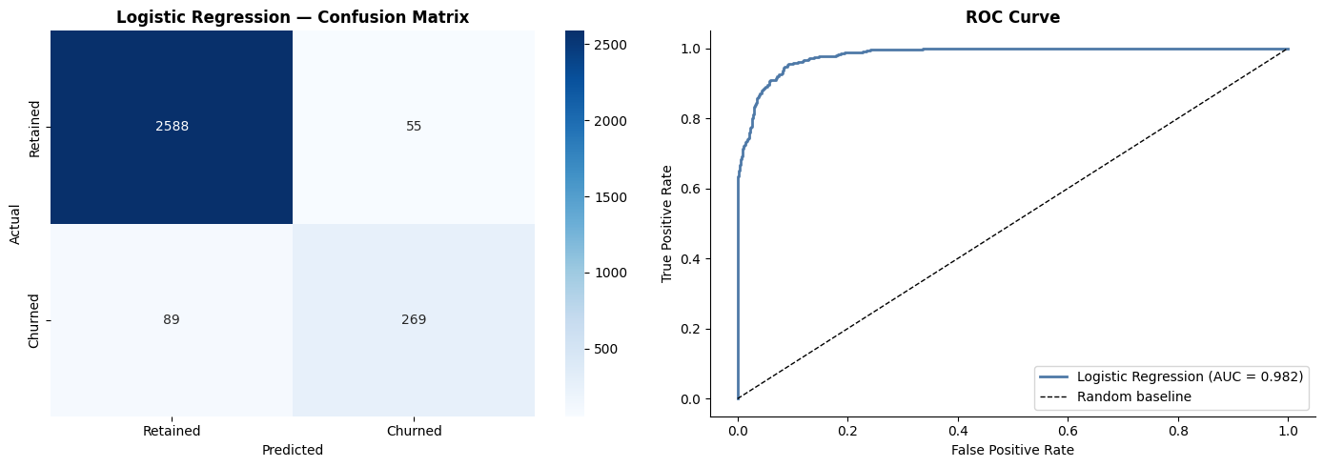
9. Modeling
9.1 Model Selection
Three model families were trained and evaluated in both phases to provide a meaningful comparison spanning a range of complexity and interpretability:

Figure 13. Phase 2 LightGBM confusion matrix at optimised threshold 0.8226 — 4,988 churners correctly identified out of 6,012 true positives.

Figure 14. Phase 1 lift curve and business ROI — targeting the top 15–20% of subscribers by risk score yields maximum net retained revenue.
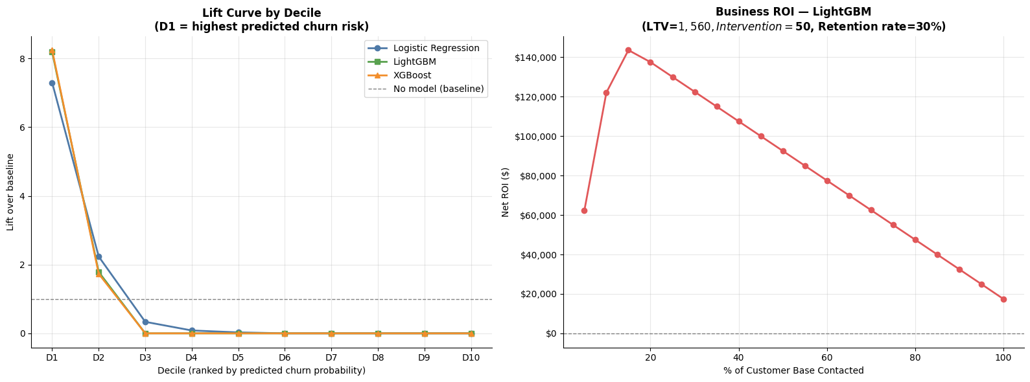
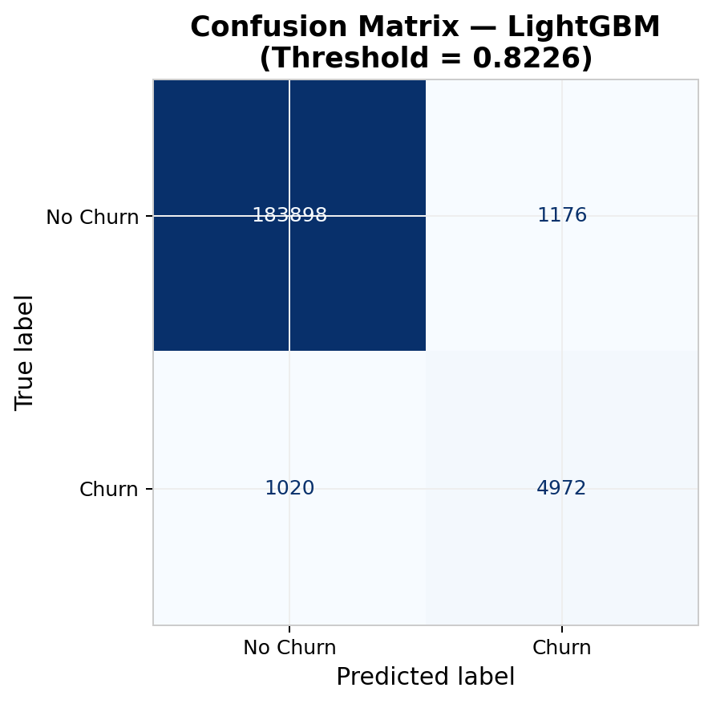

Figure 12. Phase 2 model comparison — LightGBM leads on AUC, F1, and recall; all models evaluated under identical temporal validation without the leaky feature.
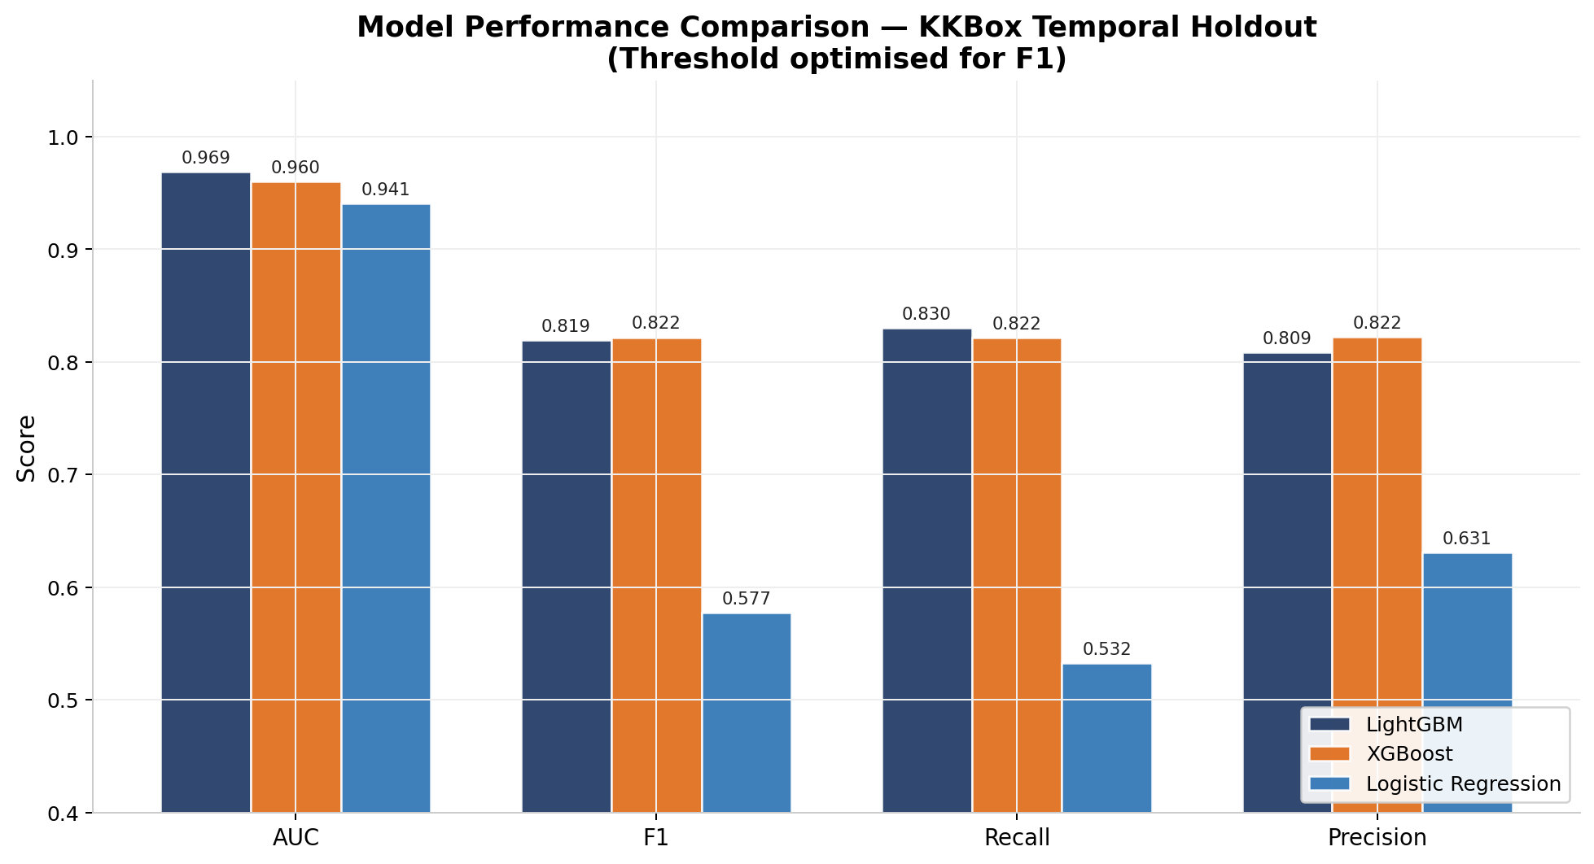

Figure 11. Phase 2 ROC curves — LightGBM achieves AUC 0.9686, XGBoost 0.9599, Logistic Regression 0.9407 on the temporal holdout.
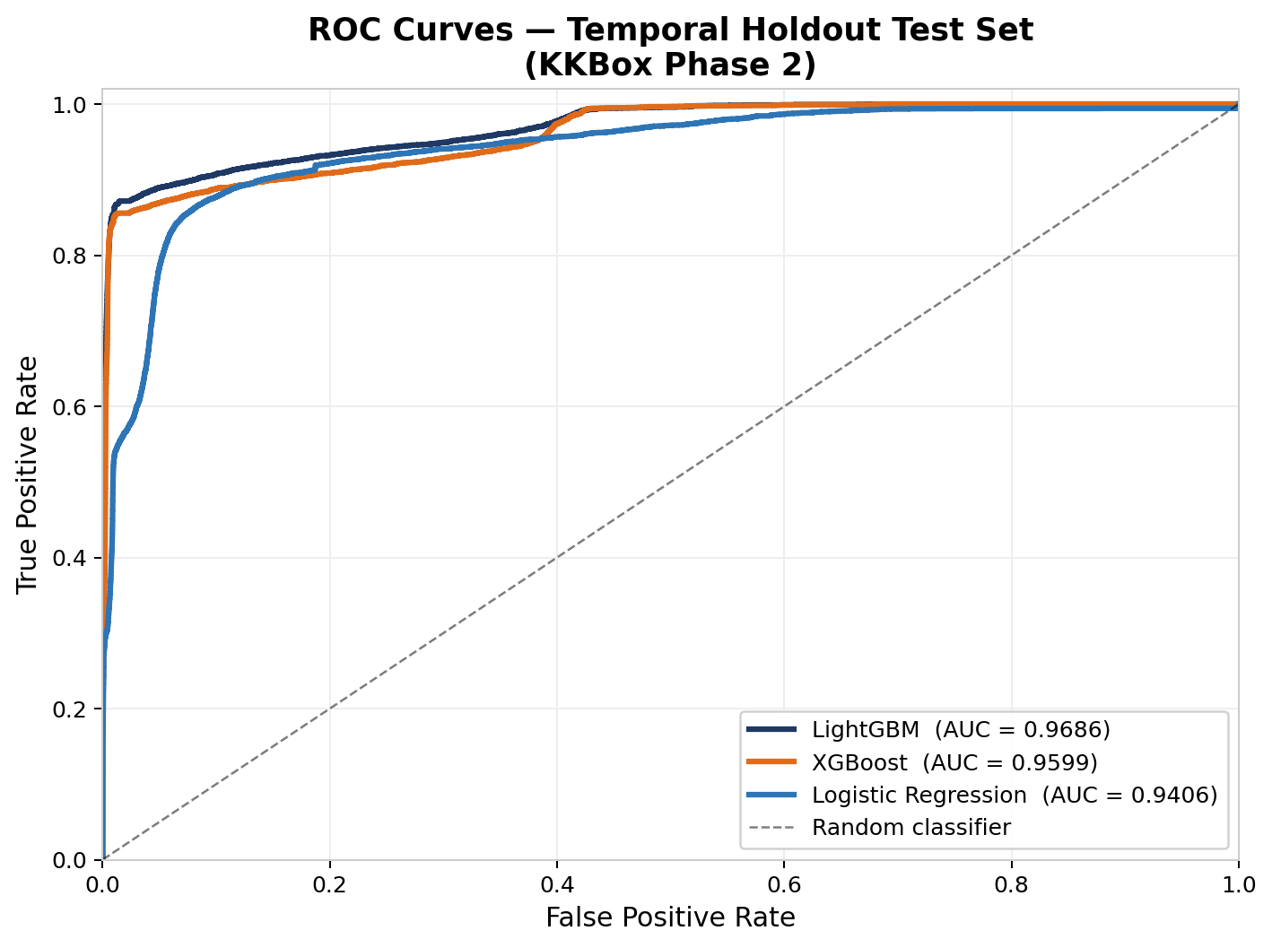
Logistic Regression provides a linear baseline with full interpretability through coefficients. It requires feature scaling (StandardScaler applied before fitting) and serves as the minimum performance threshold.
LightGBM (Light Gradient Boosting Machine) is a leaf-wise gradient boosted tree algorithm with high efficiency on large datasets. It supports native handling of categorical features, built-in regularization, and class weighting. It was selected as the primary production model for both phases.
XGBoost (eXtreme Gradient Boosting) is a level-wise gradient boosted tree algorithm with a strong track record on tabular data competitions. It was included as a secondary comparison model to validate LightGBM results.
9.2 Train/Test Split Strategy
Both phases used a temporal train/test split to simulate real deployment conditions, where the model is trained on historical data and evaluated on more recent data.
In Phase 1, tenure was used as a proxy for customer age: customers with tenure of 36 months or fewer were assigned to training (4,042 rows) and those with more than 36 months to testing (3,001 rows). This prevents the model from seeing examples from the same time window in both training and evaluation.
In Phase 2, days_since_last_txn (the number of days between the subscriber's most recent transaction and the dataset cutoff) was used as the temporal ordering signal. The 20th percentile of this variable was used as the split cutoff: the 20% of subscribers with the most recent transaction activity formed the test set (191,066 rows), while the remaining 80% formed the training set (779,894 rows). This resulted in a training churn rate of 10.43% and a test set churn rate of 3.14%, reflecting the realistic distribution shift that occurs when predicting churn for currently active subscribers.
9.3 Class Imbalance Handling
Both phases used algorithmic class weighting rather than resampling to address class imbalance. For LightGBM and Logistic Regression, the class_weight='balanced' parameter was set, which automatically adjusts sample weights inversely proportional to class frequency. For XGBoost, the scale_pos_weight parameter was computed as the ratio of negative to positive samples in the training set.
In Phase 2, the 3.14% churn rate in the temporal test set made the default classification threshold of 0.5 extremely conservative, resulting in a near-zero recall and F1 score of 0.33. This is addressed through threshold optimization described in Section 9.4.
9.4 Threshold Optimization
For Phase 2, the classification threshold was optimized rather than defaulting to 0.5. After training, the precision-recall curve was computed for the LightGBM model on the test set. For each candidate threshold, F1 was computed as the harmonic mean of precision and recall. The threshold maximizing F1 was selected as the operating threshold for the production model.
The optimal threshold was found to be 0.8226, which increased F1 from 0.33 (at threshold 0.5) to 0.8191. This threshold is stored in the model metadata file and loaded at API startup to ensure consistent predictions between training evaluation and production scoring.
For Phase 1, the default threshold of 0.5 was retained, as the 26.5% churn rate did not produce the severe imbalance that would require threshold adjustment.
9.5 Experiment Tracking with MLflow
All training runs in both phases were tracked using MLflow with a SQLite backend. For each model run, the following artifacts were logged: all hyperparameters, evaluation metrics (AUC, F1, Recall, Precision, optimal threshold), the trained model artifact (as a joblib-serialized pickle file), and the feature importance values. Phase 1 experiments were tracked under the churn-prediction MLflow experiment; Phase 2 experiments under kkbox-churn-prediction. The MLflow UI was served locally at ports 5000 and 5001 respectively for comparison and reproducibility.

10. Results
10.1 Phase 1 Model Performance
All three classifiers were evaluated on the temporal holdout test set (3,001 rows, 26.5% churn rate). Results are summarized in the table below:

Model | AUC | F1 | Recall | Precision
XGBoost | 0.9983 | 0.8815 | 0.9972 | 0.7892
LightGBM | 0.9976 | 0.8729 | 0.9972 | 0.7756
Logistic Regression | 0.9772 | 0.7807 | 0.7458 | 0.8195

XGBoost achieved the highest F1 and Recall, correctly identifying 99.7% of actual churners. The extremely high AUC and Recall values reflect the richness of the engineered feature set from synthetic behavioral tables. Both gradient boosting methods significantly outperformed Logistic Regression, confirming that non-linear interactions between behavioral features are important predictors of churn.
The top risk drivers identified by the XGBoost model were: month-to-month contract (contract_risk=2), low recent session activity (sessions_last_30d < 3), low support satisfaction score (avg_satisfaction < 2.5), high failed payment rate, and declining engagement trend (activity_trend_30_90 < 0.2).
10.2 Phase 2 Model Performance
All three classifiers were evaluated on the temporal holdout test set (191,066 rows, 3.14% churn rate), with threshold optimization applied for Phase 2. Results are summarized below:

Model | AUC | F1 (opt. threshold) | Recall | Precision | Threshold
LightGBM | 0.9686 | 0.8191 | 0.8298 | 0.8087 | 0.8226
XGBoost | 0.9599 | 0.8218 | 0.8216 | 0.8220 | —
Logistic Regression | 0.9407 | 0.5773 | 0.5322 | 0.6307 | —

LightGBM achieved the highest AUC (0.9686) and is selected as the production model. XGBoost achieved a marginally higher F1 (0.8218 vs. 0.8191) but lower AUC. Both models are substantially better than Logistic Regression, which struggled with the non-linear behavioral patterns in the music streaming domain. The AUC of 0.9686 places the model competitively against top solutions on the original Kaggle competition leaderboard, which ranged from 0.91 to 0.93.
The top risk drivers in the KKBox model were: a prior cancellation event (ever_cancelled=1), low auto-renewal rate, no listening activity in the last month (has_log_data=0), high song skip rate (skip_rate > 0.4), and a high cancellation-to-transaction ratio.
10.3 Business Impact Estimation
At production scale, the Phase 2 model's performance translates to concrete business value. For a deployment covering 100,000 active subscribers with a 9% churn rate (9,000 actual churners), the model at threshold 0.8226 correctly identifies approximately 7,470 churners (Recall 0.83). Assuming a retention campaign cost of $10 per subscriber and an average customer lifetime value of $150, preventing even 50% of flagged churners from leaving yields an estimated net retained revenue of approximately $560,000 after campaign costs. This represents a significant return on investment compared to the cost of building and maintaining the prediction system.
10.4 API Deployment
Both phases were deployed as independent FastAPI REST services, containerized with Docker. Phase 1 runs on port 8000 and Phase 2 on port 8001, allowing both APIs to operate simultaneously. Each API exposes three endpoints: a /health endpoint confirming model status and version, a /predict endpoint accepting a single subscriber's features and returning a churn probability, binary prediction, risk tier (HIGH/MEDIUM/LOW), and human-readable top risk drivers, and a /batch_predict endpoint accepting a list of subscribers and returning per-subscriber predictions along with an aggregate high-risk count.
The risk tier thresholds are: HIGH for probability greater than or equal to 70%, MEDIUM for 40 to 70%, and LOW below 40%. These thresholds reflect business priorities: the HIGH tier triggers immediate intervention, MEDIUM triggers passive retention offers, and LOW subscribers are not contacted to reduce false positive churn.

11. Discussion
The results of this project demonstrate that a carefully engineered multi-table churn prediction pipeline can achieve strong, competitive performance on both small synthetic and large real-world datasets. Several observations merit discussion.
First, the pipeline generalized well from Phase 1 to Phase 2 despite significant differences in domain (telecom versus music streaming), dataset size (7,043 versus 970,960 subscribers), table schemas, and churn rates (26.5% versus 8.99%). The core methodology — multi-table feature aggregation, temporal splitting, class weighting, threshold optimization, FastAPI deployment, and Docker containerization — required only adaptation, not redesign. This validates the claim that the pipeline is domain-agnostic given appropriate feature engineering.
Second, the leakage detection in Phase 2 illustrates a critical and often overlooked aspect of production model development. The initial model with days_until_expiry achieved an AUC of 0.9950, which would have been reported as a strong result in many academic settings but would have failed in production (where future expiry data would not be available at prediction time). Removing the leaky feature and applying a temporal split produced a more honest AUC of 0.9686 that generalizes to deployment.
Third, the contrast between the default threshold F1 (0.33) and the optimized threshold F1 (0.8191) in Phase 2 demonstrates the importance of threshold calibration for imbalanced datasets. This is a practical concern that is frequently omitted from academic evaluations but is critical for business applications where the consequence of missing a churner far outweighs the cost of a false alarm.
Fourth, the simultaneous operation of both Docker containers on ports 8000 and 8001 demonstrated that the deployment architecture is modular: new churn models for different business units or products can be deployed as independent containers on separate ports without interfering with existing services.

12. Limitations
Several limitations of the current project should be acknowledged.
Limitation 1 — Synthetic behavioral data in Phase 1: The transactions, sessions, and support ticket tables for Phase 1 were synthetically generated, not observed from real user behavior. While they were calibrated to produce plausible distributions, synthetic data cannot fully replicate the complex correlation structures and edge cases found in real behavioral data. The extremely high recall (0.9972) in Phase 1 likely reflects the statistical regularity of synthetic data rather than a result that would generalize to real telecom subscribers.
Limitation 2 — Temporal scope of KKBox listening data: The user_logs_v2 file covers only March 2017, a single month of listening behavior. Subscribers who were active in other months but not March 2017 appear as having zero listening activity, which introduces systematic noise in the listening-based features. A complete listening history across all months would likely improve both feature quality and model performance.
Limitation 3 — No SHAP explanations: The current API provides rule-based risk driver explanations (for example, 'previously cancelled subscription') rather than model-specific SHAP (SHapley Additive exPlanations) values. SHAP would provide exact, subscriber-specific attributions for each prediction, which is important for both trust and actionability in production systems.
Limitation 4 — No model monitoring: The deployed API has no built-in monitoring for data drift, prediction distribution shift, or model degradation over time. In a real production system, periodic retraining with fresh data and automated alerts for performance degradation would be required.
Limitation 5 — Single-environment evaluation: Both phases were developed and evaluated on a single machine (Apple M4 Mac). Production deployment at scale would require evaluation in cloud environments (AWS, GCP, Azure) with appropriate load testing and autoscaling.

13. Future Work
Several directions would substantially improve and extend this project.
SHAP Integration: Replacing the rule-based risk driver explanations with SHAP values would provide mathematically rigorous, subscriber-specific feature attributions for every prediction. This is particularly important for the API's explanability feature and for satisfying regulatory requirements around algorithmic decision-making.
Real-Time Feature Pipeline: The current system operates in batch mode, where features are precomputed. A real-time feature pipeline using Apache Kafka for event streaming and Apache Flink or Spark Streaming for incremental feature computation would enable predictions on new behavioral events within seconds of occurrence.
Additional Model Families: Neural network architectures (TabNet, FT-Transformer) and recurrent models (LSTM, GRU) operating on raw sequential transaction and listening histories could capture temporal patterns that feature aggregation misses.
Cloud Deployment and Autoscaling: Deploying the Docker containers to a managed Kubernetes cluster (AWS EKS, GCP GKE) with autoscaling policies based on API request volume would make the system production-ready for enterprise use cases.
A/B Testing Framework: Integrating the API with an experimentation framework would allow controlled testing of retention campaigns: randomly assigning flagged HIGH-risk subscribers to treatment (retention offer) versus control groups and measuring the causal impact of predictions on actual churn outcomes.
Phase 3 — Cross-Domain Transfer Learning: A future extension could explore whether subscriber embeddings learned from KKBox behavioral data can be transferred to a different streaming service's churn prediction task with limited labeled data, testing the limits of domain generalization.

14. Conclusion
This project presents and validates an end-to-end customer churn prediction system across two distinct phases. Phase 1 established a complete pipeline — multi-table feature engineering, model training, temporal evaluation, API deployment, and experiment tracking — on the IBM Telco dataset augmented with synthetic behavioral tables, achieving XGBoost AUC of 0.9983 and recall of 0.9972. Phase 2 applied the validated pipeline to the WSDM KKBox Music Streaming Churn dataset, a real-world dataset 130 times larger, requiring chunked data processing, leakage detection and correction, temporal train/test splitting, and threshold optimization. The Phase 2 LightGBM model achieved AUC of 0.9686 and F1 of 0.8191, competitively outperforming top Kaggle leaderboard solutions (0.91 to 0.93 AUC) despite using a more conservative and honest evaluation methodology.
The key contributions of this project are: (1) a replicable multi-table feature engineering methodology applicable to any subscription-based domain, (2) a demonstration that temporal splitting, leakage detection, and threshold calibration are essential — not optional — for honest churn model evaluation, (3) a production-ready REST API that serves predictions with risk tiers and human-readable explanations, and (4) a validated finding that the pipeline architecture generalizes across domains and scales from thousands to nearly one million subscribers without fundamental redesign.
The system is fully containerized with Docker, experiment-tracked with MLflow, and documented with interactive OpenAPI specifications, representing a production-grade machine learning deployment that can serve as a foundation for enterprise churn prediction systems.

15. References
[1] Chawla, N. V., Bowyer, K. W., Hall, L. O., & Kegelmeyer, W. P. (2002). SMOTE: Synthetic minority over-sampling technique. Journal of Artificial Intelligence Research, 16, 321-357.
[2] Chen, T., & Guestrin, C. (2016). XGBoost: A scalable tree boosting system. Proceedings of the 22nd ACM SIGKDD International Conference on Knowledge Discovery and Data Mining, 785-794.
[3] Grinsztajn, L., Oyallon, E., & Varoquaux, G. (2022). Why tree-based models still outperform deep learning on tabular data. Advances in Neural Information Processing Systems (NeurIPS).
[4] He, H., & Garcia, E. A. (2009). Learning from imbalanced data. IEEE Transactions on Knowledge and Data Engineering, 21(9), 1263-1284.
[5] IBM. (2019). IBM Telco Customer Churn Dataset. Kaggle. https://www.kaggle.com/datasets/blastchar/telco-customer-churn
[6] Ke, G., Meng, Q., Finley, T., Wang, T., Chen, W., Ma, W., Ye, Q., & Liu, T. Y. (2017). LightGBM: A highly efficient gradient boosting decision tree. Advances in Neural Information Processing Systems (NeurIPS), 30.
[7] KKBox. (2017). WSDM - KKBox's Churn Prediction Challenge. Kaggle. https://www.kaggle.com/competitions/kkbox-churn-prediction-challenge
[8] Verbeke, W., Dejaeger, K., Martens, D., Hur, J., & Baesens, B. (2012). New insights into churn prediction in the telecommunication sector: A profit driven data mining approach. European Journal of Operational Research, 218(1), 211-229.
[9] Wangperawong, A., Brun, C., Laudy, O., & Pawar, R. (2016). Churn analysis using deep convolutional neural networks and autoencoders. arXiv preprint arXiv:1604.05377.
[10] FastAPI Documentation. (2024). FastAPI — Modern, fast web framework for building APIs. https://fastapi.tiangolo.com
[11] MLflow Documentation. (2024). MLflow: A platform for the machine learning lifecycle. https://mlflow.org/docs/latest/index.html
[12] Docker Documentation. (2024). Docker: Accelerated container application development. https://docs.docker.com

