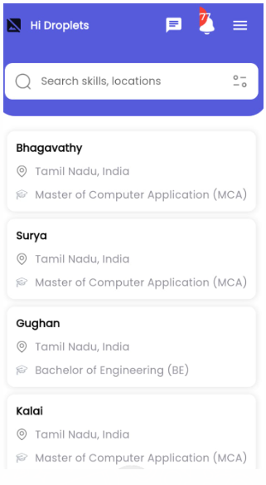

We should be which post we are getting

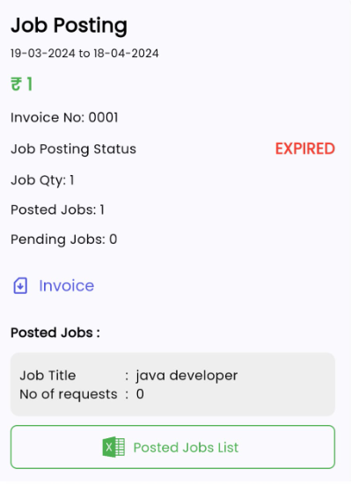

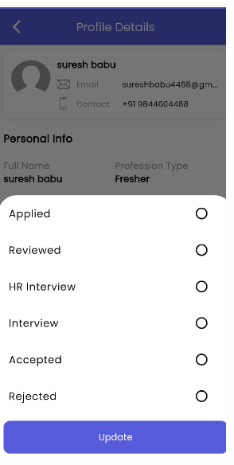

Still we have april but the status is reflecting Expired

It should have option Appiled 20 and Viewed 18

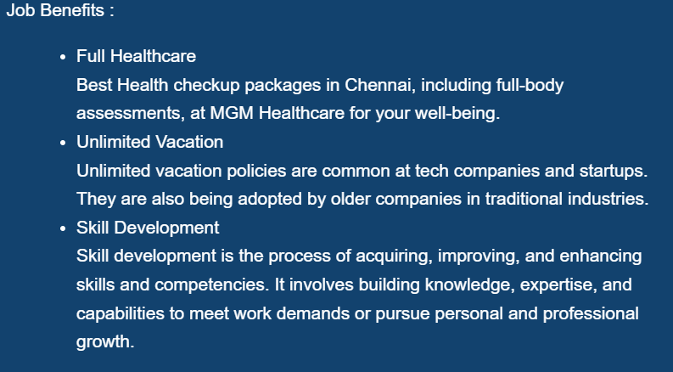

Give them option to delete are only Points Full health care ,

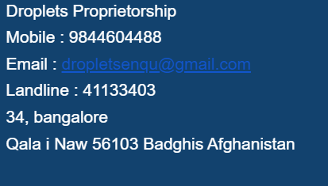

Remove the contact number are hiding option

Remove the Proprietor ship

Employer is not getting mail

How to see the people applied for it

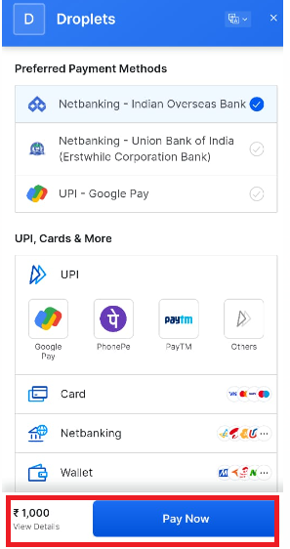

Location is afganstian but payment is reflecting in Rupees only

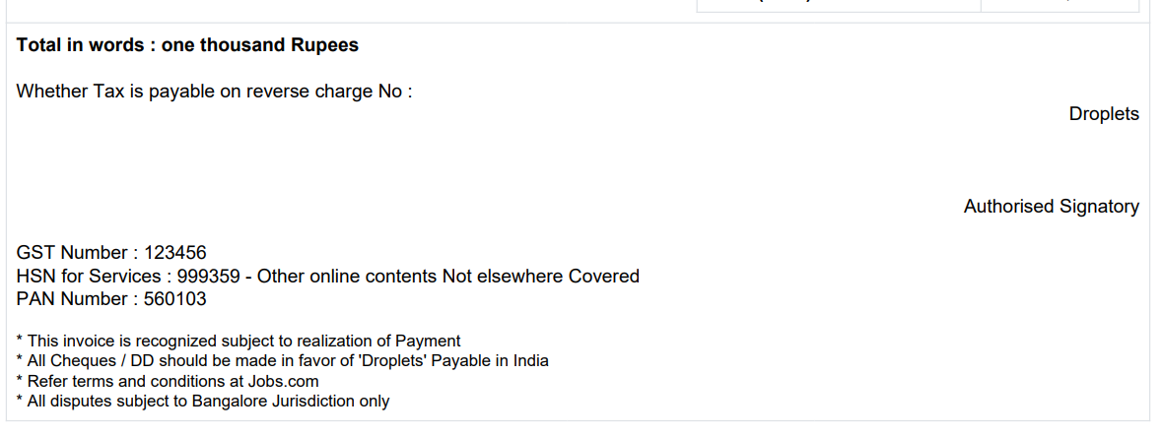

GST Number : 29BEQPP9186P1ZZ

PAN Number : BEQPP9186P

HSN for service 998311

Refer terms and condition at jobeasyee.com

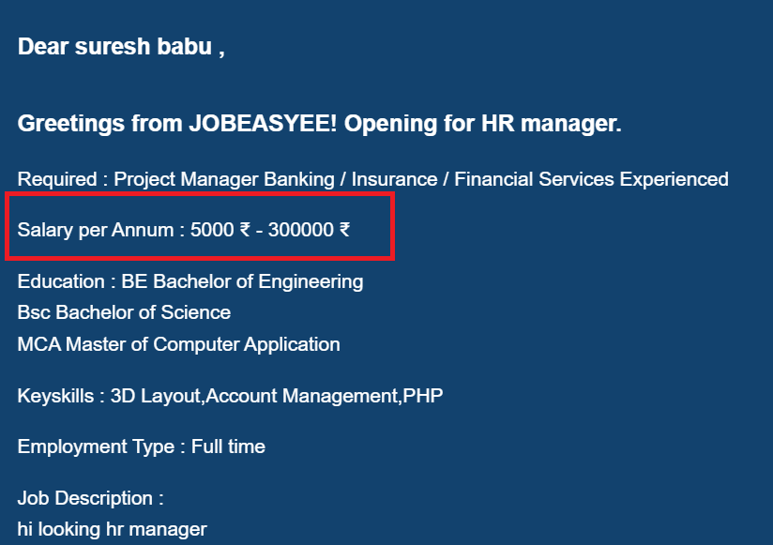

While Posting add Salary was hiden but it reflecting in add

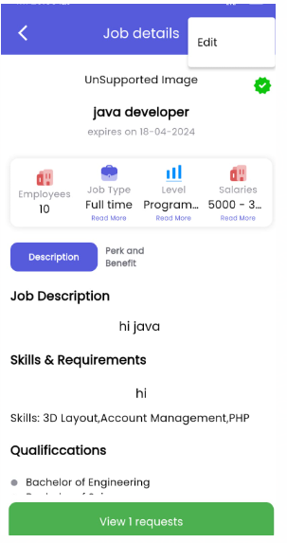

Once add is placed they should able to edit are make any changes

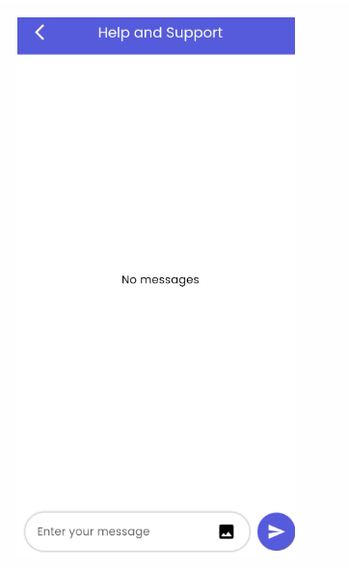

If we are offline, Message should

Our working Monday to Friday 9 to 6 clock

Please drop your message we will get back to you at earliest

You can call to customer service number +91 9740449939

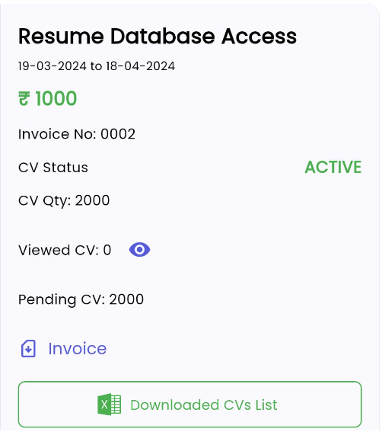

Explain how to download the resume

And explain how to use dashboard