Chat while replying message it is reflecting

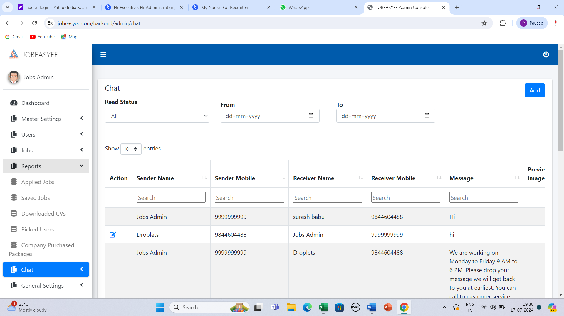

What is Industries? In Job Preference page it is used

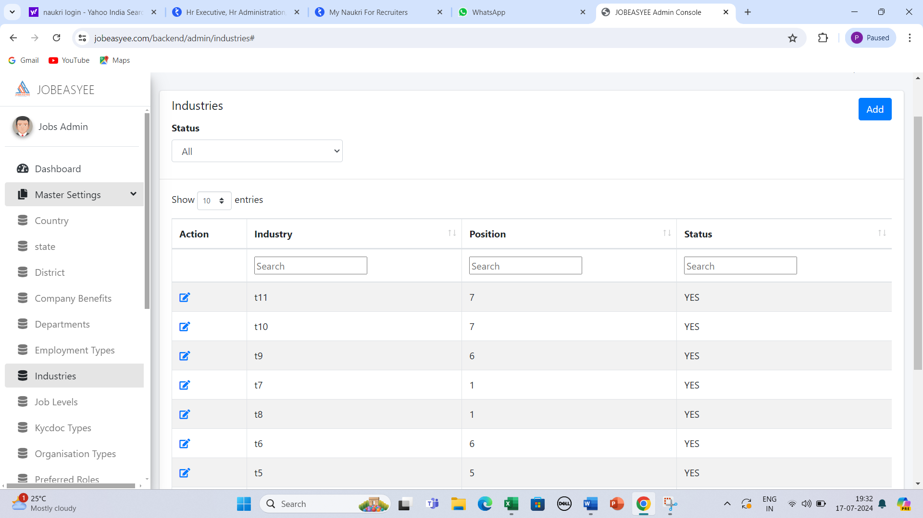

Skill and Key words both should be update by employee and Employer it should get saved if any spelling mistake we should able correct it ,Because every day there will new skill will be there



How to enter the purchase of database are Job Posting

If we select % it will consider what bases value will be calculated

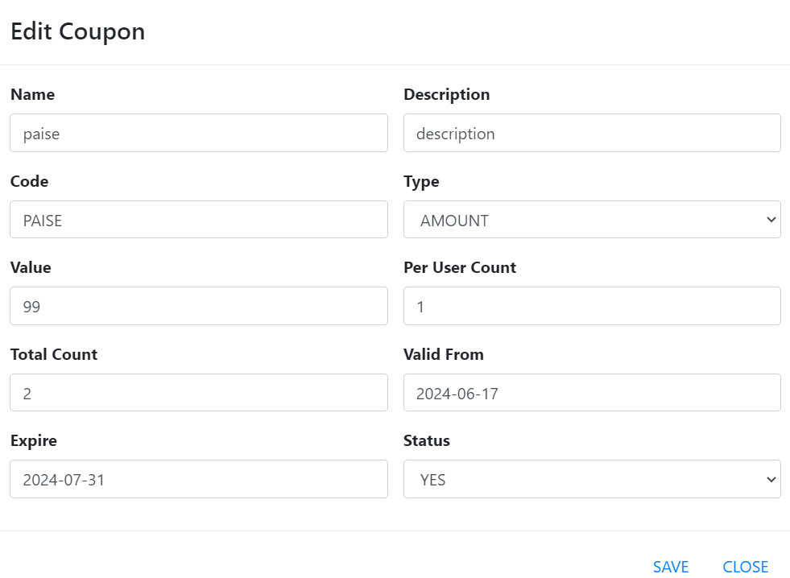

Edit option for Jobs if need block option should be there

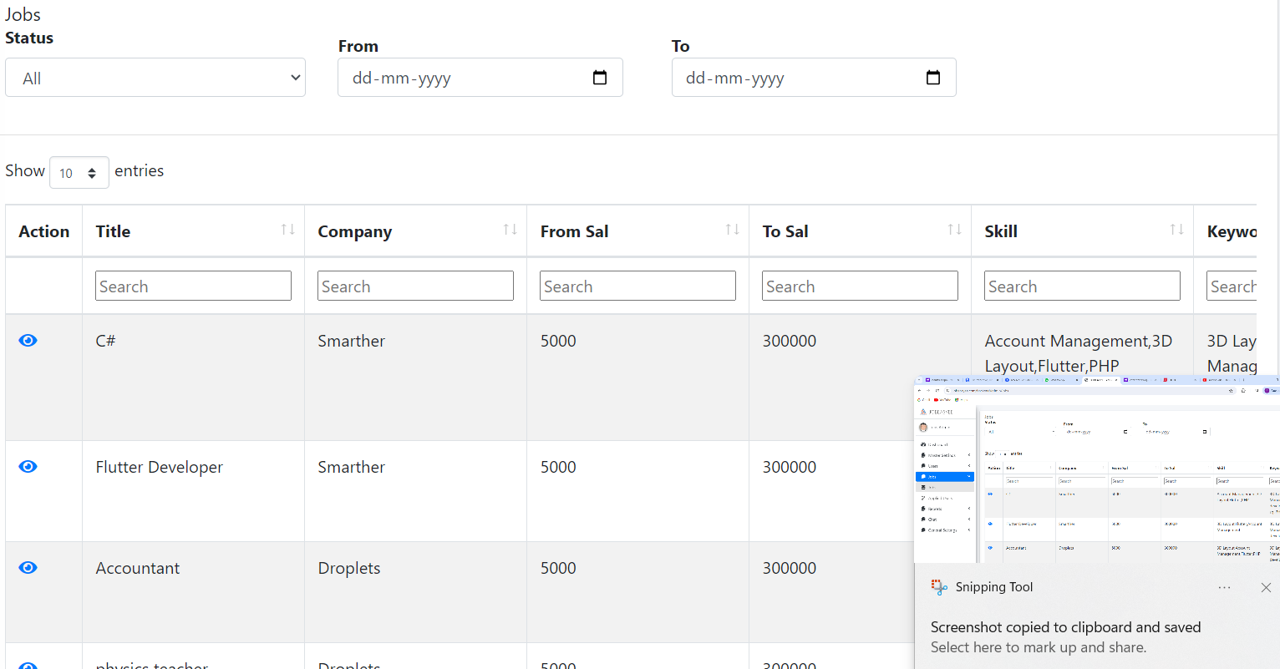

Add Qualification/Job Type/Country/State

Excel Download option need to provide

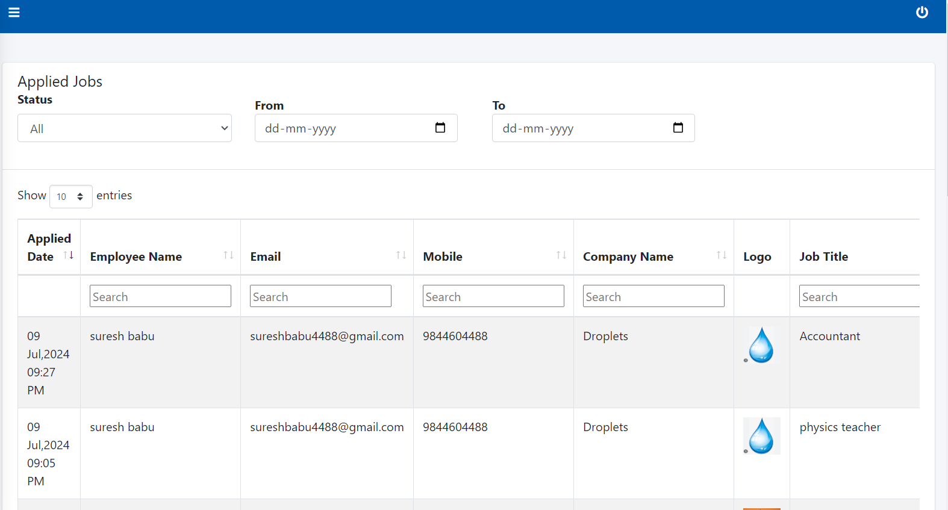

Add excel for downloading details

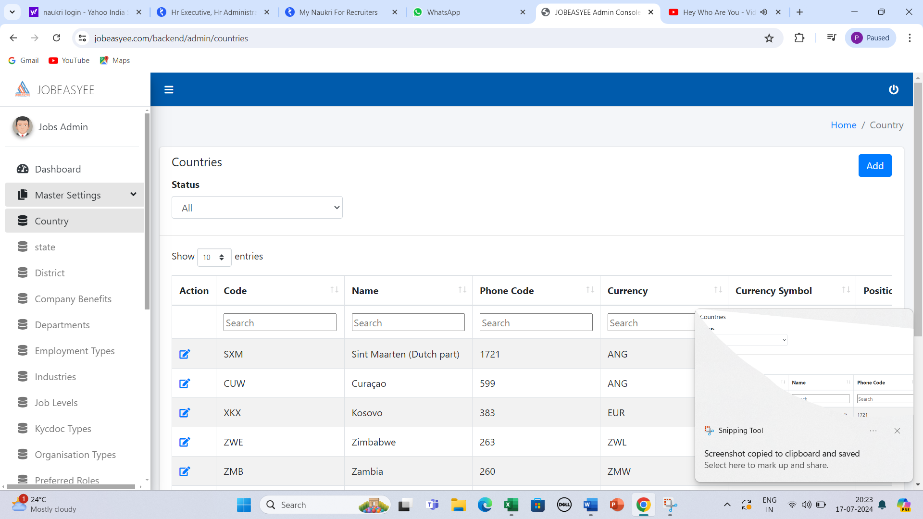

We should full edit option and Documents can download and delte option

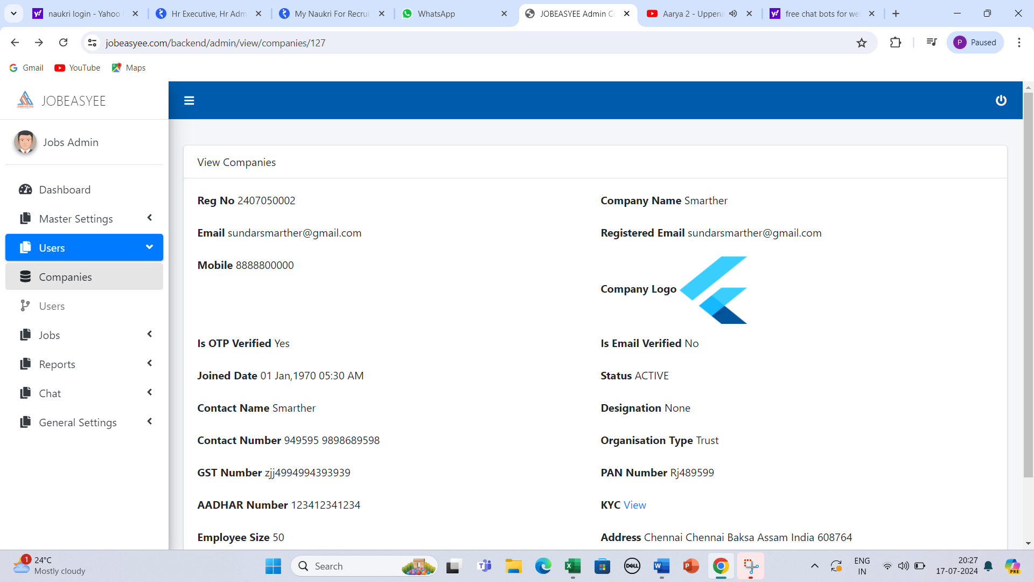

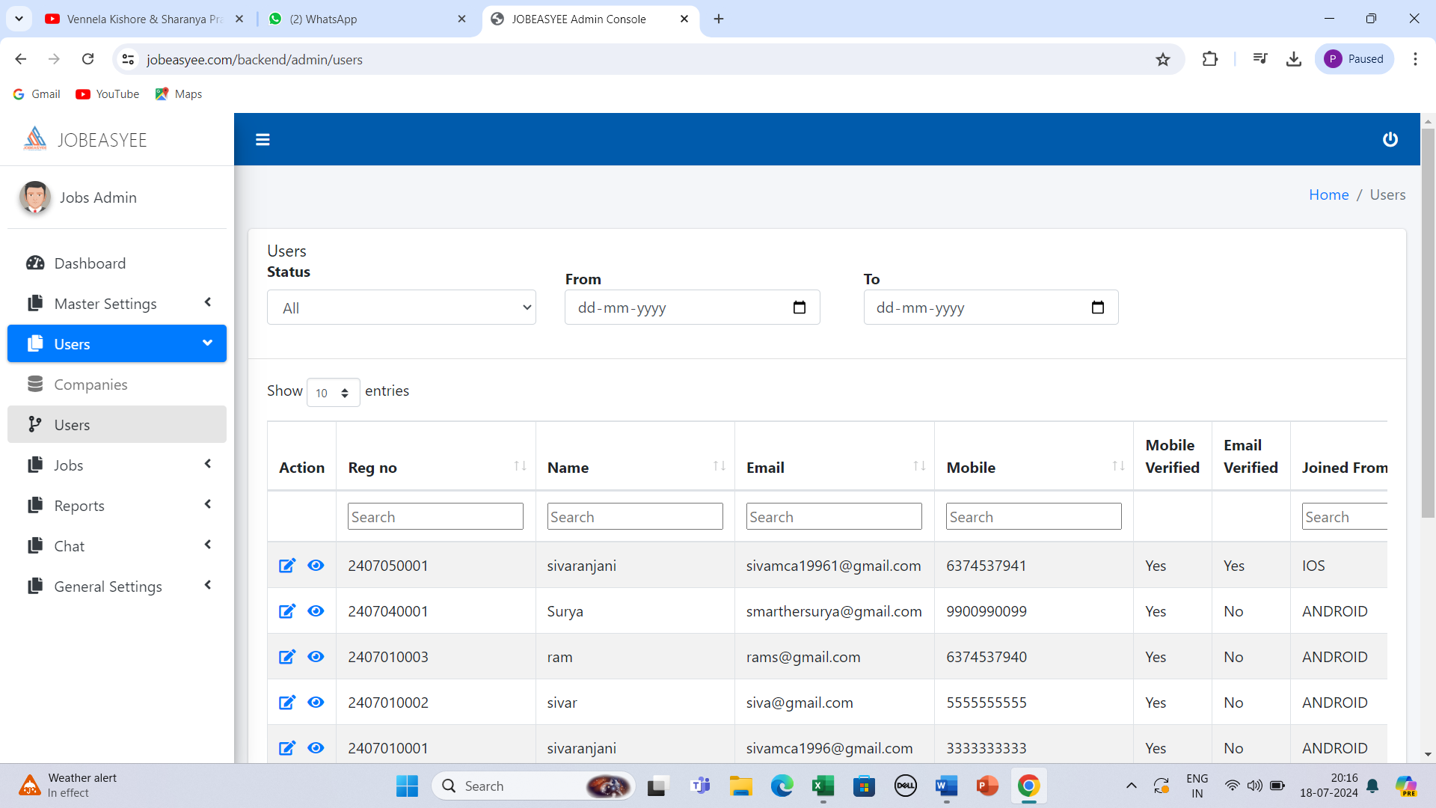

Add qualification/Country/State/City/Address/Expernice/key skill/Industry/department/Prefered LOCATION/Desgination/present Company/Total Expernice/date of Birth

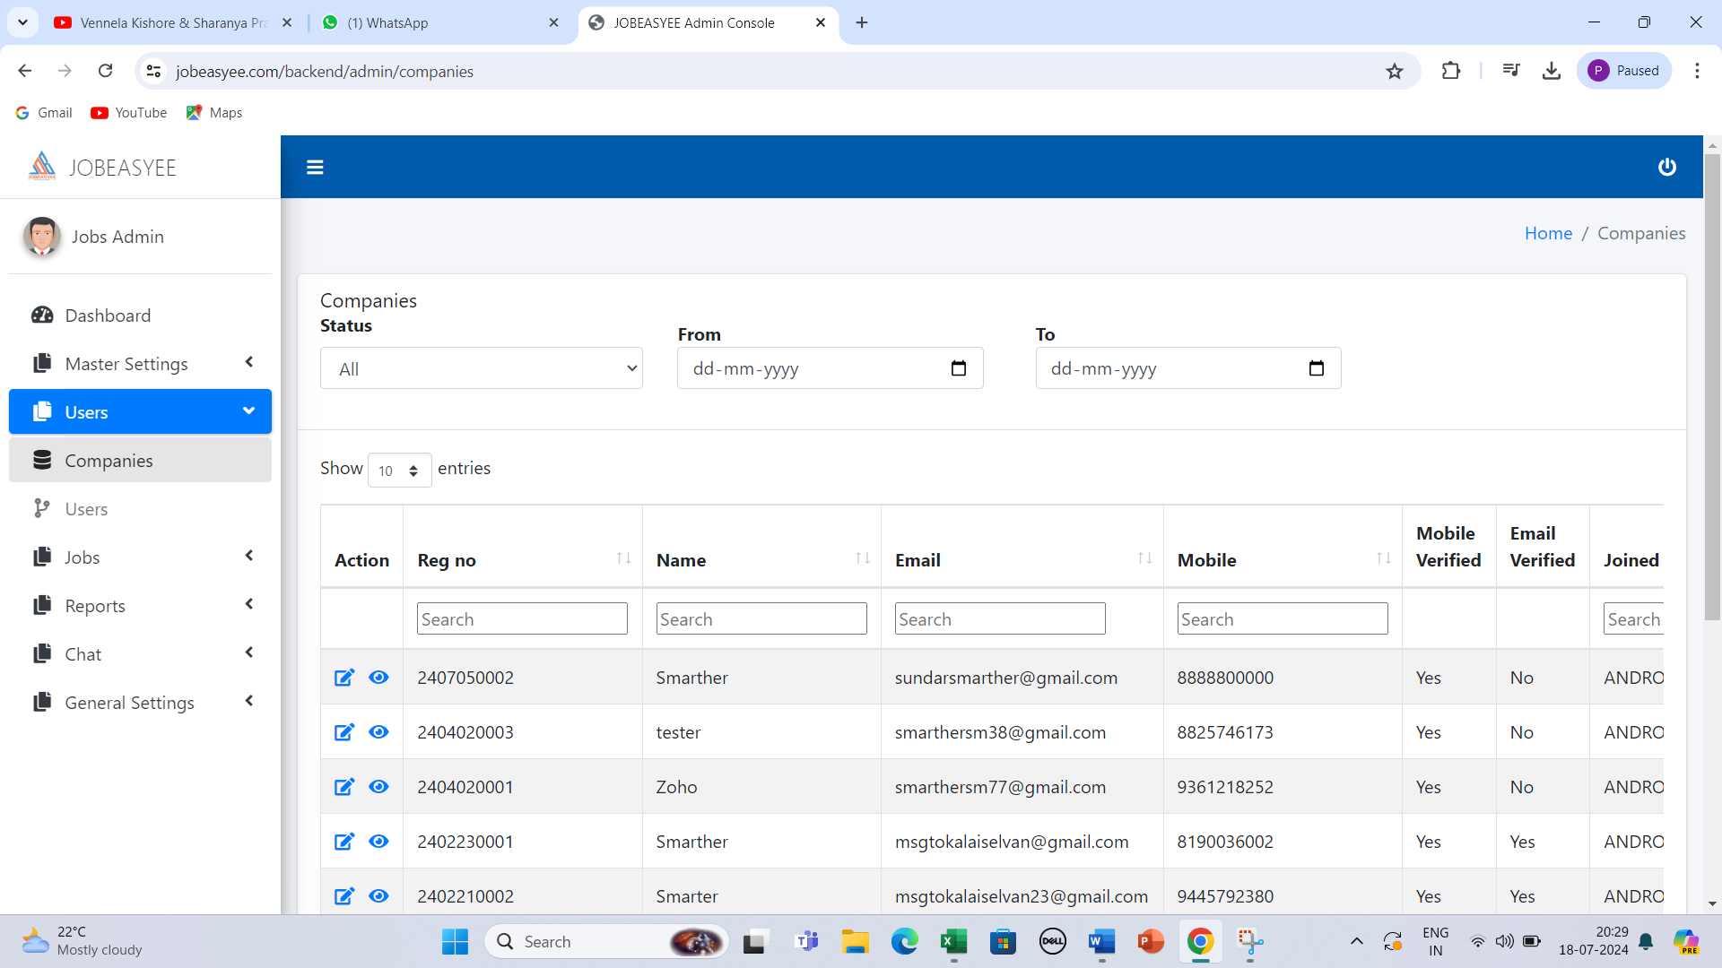

Type of Organisation/Gst Number/Pan card/Aadhar card/Address/State/Country/City/Zip Code/Skill/Keyskill

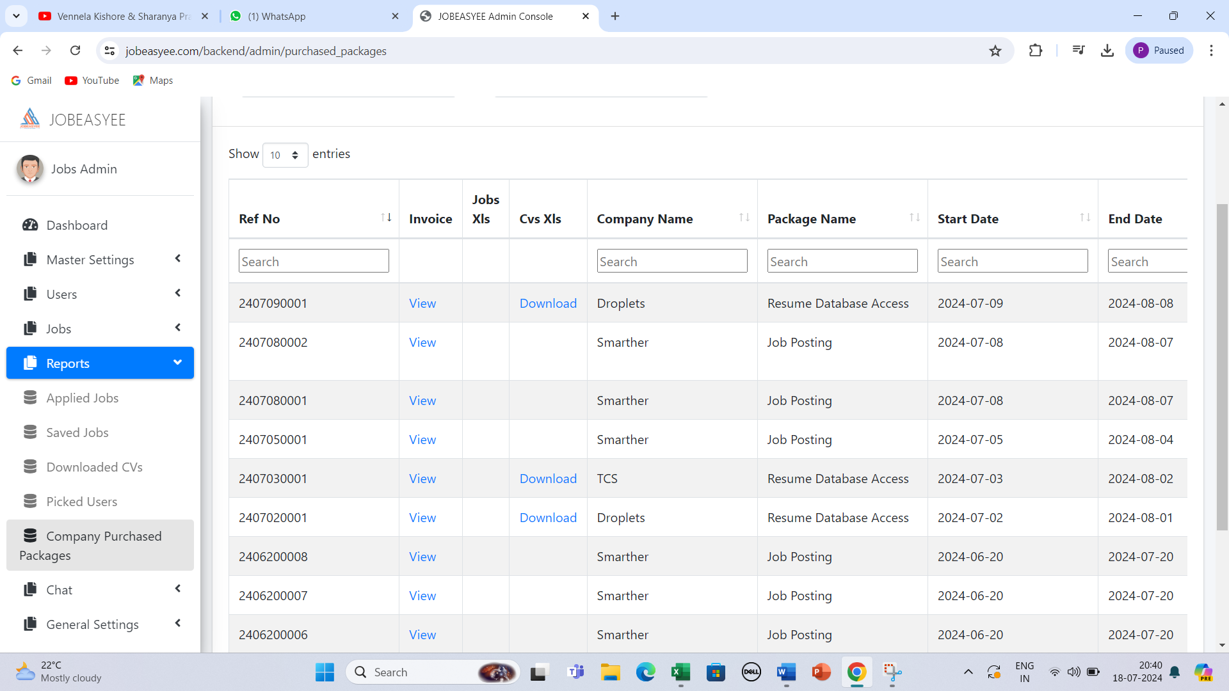

Invoice Number

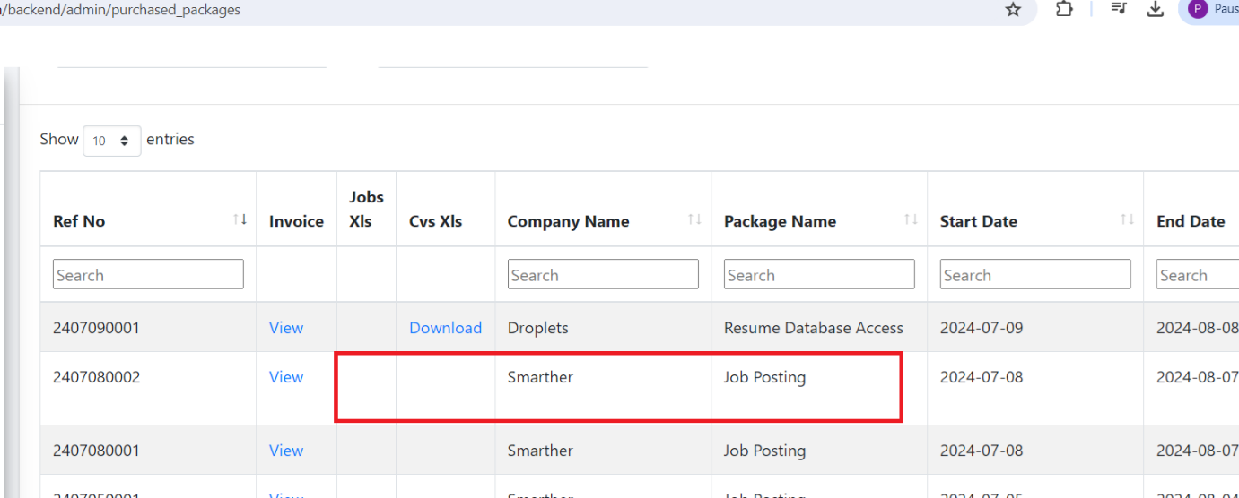

JOB Posting Excel download should be reflected

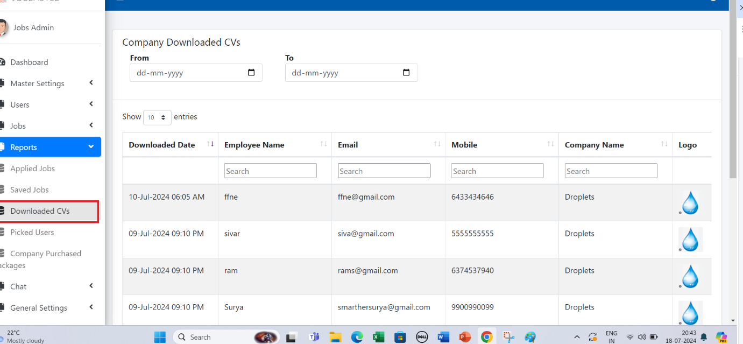

Qualification/City /Country/Total Expernice / Present Company/Salary/skill/Key Skill

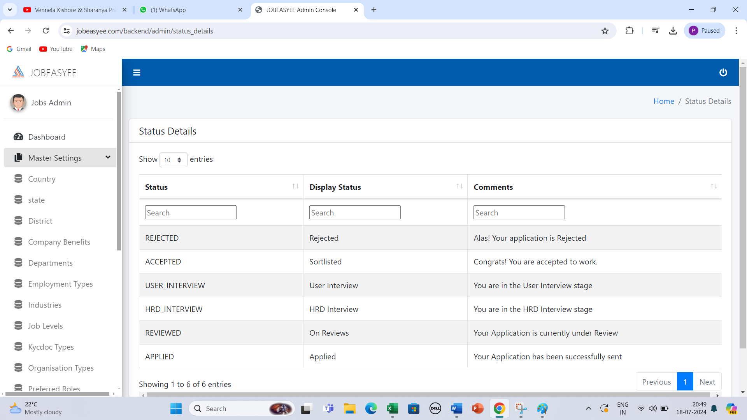

Need to provide the add /Delete/edit

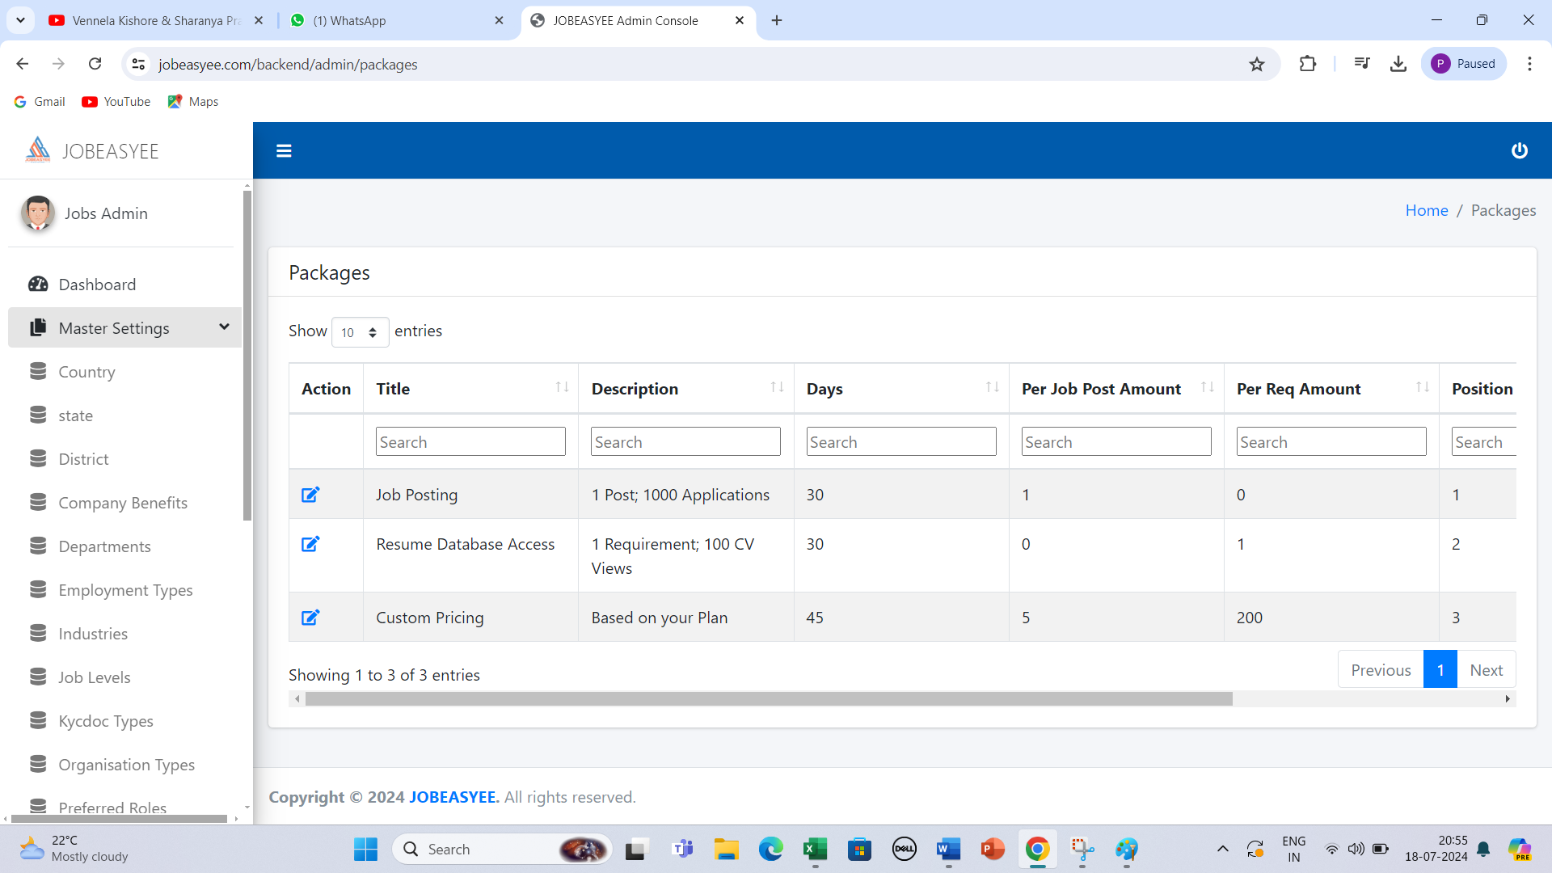

Need to Provide the Edit option

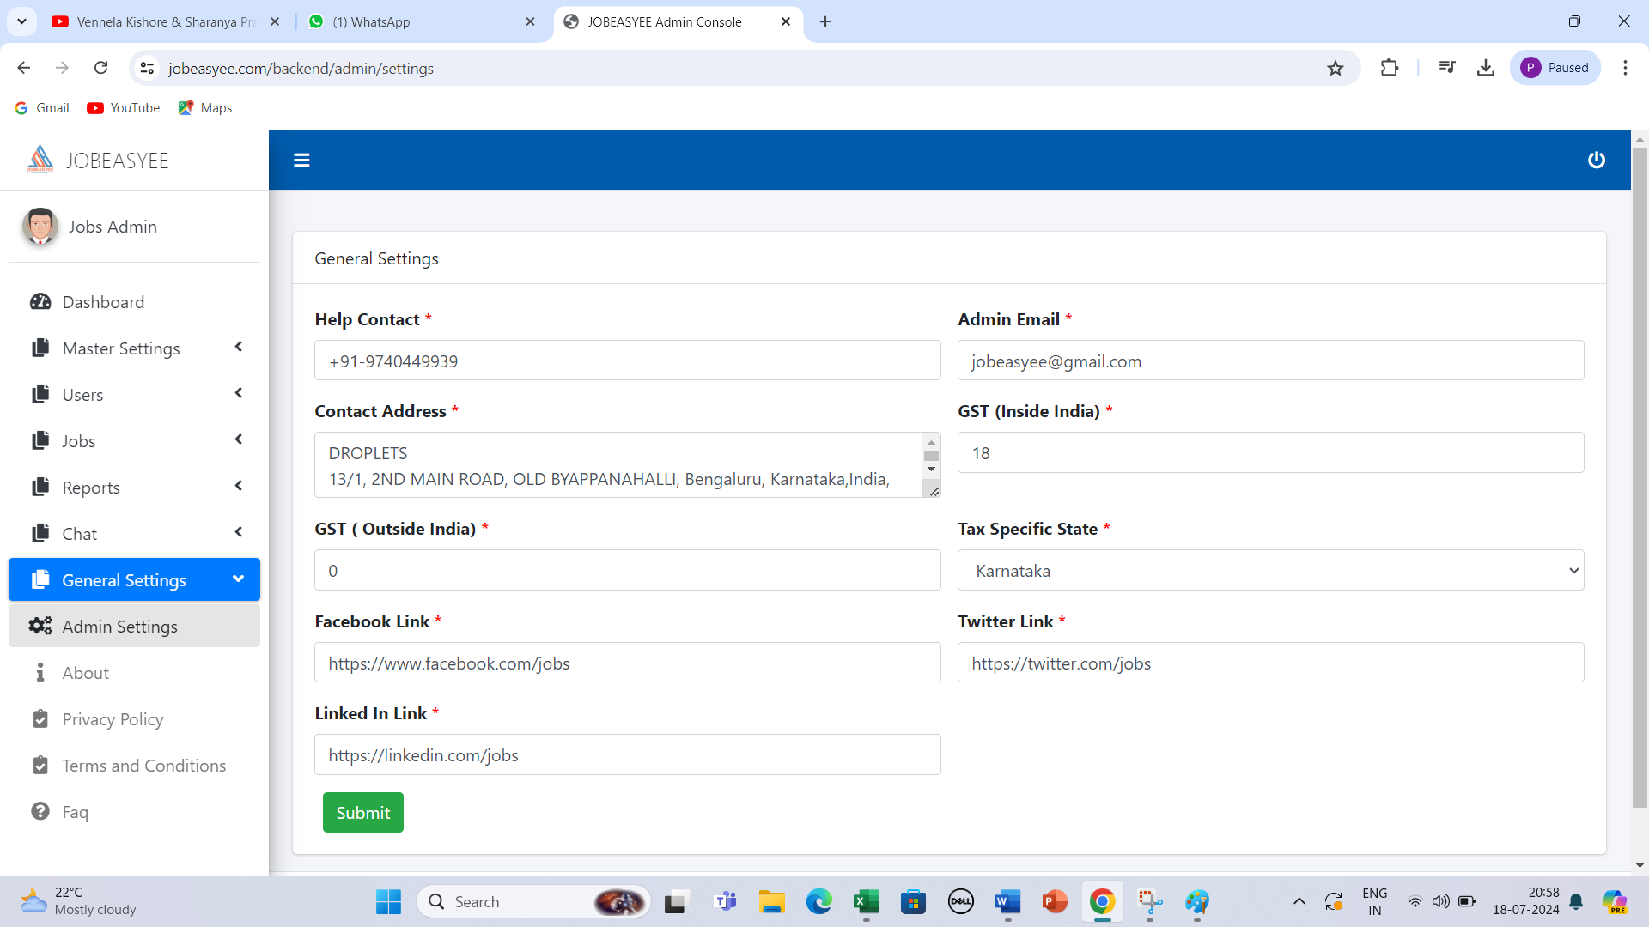

CGST and SGST option should be provide

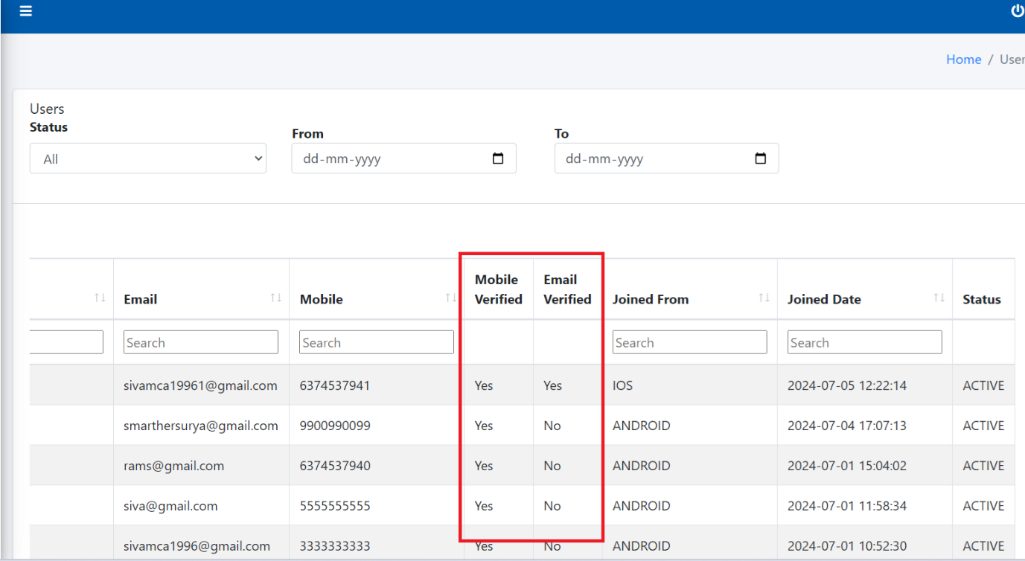

Email Verified after that it will get completed

Payment Reconsolidation format report need to Added