Praetorians Map Editor Tutorial 3: Texturing

Written by Paulus 6/26/04.
Email: pauldls@hotmail.com

Selecting and applying textures.

As you well know a Praetorians map is made up of tiles, and each tile is split into 4 square polygons, thus each tile is a square made up of 3x3 vertices. Applying textures is on the tile level, and not the polygonal. Each tile has a primary texture and a secondary texture, the significance for this will be explained shortly. The current mode is shown in the primary and secondary check boxes, and the current working texture number is show below the “change” button. To change you texture simply click on the “change” button and a dialog box will come up showing you all the textures available, simply click on the one you want and click ok. Alternatively you can change the texture number in the field manually. Applying the selected texture onto the map is as simple as clicking and dragging.

Creating smooth blends between different texture areas

If you have textured your map you’ll notice that it is quite bland and the different textures (for example grass and dirt) do not transition smoothly. This is where the primary and secondary textures come into play. As said before each tile has to it assigned a primary and secondary texture, to create smooth transitions we have the secondary blend into the primary. Each vertex has an RGBA color, the “RGB” naturally for the color and the “A” for the alpha. If the alpha is 0 (lowest) then the primary texture will show 100%, if the alpha is 255 (highest) then the secondary texture will show 100%, inbetween will yield expected results. On the geometry tab you can paint the alpha of each vertex and the slider dictates what the opacity.

Surely this makes little sense so let me explain graphicly. Consider the following crude ASCII illustration of some tiles:

*===*===* ===*
| AA | AB | BB |
*===*===* ===*
| AA | AB | BB |
*===*===*===*
| AA | AB | BB |
*===*===*===*
Let us say that “A” is grass and “B” is dirt, and that the listing is primary, secondary. So a tile that is AB is grass as primary and dirt secondary. Here in this illustration is a typical application; two different fields of textures running alongside one another and the desire for a natural transition. The tiles on the left and right both have the same primary and secondary textures, so there is no blending. The tile in the middle has the primary and secondary of the neighboring primaries. Now you can edit the Alpha and get the desired results, what level of opacity you apply to the vertices is up to you, however 50-50 is a good rule of thumb.

And here is the result in the editor with the left vertices of the middle tile 255 the center vertices 127 and the right vertices 0:

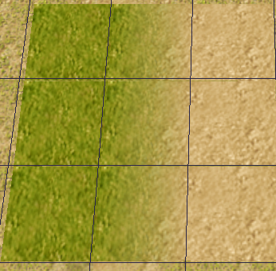

Editing in photoshop

You can edit the vertex colors and alpha by exporting and importing the vertex colors from the editor to photoshop. To export from the editor terrain menu -> “Exprt vertex colors”.

