**IoT 2023 CHALLENGE 3**

## INTERNET OF THINGS - 054323

## *Prof Cesana Matteo*

*P.hD Fabio Palmese*

(1) Name: Gustavo Santos Torrico Person Code: 10911816

(2) Name: Claudia Baz Alvarez Person Code: 10916443

## Index

**Methodology 1**

**System Architecture 1**

RadioRoute.h 1

RadioRouteApp.nc 2

RadioRoute.nc 2

Interface declarations 2

Functionalities definition and Flow Diagram 3

**Bibliography 5**

## Methodology

This laboratory challenger was based on the documents presented in class[1] and the base code provided by previous laboratories.

Based on the documentation provided the flux diagram of the project was drawn to gain a more intuitive understanding of the system and to help develop the code base.

Sequentially, the base code of the TinyOS laboratory was imported as a base model. Even Though the functionalities were different, the main function calls of the *<component>.nc* were practically the same.

Finally, as a method to evaluate the optimality of the code and to help its debug, the *dbg()* function was used to output the program.

## System Architecture

The based code is composed of mainly three components[2]:

### RadioRoute.h

Where the message payload type is defined. All the packets have the same interface, using the payload attributes as needed. The interface ahead is the one used by the nodes to exchange packets:

#ifndef RADIO_ROUTE_H

#define RADIO_ROUTE_H

typedef nx_struct radio_route_msg {

    /*

    type: defines the message format

        0 - DATA MSG

        1 - ROUTE_REQ MSG

        2 - ROUTE_REPLY

    */

    nx_uint16_t type;

    nx_uint16_t src;  // Sender

    nx_uint16_t dest; // Node Requested

    /*

    value: defines msg payload

    The meaning of the value attr changes

    with the type of the msg:

        if DATA MSG  - led value

        if ROUTE_REQ - none

        if REPLY_REQ - hop_count

    */

*Figure 1: RadioRoute.h component, definition of payload interface*

### RadioRouteApp.nc

Wrapper component used to link all the components interfaces. It declares the RadioRoute component and connects all its attributes with the corresponding TinyOs components:

#include "RadioRoute.h"

configuration RadioRouteAppC {}

implementation {

/****** COMPONENTS *****/

  components MainC, RadioRouteC as App;

  components LedsC;

  components new AMSenderC(AM_RADIO_COUNT_MSG);

  components new AMReceiverC(AM_RADIO_COUNT_MSG);

  components new TimerMilliC() as Timer0;

  components new TimerMilliC() as Timer1;

  components ActiveMessageC;

  /****** INTERFACES *****/

  App.Boot -> MainC.Boot; //Boot interface

  /****** Wire the other interfaces down here *****/

  App.Receive -> AMReceiverC;

  App.AMSend -> AMSenderC;

  App.AMControl -> ActiveMessageC;

  App.Leds -> LedsC;

  App.Timer0 -> Timer0;

  App.Timer1 -> Timer1;

  App.Packet -> AMSenderC;

}

*Figure 2: RadioTouteApp.nc , component wrapper*

### RadioRoute.nc

This component holds all the functionalities of the RadioRoute component. Its interfaces are connected on the *RadioRoutApp.nc* and its payload type is defined at the *RadioRoute.h.* Its structure is defined by the function calls of its interfaces: defined by the TinyOS documentation[3]:

#### Interface declarations

#include "Timer.h"

#include "RadioRoute.h"

module RadioRouteC @safe() {

  uses {

interface Boot;

//interface for LED

interface Leds;

//interface for timers

interface Timer<TMilli> as Timer0;// used to impose a delay on sent packets

interface Timer<TMilli> as Timer1;// Used as the total time of the simulation

//interfaces for communication

interface SplitControl as AMControl;

interface AMSend;

interface Receive;

interface Packet;

}

}

*Figure 3: Interface declaration of RadiouRoute.nc*

#### Functionalities definition and Flow Diagram

The main functionalities of the component are:

* **Receive packets:** decision making based on the receive message type, destination and source
* **Send packets:** decision making based on the received message type, destination and source and if the destination is or not in the routing table.

The decision making in of each main function is describe ahead:

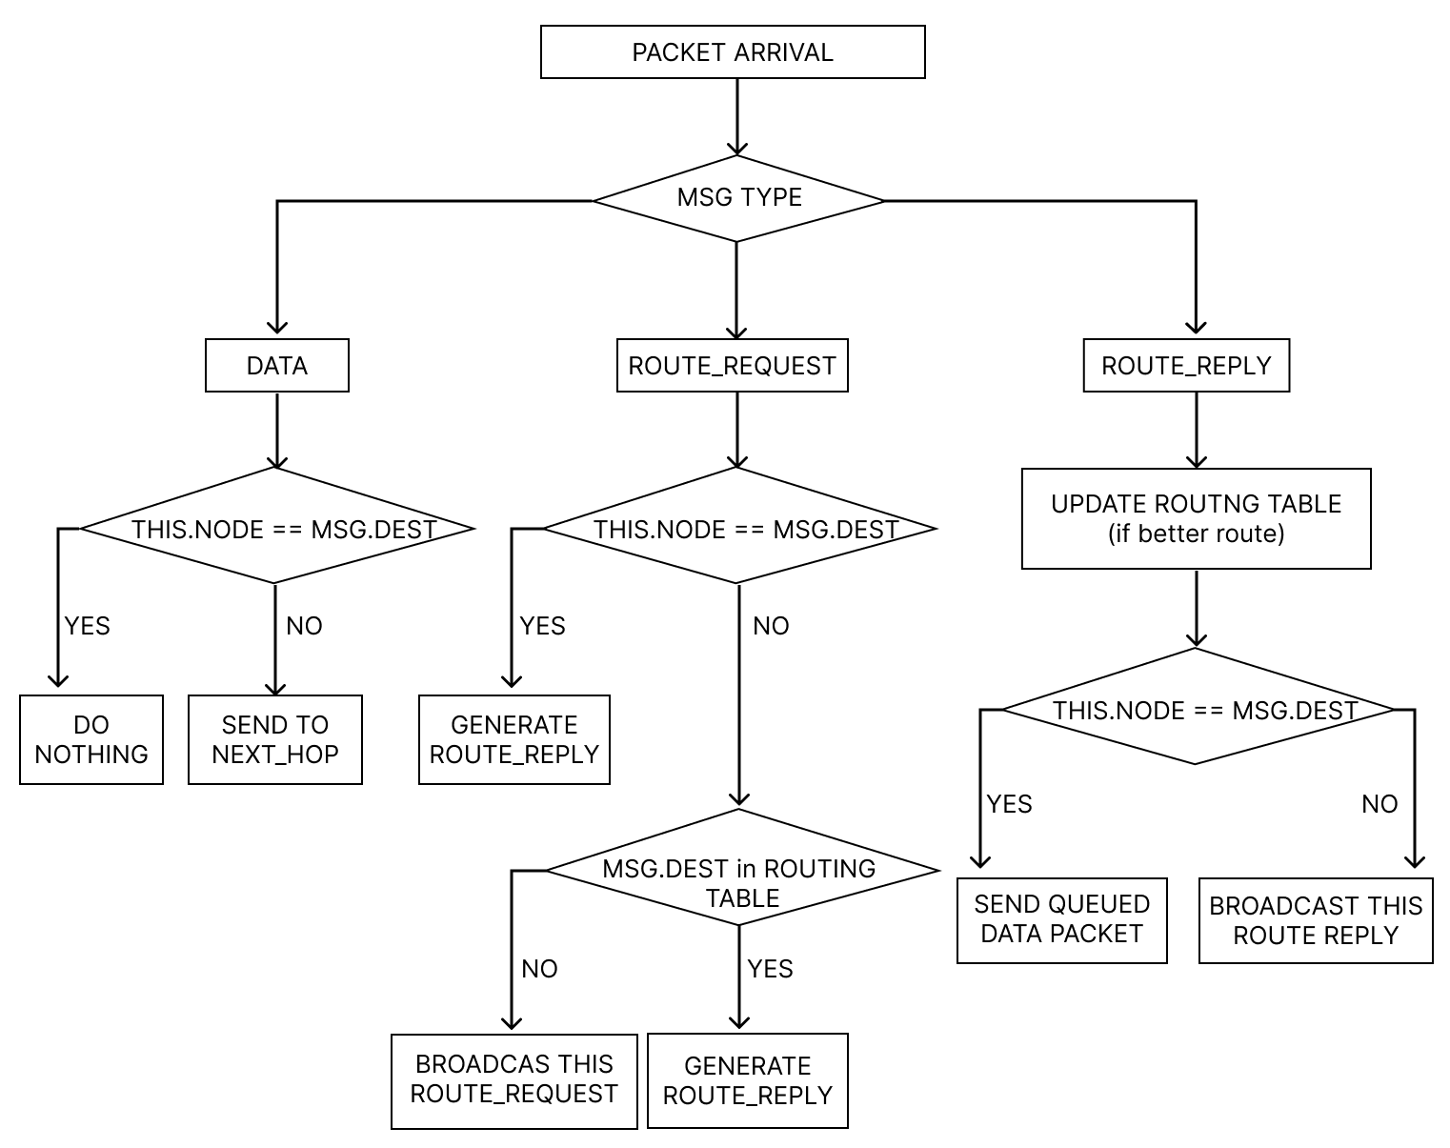

*Figure 4: Receive packets flow diagram RadioRoute.nc*

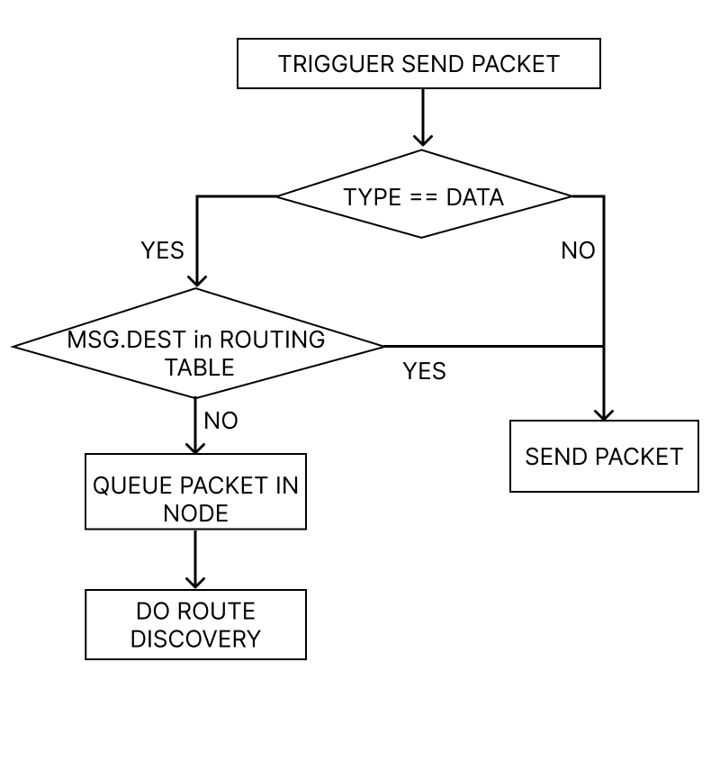

*Figure 5: Send packets flow diagram RadioRoute.nc*

The base code for these functionalities can be found at **[2]**, commented and explained step by step. The joined with the triggered events, the functions and variables used in the component list ahead are the main pieces for the features described at Figures 4 and 5:

implementation {

  message_t packet;

  // Variables to store the message to send

  message_t queued_packet;

  uint16_t queue_addr;

  uint16_t time_delays[7]={61,173,267,371,479,583,689};// Time delay in milli seconds

  message_t waiting_packet; // Packet stored while route discovery is executed

  /*****  CONSTANTS  *****/

  uint16_t NODES_COUNT = 7;

  uint16_t DATA = 0;

  uint16_t ROUTE_REQ = 1;

  uint16_t ROUTE_REP = 2;

  /*****  ROUTING TABLE  *****/

  // the index of the arrays is the destination address

  uint16_t rt_next_hop[7]={NULL,NULL,NULL,NULL,NULL,NULL,NULL};

  uint16_t rt_hot_count[7]={NULL,NULL,NULL,NULL,NULL,NULL,NULL};

  uint16_t route_req_dest_node = 0;

  /*****  LEDs  *****/

  uint16_t leader_code[8] = {1,0,9,1,1,8,1,6};

  uint16_t led_counter;

  uint16_t led_0, led_1, led_2;

  /*****  ROUTER VARIABLES  *****/

  bool route_req_sent=FALSE;

  bool route_rep_sent=FALSE;

  bool data_sent=FALSE;

  bool locked;

  void change_leds();

  bool actual_send (uint16_t address, message_t* packet);

  bool generate_send (uint16_t address, message_t* packet, uint8_t type);

  bool clear_queue(int8_t type);

## System Outputs

seria legal um print do output do codigo e comentar minimamente

## Bibliography

[1] Matteo, Cesana. (2023). IoT Challenge #3: TinyOS and TOSSIM [Published course material]. Politecnico di Milano.

[2] System Implementation at: <https://github.com/claualc/iot>

[3] TinyOS Documentation Wiki. (n.d.). Retrieved from<http://tinyos.stanford.edu/tinyos-wiki/index.php/TinyOS_Documentation_Wiki>