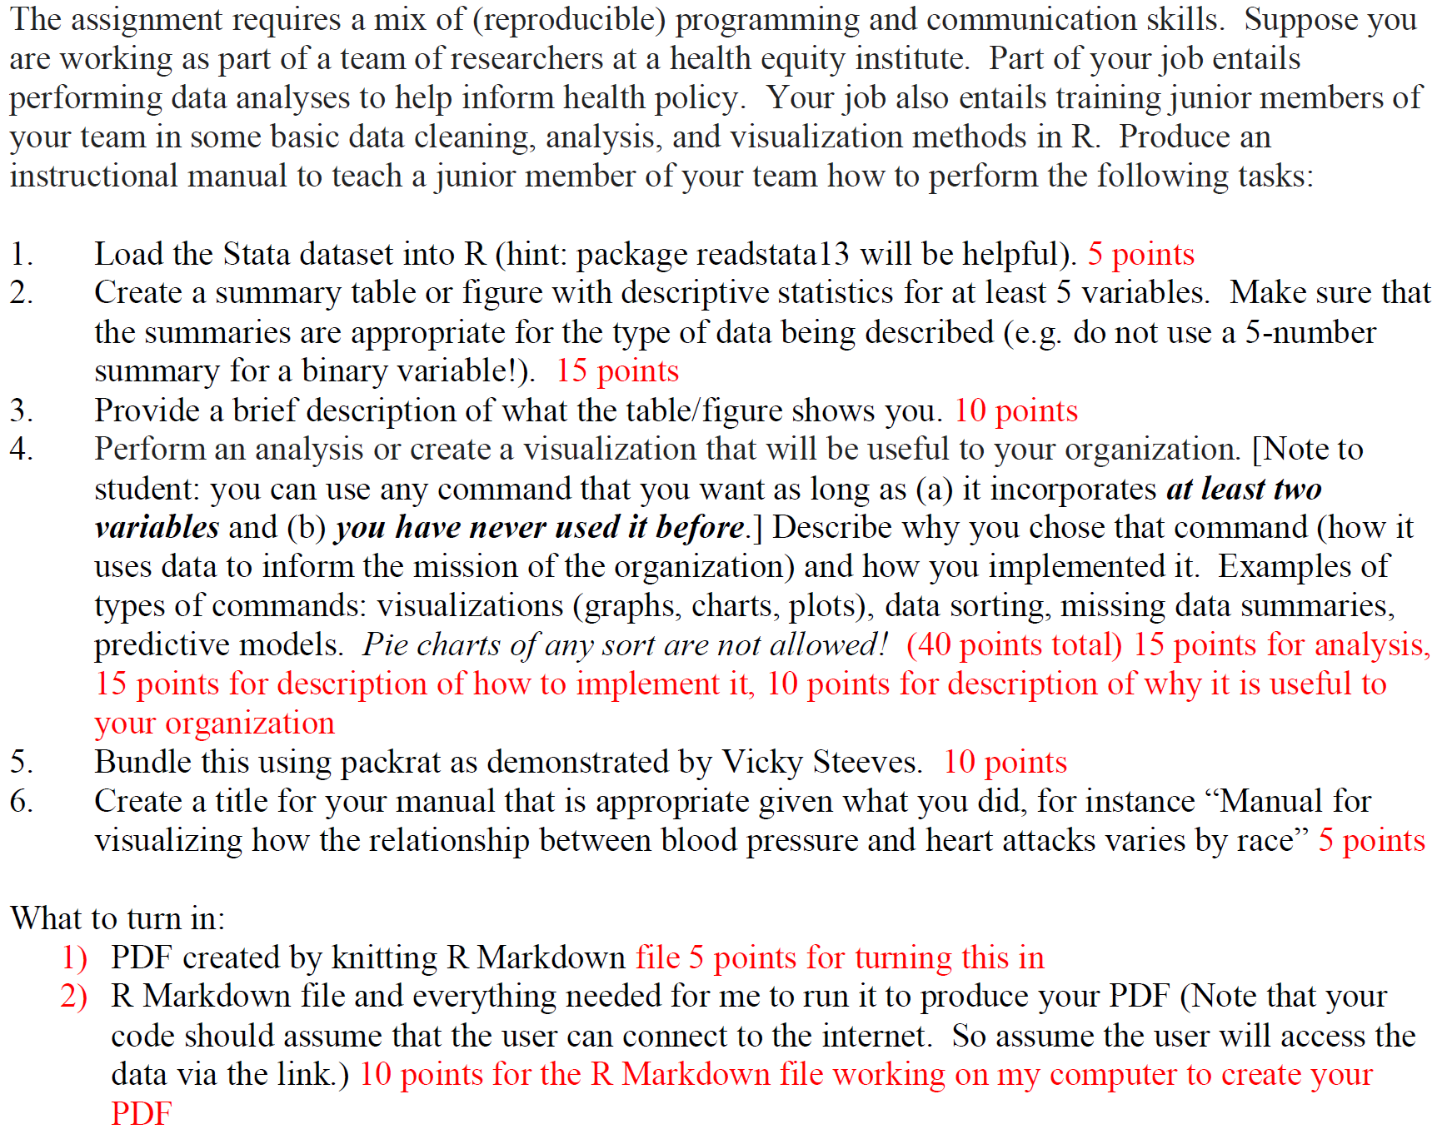var.labels <- attr(data, "var.labels")

Many folks are having trouble with packrat (both in getting Vicky's to work and getting their own to work on someone else's machine).  So I'm proposing an amendment.  If you can't get your zip file to work on someone else's machine then please upload instead the following:

1)  An .Rmd that uses the require command for all packages that are needed.  This will check to make sure that the needed packages are installed in the user's computer and only install them if they aren't there (will also check for dependencies).  In addition, please include the output of sessionInfo() as a comment to your .Rmd so I know what versions of everything you are working with (this will help me to diagnose if things get wonky).  Please try to work with a reasonably up to date (within the last few months) version of R.

2)  Your PDF

The .Rmd that Vicky used in her lecture is [here](https://goo.gl/tJbHo3).  (Thanks to Dorothy for finding and sending!)

Let me know if you have problems/questions.

Best,

Jennifer

ps In either case please make sure when you are sending works on another computer first before uploading it to Classes.  Thanks!

**Instructions**

Two options now exist for submission.

1) Submit packrat zip file with .Rmd and everything else.  Also submit the PDF that your .Rmd knits to.

2) Or submit the following

--  An .Rmd that uses the require command for all packages that are needed.  This will check to make sure that the needed packages are installed in the user's computer and only install them if they aren't there (will also check for dependencies).  In addition, please include the output of sessionInfo() as a comment to your .Rmd so I know what versions of everything you are working with (this will help me to diagnose if things get wonky).  Please try to work with a reasonably up to date (within the last few months) version of R.

-- Your PDF

In either case please make sure when you are sending works on another computer first before uploading it to Classes.  Thanks!

If you want more info about the variables in the dataset, here are two options:

1) If you have Stata, then read it into Stata and use the codebook command.

2) Otherwise, after you read the file into R with read.dta13 suppose you've

named it "data") check the attributes.  That give you more informative labels.

. var.labels <- attr(data, "var.labels")

A document with a rubric is attached.