Term Project: Web Chat Application
Design Document
Table of Contents
1 Introduction 3
1.1 Purpose and Scope 3
1.2 Target Audience 3
1.3 Terms and Definitions 3
2 Design Considerations 4
2.1 Constraints and Dependencies 4
2.2 Methodology 4
3 System Overview 5
4 System Architecture 6
4.1 Server 6
4.1.1 Verifying Account Creation 6
4.1.2 Processing Login Information 6
4.1.3 Routing and Storing Messages 7
4.1.4 Retrieving Message Logs 7
4.1.5 Updating List of Online Users 7
4.2 Client 7
4.2.1 The “Login” Screen 8
4.2.2 The “Create an Account” Screen 9
4.2.3 The “Chat” Screen 9
5 Detailed System Design 11
5.1 Server 11
5.1.1 Verifying Account Creation 12
5.1.2 Processing Login Information 13
5.1.3 Routing and Storing Messages 14
5.1.4 Retrieving Message Logs 15
5.1.5 Updating List of Online Users 16
5.2 Client 16
5.2.1 The “Login” Screen 17
5.2.2 The “Create an Account” Screen 17
5.2.3 The “Chat” Screen 18

Introduction
This design document provides information on the design of my Web Chat Application for CS300. The document consists of this introduction page, the considerations and methodologies, an overview of the systems used, an overview of each component in the systems, and finally a detailed description of each component.

Purpose and Scope
The purpose of this document is to provide details of the design goals of this project. It avoids the specific requirements that have already been detailed within the Requirements Document.

Target Audience
This document is aimed at my professor and TA who will be reading this document to get a better understanding of my project’s design.

Terms and Definitions
None.

Design Considerations
This section outlines the design considerations taken when planning this project. This includes the constraints, dependencies, and methodologies used within this project.

Constraints and Dependencies
The entire project is to be made using Java and the standard Java libraries. The internet IO portion of the project relies on Java’s Socket library. Since the project is limited to Java only, there will be no database solution such as SQL. All the database handling will be done using text files controlled by the Java application.

Methodology
This design will rely on objected oriented design, encapsulation, and data hiding. For example, all requests sent to the server are stored in a unified Request node. Users are only able to send requests to the server, which then determines if it should fulfill the request. Input validation is done on both the client and again on the server.

System Overview
This application is designed to send and receive text messages between users over the internet. There are many different steps involved in this process, and in this section I will give an overview of these different systems.

The project consists of two different applications. A server application, and a client application. The client application will create requests and messages, then send these to the server application. These requests and messages will then be processed by the server application, and any response will be sent back to the user. There will only be one server application running at a time, but every user will have their own copy of the client application. The server application will be designed to handle many different incoming requests and messages at once, and process all of them accordingly.

System Architecture
The overall system of the Web Chat Application is divided between the Server application, and the Client applications. There is only one Server running at a time, storing all requests in a queue, then processing them when it is able to. The client class displays all of the information to the users, and allows the users to interact with a GUI.

Server
The server is designed to process requests and messages from the client application. The server also stores all messages sent from the clients, and keeps track of which users are online.

Verifying Account Creation
When a user attempts to create a new account in the client application, the client application submits a request to the server to create the new account with the input credentials. The server will check these credentials by doing the following:
- Check that the account name meets the requirements.
- Check that the account name is not already taken by another user.
- Check that the password meets the password meets the requirements.

If these requirements are all met, then the server will create and store the new account information within the server. The server will then return a message to the client application verifying the account created successfully, and it will allow the user to login.

If the requirements are not met, then the server will return an error to the client application, detailing which of the requirements was not met.

Processing Login Information
When a user attempts to login within a client application, the client application will send a login request to the server. The server will process this request in the following way:
- Check that the account name is stored within the server.
- Check that the password is correct for this account.

If these requirements are met, the server will return a message to the client application, informing the application that the login was successful.

If these requirements are not met, the server will return an error detailing which specific requirement was not met.

Routing and Storing Messages
Once a user is logged in, they can send messages from the client application to other users. The server checks that these messages meet the requirements outlined within the requirements document, and returns an error if they do not. If the requirements are met, the server stores the message, then attempts to send the message to the recipient. If the recipient is not online, or the message fails to send, an error is returned to the sender.

Retrieving Message Logs
A user can optionally retrieve a log of all of the messages they have sent privately to another user, or all of the messages from the public chat room. The client application sends this request to the server. If the request fails, the server will return an error to the client application. If the request succeeds, the server will then give the client application a link to download the log file, and the client application will then automatically start downloading the log file onto the client’s local machine.

Updating List of Online Users
When the user first logs into their account, the server will send their client application a list of all user accounts. Every 10 seconds the server checks if this list has changed, and if it has, it sends out the updated list to all online clients.

Client
Each user is running their own copy of the client application. The client application sends request and messages to the server for processing. The client application allows the user to perform all of the functions detailed within the requirements document. These functions are outlined below.

The “Login” Screen
When the client application is opened, the “Login” screen will appear. The “Login” screen will allow the user to input their account information, and attempt to login.
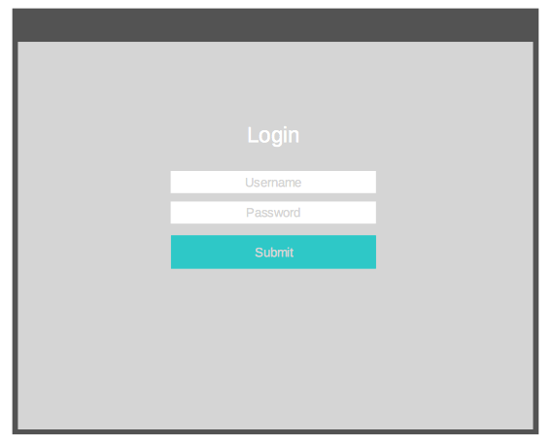

When the user presses the “Login” button, the input is checked to see if it fits the requirements, and if not an error is returned to the user. If the input does conform to the requirements, then the login request is sent to the server. If the server validates the login, then the client application will continue on to the “Chat” screen.

When the user presses the “Create an Account” button, the application will switch to the Create an Account Screen, detailed in the next section.

The “Create an Account” Screen
The client application will prompt the user to set up a new account, and present a GUI to allow the user to input their account information. Similar to the “Login” screen, this input is checked for validity before being sent to the server, where it is checked again. If the account creation is successful, then the client application will proceed on to the “Chat” screen.
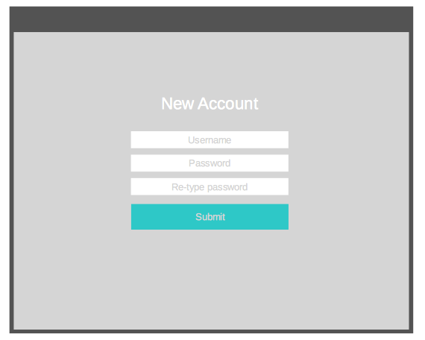

The “Chat” Screen
Once a user has successfully logged into their account, they will be presented with the “Chat” screen. The “Chat” screen consists of a list of all usernames, and a messaging window. The message portion of the window will show the user the messages to and from the currently selected user. If the user selects “All Users”, then it will show the messages to and from the global public chat room. The message sub-window also contains a text box where the user can enter their message to send. This message is checked for validity before sending to the server.
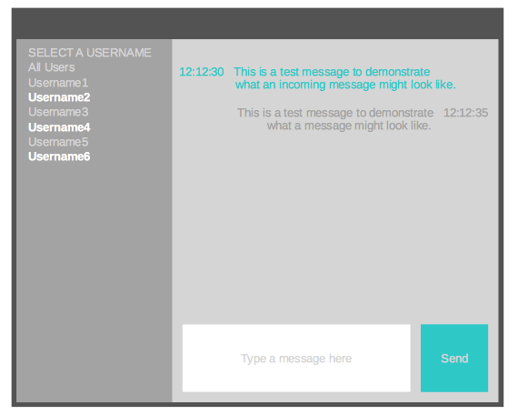

The list of all usernames will display the usernames, in alphabetical order, of every user account stored on the server. Online users will be displayed in bold, bright text, while offline users will be displayed in light grey text. When the user clicks on an username from this list, the chat window will change to a private chat room between the user and the username that they have clicked on. Above the list of usernames there will be a button labeled “All Chat”, which will return the user to the main chat room containing all other users.

Detailed System Design

Server
The server will consist of an infinite loop that will run as long as the server application is on. The server will receive requests from the client applications and store these requests in a queue. This queue will be processed whenever the server is able to.

The server will also keep track of all of the online users in a List of “Online” nodes. Each “Online” node contains the username and IP address of that client.

Each request has a special code to indicate to the server the type of request. Below is a table of the request numbers and what they indicated.
CODE | REFERENCE
1 | New Account
2 | Login
3 | Message
4 | Retrieve Logs
5 | Ping to Confirm Online

Each request type has corresponding data that is sent with it. This data is detailed in the following sections.

Each request that is received by the server is stored in a queue of “Request” nodes. Every “Request” node contains 3 parts.
- Ip address of the client that sent the request
- Request code
- Request data

Below is a basic pseudo code representation of the server application.

Queue<Request> requests
ArrayList<Online> listOfOnlineUsers
ArrayList<Online> newListOfOnlineUsers
while(true){
receiveNewRequests()
processRequestQueue()
if (20 seconds has passed){
updateListOfOnlineUsers()
}
}

Verifying Account Creation
When the server receives the code to create a new account, code “1”, the server then processes the request in the following pseudo code:

if(code == 1){
String username = data.line1
String password = data.line2

Boolean validUsername = validateUsername(username)
Boolean validPassword = validatePassword(password)
if(validUsername && validPassword){
Boolean userExists = checkIfUsernameExists(username)

if( !userExists ){
createNewAccount(username, password)
listOfOnlineUsers.insert(username)
return valid account creation message
}
}
return invalid account creation message
}

When the new account is created the account is stored onto the server’s hard drive, and the account is also added to the list of online accounts.

Processing Login Information
When a login attempt is sent to the server, code 2, the request is processed using the following pseudo code:

if(code == 2){
String username = data.line1
String password = data.line2

Boolean validUsername = validateUsername(username)
Boolean validPassword = validatePassword(password)
if(validUsername && validPassword){
Boolean userExists = checkIfUsernameExists(username)
if(userExists){
Boolean correctPassword = checkPassword(username, password)
if( correctPassword ){
listOfOnlineUsers.insert(username)
return valid login message
}
}
}
return invalid login message
}

If the user logs in successfully, add their username to the list of online users, and return a message to the user informing the client application that the login was successful.
If the login fails, return a message to the client application that the login has failed.

Routing and Storing Messages
When a new message is sent to the server, code 3, the request is processed using the following pseudo code:

if(code == 3){
String senderUsername = data.line1
String targetUsername = data.line2
String timestamp = data.line3
String messageText = data.line4

Boolean userIsOnline = checkIfUserIsOnline(targetUsername)
if(userIsOnline){
Boolean validMessage = validateMessage(messageText)
if(validMessage){
sendMessageTo(targetUsername, senderUsername, timestamp, messageText)
return message sent sucessfully
}
}
return invalid message
}

Message logs are stored on the server using text files. A folder called “LOGS” will contain all of these different text files. There will be one text file for the global chat between all users, and one text file for each private conversation between users. The global chat text file will be called “ALLCHAT_LOG.txt”. Each file for private conversations will be name based on the two users having the conversation. The files will be named alphabetically in the style of “UsernameA-UsernameB.txt”. Usernames are only allowed to have alphanumeric characters, as detailed in the requirements doc. The log file will contain all conversation that has happened in that specific chat, including timestamps for each message that was sent or received.

Retrieving Message Logs
When a user requests their message logs from the server, code 4, the request is processed using the following pseudo code:

if(code == 4){
String senderUsername = data.line1
String targetUsername = data.line2

// If the user requests the logs for the public chat, the targetUsername will be the reserved value of “ALLCHAT”.

Boolean senderUsernameExists = checkIfUsernameExists(senderUsername)
Boolean targetUsernameExists = checkIfUsernameExists(targetUsername)
if( senderUsernameExists && targetUsernameExists){
return getMessageLogLink(senderUsername, targetUsername)
}
return invalid log request
}

The server returns a URL to the requested message log, and then the client application will start to download the log to disk using the URL. This URL is not presented to the user, the client application will download the file automatically. If the URL is invalid, or the server cannot fulfill the request, an error is returned to the user.

Updating List of Online Users
Every 10 seconds the client applications send a “Ping” message to the server in order to confirm that the client is still online. The server then creates a list of all of “Online” objects containing all of the users that it received “Pings” from. The server compares this new list of online users to the old list of online users, and if the lists are different, the old list is replaced with the new one, and the server sends this new list out to all online clients.
I have provided pseudo code below:

if(listOfOnlineUsers, compareTo(newListOfOnlineUsers) != 0){
listOfOnlineUsers = newListOfOnlineUsers;
sendOnlineListToAllClients()
}

Client
The client application sends request to the server for processing. The client application all runs within one main window. This main window is a Java JFrame window. This window contains the standard buttons on the top right corner of the screen, as determined by the operating system. These buttons typically include a “Close” button to close the window, a “Maximize” button to fit the window to the size of the screen, and a “Minimize” button to minimize the window to the application tray.

Every time the application is closed and re-opened, the user has to log back into their account. For this reason there is no “Logout” button. The user simply closes the window by pressing the “Close” button in the corner of the window.

All requests sent from the client application to the server are done using Java’s Socket class. The requests are split into multiple lines.
- Ip address of the client that sent the request
- Request code
- Request data

For the purposes of this student project, the user needs to be able to specify the server that they wish to connect to. The server’s IP address will be stored and read from a text file stored on the client machine local directory. This text file will be called “SERVER-IP.txt” and contain an IPv4 address of the server to connect to.

The “Login” Screen
When the client application is opened, the “Login” screen will appear. The “Login” screen will contain two input text fields, and one button.
The two input fields are:
- Username
- Password

The two buttons are:
- Login
- Create an Account

When the user presses the “Login” button, the client application will check if the input conforms to the requirements outlined in the requirements document. If the input does not fit the requirements, an error is returned to the user. If the input does conform to the requirements, then the login request containing the form input is sent to the server. If the server determines that the login is invalid, it returns an error to the client application stating which part of the form was invalid. If the input was valid, it returns a success message to the client application to allow the user to pass the login screen, and continue on to the messaging portion of the application.

When the user presses the “Create an Account” button, the application will switch to the Create an Account Screen, detailed in the next section.

The “Create an Account” Screen
The client application will prompt the user to set up a new account, and present a GUI to allow the user to input their account information. The GUI will include three input fields and two buttons. The three input fields are:
- Username
- Password
- Re-type password

The user may enter any characters they wish into these fields, but the input will be checked by the client application, and checked again by the server application, to make sure that it fits the requirements outline in the requirements document. If the input is invalid, the server application will return an error to the user.

The two buttons are:
- Submit
- Cancel

By default the “Submit” button will be deactivated and appear slightly transparent in color to indicate that it is un-clickable. If the “Password” and “Re-type password” fields contain the exact same characters, then the “Submit” button will activate, and change into the same color as the “Cancel” button. The “Submit” button is used to send the request to the server to create a new account, and the “Cancel” button will return the user to the “Login” screen.

The “Chat” Screen
Once a user has successfully logged into their account, they will be presented with the “Chat” screen. The “Chat” screen is a GUI split into two sections. A list of all user account names will be on the left side of the screen, and a message window on the right.

The message window will contain all messages sent or received since the application was last opened. By default the chat window will display the global chat room containing all users. Any user can send a message to this chat room, and it will display their username along with a timestamp and the message that they send.

At the bottom of the chat window, there will be a text field and a “Send” button. The user may input any text message into this field, and click “Send” to attempt to send the message to the server. The message contents are validated by the user application to make sure that they conform to the requirements outlined in the requirements document. If the input does not met the requirements, then an error is displayed to the user and the message is not sent. If the input does meet the requirements, then the message is sent to the server.

The list of all usernames will display the usernames, in alphabetical order, of every user account stored on the server. The list of usernames will be stored in an ArrayList. The list of usernames is received from the server when the user logs into their account, and it is updated whenever the server determines that the list has changed. This is detailed in section 5.1.5.

Users that are online will be displayed in bright text, while users that are offline will be displayed in light grey text. When the user of the client application clicks on an username, the chat window will change to a private chat room between the user and the username that they have clicked on. Above the list of usernames there will be a button labeled “All Chat”, which will return the user to the main chat room containing all other users.

A button to download the log file for the current conversation will be provided below the text field box in the message window. When the button is pressed, the client application creates a request to send to the server, asking for the link to the current chat log’s file. If the request is fulfilled successfully, then the server will return a link to the file requested. The client application will then download this linked file using Java’s Files library.

Every 10 seconds within the “Chat” screen, the client application will send a “Ping” message (code 5) to the server application. This will inform the server that the client is still online.
asdfstill online still online.

