**Baltic Fury #1, Storm the Gates.**

13 Feb 1994, 1300 Zulu, 1400 Local

You are the commander NATO’s [BALTAP](https://en.wikipedia.org/wiki/Allied_Forces_Baltic_Approaches) (Baltic Approaches) Command. BALTAP is a joint force of land, sea and air forces arrayed specifically to keep hostile WP forces bottled up in the Baltic Sea. Your forces are primarily Danish and German but some NATO reinforcements can be expected. The restricted waters in the western Baltic funnel hostile forces directly to the island of Zeeland and Copenhagen itself. One thing is certain, there will be a lot of combat power deployed into a very small space.

Precautions over the past few hours have put a flight of F-16s forward on Bornholm Island, a few ships to sea and a NATO AWACs forward in the area of Kiel Germany. Other forces are preparing but so far there have been no hostilities.

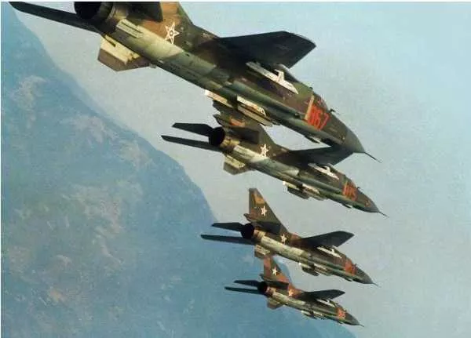

**Baltic Fury #1** is an intense scenario where the Soviets unleash an overwhelming onslaught to try and overwhelm NATO defences in the first few hours of the war. Early in the scenario the player is scrambling to muster resources and launch key counterstrokes when appropriate. As the game progresses and the Soviets have largely shot their bolt, NATOs position improves somewhat. If you can weather the storm.

