**Baltic Fury 2, Borsht on Bornholm.**

14 Feb 1994, 1800 Zulu, 1900 Local

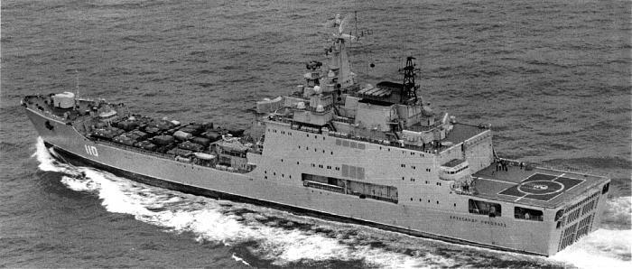

In this scenario you are playing the Soviet side and are charged with conducting an airborne and amphibious landing on Bornholm. NATO is on the backfoot so this should be a quick and relatively simple operation, but it’s essential that the island is seized and secured rapidly to allow for future operations.

You are Commander of the 27th Landing Ship Division and have recently hoisted your flag on the brand-new Landing Ship *Vasily Trushin*. As the newest ship of the *Ivan Rogov* class he is a very welcome addition to your force. In addition to the flagship, you have two Brigades of Landing ships and one of fast landing craft. In total you have enough capacity to lift the entire 336th Guards Naval Infantry Brigade and have also been tasked with transporting an Air Defence Brigade. Combined with an Airborne Brigade you should have no difficulty overwhelming the Danish defences, once you get past their submarines.

**Baltic Fury #2** is an interesting scenario in that your perspective is from the Soviet side and your amphibious forces are very different from the classic US Marine Corps force that has been portrayed in many scenarios. The size and scale would makes this a very manageable scenario while still posing some difficult challenges.

Bornholm is an idyllic island with beautiful beaches in the south and rocky cliffs in the north. Although small, its placement directly in the center of a very narrow sea makes it critical steppingstone for the Soviet plan.

The main air battle with NATO is not portrayed but will be very relevant to play. Ground combat should be minimal as most targets on Bornholm should be located and neutralized by the player before Soviet boots hit the ground. If they are not, there could be trouble.

