**Baltic Fury 3, Warsaw Uprising.**

18 Feb 1994, 1700 Zulu, 1800 Local

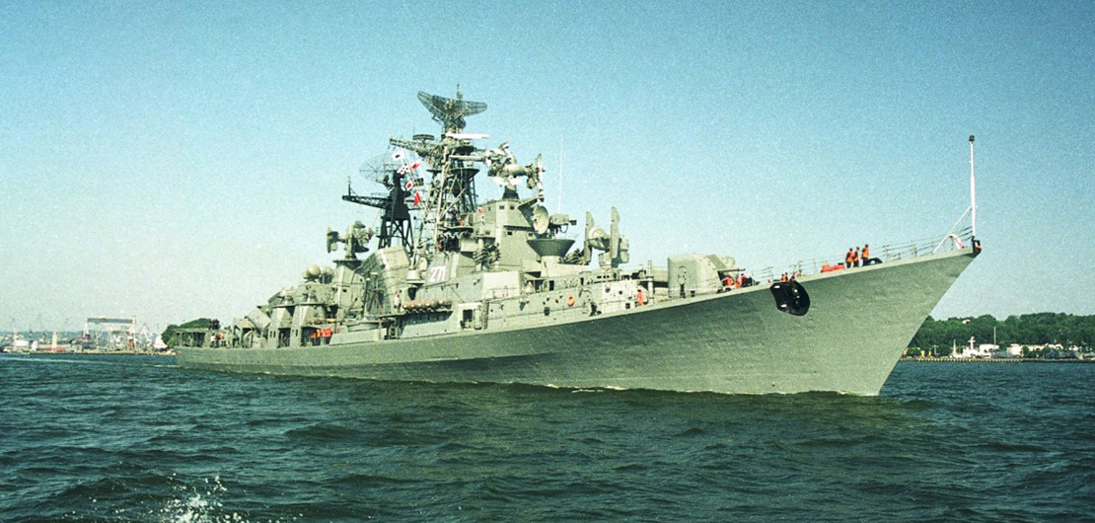

You are the commander NATO’s [BALTAP](https://en.wikipedia.org/wiki/Allied_Forces_Baltic_Approaches) (Baltic Approaches) Command. BALTAP is a joint force of land, sea and air forces arrayed specifically to keep hostile WP forces bottled up in the Baltic Sea. Your forces are primarily Danish and German reinforced by British and American air forces. The restricted waters in the western Baltic funnel hostile forces directly to the island of Zeeland and Copenhagen itself. Over the past five days the air and sea fight in the central and western Baltic has been withering. Casualties have been high with huge stocks of munitions being expended. Since Bornholm was captured an expanding Soviet presence on that island has forced you to limit your activities to being largely defensive. Today you plan to change that.

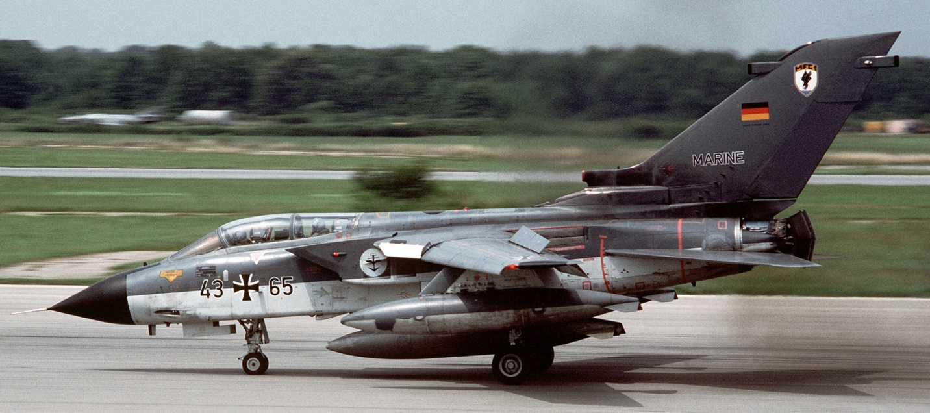

**Baltic Fury #3** puts the player in the position of mounting a major counterstrike to throw the Soviet juggernaut off balance. Although your forces are adequate, the Soviets have not been idle and the defences on and around Bornholm have been bolstered into a formidable problem.

Through the scenario the situation changes somewhat, although the mission remains, events will transpire to cause the player to re-think the situation and re-task resources.

