**Baltic Fury 4, Ride of the Valkyries.**

25 Feb 1994, 0300 Zulu, 0400 Local

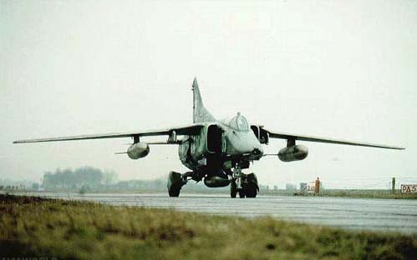

You are the commander the [Soviet 15th Air Army](http://northernfury.us/warsaw/su/air/vvs/). Your formation has deployed forward into advanced bases in Poland and has been resting for the past three days. With reinforcements you are tasked to conduct offensive strikes into Denmark in order to gain air and sea superiority over Jutland. You are to strike and 25+ runways 20+ naval piers and several communications bunkers. By completing this operation successfully, you will enable major follow-on operations to take place over the next few days. It would be unwise to consider failure.

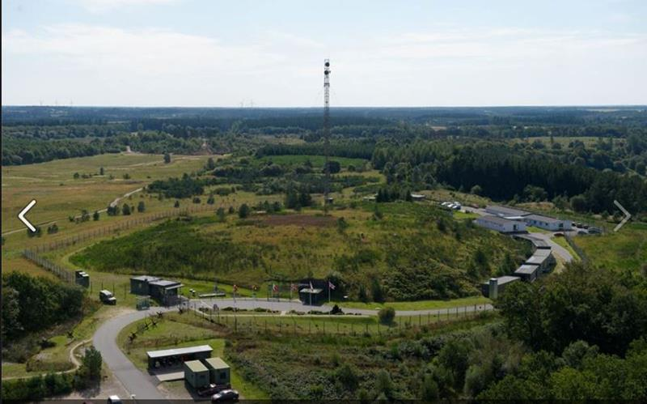

**Baltic Fury #4** is a challenging scenario as the list of tasks is long, resources are short and somewhat limited and you must complete the entire operation in 16 hours. Although you control between 375 and 400 aircraft, they are of different capabilities and with some variance in pilot quality.

NATO will be throwing everything they can into the air to stop you. Although casualties have been high on both sides, western pilots are generally better trained and ready to meet the larger numbers the Soviets can attack with.

