**Baltic Fury 5, Cut to the Jugular**

25 Feb 1994, 2000 Zulu, 2100 Local

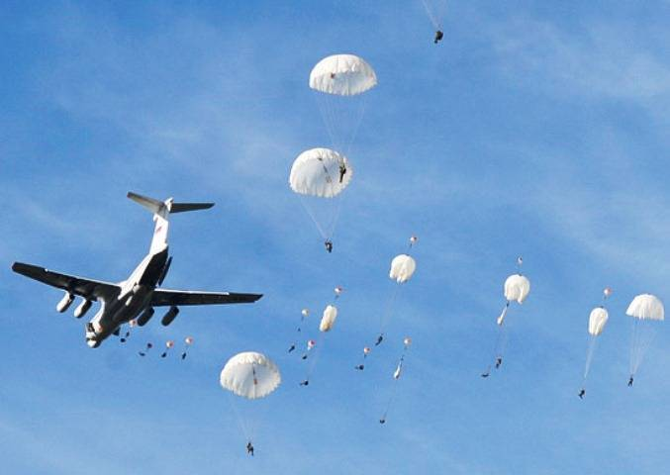

38th Airborne Corps has shifted forward from Carpathian Military District to command the operation. With a Kaliningrad based MRD as the key ingredient, two Airborne Divisions and four Brigades (including the Polish 6th AB Division) and Corps troops - this is a big force. You have enough air lift to move about 1.5 Divisions at a time with a bunch of car ferries, RoRos and freighters augmenting the Baltic Fleet's slightly reduced amphibious force..

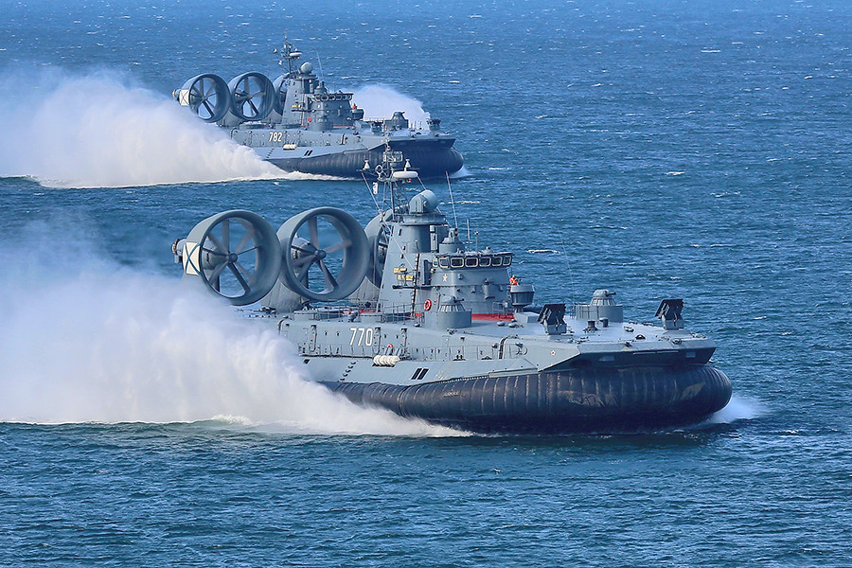

**Baltic Fury #5** is a large airborne and amphibious operation to capture key areas in Denmark.

Under development