**Baltic Fury**

Baltic Fury is a small Battleset comprising five CMO scenarios. Focusing largely on the struggle between the Soviet [Baltic Fleet](https://en.wikipedia.org/wiki/Baltic_Fleet) and NATO’s Allied Forces Baltic Approaches ([BALTAP](https://en.wikipedia.org/wiki/Allied_Forces_Baltic_Approaches)) for control of the small and shallow Baltic sea.

The geopolitical situation for the Soviets is much worse here than during most of the Cold War. With the reunification of Germany and the troubles in Poland, these allied forces and more importantly the bases located there either don’t exist or cannot be counted upon.

On the NATO side the bulk of the forces available to BATLAP, at least initially are Danish and German, two of the countries hardest hit by the supposed post Cold War *Peace Dividend*. Although reinforcements will arrive quickly from the UK and in a few days from the US, events elsewhere will keep the flow of forces into this area small.

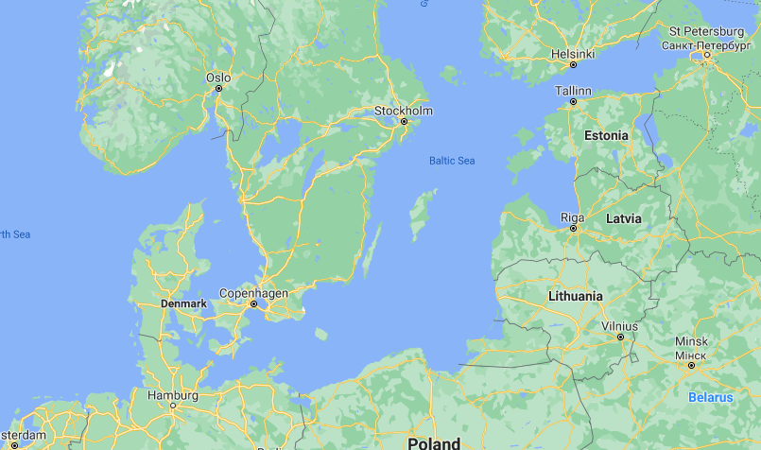

Of the five scenarios, three are played from the Soviet side and two from the NATO side.

1. Storm the Gates, NATO needs to weather the initial Soviet onslaught
2. Borsht on Bornholm, As the Soviet player conduct an amphibious assault on Bornholm Island
3. Warsaw Uprising, NATO takes advantage of political tensions in the region
4. Ride of the Valkyries, A Soviet bomber division works to destroy Denmark’s air defences
5. Cut to the Jugular, A major Soviet assault on Denmark