**Caribbean Fury 2: Retribution!**

15 Feb 1994, 1100 Zulu, 0600 Local

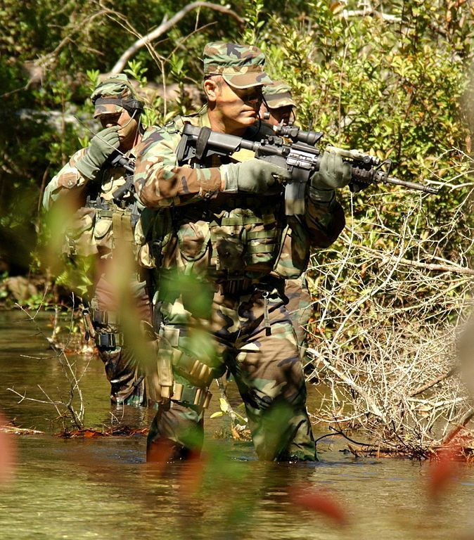

The situation in the Caribbean is somewhat unique in that it is a small ‘side show’ to the great events occurring in Europe, the North Atlantic and Pacific, but of vital interest to NATO’s largest partner – the US. The American government and military commanders want to quickly stabilize the situation here and get on with fighting the ‘real war’. While at the same time the American public, especially those in Florida and the south are very concerned with the Cuban situation. The Soviets want to capitalize on this sentiment and are using Cuba, and in other situations Guatemala, Honduras and Nicaragua to distract and tie down as many US forces as possible.

In this second scenario you’re tasked with continuing the reduction of Cuban/Soviet combat power while positioning for the next moves. In the midst of these sweeping objectives, the Commander of the new Special Operations Command (SOCOM)wants to turn the situation to an advantage by gaining as much strategic intelligence as possible.

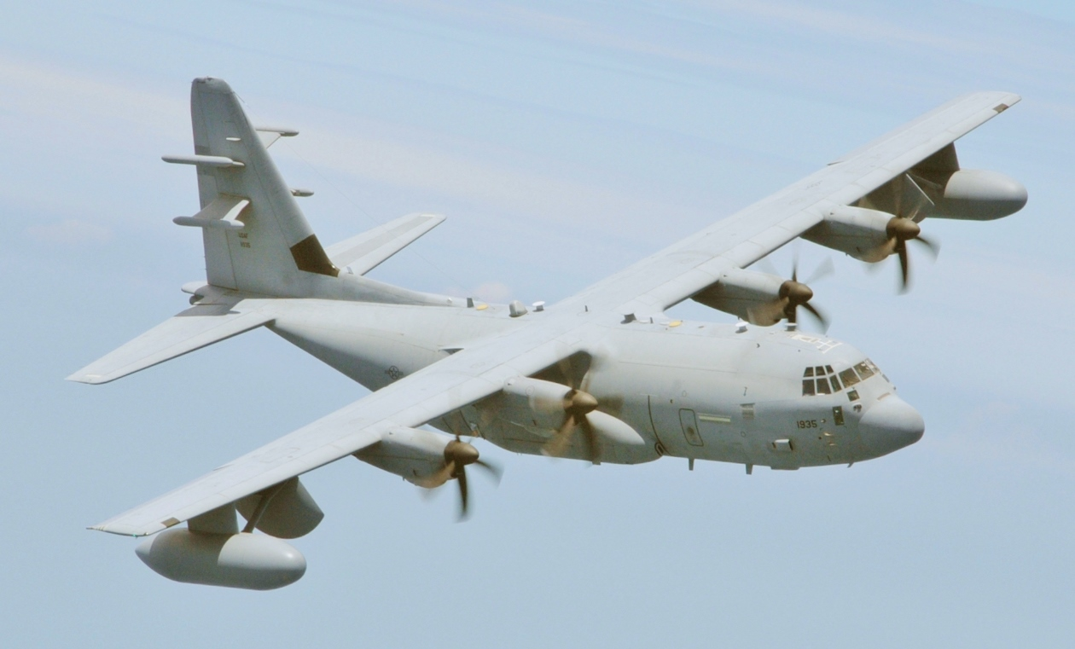

----------------

**Caribbean Fury #2** gives the player the problem of balancing hard strike operations against the more delicate and risky Special Operations Forces (SOF) action. Key targets such as the Ministry of the Interior and the Central Railway Station as well as various Television and Radio stations must be destroyed. Once the Cuban government’s ability to communicate with its people is curtailed you will need to fly missions with your own Psychological Operations aircraft over Havana. Simultaneously, SOF need to be inserted to collect intelligence at communications facilities and Castro’s home. A kill or capture operation against Castro himself is a bonus.

Of course, the Cubans don’t like this approach at all and will counter the player with everything they can including modern Surface to Air (SAM) missiles to mobile army patrols with tanks and armored vehicles. The scenario player is faced with a set of problems ranging from the ultra-tactical to the strategic and faces many key decisions.

