**Caribbean Fury 3: Rumble in the Jungle**

17 Feb 1994, 0600 Zulu, 0100 Local

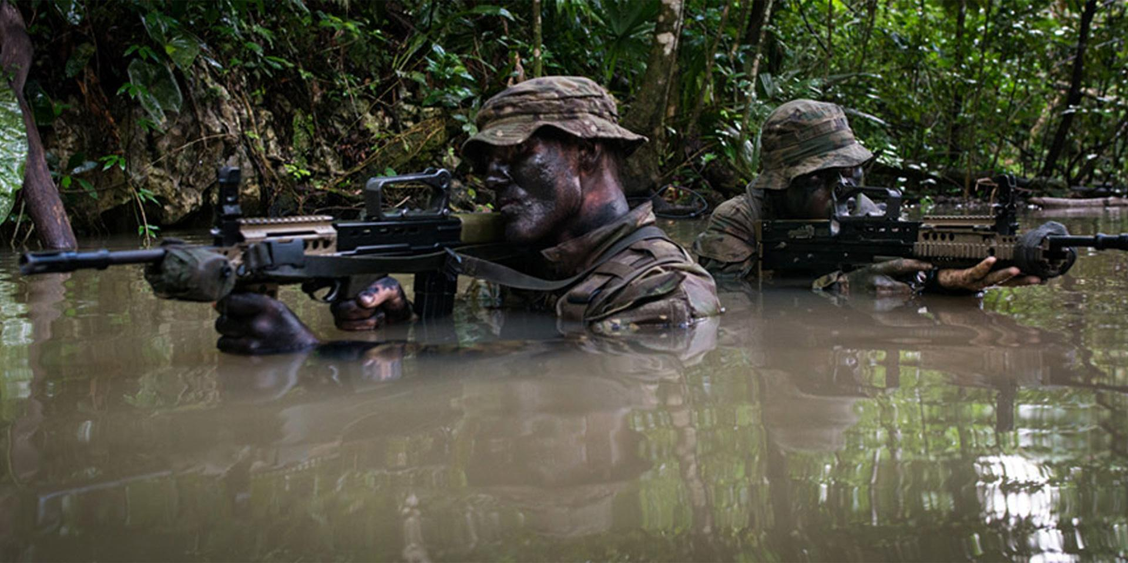

The Caribbean, although a sideshow to the global events occurring elsewhere, is of vital interest to NATO’s largest partner – the US, and also vitally important to the British, Dutch and French, all holding on to the last vestiges of their colonial empires. The American government and military commanders want to quickly stabilize the situation here and get on with fighting the real war. The British want to prevent a protracted insurgency in Belize, while the French and Dutch want the other two to focus on the largest threat to their territory – Venezuela. The Americans are not interested, they have no interest in protecting European imperial linkages in their backyard and as far as Venezuela is concerned, they want to give the newly anointed President Chavez a chance to renew close ties with the US.

The Soviets simply want their proxies to distract and tie down as many US forces as possible, for as long as possible. Cuba has essentially been knocked out of the war already, the raid on Castro’s Hacienda either killed him or forced him into hiding. The Dictator has not been seen in 36 hours and a ‘pro-piece’, but not necessarily ‘pro-American’ government has taken power and called for a cease fire. Nicaragua, Honduras and the rebellions in Panama and Belize are still in play however and Moscow is keen on having others do their fighting for as long as possible

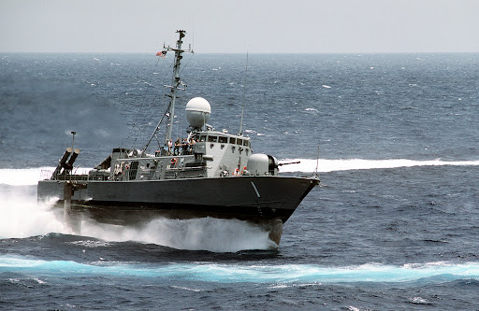

----------------

**Caribbean Fury #3** In this third scenario you have two main tasks: The American focus is to knock Honduras and Nicaragua out of the war; the British focus, aided by the French, Dutch and others is to stabilize the situation in Belize and deliver knock-out blows to the Guatemalan backed insurgents without bringing Guatemala into the war.

It may be wise on a military level for US forces to assist the British, but that must be balanced with the political imperatives from Washington. Your resources in this theater are dwindling, distances are growing as targets are more remote, and the bad guy *always* gets a vote.

