**Caribbean Fury #4 Show of Force, 1994**

19 Feb 1994, 1800 Zulu, 1400 Local

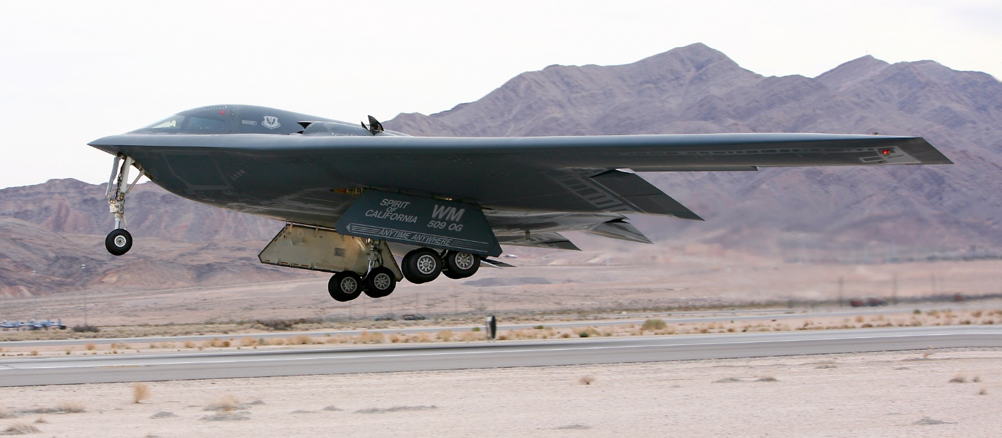

The threat from Cuba, Honduras and Nicaragua have now been neutralized, the insurgency in Belize has at least been contained and the one in Panama has petered out, so the Soviets only have one major player remaining in the region. Venezuela, however, is playing a dangerous game with both sides in the conflict. Although they are outwardly neutral, there is a supposedly secret Soviet airbase on Venezuelan soil, and Soviet submarines continue to replenish in Venezuelan ports. The US and NATO know this, but don’t want to expand the war. The Venezuelan people however don’t know about this, or at least they haven’t been told and those that do know don’t wish to acknowledge it.

A plan has been developed that will hopefully maintain the fragile peace, eliminate Soviet capability in the region, and to show Venezuela the power and reach of the US military. Proponents of US air power within Washington have convinced the President and National Security Council that by using stealth technology, they cold conduct a covert strike to destroy the Soviet footprint while getting away undetected and leave the Venezuelan population none the wiser.

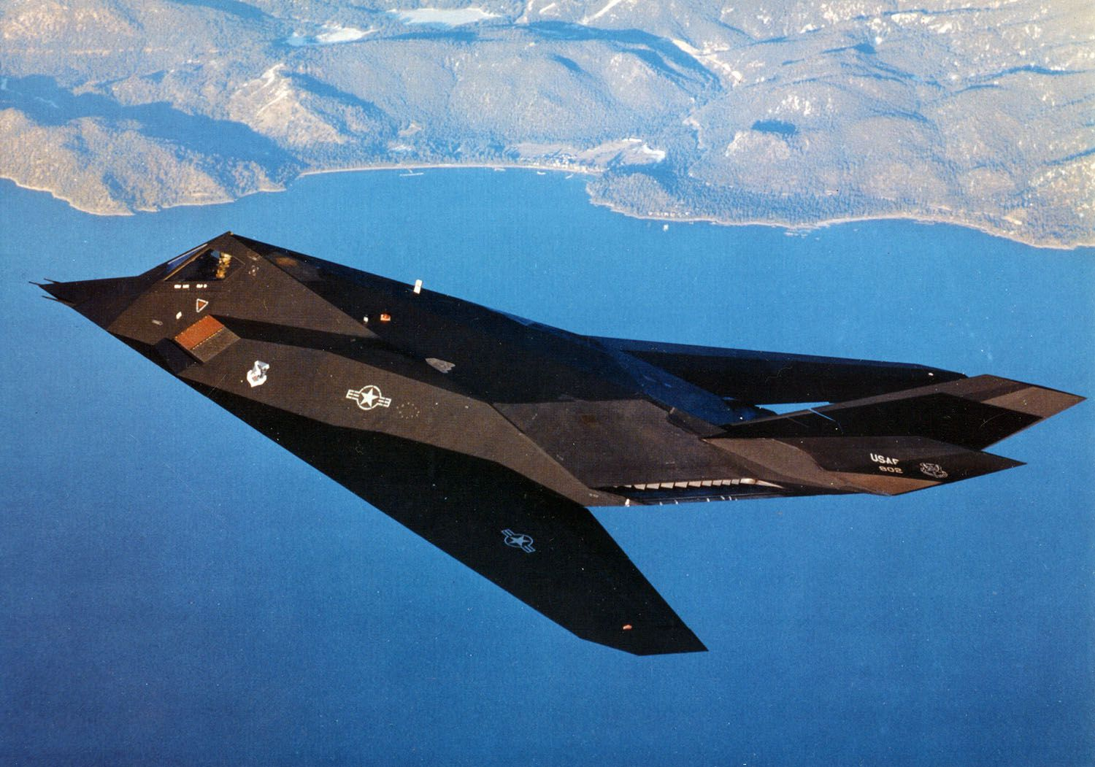

----------------

**Caribbean Fury #4** In this scenario you fill the role of Commander 49th Fighter Wing, US Air Force. With a combination of F-117 Strike Fighters, a B-2 Stealth Bomber and reconnaissance from an SR-71 you are to conduct a strike on Manodez Air Base in Venezuela. In addition to destroying any Soviet aircraft located there, your targets include communications and command infrastructure being used by the Soviet ‘advisors’ in Venezuela. You are not to be detected.

