**Caribbean Fury #5 Caribbean Cruise, 1994**

**1 April 1994, 1400 Zulu, 0900 Local**

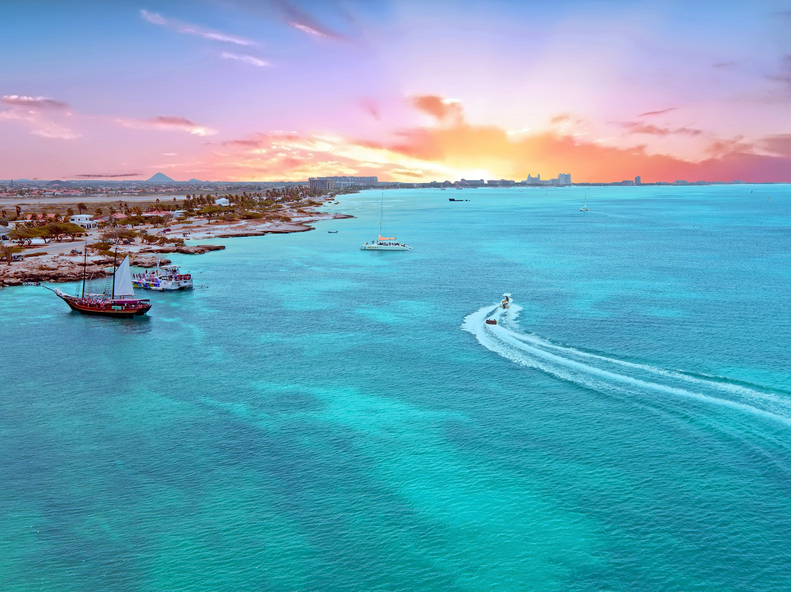

Six weeks into the war and the situation in the [Caribbean](http://northernfury.us/blog/post20/) has fallen into something of a routine. Beyond an occasional Soviet submarine, the area has been quiet for over a month.

Of course, there is always one fly in the ointment, and here is it Venezuela. Rhetoric and accusations over the strike at Manodez Air Base, as well as strong evidence that Soviet submarines are still replenishing at *Puerto La Cruz* have fueled the tensions but so far, restraint has been shown by both sides.

Growing intelligence indicators, however, predict that this situation is about to change. Both Dutch and British sources are warning of a potential Venezuelan move on either Trinidad & Tobago or the Dutch ABC Islands (Aruba, Bonaire, and Curacao), or both. With NATO forces focused on protecting merchant shipping, the thought is that Venezuela will try for a quick grab at the islands and present the US with a *fait accompli*, before standing down and offering a quick cessation of any hostilities.

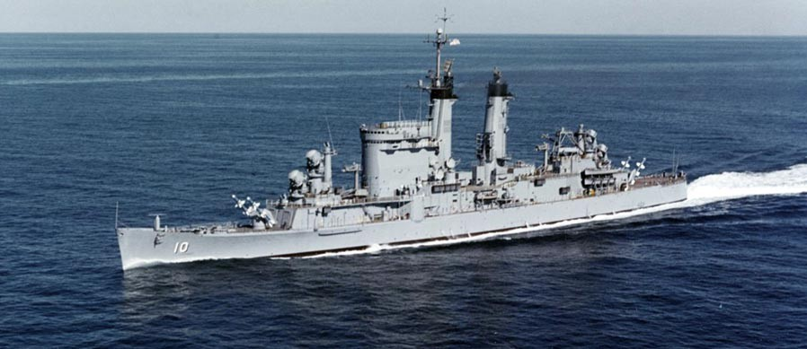

----------------

**Caribbean Fury #5** this is the fifth and final scenario of a short campaign. You are commander of the newly re-established US 4th Fleet with your flag aboard the re-commissioned ***USS Albany (CG-10)***. The ***Albany*** originally commissioned nine months after the end of World War Two and she has seen her share of sea miles, just like many of the ships under your command. Your primary task is to ensure the safety of merchant shipping gathering in convoy assembly areas, while keeping a weather eye on Venezuela. The Dutch and the British have wider concerns but fewer resources.

